AIXM

AIXM 4.5 TO AIXM 5.1 MAPPING GUIDELINES

Aeronautical Information Exchange Model
(AIXM)

Copyright: 2013 - EUROCONTROL and Federal Aviation Administration
All rights reserved.
This document and/or its content can be download, printed and copied in whole or in part, provided that the above copyright notice and this condition is retained for each such copy.
For all inquiries, please contact:
Diana YOUNG – diana.young@faa.gov
Eduard POROSNICU - eduard.porosnicu@eurocontrol.int

Edition No. |  | Issue Date | Author | Reason for Change
0.8 | Draft | 23 FEB 2010 | Benoit GEFFROY (EgisAvia – under contract for Eurocontrol) | First public release on the AIXM Forum as « draft » version, for review by the stakeholders
0.9 | Draft | 01 DEC 2010 | Benoit GEFFROY (EgisAvia – under contract for Eurocontrol) | Updated version, based on comments from EUROCONTROL and AIXM Forum
1.0 | Released | 03 June 2013 | Eduard Porosnicu  Razvan Guleac | Updated version based on feedback from developments, in particular the Eurocontrol EAD AIXM 5.1 implementation effort
1.0.1 | Released | 11 June 2013 | Eduard Porosnicu | Editorial corrections – version number in the footer and misplaced new diagram in section 2.78 instead of 2.77
1.1 | Released | 31 July 2013 | Eduard Porosnicu | Updated after public review. Small changes/clarifications in several sections, mostly of editorial nature. Added one section (1.4) indicating limitations of the mapping guidelines.

Contents
EXECUTIVE SUMMARY 7
CHAPTER 1 – How to read this document 8
1.1 General principles 8
1.2 Document structure 8
1.3 Graphical representation 8
1.3.1 Diagram layout 8
1.3.2 Stereotypes and associations 9
1.3.3 Class and attribute names 10
1.3.4 AIXM 5.1 - XML attributes representation 10
1.3.5 Special conversion rules 10
1.3.6 Crossed out AIXM 4.5 attributes 11
1.3.7 Conversion rules in the Annex 11
1.3.8 Codelist 11
1.3.9 Representation of the Uid 11
1.3.10 Classes grouped together 12
1.3.11 Crossed out AIXM 4.5 class names 12
1.4 Limitations 12
1.4.1 Fully automatic versus human intervention 12
1.4.2 Deprecated AIXM 4.5 elements not included 13
1.4.3 “Dynamic” mapping rules not included 13
CHAPTER 2 – Mapping diagrams 14
2.1 ADDRESS 15
2.2 AD_HP 17
2.3 AD_HP_COLLOCATION 19
2.4 AD_HP_GND_SER 20
2.5 AD_HP_NAV_AID 24
2.6 AD_HP_OBSTACLE 25
2.7 AD_HP_SURFACE_BORDER 26
2.8 AD_HP_SURFACE_VERTEX 31
2.9 AD_HP_USAGE 32
2.10 AERO_GND_LGT 33
2.11 AIRSPACE 37
2.12 AIRSPACE_ASSOCIATION 43
2.13 AIRSPACE_BORDER 44
2.13.1 AIRSPACE_BORDER with vertices 44
2.13.2 AIRSPACE_BORDER with circle 52
2.14 AIRSPACE_BORDER_CROSSING 54
2.15 AIRSPACE_BORDER_VERTEX 55
2.16 AIRSPACE_CIRCLE_VERTEX 56
2.17 AIRSPACE_CLINE_VERTEX 57
2.18 AIRSPACE_CORRIDOR 58
2.19 AIRSPACE_DERIV_GEOMETRY 63
2.19.1 AIRSPACE_DERIV_GEOMETRY with same extent 63
2.19.2 AIRSPACE_DERIV_GEOMETRY with aggregation 65
2.20 ANGLE_INDICATION 67
2.21 APRON 69
2.22 APRON_LGT_SYS 71
2.23 AUTH_FOR_AIRSPACE 72
2.24 CALLSIGN_DETAIL 73
2.25 DESIGNATED_POINT 74
2.26 DISTANCE_INDICATION 76
2.27 DIRECT_FLIGHT_CLASS 78
2.28 DIRECT_FLIGHT_SEGMENT 79
2.29 DME 80
2.30 DME_USAGE_LIMIT 83
2.31 EN_ROUTE_RTE 85
2.32 FATO 86
2.33 FATO_CLINE_POINT 88
2.34 FATO_DIRECTION 89
2.35 FATO_DIRECTION_ALS 91
2.36 FATO_DIRECTION_DECL_DIST 93
2.37 FATO_DIRECTION_LGT_SYS 95
2.38 FATO_DIRECTION_OBSTACLE 98
2.39 FATO_DIRECTION_STAR 100
2.40 FATO_PROTECT_AREA 101
2.41 FLIGHT_CLASS 103
2.42 FLOW_COND_COMBINATION 104
2.43 FLOW_COND_ELEMENT 106
2.44 FLOW_COND_ELEMENT_LVL 107
2.45 FREQUENCY 108
2.46 FUEL 111
2.47 GATE_STAND 113
2.48 GEO_BORDER 115
2.49 HOLDING_PROCEDURE 118
2.50 IAP 122
2.51 IAP_USAGE 126
2.52 ILS 127
2.53 MKR 130
2.54 MLS 133
2.55 MSA 136
2.56 MSA_GROUP 137
2.57 NAVAID_LIMITATION 139
2.58 NAV_SYS_CHECKPOINT 140
2.59 NDB 142
2.60 NDB_USAGE_LIMIT 145
2.61 NITROGEN 147
2.62 OBSTACLE 148
2.63 OIL 152
2.64 ORG_AUTH 153
2.65 ORG_AUTH_ASSOC 154
2.66 OXYGEN 156
2.67 PASSENGER_FACILITY 157
2.68 PREDEFINED_LVL 158
2.69 PREDEFINED_LVL_COLUMN 159
2.70 PREDEFINED_LVL_TABLE 160
2.71 PROCEDURE_LEG 162
2.72 RTE_PORTION 168
2.73 RTE_SEG 169
2.74 RTE_SEG_USE 174
2.75 RTE_SEG_USE_LVL 176
2.76 RWY 177
2.77 RWY_CLINE_POINT 179
2.78 RWY_DIRECTION 180
2.79 RWY_DIRECTION_ALS 182
2.80 RWY_DIRECTION_DECL_DIST 184
2.81 RWY_DIRECTION_LGT_SYS 186
2.82 RWY_DIRECTION_OBSTACLE 189
2.83 RWY_DIRECTION_STAR 190
2.84 RWY_PROTECT_AREA 191
2.85 SEGMENT 193
2.86 SERVICE 194
2.87 SERVICE_AT_AD_HP 199
2.88 SERVICE_IN_AIRSPACE 200
2.89 SERVICE_ON_HOLDING_PROC 201
2.90 SERVICE_ON_IAP 202
2.91 SERVICE_ON_RTE_SEG 203
2.92 SERVICE_ON_SID 204
2.93 SERVICE_ON_STAR 205
2.94 SID 206
2.95 SID_USAGE 209
2.96 SIGNIFICANT_POINT 210
2.97 SIGNIFICANT_POINT_IN_AS 211
2.98 SPECIAL_DATE 213
2.99 SPEC_NAV_STATION 214
2.100 SPEC_NAV_SYS 216
2.101 STAR 217
2.102 STAR_USAGE 220
2.103 SURFACE_CHARACTERISTICS 221
2.104 SURFACE_LGT_GROUP 224
2.105 SWY 226
2.106 TACAN 227
2.107 TACAN_USAGE_LIMIT 230
2.108 TFC_FLOW_RESTR 232
2.109 TFC_FLOW_RTE 234
2.110 TFC_FLOW_RTE_ELEMENT 236
2.111 TFC_FLOW_RTE_ELEMENT_LVL 237
2.112 TIMESHEET 238
2.113 TIMETABLE 239
2.114 TLOF 244
2.115 TLOF_LGT_SYS 246
2.116 TLOF_SAFE_AREA 248
2.117 TWY 249
2.118 TWY_CLINE_POINT 251
2.119 TWY_HOLDING_POSITION 253
2.120 TWY_INTERSECTION 255
2.121 TWY_LGT_SYS 256
2.122 UNIT 258
2.123 UNIT_ASSOC 261
2.124 VOR 263
2.125 VOR_USAGE_LIMIT 266
ANNEX 1 – Additional mapping 268
A1.1 Mapping of geographical coordinates 269
A1.2 Mapping of an attribute into Note 272
A1.3 Mapping of “valCrc” attributes 274
A1.4 Mapping of AIRSPACE_VERTEX and AD_HP_SURFACE_VERTEX 275
A1.4.1 codeType = ABE 275
A1.4.2 codeType = CCA 276
A1.4.3 codeType = CWA 279
A1.4.4 codeType = FNT 282
REFERENCES 283
ABBREVIATIONS 284

EXECUTIVE SUMMARY

This document provides data mapping and conversion rules from AIXM 4.5 to AIXM 5.1. The document tries to provide guidance for both automatic mapping code and, where appropriate, indications for more precise data conversions that could be done with manual effort. This concerns in particular attributes that are free text format in AIXM 4.5 and which correspond to structured attributes in AIXM 5.1. Starting with version 1.0 of the document, there are indications in the document on the (simplified) solution to be adopted when only automatic mapping is executed.
The data mapping encompasses all AIXM 4.5 classes, including their attributes and their relationships. Conversion rules are providing whenever necessary.
The mapping representation stays as close as possible to the UML formalism. Even if UML does not have a norm for “conversion diagrams”, the diagrams in the document are quite similar to class diagrams. The exact way of reading the diagrams is described in detail in the first chapter – How to read this document.
Since this document emphasizes a UML approach, it should be especially adapted to the mapping of AIXM 4.5 databases. However, it does not provide any information about the differences between AIXM 4.5 and AIXM 5.1 XML files, nor does it cover the whole spectrum of AIXM 5.1. Only the 5.1 classes used in the mapping from AIXM 4.5 are detailed here.
The readers of this document are also advised to consult the AIXM 4.5 Primer document, which the mapping between the AIXM 4.5 entity-relationship model and the AIXM 4.5 XML Schema. These aspects are particularly important for those attempting to map data coming from an AIXM 4.5 XML data source.

How to read this document

General principles
In order to facilitate the understanding, a graphical representation of the mapping guidelines was favoured. Additional conversion rules and explanations are provided in textual format, complementing the graphical representation.
AIXM classes are represented according to the UML norm for class diagrams. However this formalism is not entirely suited for conversion diagrams, which UML does not cover. That is why additional representation conventions have been adopted.

Document structure
All AIXM 4.5 classes have their own section and most of them have their own conversion diagram. When an AIXM 4.5 class does not have a diagram, it is because its mapping is included in another diagram. In such a case, a link is provided to the section containing that diagram.

Graphical representation

Diagram layout
AIXM 4.5 entities are represented as UML classes, in pale yellow, and are positioned on the left of the diagrams. AIXM 5.1 classes are represented in light green, and are positioned on the right.
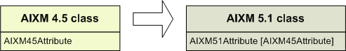
A white arrow (not belonging to the UML formalism) points from the AIXM 4.5 class to its AIXM 5.1 equivalent. A diagram with several white arrows indicates that an AIXM 4.5 class may be mapped into one of several AIXM 5.1 classes. In such a case, the rules about which AIXM 5.1 class should be used are detailed after the diagram.
The mapping of an AIXM 4.5 attribute is indicated between brackets right after the AIXM 5.1 attribute(s) into which it shall be mapped.

Stereotypes and associations
AIXM 5.1 classes have three different stereotypes: <<feature>>, <<object>> and <<choice>>, all of them being designated as “entities” in the rest of the document.
- <<feature>> are independent entities, such as AirportHeliport or Airspace.
- <<object>> are entities depending on a <<feature>> or another <<object>>, such as AirportHeliportAvailability or AirspaceVolume.
- <<choice>> are entities without attributes, used only to establish selective associations between other entities. SignificantPoint is a <<choice>> associating various entities with either a DesignatedPoint, a Navaid, a RunwayCentrelinePoint, the centrepoint of a TouchDownLiftOff or the ARP of an AirportHeliport.
In the rest of the document, <<feature>> and <<object>> are represented the same way, with a regular class diagram, while <<choice>> classes are represented with dotted outline, and have no attribute.
In AIXM 5.1, associations to a <<feature>> are simple associations, while associations to an <<object>> are compositions. Association classes are linked to an association through a dotted line.
AIXM 4.5 does not make a distinction between <<feature>> and <<object>>. In the AIXM 4.5 diagrams, compositions are only used when a class is included into another according to the AIXM XML schema (see the AIXM 4.5 Primer for further details on this aspect).
Indicated multiplicities are always in direction of the association navigability (from the class at the beginning and in the direction of the arrow representing the association).

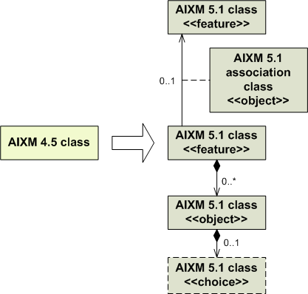

Class and attribute names
AIXM 4.5 class names are always written in capital letters, with underscores between words, such as AD_HP, GEO_BORDER, etc.
AIXM 5.1 classes are written in UpperCamelCase style, such as AerodromeHeliport, GeoBorder, etc.
This provides an easy way of differentiating versions of a same class. AIRSPACE always refers to the AIXM 4.5 class, while Airspace refers to the AIXM 5.1 version. The word “airspace” without capital letter refers to the general idea of airspace.
Although in the AIXM 4.5 model the attribute names are written in upper case, in this document they are written according to AIXM 5.1 convention (in “lowerCamelCase”). This way AIXM 4.5 and AIXM 5.1 attributes are written the same way in the mapping diagrams.

AIXM 5.1 - XML attributes representation
AIXM 5.1 attributes that are implemented in the XSD schema as XML attributes (as opposed to XML elements) are prefixed with an “@” sign. For example, the Unit of Measurement attributes (“@uom”).

Special conversion rules
Attributes and classes subjected to special conversions rules and / or mapping issues are followed by a note number (in ^{superscript} style) . Additional information about the issue may be found after the diagram in the appropriate note.
Attributes and classes in red (font colour) indicate issues that are considered difficult mapping situations. The mapping rules for these items are expected to be refined based on feed-back from implementations. The final solution applied in some of these situations might depend on the actual content of the data source that needs to be converted.

Crossed out AIXM 4.5 attributes
When AIXM 4.5 attributes do not to map into an AIXM 5.1 attribute, they are represented in the left side of the diagram strikethrough and the reason is explained in a comment. For example, this occurs when an AIXM 4.5 “type” attribute is the equivalent of some specialised classes in AIXM 5.1.

Conversion rules in the Annex
AIXM 4.5 attributes represented in italics are to be mapped according to rules detailed in an Annex. The AIXM 5.1 diagrams will not provide any attributes to map them, but these attributes are not crossed out.
Attributes in italics may be:
- Geographical information: in most cases, the “geoLat”, “geoLong”, “codeDatum”, “valGeoAccuracy”, “uomGeoAccuracy”, “valElev”, “valElevAccuracy”, valGeoidUndulation”, “uomDistVer” and “txtVerDatum” attributes are mapped into Point or ElevatedPoint according to the rules described in the Mapping of geographical coordinates section;
- Free text attributes: “txtRmk”, “txtDescr” and most free text attributes are mapped into Note;
- “valCrc” attributes: these attributes must be mapped in a Note according to the rules described in the Mapping of “valCrc” attributes section;
- Attributes that cannot be mapped into a specific AIXM 5.1 attribute. They have to be mapped into Note just like free text attributes.
Attributes in italics are followed by:
- a small superscript “Note” if they are to be mapped in a Note, or
- a small superscript “Point” if they are to be mapped in a Point or an ElevatedPoint.
When AIXM 4.5 attributes are mapped in a Note in AIXM 5.1, that Note shall always get purpose = “OTHER:AIXM45_MAPPING”, unless otherwise specified by a mapping remark in the document.

Codelist
The enumerated datatypes in AIXM 5.1 have a stereotype <<codelist>>. The <<codelist>> stereotype works as an enumeration, except that it also accepts extra values in addition to the listed ones.
Some AIXM 4.5 enumeration values do not have a strict equivalent in AIXM 5.1. When the corresponding AIXM 5.1 enumeration is a <<codelist>>, it is possible to map such a value in the form “OTHER:AIXM 4.5 value)”. Whenever this occurs, the value is written in italics within the conversion rules tab. This shall not be confused with the class attributes written in italics, for which general mapping guidelines are provided in an Annex.

Representation of the Uid
AIXM 4.5 attributes that are part of the AIXM 4.5 natural key (the “Uid” element) are represented in a separate frame.

Classes grouped together
When several classes are grouped together in a single block, it means the associations to and from the block are to only one class among those of the block. The corresponding class in the other version is most of the time obvious. If this is not the case, the exact mapping is detailed in text notes below the diagram.

Crossed out AIXM 4.5 class names
When an AIXM 4.5 class is crossed out on a diagram, it means its association to the main class of the diagram is not mappable, not that the class itself is not directly mappable. The reason is explained in a comment.

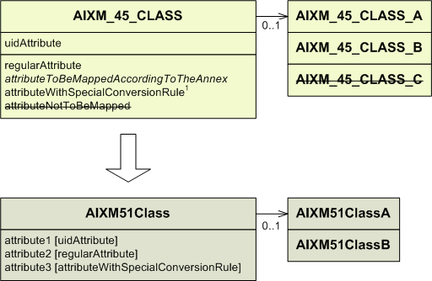

In this case, the AIXM_45_CLASS may be associated to one of the classes AIXM_45_CLASS_A, AIXM_45_CLASS_B or AIXM_45_CLASS_C.
Since AIXM51Class can only be associated to either AIXMClassA or to AIXMClassB, the association between AIXM_45_CLASS and AIXM_45_CLASS_C cannot be mapped and the AIXM_CLASS_C is crossed out. This does not mean AIXM_CLASS_C is not mappable as a class.

Limitations
The readers of this document shall keep in mind that some limitations in the scope of the mapping have been applied in the definition of the mapping guidelines. These are described in this section,

Fully automatic versus human intervention
Some attributes that are of type “free text” in AIXM 4.5 correspond to structured attributes/associations in AIXM 5.1. Starting with version 1.0 of the document, there are indications in the document on the (simplified) solution to be adopted when only automatic mapping is executed. However, the document also provides indications for more precise data conversions that could be done with manual effort.

Deprecated AIXM 4.5 elements not included
The AIXM 4.5 model contains certain attributes and associations that are marked as ‘Deprecated’. They were maintained in AIXM 4.5 for syntactical backwards compatibility with AIXM 3.3. All such ‘Deprecated’ elements are not in the scope of this document.

“Dynamic” mapping rules not included
The mapping guidelines provided in this document are limited to a ‘static’ view of the AIXM 4.5 and AIXM 5.1 models. The mapping of the AIXM 4.5 ‘Update’ and ‘Snapshot’ messages is not discussed. In general, that should be straight-forward considering the AIXM 5.1 Temporality Concept.
However, there exist particular situations that might require specific procedures. Two examples are given below, but this list is certainly not exhaustive and the actual solution might depend on the particularities of the system/data source being mapped and on the client system requirements:
- Navaid type change or withdraw/create: consider a VOR-DME encoded according to the AIXM 4.5 model, as a VOR having a collocated association with a DME. According to the mapping guidelines, a VOR_DME Navaid is created in AIXM 5.1. If the VOR is withdrawn one day, then either the Navaid changes type into ‘DME’ or the previous VOR_DME Navaid is also set to ‘end of life’ and a new DME Navaid is created in AIXM 5.1. This new DME Navaid might shift its position, as the VOR coordinated are typically used for the VOR/DME (a collocated en-route DME may be as far as 600 m apart);
- Processing of "cancel future commit": this may occur in systems that allow overriding future changes by making a change with an earlier applicability date (such as the European AIS Database (EAD/SDO) does. This may occur when correcting errors and/or when merging non-AIRAC changes onto a feature that already has a future AIRAC change published. The mapping rules need to consider the impact on the AIXM 5.1 feature timeline of such situations. Such details are not provided in this document.

Mapping diagrams

ADDRESS
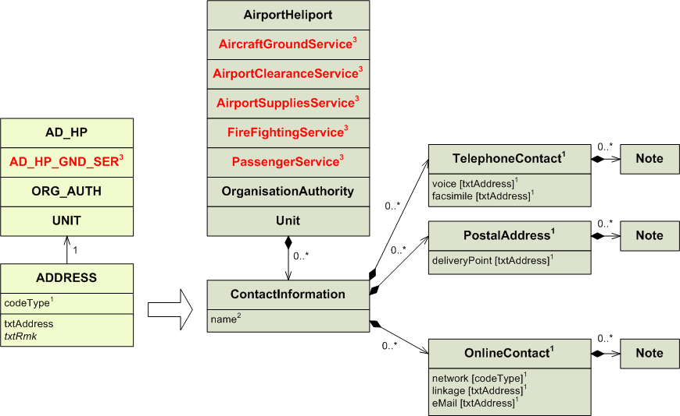
1) Conversion rules for codeType and txtAddress:

codeType | AIXM 5.1 class to be used | Attribute to be used | Also use the “network” attribute
POST  PHONE  FAX  TLX  SITA  AFS  EMAIL  URL  RADIO  OTHER | PostalAddress  TelephoneContact  TelephoneContact  OnlineContact  OnlineContact  OnlineContact  OnlineContact  OnlineContact  OnlineContact  OnlineContact** | deliveryPoint*  voice  facsimile  linkage  linkage  linkage  eMail  linkage  linkage  linkage | OTHER:TLX  SITA  AFTN  INTERNET  INTERNET  OTHER:RADIO  OTHER

* It is estimated that trying to split an AIXM 4.5 txtAddress into components such as deliveryPoint, city, postalCode, etc. is not always possible and not worth the effort. Therefore, this simplified mapping is proposed.
** if an address of type OTHER is encountered in an AIXM 4.5 data source, it is likely to be a very special type of network connection.

In AIXM 5.1, several Addresses related to the same entity can be grouped together in the same ContactInformation, if they describe several ways of reaching the same person, service, etc. However, this grouping is not recommended for AIXM 4.5 to AIXM 5.1 conversions at it might be difficult to implement for automatic conversions.

2) The “name” attribute in ContactInformation should not be populated with any value from ADDRESS. However it may be used to differentiate ContactInformation of the same type associated to a same entity, although there is no recommended way of doing so.

3) AD_HP_GND_SER may be mapped into five different types of ground service. See the AD_HP_GND_SER section for more details.

AD_HP

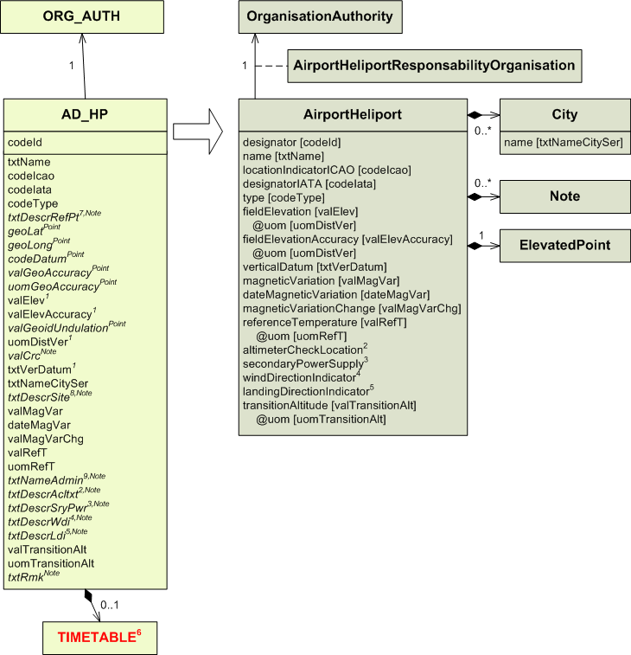
1) Note that the “valElev” and “valElevAccuracy” are not those of the Airport Reference Point. They are mapped to the fieldElevation and fieldElevationAccuracy in AIXM 5.1. See A1.1 for more details about the conversion of txtVerDatum and geographical coordinates in general.

2) The Note in AIXM 5.1 shall have purpose=”DESCRIPTION” and propertyName=”altimeterCheckLocation”. In addition, the “altimeterCheckLocation” attribute in AirportHeliport might be set to YES or NO according to the content of the “txtDescrAcl” attribute. As this requires manual interpretation of the data, it is not recommended for automatic conversions.

3) The Note in AIXM 5.1 shall have purpose=”DESCRIPTION” and propertyName=”secondaryPowerSupply”. In addition, the “secondaryPowerSupply” attribute in AirportHeliport might be set to YES or NO according to the content of the “txtDescrSryPwr” attribute. As this requires manual interpretation of the data, it is not recommended for automatic conversions.

4) The Note in AIXM 5.1 shall have purpose=”DESCRIPTION” and propertyName=” windDirectionIndicator”. In addition, the “windDirectionIndicator” attribute in AirportHeliport might be set to YES or NO according to the content of the “txtDescrWdi” attribute. As this requires manual interpretation of the data, it is not recommended for automatic conversions.

5) The Note in AIXM 5.1 shall have purpose=”DESCRIPTION” propertyName=” landingDirectionIndicator”. In addition, the “landingDirectionIndicator” attribute in AirportHeliport might be set to YES or NO according to the content of the “txtDescrLdi” attribute. As this requires manual interpretation of the data, it is not recommended for automatic conversions.

6) The mapping of the Timetable associated with the AD_HP will be dealt with as part of the mapping of the AD_HP_USAGE, in section 2.9.

7) txtDescrRefPt attribute shall be mapped into a Note with propertyName=”arp” and purpose=”DESCRIPTION”.

8) txtDescrSite attribute shall be mapped into a Note with an empty propertyName, purpose=”DESCRIPTION” and with the value “Site description: ” followed by the value of the AIXM 4.5 attribute.

9) txtNameAdmin attribute shall be mapped into a Note with an empty propertyName, purpose=”REMARK” and with the value “Organisation in charge: ” followed by the value of the AIXM 4.5 attribute.

AD_HP_COLLOCATION

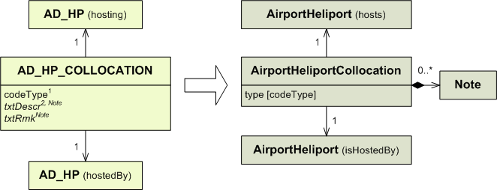

1) Conversion rules for codeType:

codeType | type
F  R  P  U  S  OTHER | FULL  RWY  PARTIAL  UNILATERAL  SEPARATED  OTHER

2) The attribute txtDescr shall be mapped into a Note with propertyName=”type”.

AD_HP_GND_SER
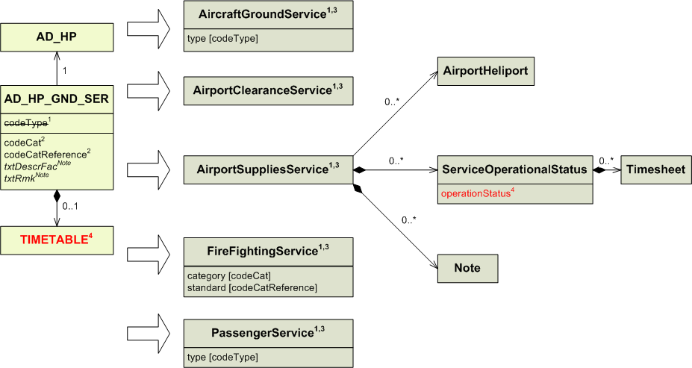
1) Conversion rules for codeType

codeType | Entity to use | type
FIRE | FireFightingService | If codeType = FIRE, then AD_HP_GND_SER is mapped into a FireFightingService and codeType is not mapped.
CUST  SAN  FUEL | PassengerService  PassengerService  AirportSuppliesService | CUST  SAN  If codeType = FUEL, then AD_HP_GND_SER is mapped into a AirportSuppliesService and codeType is not mapped.
HAND  CLEAR | AircraftGroundService  For automated mapping, AircraftGroundService shall be used. When manual intervention is envisaged, this could also map into AirportClearanceService if the service provides clearance capabilities for airport surfaces. | HAND  REMOVE
SECUR  DEICE  HANGAR  REPAIR  VET  OTHER | PassengerService  AircraftGroundService  AircraftGroundService  AircraftGroundService  PassengerService  For automatic mapping, AircraftGroundService shall be used.  When manual intervention is envisaged, the best fitted service among the five available ones should be picked according to whatever information is stored in the “txtRmk” attribute. However, because FireFightingService, AirportSuppliesService and AirportClearanceService all account for specialised services, the best choice is likely to be either an AircraftGroundService, if the service deals with aircraft, or a PassengerService, if it deals with passengers. | SECUR  DEICE  HANGAR  REPAIR  VET  OTHER

2) codeCat and codeCatReference only make sense when codeType = FIRE. A data coding error may be suspected otherwise. For automatic conversion, they should be mapped in a Note if codeType ≠ FIRE.

3) Only the associations for AirportSuppliesService are displayed, however all five service entities have the same ones.

4) Conversion rules for TIMETABLE:

codeWorkHr in TIMETABLE | Attached TIMESHEET | operationalStatus | Additional mapping required. See the TIMETABLE section for more details.
H24 | No | NORMAL | No
Any other case |  | LIMITED | Yes

AD_HP_NAV_AID

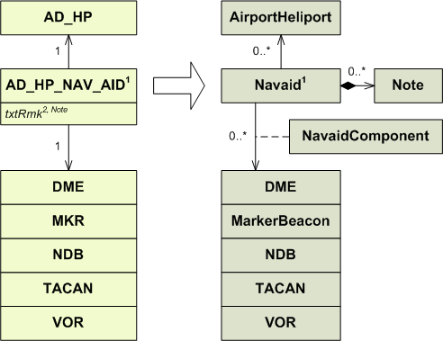

1) AD_HP_NAV_AID shall be mapped as an association between the corresponding Navaid and AirportHeliport. See the DME, MKR, NDB, TACAN and VOR sections for more details about how to map the navaid associated to AD_HP_NAV_AID.
2) The txtRmk shall be mapped as a Note on the Navaid feature with propertyName=”servedAirport”.

AD_HP_OBSTACLE
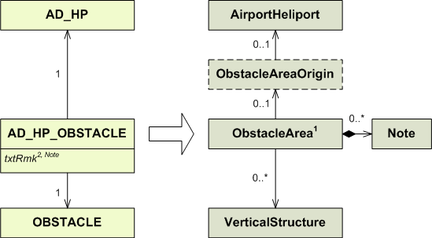

1) A single ObstacleArea type=AREA2 shall be created for each AirportHeliport. All AD_HP_OBSTACLE that are associated with the same AD_HP shall be mapped as associations between that unique ObstacleArea and the corresponding VerticalStructure.

2) txtRmk shall be mapped as a Note on the ObstacleArea with an empty propertyName and LinguisticNote.note being a concatenation of the following: “Obstacle: ”, OBSTACLE.txtDescrType, “ “, OBSTACLE.geoLat, “ / ”, OBSTACLE.geoLontg, “Remark: ”,txtRmk. This is done in order to preserve the information that the remark from AIXM 4.5 concerns a particular obstacle in AIXM 5.1 as there is no possibility to associate the Note with one particular association between ObstacleArea and VerticalStructure.

AD_HP_SURFACE_BORDER
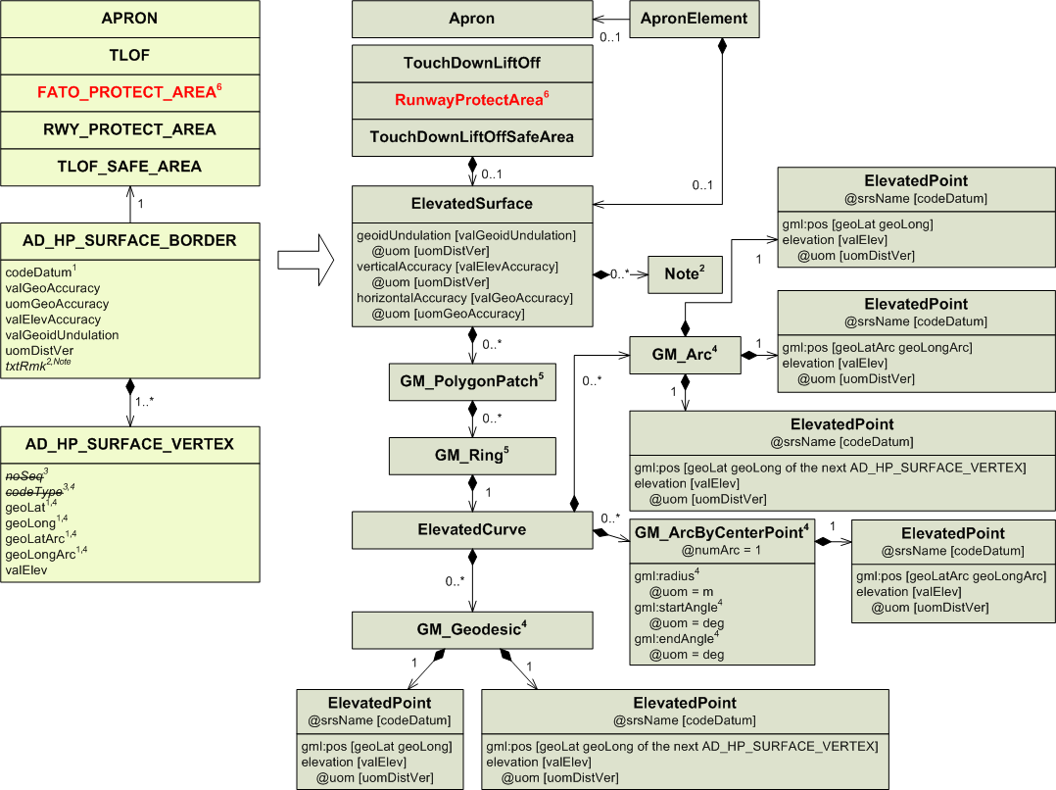
1) See the Mapping of geographical coordinates section in the Annex about how to format the “geoLat”, “geoLong”, “geoLatArc”, “geoLongArc” and “codeDatum” attributes.

2) ElevatedSurface does have an association with Note.
Therefore, the “txtRmk” attribute of the AD_HP_SURFACE_BORDER may be saved into a Note associated tothe ElevatedSurface with an empty propertyName and purpose=”REMARK”...

3) The “noSeq” and “codeType” attributes from AD_HP_SURFACE_VERTEX are not saved as such; they are used in the mapping algorithm of the ElevatedSurface.

4) Airport surface borders are no longer defined point by point, but segments by segments. Because of this, every AD_HP_SURFACE_VERTEX shall be mapped into a GM_Arc, a GM_ArcByCentrePoint or a GM_Geodesic. All these segments are in turn part of the same ElevatedCurve.
The GML segments also use the AD_HP_SURFACE_VERTEX coming next after the one being mapped as the end of the segment. Because of this every AD_HP_SURFACE_VERTEX is used twice (even the first and last ones, as the border must be closed). The only exception to this rule are AD_HP_SURFACE_VERTEX with codeType = CWA or CCA. Such vertices are mapped into GM_ArcByCentrePoint which only store the centre point. However, the starting point of a CWA/CCA arc may still be saved as the ending point of the previous segment.

Whether a GM_Arc, a GM_ArcByCentrePoint or a GM_Geodesic should be used depends on the “codeType” attribute of the first point of the segment.

codeType | Object to use | Coordinates
ABE | GM_Arc | first Point: geoLat geoLong  second Point: geoLatArc geoLongArc  third Point: geoLat geoLong from the next AD_HP_SURFACE_VERTEX  See the example in the Annex.
GRC | GM_Geodesic  AIXM 5.1 does not support great circle, however the difference between a great circle and a geodesic is negligible for such small distances. | first Point: geoLat geoLong  second Point: geoLat geoLong from the next AD_HP_SURFACE_VERTEX
CCA | GM_ArcByCenterPoint | It is very likely that the coordinates of the centre as provided by the AIXM 4.5 data are approximate, as AIXM 4.5 tolerates a difference of no more than 1% between the calculated radius values from the centre to the two end points.  Even so, the AIXM 4.5 centre coordinates (the attributes geoLatArc and geoLongArc from the considered AD_HP_SURFACE_VERTEX) shall be mapped as they are. This may cause the surface border not to be perfectly closed.  The radius has to be computed as the arithmetic mean of the distance between the centre and the starting point of the arc (the attributes geoLat and geoLong from the considered AD_HP_SURFACE_VERTEX) and the distance between the centre and the ending point of the arc (the starting point of the next segment of the border, the attributes geoLat and geoLong from the next AD_HP_SURFACE_VERTEX). The computed radius shall be expressed in meters.  Then the startAngle has to be computed as the bearing from the centre to the current point and the endAngle as the bearing from the centre to the next point. If the startAngle value is smaller than the endAngle value, then the endAngle value shall be adjusted by subtracting 360.0, thus ensuring that the arc is drawn counter-clockwise (see explanations in the OGC Guidelines for the use of GML for aviation data).  With this mapping, the attributes geoLat and geoLong from the AD_HP_SURFACE_VERTEX are not saved in the GM_ArcByCentrePoint. This is not a problem because these attributes are saved as the ending point of the previous segment.  However, it becomes a problem if the previous segment is also a GM_ArcByCentrePoint (that is, if the previous AD_HP_SURFACE_VERTEX is also of type CCA or CWA), because such segments do not store their ending point.  In such a case, an intermediate GM_LineStringSegment shall be created and inserted between the two ArcByCentrePoint. It shall receive as starting point and as ending point the coordinates of the starting point of the second AD_HP_SURFACE_VERTEX that would otherwise be lost. This way, all coordinates are saved and the shape of the border remains unchanged.  See the examples in the Annex.
CWA | GM_ArcByCenterPoint | It is very likely that the coordinates of the centre as provided by the AIXM 4.5 data are approximate, as AIXM 4.5 tolerates a difference of no more than 1% between the calculated radius values from the centre to the two end points.  Even so, the AIXM 4.5 centre coordinates (the attributes geoLatArc and geoLongArc from the considered AD_HP_SURFACE_VERTEX) shall be mapped as they are. This may cause the surface border not to be perfectly closed.  The radius has to be computed as the arithmetic mean of the distance between the centre and the starting point of the arc (the attributes geoLat and geoLong from the considered AD_HP_SURFACE_VERTEX) and the distance between the centre and the ending point of the arc (the starting point of the next segment of the border, the attributes geoLat and geoLong from the next AD_HP_SURFACE_VERTEX). The computed radius shall be expressed in meters.  Then the startAngle has to be computed as the bearing from the centre to the considered point and the endAngle as the bearing from the centre to the next point. If the startAngle value is larger than the endAngle value, then the startAngle value shall be adjusted by subtracting 360.0, thus ensuring that the arc is drawn counter-clockwise (see explanations in the OGC Guidelines for the use of GML for aviation data).  With this mapping, the attributes geoLat and geoLong from the AD_HP_SURFACE_VERTEX are not saved in the GM_ArcByCentrePoint. This is not a problem because these attributes are saved as the ending point of the previous segment.  However, it becomes a problem if the previous segment is also a GM_ArcByCentrePoint (that is, if the previous AD_HP_SURFACE_VERTEX is also of type CCA or CWA), because such segments do not store their ending point.  In such a case, an intermediate GM_LineStringSegment shall be created and inserted between the two ArcByCentrePoint. It shall receive as starting point and as ending point the coordinates of the starting point of the second AD_HP_SURFACE_VERTEX that would otherwise be lost. This way, all coordinates are saved and the shape of the border remains unchanged.  See the examples in the Annex.
OTHER | GM_Geodesic | This case is most likely an error in the AIXM 4.5 data. For the completeness of the mapping:  first Point: geoLat geoLong  second Point: geoLatArc geoLongArc  third Point: geoLat geoLong from the next AD_HP_SURFACE_VERTEX

5) When mapping from AIXM 4.5, only one GM_PolygonPatch and one GM_Ring shall be created.

6) FATO_PROTECT_AREA is mapped into RunwayProtectArea. See the FATO_PROTECT_AREA section for more details.

AD_HP_SURFACE_VERTEX

See the AD_HP_SURFACE_BORDER section.

AD_HP_USAGE

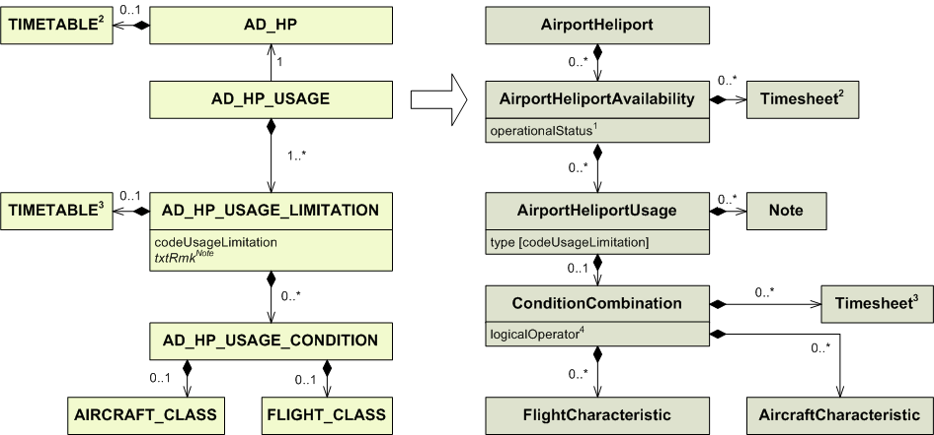

1) The operationalStatus attribute should always get the value “NORMAL” when static data is mapped. The value LIMITED and CLOSED are intended for temporary situations.
2) The TIMETABLE associated with the AD_HP maps into the Timesheet associated with the AirportHeliportAvailability. See the TIMETABLE section for more details.
3) See the TIMETABLE section for more details.
4) The logicalOperator shall get a value based on the following algorithm:
AD_HP_USAGE_CONDITION shall be mapped into the ConditionCombination object, as follows:
a. if the AD_HP_USAGE_LIMITATION contains a single USAGE_CONDITION having a FLIGHT_CLASS or an AIRCRAFT_CLASS, the corresponding ConditionCombination shall have the logicalOperator = “NONE”
b. if the AD_HP_USAGE_LIMITATION contains a single USAGE_CONDITION having a FLIGHT_CLASS and an AIRCRAFT_CLASS, the corresponding ConditionCombination shall have the logicalOperator = “AND”
c. if the AD_HP_USAGE_LIMITATION contains more than one USAGE_CONDITION, each having only a FLIGHT_CLASS or only an AIRCRAFT_CLASS, the corresponding ConditionCombination shall have the logicalOperator = “OR”
d. if the AD_HP_USAGE_LIMITATION contains more than one USAGE_CONDITION and at least one of them contains both a FLIGHT_CLASS and an AIRCRAFT_CLASS, the corresponding ConditionCombination shall have the logicalOperator = “OR” and each USAGE_CONDITION shall be encoded under separate subCondition properties; within each subCondition, rules a. and b. apply respectively..

AERO_GND_LGT

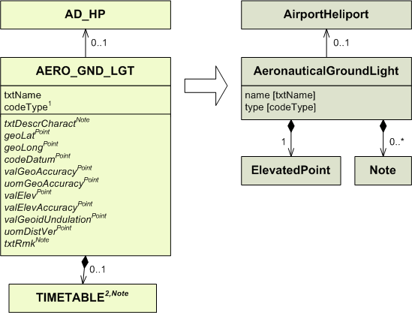

1) Conversion rules for codeType:

codeType | type
BCN  IBN  HBCN  ABN  MARINE  RSP  SIG  OTHER | BCN  IBN  HEL_BCN  ABN  MAR_BCN  RSP_BCN  TWR_BCN  OTHER

2) AeronauticalGroundLight is missing an “operationalStatus” attribute (object) in AIXM 5.1 and the possibility to associate a schedule with it. This is expected to be corrected in a future version. Until then, the mapping of the AIXM 4.5 TIMETABLE associated with an AERO_GND_LGT shall be done in a Note, which shall contain the name of the TIMETABLE and (if applicable) TIMESHEET properties from AIXM 4.5, followed by their values.
AIRCRAFT_CLASS
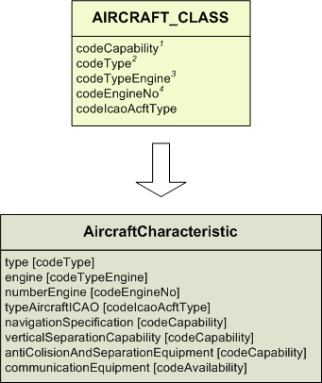

1) Conversion rules for codeCapability:

codeCapability | navigation  Specification  <<codelist>> | vertical  Separation  Capability | antiCollision  AndSeparation  Equipment | communication  Equipment
RVSM  RNAV  TCAS  8.33  OTHER | OTHER:RNAV  OTHER | RVSM | OTHER:TCAS | VHF_833

2) Conversion rules for codeType:

codeType | type
L  S  A  H  G  T  R  E  N  P  U  B  D  OTHER | LANDPLANE  SEAPLANE  AMPHIBIAN  HELICOPTER  GYROCOPTER  TILT_WING  STOL  GLIDER  HANDGLIDER  PARAGLIDER  ULTRA_LIGHT  BALLOON  UAV  OTHER

3) Conversion rules for codeTypeEngine:

codeTypeEngine | engine
J  P  T  OTHER | JET  PISTON  TURBOPROP  OTHER

4) Conversion rules for codeEngineNo:

codeEngineNo | numberEngine
1  2  3  4  6  8  C  OTHER | 1  2  3  4  6  8  2C  OTHER

AIRSPACE

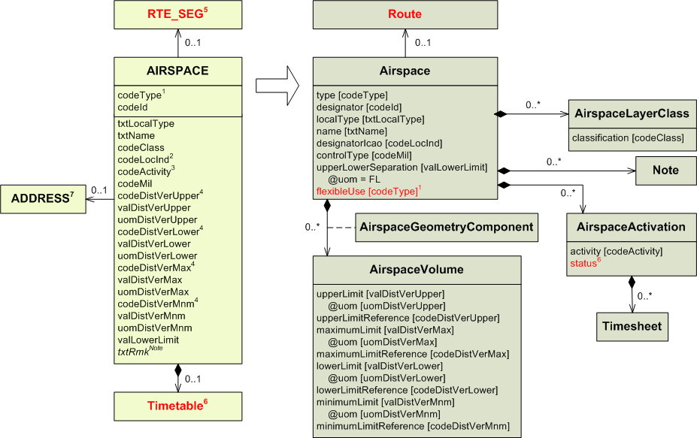
1) Conversion rules for codeType:

codeType | type | flexibleUse*
NAS  FIR  FIR-P  UIR  UIR-P  CTA  CTA-P  OCA  OCA-P  UTA  UTA-P  TMA  TMA-P  CTR  CTR-P  CLASS  OTA  SECTOR  SECTOR-C  TSA  TRA  CBA  RCA  RAS  AWY  P  R  R-AMC*  D  D-AMC*  D-OTHER  ADIZ  A  W  PROTECT  AMA  ASR  NO-FIR  POLITICAL  PART | NAS  FIR  FIR_P  UIR  UIR_P  CTA  CTA_P  OCA  OCA_P  UTA  UTA_P  TMA  TMA_P  CTR  CTR_P  CLASS  OTA  SECTOR  SECTOR_C  TSA  TRA  CBA  RCA  RAS  AWY  P  R  R  D  D  D_OTHER  ADIZ  A  W  PROTECT  AMA  ASR  NO_FIR  POLITICAL  PART | YES  YES  YES  YES  YES

* The “flexibleUse” attribute is only available through EUROCONTROL’s eASM (www.aixm.aero/schema/5.1/extensions/EUR/eASM) or ADR-18 (http://www.aixm.aero/schema/5.1/extensions/EUR/ADR-18) extensions.

2) Conversion rules for codeLocInd:
- if codeLocInd=codeId, then designatorIcao = YES.
- otherwise designatorIcao = NO.

3) Conversion rules for codeActivity:

codeActivity | activity
TFC-AD  TFC-HELI  TRG  ACROBAT  AIRSHOW  SPORT  ULM  GLIDER  PARAGLIDER  HANGGLIDER  PARACHUTE  DROP  BALLOON  ASCENT  SPACEFLT  UAV  WORK  DUSTING  FIRE  MILOPS  REFUEL  JETCLIMB  EXERCISE  TOWING  NAVAL  MISSILES  AIRGUN  ARTILERY  SHOOT  BLAST  WATERBLAST  ANTIHAIL  BIRD  BIRD-MGR  FIREWORK  HI-RADIO  HI-LIGHT  LASER  NATURE  FAUNA  NO-NOISE  ACCIDENT  POPULATION  VIP  VIP-PRES  VIP-VICE  OIL  GAZ  IND-OIL  IND-CHEM  IND-NUCLEAR  TECHNICAL  ATS  EQUIPMENT  PROCEDURE  EQUIPMENT-RSVM  EQUIPMENT-RNAV  EQUIPMENT-833  OTHER | AD_TFC  HELI_TFC  TRAINING  ACROBATICS  AIRSHOW  SPORT  ULM  GLIDING  PARAGLIDER  HANGGLIDING  PARACHUTE  AIR_DROP  BALLOON  RADIOSONDE  SPACE_FLIGHT  UAV  AERIAL_WORK  CROP_DUSTING  FIRE_FIGHTING  MILOPS  REFUEL  JET_CLIMBING  EXERCISE  TOWING  NAVAL_EXER  MISSILES  AIR_GUN  ARTILLERY  SHOOTING  BLASTING  WATER_BLASTING  ANTI_HAIL  BIRD  BIRD_MIGRATION  FIREWORK  HI_RADIO  HI_LIGHT  LASER  NATURE  FAUNA  NO_NOISE  ACCIDENT  POPULATION  VIP  VIP_PRES  VIP_VICE  OIL  GAS  REFINERY  CHEMICAL  NUCLEAR  TECHNICAL  ATS  OTHER:EQUIPMENT  PROCEDURE  OTHER:EQUIPMENT_RVSM  OTHER:EQUIPMENT_RNAV  OTHER:EQUIPMENT_833  OTHER

4) Conversion rules for codeDistVerXxx:

codeDistVerXxx | xxxLimitReference
HEI  ALT  W84  QFE*  QNH*  STD  OTHER | SFC  MSL  W84  SFC  MSL  STD  OTHER

* These values were not supposed to be used with this entity. It is likely this is a mistake if such values are found in Airspace records.

5) Airspace is now associated to a route instead of a segment of the route.

6) Conversion rules for TIMETABLE:

codeWorkHr in TIMETABLE | Attached TIMESHEET | status | Additional mapping required. See the TIMETABLE section for more details.
H24 | No | ACTIVE | No
Any other case |  | LIMITED | Yes

7) The AICM 4.5 AIRSPACE relationship with ADDRESS (requiring for FPL-MSG the use of) is deprecated in AIXM 5.1 and it shall be mapped into an AIRSPACE annotation with propertyName = “” (empty) with the corresponding LinguisticNote note = “Airspace address: “ followed (on a new line) by:

Label |  | Value
“Address type: “ | & | <ADDRESS.codeType> | New line
“Address: “ | & | <ADDRESS.txtAddress> | New line
“Remark: “ | & | <ADDRESS.txtRmk > | New line

AIRSPACE_ASSOCIATION

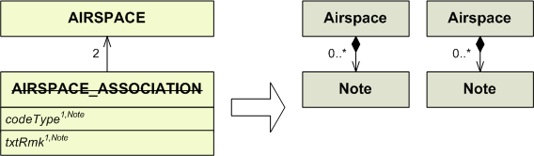

1) Because it is no longer possible to associate airspaces in AIXM 5.1, this information shall be saved in a Note. This Note shall be associated to both Airspaces and shall contain the codeType and the codeId of the other airspace (which together form the functional identification of the airspace in AIXM 4.5), followed by the content of the “codeType” and “txtRmk” attributes from AIRSPACE_ASSOCIATION. These four values shall be separated by a comma.

AIRSPACE_BORDER

AIRSPACE_BORDER with vertices

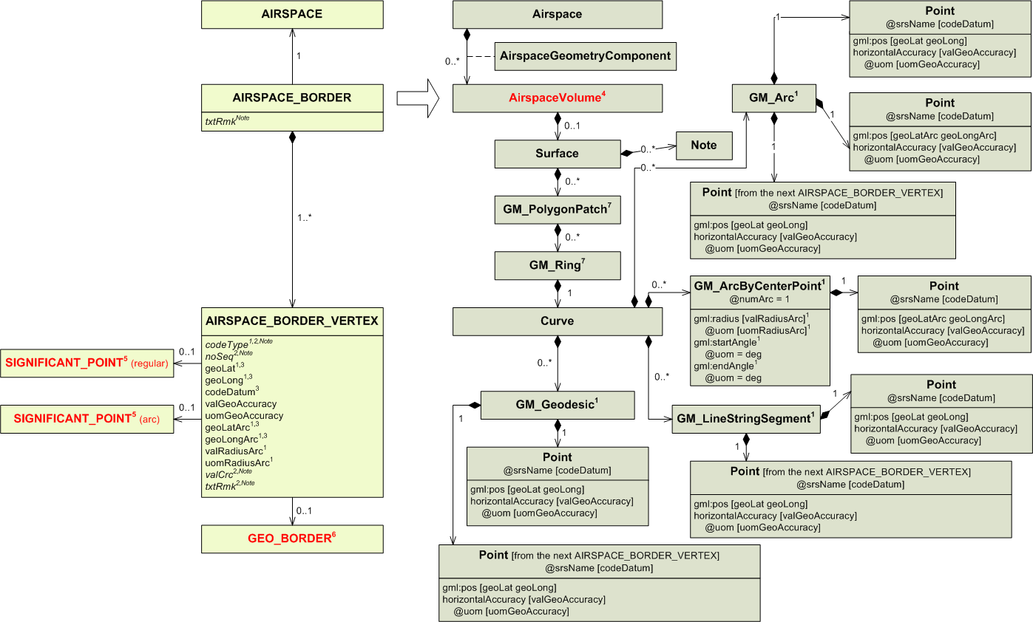
1) Airspace borders are no longer defined point by point; they are defined segment by segment. Because of this, every AIRSPACE_BORDER_VERTEX shall be mapped as a coordinate pair, inside either a GM_Arc, a GM_ArcByCentrePoint, a GM_LineStringSegment or a GM_Geodesic. All these segments are in turn part of the same Curve.
The GML segments also use the AIRSPACE_BORDER_VERTEX coming next after the one being mapped as the end of the segment. Because of this every AIRSPACE_BORDER_VERTEX is used twice (even the first and last ones, as the border must be closed). The only exception to this rule are AD_HP_SURFACE_VERTEX with codeType = CWA or CCA. Such vertices are mapped into GM_ArcByCentrePoint which only store the centre point. However, the starting point of a CWA/CCA arc may still be saved as the ending point of the previous segment.
Whether a GM_Arc, a GM_ArcByCentrePoint, a GM_LineStringSegment or a GM_Geodesic should be used depends on the “codeType” attribute.

codeType | Object to use | Coordinates
ABE | GM_Arc | first Point: geoLat geoLong  second Point: geoLatArc geoLongArc  third Point: geoLat geoLong from the next AIRSPACE_BORDER_VERTEX  See the example in the Annex.  Note that if the current point is the one with the highest NO_SEQ, then the next point is considered to be the one with the lowest NO_SEQ (the surface is closed by the first point).
GRC | GM_Geodesic | first Point: geoLat geoLong  second Point: geoLat geoLong from the next AIRSPACE_VERTEX_BORDER  Note that if the current point is the one with the highest NO_SEQ, then the next point is considered to be the one with the lowest NO_SEQ (the surface is closed by the first point).
RHL | GM_LineStringSegment | first Point: geoLat geoLong  second Point: geoLat geoLong from the next AIRSPACE_VERTEX_BORDER  Note that if the current point is the one with the highest NO_SEQ, then the next point is considered to be the one with the lowest NO_SEQ (the surface is closed by the first point).  Rhumbline should only be used when describing a segment where both points have the same latitude (i.e. the segment is a parallel). The value “RHL” in AIXM 4.5 was not intended to be used otherwise. Such a case is probably a mistake in the AIXM 4.5 data.
CCA | GM_ArcByCenterPoint | It is very likely that the coordinates of the centre as provided by the AIXM 4.5 data are approximate, as AIXM 4.5 tolerates a difference of no more than 1% between the calculated radius values from the centre to the two end points. Otherwise it would be impossible to encode most of the AIP arc data!  Even so, the AIXM 4.5 centre coordinates (the attributes geoLatArc and geoLongArc from the considered AD_HP_SURFACE_VERTEX) shall be mapped as they are. This may cause the surface border not to be perfectly closed.  If the valRadiusArc and uomRadiusArc attributes are not bearing any value, then the radius shall be computed as the arithmetic mean of the distance between the centre and the starting point of the arc (the attributes geoLat and geoLong from the considered AD_HP_SURFACE_VERTEX) and the distance between the centre and the ending point of the arc (the starting point of the next segment of the border, the attributes geoLat and geoLong from the next AD_HP_SURFACE_VERTEX). If the radius is computed, then it shall be expressed in nautical miles.  Then the startAngle has to be computed as the bearing from the centre to the current point and the endAngle as the bearing from the centre to the next point. If the endAngle value is higher than the startAngle value, then the endAngle shall be adjusted by subtracting 360.0 from it. This ensures that the arc is drawn counter-clockwise, according to the OGC Guidelines for the use of GML for aviation data (https://portal.opengeospatial.org/files/?artifact_id=47859)  With this mapping, the attributes geoLat and geoLong from the AD_HP_SURFACE_VERTEX are not saved in the GM_ArcByCentrePoint. This is not a problem because these attributes are saved as the ending point of the previous segment.  However, it becomes a problem if the previous segment is also a GM_ArcByCentrePoint (that is, if the previous AD_HP_SURFACE_VERTEX is also of type CCA or CWA), because such segments do not store their ending point.  In such a case, an intermediate GM_LineStringSegment shall be created and inserted between the two ArcByCentrePoint. It shall receive as starting point and as ending point the coordinates of the starting point of the second AD_HP_SURFACE_VERTEX that would otherwise be lost. This way, all coordinates are saved and the shape of the border remains unchanged.  See also the OGC Guidelines for the use of GML for aviation data (https://portal.opengeospatial.org/files/?artifact_id=47859) and the examples in the Annex.
CWA | GM_ArcByCenterPoint | It is very likely that the coordinates of the centre as provided by the AIXM 4.5 data are approximate, as AIXM 4.5 tolerates a difference of no more than 1% between the calculated radius values from the centre to the two end points. Otherwise it would be impossible to encode most of the AIP arc data!  Even so, the AIXM 4.5 centre coordinates (the attributes geoLatArc and geoLongArc from the considered AD_HP_SURFACE_VERTEX) shall be mapped as they are. This may cause the surface border not to be perfectly closed.  If the valRadiusArc and uomRadiusArc attributes are not bearing any value, then the radius shall be computed as the arithmetic mean of the distance between the centre and the starting point of the arc (the attributes geoLat and geoLong from the considered AD_HP_SURFACE_VERTEX) and the distance between the centre and the ending point of the arc (the starting point of the next segment of the border, the attributes geoLat and geoLong from the next AD_HP_SURFACE_VERTEX). If the radius is computed, then it shall be expressed in nautical miles.  Then the startAngle has to be computed as the bearing from the centre to the considered point and the endAngle as the bearing from the centre to the next point. If the startAngle value is higher than the endAngle value, then the startAngle shall be adjusted by subtracting 360.0 from it. This ensures that the arc is drawn clockwise, as specified in the OGC Guidelines for the use of GML for aviation data (https://portal.opengeospatial.org/files/?artifact_id=47859).  With this mapping, the attributes geoLat and geoLong from the AD_HP_SURFACE_VERTEX are not saved in the GM_ArcByCentrePoint. This is not a problem because these attributes are saved as the ending point of the previous segment.  However, it becomes a problem if the previous segment is also a GM_ArcByCentrePoint (that is, if the previous AD_HP_SURFACE_VERTEX is also of type CCA or CWA), because such segments do not store their ending point.  In such a case, an intermediate GM_LineStringSegment shall be created and inserted between the two ArcByCentrePoint. It shall receive as starting point and as ending point the coordinates of the starting point of the second AD_HP_SURFACE_VERTEX that would otherwise be lost. This way, all coordinates are saved and the shape of the border remains unchanged.  See the examples in the Annex.
FNT | GM_Geodesic | In AIXM 5.1, it is still possible to use a geographical border as part of an airspace border by using a gml:curveMember element with an xlink:href reference to the corresponding geoBorder. See the OGC GML Guidelines document. An abstract reference shall be used in this case, because an internal reference (by “#” would be misinterpreted by a GML engine as if the whole referenced curve is embedded. This is not true, only a part of the curve needs to be embedded).  To realise the junction between the AIRSPACE_BORDER_VERTEX of type FNT and the GEO_BORDER, an additional point has to be computed. This point is the nearest point from the AIRSPACE_BORDER_VERTEX belonging to the GEO_BORDER. It may or it may not be a GEO_BORDER_VERTEX itself. Occasionally, this point could be equal to the AIRSPACE_BORDEX_VERTEX itself, when this is situated exactly on the GEO_BORDER.  A GM_Geodesic shall then be created between the AIRSPACE_BORDER_VERTEX of type FNT and the newly-computed point. This will then be followed by a gml:curveMember with an xlink:href pointing to the corresponding GeoBorder feature.  The GEO_BORDER must be travelled along until the point (belonging to the GEO_BORDER) closest to the next AIRSPACE_BORDER_VERTEX is reached. The next true AIRSPACE_BORDER_VERTEX is likely to have a codeType different from FNT (although it may happen if the airspace border follows two different geographical borders). A second new point shall be created there too and exported as an additional GM_Geodesic.  See also the detailed explanations in section A1.4.4.  See the example in the Annex.  A particular case may occur when a sequence of two consecutive FNT points occur in AIXM 4.5. In this case, the same algorithm shall be applied. It is likely that the point that makes the transition between the two geo-borders actually exists as vertex on both geoBorders. This will generate a GM_Geodesic of zero length in the AIXM 5.1 mapping. However, this is not an problem.
OTHER | GM_Geodesic | This is most likely an error in the encoded AIXM 4.5 data. For automatic conversion, it shall be mapped as a Geodesic.  first Point: geoLat geoLong  second Point: geoLat geoLong from the next AIRSPACE_VERTEX_BORDER  Note that if the current point is the one with the highest NO_SEQ, then the next point is considered to be the one with the lowest NO_SEQ (the surface is closed by the first point).

2) Point is associated to Note, so the “codeType”, “noSeq”, “valCrc” and “txtRmk” attributes from AIRSPACE_BORDER_VERTEX may be saved in a Note of Point (this does not appear on the diagram). as: ”noSeq:(actual value of the “noSeq” attribute)-codeType:(actual value of the “codeType” attribute)”,. -valCrc:(value as defined in the Mapping of “valCrc” attributes section in the Annex)”, ”-txtRmk:(actual value of the “txtRmk” attribute)”.

3) See the Mapping of geographical coordinates section in the Annex about how to format the “geoLat”, “geoLong”, “geoLatArc”, “geoLongArc” and “codeDatum” attributes.

4) AIRSPACE_BORDER has to be mapped into an AirspaceVolume. This AirspaceVolume is not a <<feature>> but an <<object>> of Airspace. It is the same AirspaceVolume into which the vertical limits of the airspace were mapped during the mapping of AIRSPACE.

5) When an AIRSPACE_BORDER_VERTEX is associated to a SIGNIFICANT_POINT (regular), its coordinates replace geoLat and geoLong. When an AIRSPACE_BORDER_VERTEX is associated to a SIGNIFICANT_POINT (arc), its coordinates replace geoLatArc and geoLongArc. A SIGNIFICANT_POINT may be associated to several entities. All of them are presented in the SIGNIFICANT_POINT section.
From a UML perspective, it is not possible to associate a Point to a SignificantPoint, that is why there is no SignificantPoint on the diagram.
It is however possible in the XML schema. According to OGC Guidelines for the use of GML for aviation data, every Point of this diagram can be associated to any of the entity into which a SIGNIFICANT_POINT may to be mapped. In such a case, the coordinates from the entity are used for the Point.

6) See 1), codeType = FNT.

7) When mapping from AIXM 4.5, only one GM_PolygonPatch and one GM_Ring shall be created.

AIRSPACE_BORDER with circle

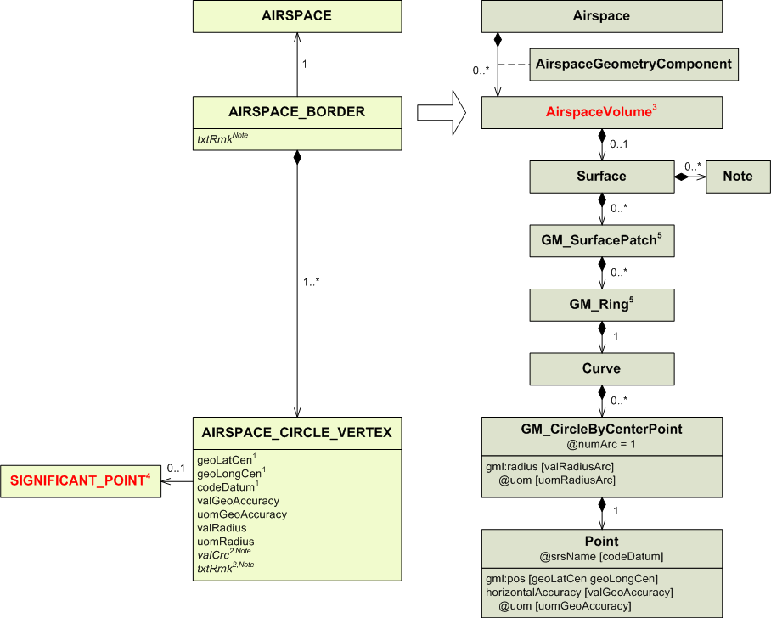
1) See the Mapping of geographical coordinates section in the Annex about how to format the “geoLatCen”, “geoLongCen” and “codeDatum” attributes.

2) Point is associated to Note, so the “valCrc” and “txtRmk” attributes from AIRSPACE_CIRCLE_VERTEX may be saved in a Note (which does not appear on the diagram) as valCrc:( value as defined in the Mapping of “valCrc” attributes section in the Annex)”, “, txtRmk:(actual value of the “txtRmk” attribute)”

3) AIRSPACE_BORDER has to be mapped into an AirspaceVolume. This AirspaceVolume is not a <<feature>> but an <<object>> of Airspace. It is the same AirspaceVolume into which the vertical limits of the airspace were mapped during the mapping of AIRSPACE.

4) When an AIRSPACE_CIRCLE_VERTEX is associated to a SIGNIFICANT_POINT, its coordinates replace geoLatCen and geoLongCen. A SIGNIFICANT_POINT may be associated to several entities. All of them are presented in the SIGNIFICANT_POINT section.
From a UML perspective, it is not possible to associate a Point to a SignificantPoint, that is why there is no SignificantPoint on the diagram.
It is however possible in the XML schema. According to the OGC Guidelines for the use of GML for aviation data, the Point of this diagram can be associated to any of the entity into which a SIGNIFICANT_POINT may to be mapped. In such a case, the coordinates from the entity are used for the Point.
More information about how to associate a geographical object to an entity can be found in the AIXM Wiki (Solutions, Point references) at www.aixm.aero.

5) When mapping from AIXM 4.5, only one GM_PolygonPatch and one GM_Ring shall be created.

AIRSPACE_BORDER_CROSSING

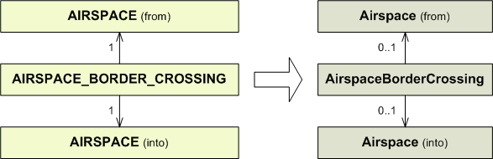

AIRSPACE_BORDER_VERTEX

See the AIRSPACE_BORDER with vertices section.

AIRSPACE_CIRCLE_VERTEX

See the AIRSPACE_BORDER with circle section.

AIRSPACE_CLINE_VERTEX

See the AIRSPACE_CORRIDOR section.

AIRSPACE_CORRIDOR

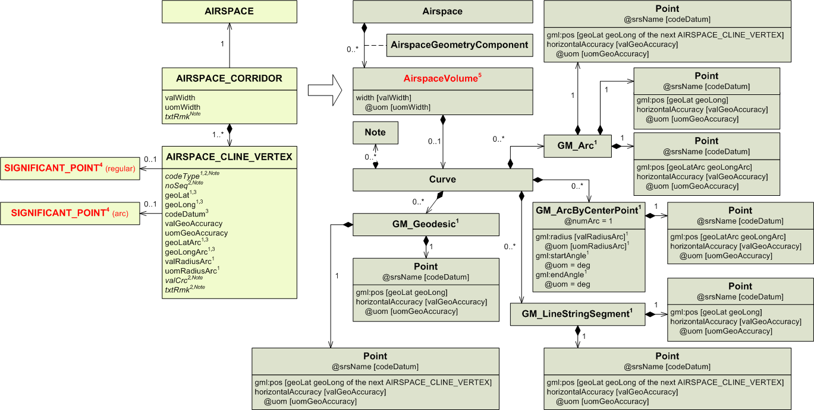
1) Airspace centrelines are no longer defined point by point, but segments by segments. Because of this, every AIRSPACE_CLINE_VERTEX shall be mapped as a coordinate pair, inside either a GM_Arc, a GM_ArcByCentrePoint, a GM_LineStringSegment or a GM_Geodesic. All these segments are in turn part of the same Curve.
The GML segments also use the AIRSPACE_CLINE_VERTEX coming next after the one being mapped as the end of the segment. Because of this every AIRSPACE_CLINE_VERTEX is used twice, except for the first one, which will not be an end point for any segment, and the last one, which will not have a segment of its own and will just be used as the ending point of the segment starting with the penultimate AIRSPACE_CLINE_VERTEX of the sequence. AD_HP_SURFACE_VERTEX with codeType = CWA or CCA are also not used twice. Such vertices are mapped into GM_ArcByCentrePoint which only store the centre point. However, the starting point of a CWA/CCA arc may be still be saved as the ending point of the previous segment.

Whether a GM_Arc, a GM_ArcByCentrePoint, a GM_LineStringSegment or a GM_Geodesic should be used depends on the “codeType” attribute.

codeType | Object to use | Coordinates
ABE | GM_Arc | first Point: geoLat geoLong  second Point: geoLatArc geoLongArc  third Point: geoLat geoLong from the next AIRSPACE_BORDER_VERTEX  See the example in the Annex.
GRC | a GM_Geodesic | first Point: geoLat geoLong  second Point: geoLat geoLong from the next AIRSPACE_CLINE_VERTEX
RHL | GM_LineStringSegment | first Point: geoLat geoLong  second Point: geoLat geoLong from the next AIRSPACE_CLINE_VERTEX  Rhumbline should only be used when describing a segment where both points have the same latitude (i.e. the segment is a parallel). The value “RHL” in AIXM 4.5 was not intended to be used otherwise. Such a case is probably a mistake in the AIXM 4.5 data.
CCA | GM_ArcByCenterPoint | It is very likely that the coordinates of the centre as provided by the AIXM 4.5 data are approximate, as AIXM 4.5 tolerates a difference of no more than 1% between the calculated radius values from the centre to the two end points. Otherwise it would be impossible to encode most of the AIP arc data!  Even so, the AIXM 4.5 centre coordinates (the attributes geoLatArc and geoLongArc from the considered AD_HP_SURFACE_VERTEX) shall be mapped as they are. This may cause the surface border not to be perfectly closed.  If the valRadiusArc and uomRadiusArc attributes are not bearing any value, then the radius shall be computed as the arithmetic mean of the distance between the centre and the starting point of the arc (the attributes geoLat and geoLong from the considered AD_HP_SURFACE_VERTEX) and the distance between the centre and the ending point of the arc (the starting point of the next segment of the border, the attributes geoLat and geoLong from the next AD_HP_SURFACE_VERTEX). If the radius is computed, then it shall be expressed in nautical miles.  Then the startAngle has to be computed as the bearing from the centre to the current point and the endAngle as the bearing from the centre to the next point. If the endAngle value is higher than the startAngle value, then the endAngle shall be adjusted by subtracting 360.0 from it. This ensures that the arc is drawn counter-clockwise, according to the OGC Guidelines for the use of GML for aviation data (https://portal.opengeospatial.org/files/?artifact_id=47859)  With this mapping, the attributes geoLat and geoLong from the AD_HP_SURFACE_VERTEX are not saved in the GM_ArcByCentrePoint. This is not a problem because these attributes are saved as the ending point of the previous segment.  However, it becomes a problem if the previous segment is also a GM_ArcByCentrePoint (that is, if the previous AD_HP_SURFACE_VERTEX is also of type CCA or CWA), because such segments do not store their ending point.  In such a case, an intermediate GM_LineStringSegment shall be created and inserted between the two ArcByCentrePoint. It shall receive as starting point and as ending point the coordinates of the starting point of the second AD_HP_SURFACE_VERTEX that would otherwise be lost. This way, all coordinates are saved and the shape of the border remains unchanged.  See also the OGC Guidelines for the use of GML for aviation data (https://portal.opengeospatial.org/files/?artifact_id=47859) and the examples in the Annex.
CWA | GM_ArcByCenterPoint | It is very likely that the coordinates of the centre as provided by the AIXM 4.5 data are approximate, as AIXM 4.5 tolerates a difference of no more than 1% between the calculated radius values from the centre to the two end points. Otherwise it would be impossible to encode most of the AIP arc data!  Even so, the AIXM 4.5 centre coordinates (the attributes geoLatArc and geoLongArc from the considered AD_HP_SURFACE_VERTEX) shall be mapped as they are. This may cause the surface border not to be perfectly closed.  If the valRadiusArc and uomRadiusArc attributes are not bearing any value, then the radius shall be computed as the arithmetic mean of the distance between the centre and the starting point of the arc (the attributes geoLat and geoLong from the considered AD_HP_SURFACE_VERTEX) and the distance between the centre and the ending point of the arc (the starting point of the next segment of the border, the attributes geoLat and geoLong from the next AD_HP_SURFACE_VERTEX). If the radius is computed, then it shall be expressed in nautical miles.  Then the startAngle has to be computed as the bearing from the centre to the considered point and the endAngle as the bearing from the centre to the next point. If the startAngle value is higher than the endAngle value, then the startAngle shall be adjusted by subtracting 360.0 from it. This ensures that the arc is drawn clockwise, as specified in the OGC Guidelines for the use of GML for aviation data (https://portal.opengeospatial.org/files/?artifact_id=47859).  With this mapping, the attributes geoLat and geoLong from the AD_HP_SURFACE_VERTEX are not saved in the GM_ArcByCentrePoint. This is not a problem because these attributes are saved as the ending point of the previous segment.  However, it becomes a problem if the previous segment is also a GM_ArcByCentrePoint (that is, if the previous AD_HP_SURFACE_VERTEX is also of type CCA or CWA), because such segments do not store their ending point.  In such a case, an intermediate GM_LineStringSegment shall be created and inserted between the two ArcByCentrePoint. It shall receive as starting point and as ending point the coordinates of the starting point of the second AD_HP_SURFACE_VERTEX that would otherwise be lost. This way, all coordinates are saved and the shape of the border remains unchanged.  See the examples in the Annex.
END | not to be mapped | The ending point is only used as the second point of the last segment. It is not to be mapped in a segment of its own.
OTHER | GM_Geodesic | This is most likely an error in the encoded AIXM 4.5 data. For automatic conversion, it shall be mapped as a Geodesic.  first Point: geoLat geoLong  second Point: geoLat geoLong from the next AIRSPACE_CLINE_VERTEX

2) Point is associated to Note, so the “codeType”, “noSeq”, “valCrc” and “txtRmk” attributes from AIRSPACE_CLINE_VERTEX may be saved in a Note of Point (which does not appear on the diagram) as:
“noSeq:(actual value of the “noSeq” attribute)-codeType:(actual value of the “codeType” attribute)”, “-valCrc:(value as defined in the Mapping of “valCrc” attributes section in the Annex)”, “-txtRmk:(actual value of the “txtRmk” attribute)”.

3) See the Mapping of geographical coordinates section in the Annex about how to format the “geoLat”, “geoLong”, “geoLatArc”, “geoLongArc” and “codeDatum” attributes.

4) When an AIRSPACE_BORDER_VERTEX is associated to a SIGNIFICANT_POINT (regular), its coordinates replace geoLat and geoLong. When an AIRSPACE_CLINE_VERTEX is associated to a SIGNIFICANT_POINT (arc), its coordinates replace geoLatArc and geoLongArc. A SIGNIFICANT_POINT may be associated to several entities. All of them are presented in the SIGNIFICANT_POINT section.
From a UML perspective, it is not possible to associate a Point to a SignificantPoint, that is why there is no SignificantPoint on the diagram.
It is however possible in the XML schema. According to to OGC Guidelines for the use of GML for aviation data, every Point of this diagram can be associated to any of the entity into which a SIGNIFICANT_POINT may to be mapped. In such a case, the coordinates from the entity are used for the Point.

5) AIRSPACE_CORRIDOR has to be mapped into an AirspaceVolume. This AirspaceVolume is not a <<feature>> but an <<object>> of Airspace. It is the same AirspaceVolume into which the vertical limits of the airspace were mapped during the mapping of AIRSPACE.

AIRSPACE_DERIV_GEOMETRY

AIRSPACE_DERIV_GEOMETRY with same extent

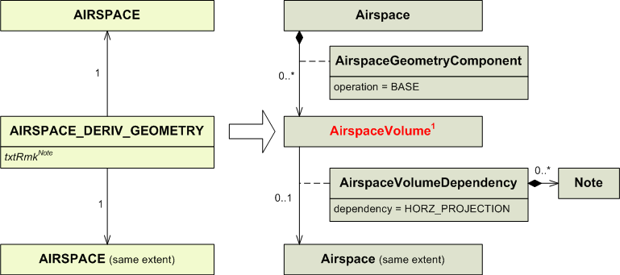
1) AIRSPACE_DERIV_GEOMETRY has to be mapped into an AirspaceVolume. This AirspaceVolume is not a <<feature>> but an <<object>> of Airspace. It is the same AirspaceVolume into which the vertical limits of the airspace were mapped during the mapping of AIRSPACE.

AIRSPACE_DERIV_GEOMETRY with aggregation

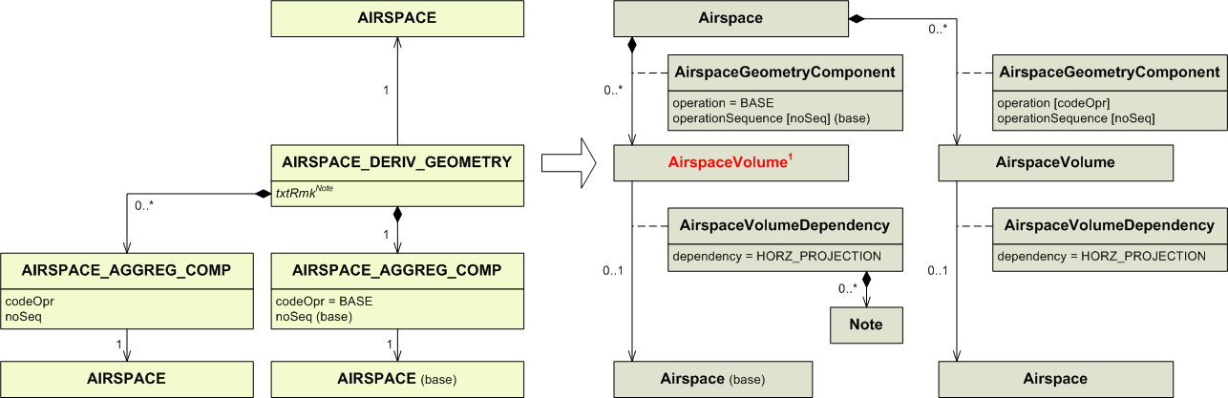
1) AIRSPACE_DERIV_GEOMETRY has to be mapped into an AirspaceVolume. This AirspaceVolume is not a <<feature>> but an <<object>> of Airspace. It is the same AirspaceVolume into which the vertical limits of the airspace were mapped during the mapping of AIRSPACE.

ANGLE_INDICATION

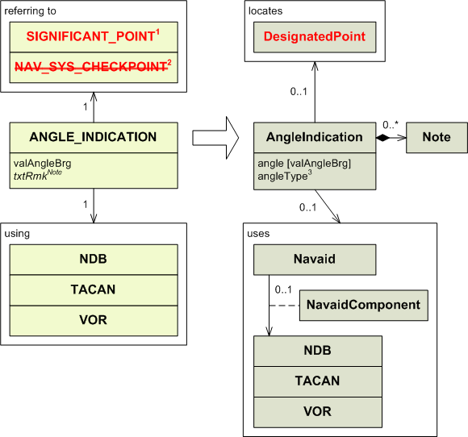

1) AngleIndication has to be associated to a DesignatedPoint. That means that if the ANGLE_INDICATION is associated to a SIGNIFICANT_POINT referring to a navaid, it cannot be directly mapped. However, it is unlikely that this happens in an AIXM 4.5 data source. Still, for the completeness of the mapping, a DesignatedPoint has to be created at the location of the navaid, and then associated to the AngleIndication.

2) For ANGLE_INDICATION associated to NAV_SYS_CHECKPOINT, see the NAV_SYS_CHECKPOINT section.

3) The “angleType” attribute in AngleIndication should be populated as follows: using | angleType
NDB | MAG
VOR | RDL
TACAN | RDL

APRON

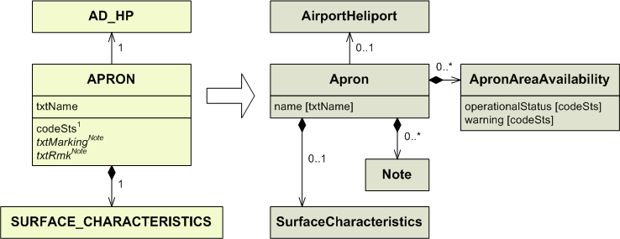
1) Conversion rules for codeSts :

codeSts | operationalStatus | warning
WIP  PARKED  CLSD  FAILAID  SPOWER  OTHER | CLOSED  OTHER | WIP  PARKED_ACFT  OTHER:FAILAID  OTHER:SECONDARY_POWER

APRON_LGT_SYS

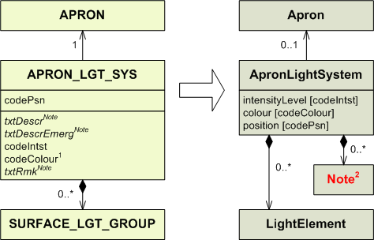

1) Conversion rules for codeColour:

codeColour | colour
YEL  RED  WHI  BLU  GRN  PRP  OTHER | YELLOW  RED  WHITE  BLUE  GREEN  PURPLE  OTHER

2) Note may be populated with information from SURFACE_LGT_GROUP. See the SURFACE_LGT_GROUP section for more details.

AUTH_FOR_AIRSPACE

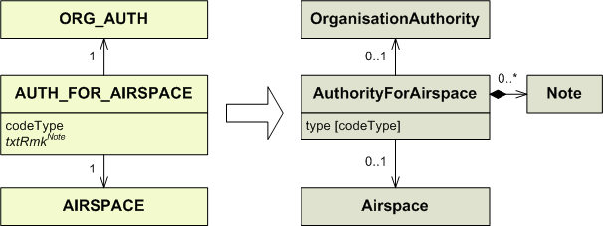

CALLSIGN_DETAIL

See the FREQUENCY section.

DESIGNATED_POINT

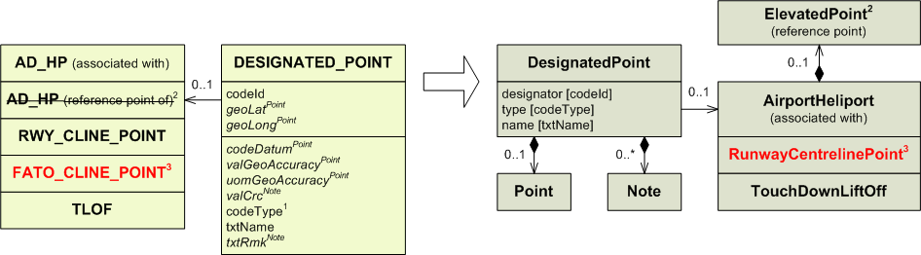
1) Conversion rules for codeType:

codeType | type
ICAO  ADHP  COORD  OTHER | ICAO  OTHER:ADHP  COORD  OTHER

2) An airport reference point is now an ElevatedPoint associated to AirportHeliport. It is not possible to associate this ElevatedPoint to a DesignatedPoint. Instead, any association using that DesignatedPoint as SignificantPoint should use directly the AirportHeliport as SignificantPoint.
3) FATO_CLINE_POINT is mapped into a RunwayCentrelinePoint. See the FATO_CLINE_POINT section for more details.

DISTANCE_INDICATION

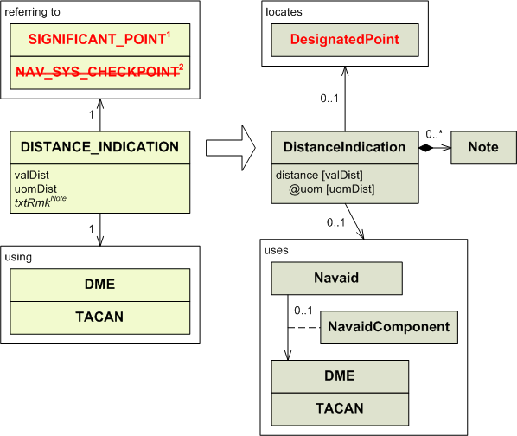

1) DistanceIndication has to be associated to a DesignatedPoint. That means that if the DISTANCE_INDICATION is associated to a SIGNIFICANT_POINT referring to a navaid, it cannot be directly mapped. Instead a DesignatedPoint has to be created at the location of the navaid, and then associated to the DistanceIndication.

2) For DISTANCE_INDICATION associated to NAV_SYS_CHECKPOINT, see the NAV_SYS_CHECKPOINT section.

DIRECT_FLIGHT_CLASS

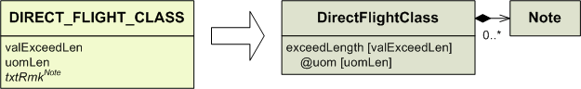

DIRECT_FLIGHT_SEGMENT

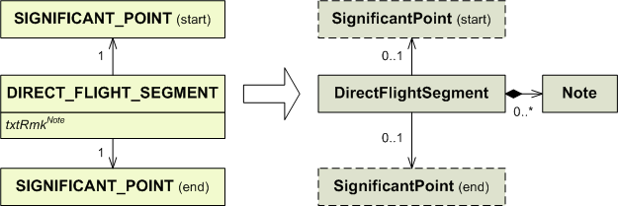

DME

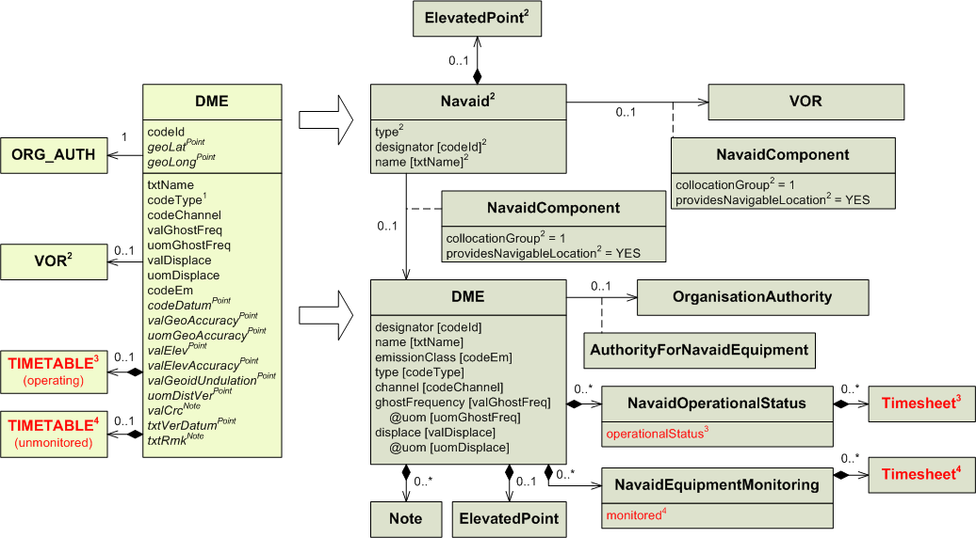

1) Conversion rules for codeType:

codeType | type
N  P  W  OTHER | NARROW  PRECISION  WIDE  OTHER

2) A Navaid has to be created in addition to the DME (NavaidEquipment), as follows:
AIXM 4.5 | AIXM 5.1 Navaid
DME is collocated with VOR | type=VOR_DME  designator – use VOR.codeId  name – use VOR.txtName  ElevatedPoint – use geoLat, geoLong, codeDatum of the VOR  providesNavigableLocation = YES on the NavaidComponent that is associated with the VOR  collocationGroup=1 on both associations with DME and VOR
DME is standalone (not collocated with VOR) | type= DME  designator – use DME.codeId  name – use DME.txtName  ElevatedPoint – use geoLat, geoLong, codeDatum of the DME  providesNavigableLocation = YES on the NavaidComponent that is associated with the DME  collocationGroup – leave empty

A NavaidOperationalStatus should also be encoded for the resulting Navaid. However, automatic generation is difficult as in some situations the VOR and DME might have different operational hours and/or unmonitored hours. Therefore, it is recommended that the NavaidOperationalStatus for the resulting Navaid is left empty.

3) Conversion rules for TIMETABLE (operating):

codeWorkHr in TIMETABLE | Attached TIMESHEET | operationalStatus | Additional mapping required. See the TIMETABLE section for more details.
H24  NOTAM  NOTAM | No  No  Yes | OPERATIONAL  CONDITIONAL  CONDITIONAL | No  No  Yes
Any other case |  |  | Yes

4) Conversion rules for TIMETABLE (unmonitored):

codeWorkHr in TIMETABLE | Attached TIMESHEET | monitored | Additional mapping required. See the TIMETABLE section for more details.
H24 | No | NO | No
Any other case |  | YES | Yes

DME_USAGE_LIMIT

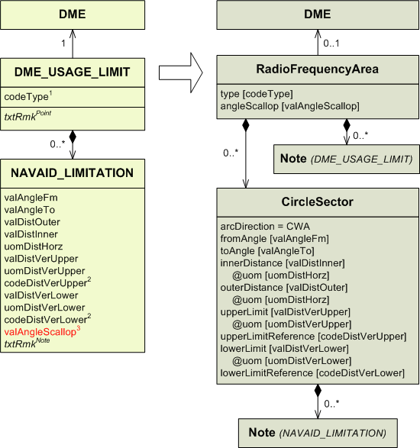

1) Conversion rules for codeType:

codeType | type
CVR  SCL  RHG  UNL  RES  UUS  OUT  TCVR  OTHER | COV  SCL  RHG  UNREL  RES  UUS  OUT  T_COV  OTHER

2) Conversion rules for codeDistVerXxx:

codeDistVerXxx | xxxLimitReference
HEI  ALT  W84  QFE*  QNH*  STD  OTHER | SFC  MSL  W84  SFC  MSL  STD  OTHER

* These values were not supposed to be used with this entity. It is likely this is a mistake.

3) Since the “angleScallop” attribute belongs to RadioFrequencyArea, there can no longer be a different value for each sector. If there were NAVAID_LIMITATION belonging to the same DME_USAGE_LIMIT with different valAngleScallop values, the higher one shall be chosen to populate the “angleScallop” attribute in RadioFrequencyArea.

EN_ROUTE_RTE

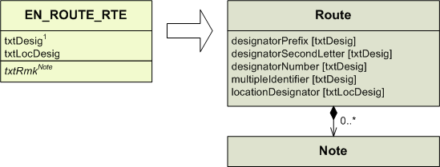

1) Conversion rules for txtDesig:

From AIXM 4.5 (business rule):
The route designator has to be compliant with the rules defined by ICAO Annex 11, Appendix 1, section 2. The rule consists therefore of the following parts:
- The route designator consists at most of 6 uppercase characters and ciphers.
- The designator starts with one or two uppercase characters and is followed by a number between 1 and 999 without leading zeros and may end with an additional character.
- Of the three possible characters the first one is optional and may be 'K', 'U' or 'S'.
- Of the three possible characters the second one is mandatory and may be 'A', 'B', 'G', 'H', 'J', 'L', 'M', 'N', 'P', 'Q', 'R', 'T', 'V', 'W', 'Y' or 'Z'.
- Of the three possible characters the third one (after the number) is optional and may be 'F', 'G', 'Y' or 'Z'.
- The following characters are not allowed in any position: 'C', 'D', 'E', 'I', 'O' and 'X'.
- If the AIXM 4.5 data complies with the rule stated above, then:If txtDesig starts with two characters, the first one shall populate designatorPrefix, the second one designatorSecondLetter.
- If txtDesig starts with only one character, it shall populate designatorSecondLetter.
- The number shall populate designatorNumber.
- if txtDesig ends with a character, it shall populate multipleIdentifier.
If the AIXM 4.5 data does not comply with rule stated above, then txtDesig shall be mapped into Route.name in AIXM 5.1 (the attribute does not appear on the diagram)

Note: See also the mapping of RTE_SEG, which might produce additional values (flightRule, internationalUse, militaryUse) for the Route in AIXM 5.1

FATO

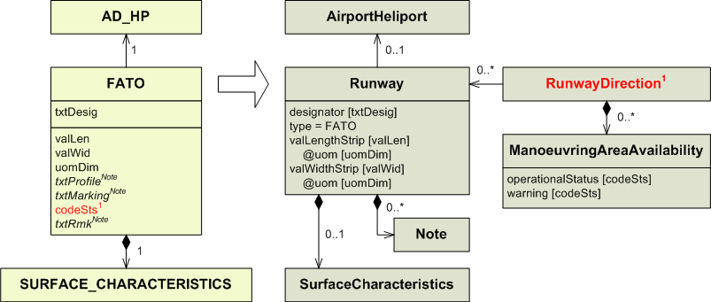
1) FATO is mapped as a Runway of type = FATO. Logically, FATO_DIRECTION is then mapped as a RunwayDirection associated to Runway of type = FATO.
ManoeuvringAreaAvailability is associated to RunwayDirection. To map the “codeSts” attribute from FATO, a ManoeuvringAreaAvailability shall be created for every RunwayDirection associated to the Runway into which FATO has been mapped.
However, these RunwayDirection will only be created after mapping the corresponding FATO_DIRECTION, which in turn can only be mapped after FATO. That is why the “codeSts” attribute from FATO cannot be mapped at the same time as the other attributes of FATO. It has to be mapped after the FATO_DIRECTION have been mapped.

Conversion rules for codeSts:

codeSts | operationalStatus | warning
WIP  PARKED  CLSD  FAILAID  SPOWER  OTHER | CLOSED  OTHER | WIP  PARKED_ACFT  OTHER:FAILAID  OTHER:SECONDARY_POWER

FATO_CLINE_POINT

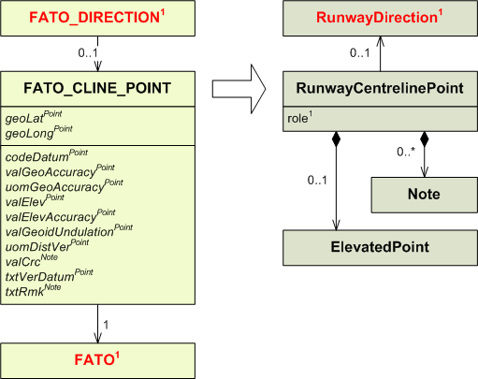

1) If FATO_CLINE_POINT is associated to a FATO_DIRECTION, it means it is the threshold for that direction. In this case RunwayCentrelinePoint shall be associated to the RunwayDirection into which FATO_DIRECTION has been mapped and the “role” attribute shall be populated with the value THR.
If FATO_CLINE_POINT is only associated to a FATO, the “role” attribute remains empty, and RunwayCentrelinePoint should be duplicated in AIXM 5.1 and associated to each RunwayDirection associated to the Runway into which FATO has been mapped. See the FATO section for more details.

FATO_DIRECTION

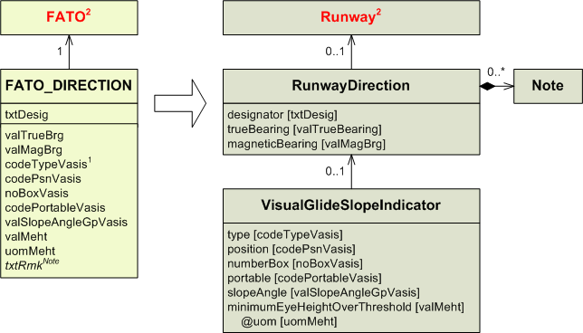
1) Conversion rules for codeTypeVasis:

codeTypeVasis | type
PAPI  APAPI  HAPI  VASIS  AVASIS  TVASIS  ATVASIS  3B-VASIS  3B-AVASIS  3B-ATVASIS  PVASI  TRCV  PNI  ILU  OLS  LCVASI  OTHER | PAPI  APAPI  HAPI  VASIS  AVASIS  TVASIS  ATVASIS  3B_VASIS  3B_AVASIS  3B_ATVASIS  PVASI  TRCV  PNI  ILU  OLS  LCVASI  OTHER

2) FATO is mapped into a Runway. See the FATO section for more details.

FATO_DIRECTION_ALS

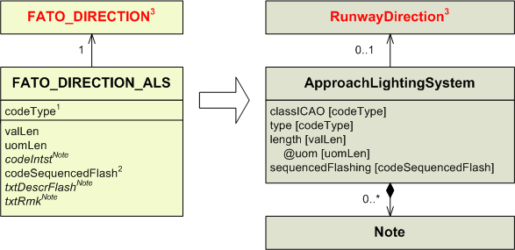

1) Conversion rules for codeType:

codeType | classICAO | type
A  B  C  D  E  F  G  H  ALSAF  MALS  MALSR  SALS  SSALS  SSALR  LDIN  ODALS  AFOVRN  MILOVRN  OTHER | CAT1  CAT23  CAT23  CAT23  SIMPLE  CIRCLING  OTHER:G  OTHER:H | ALSAF  MALS  MALSR  SALS  SSALS  SSALR  LDIN  ODALS  AFOVRN  MILOVRN  OTHER

2) Conversion rules for codeSequencedFlash:

codeSequencedFlash | sequencedFlashing
Y  N | YES  NO

3) FATO_DIRECTION is mapped into a RunwayDirection. See the FATO_DIRECTION section for more details.

FATO_DIRECTION_DECL_DIST

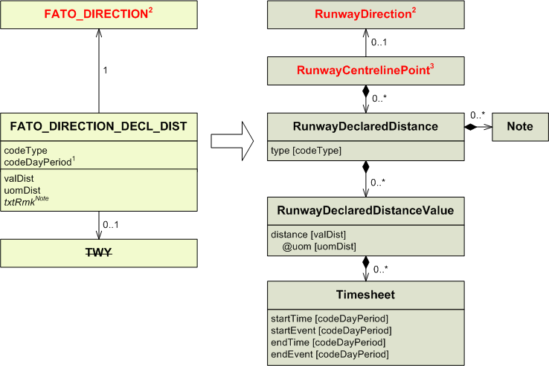
1) Conversion rules for codeDayPeriod:

codeDayPeriod | startTime | startEvent | endTime | endEvent
D  N  A  OTHER | 00:00  Due to the AIXM 4.5 limitation, probably the schedule was encoded as txtRmk, therefore it will appear as a Note in AIXM 5.1. For automatic conversion, a Note with propertyName=timeInterval and value “Other schedule” shall be encoded. | SR  SS | 24:00 | SS  SR

2) FATO_DIRECTION is mapped into a RunwayDirection. See the FATO_DIRECTION section for more details.

3) RunwayDeclaredDistance has to be associated to a RunwayCentrelinePoint. It should be the centreline point from which the distance is starting.
It may have been already created while mapping existing FATO_CLINE_POINT. For this reason, it is strongly advised to map all FATO_CLINE_POINT before any FATO_DIRECTION_DECL_DIST.

See the FATO_CLINE_POINT section for more details.

FATO_DIRECTION_LGT_SYS

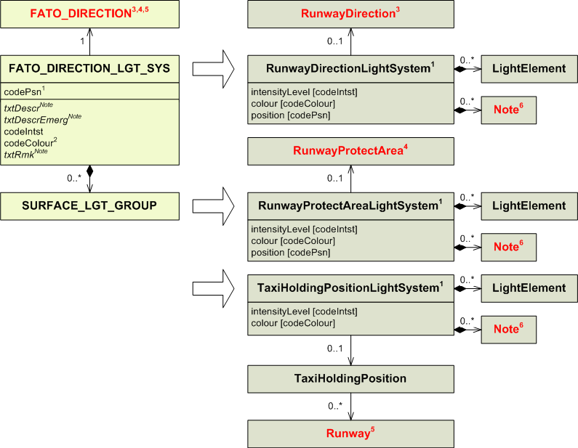
1) Conversion rules for codePsn:

codePsn | Entity to use | position
TDZ  AIM  CL  EDGE  THR  SWYEDGE  DESIG  AFTTHR  DISPTHR  SWYCL  END  SWYEND  TWYINT  HOLDBAY  RTWYINT  OTHER | RunwayDirectionLightSystem  RunwayDirectionLightSystem  RunwayDirectionLightSystem  RunwayDirectionLightSystem  RunwayDirectionLightSystem  RunwayProtectAreaLightSystem  RunwayDirectionLightSystem  RunwayDirectionLightSystem  RunwayDirectionLightSystem  RunwayProtectAreaLightSystem  RunwayDirectionLightSystem  RunwayProtectAreaLightSystem  RunwayDirectionLightSystem  TaxiHoldingPositionLightSystem  RunwayDirectionLightSystem  RunwayDirectionLightSystem | TDZ  AIM  CL  EDGE  THR  EDGE  DESIG  AFT_THR  DTHR  CL  END  END  TWY_INT  RPD_TWY_INT  OTHER

2) Conversion rules for codeColour:

codeColour | colour
YEL  RED  WHI  BLU  GRN  PRP  OTHER | YELLOW  RED  WHITE  BLUE  GREEN  PURPLE  OTHER

3) RunwayDirectionLightSystem mapped from FATO_DIRECTION_LGT_SYS are associated to a RunwayDirection. See the FATO_DIRECTION section for more details.

4) RunwayProtectAreaLightSystem mapped from FATO_DIRECTION_LGT_SYS are associated to a RunwayProtectArea.
This RunwayProtectArea may have been already created while mapping FATO_PROTECT_AREA. For this reason, it is strongly advised to map all FATO_PROTECT_AREA before any FATO_DIRECTION_LGT_SYS.
See the FATO_PROTECT_AREA section for more details.

5) TaxiHoldingPositionLightSystem mapped from FATO_DIRECTION_LGT_SYS are associated to a Runway (through a TaxiHoldingPosition). See the FATO section for more details.

6) Note may be populated with information from SURFACE_LGT_GROUP. See the SURFACE_LGT_GROUP section for more details.

FATO_DIRECTION_OBSTACLE

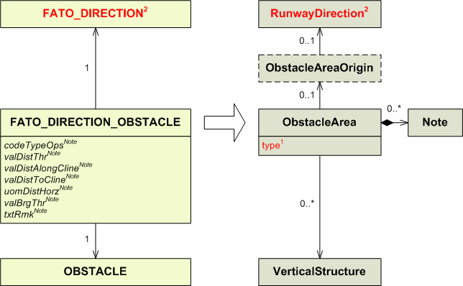

1) By default, each FATO_DIRECTION_OBSTACLE from AIXM 4.5 shall be considered an AREA2 obstacle in AIXM 5.1. Therefore, the corresponding VerticalStructure in AIXM 5.1 shall be associated with the ObstacleArea type=AREA2 associated with the corresponding AirprotHeliport.

2) FATO_DIRECTION is mapped into a RunwayDirection. See the FATO_DIRECTION section for more details.

FATO_DIRECTION_STAR

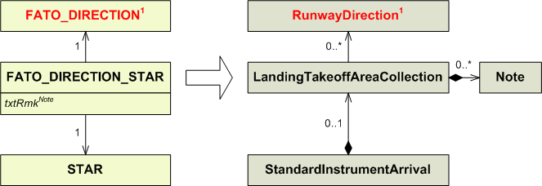

1) FATO_DIRECTION is mapped into a RunwayDirection. See the FATO_DIRECTION section for more details.

FATO_PROTECT_AREA

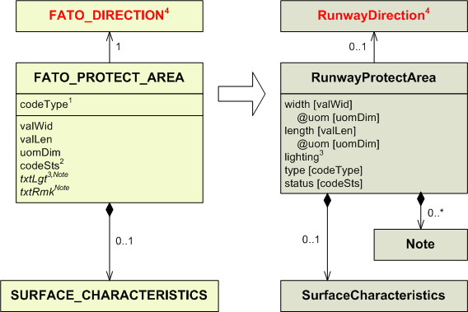
1) Conversion rules for codeType:

codeType | type
CWY  SAFE  ILS  OTHER | CWY  RESA  ILS  OTHER

2) Conversion rules for codeSts:

codeSts | status
WIP  PARKED  CLSD  FAILAID  SPOWER | WORK_IN_PROGRESS  DOWNGRADED  UNSERVICEABLE  DOWNGRADED  DOWNGRADED
OTHER | OTHER

3) The “lighting” attribute in RunwayProtectArea may be set to YES or NO according to the content of the “txtLgt” attribute.

4) FATO_DIRECTION is mapped into a RunwayDirection. See the FATO_DIRECTION section for more details.

FLIGHT_CLASS

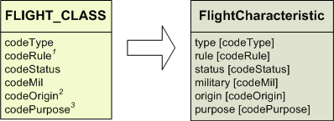

1) Conversion rules for codeRule:

codeRule | rule
I  V  IV | IFR  VFR  ALL

2) Conversion rules for codeOrigin:

codeOrigin | origin
NTL  INTL  ANY  OTHER | NTL  INTL  ALL  OTHER

3) Conversion rules for codePurpose:

codePurpose | purpose
S  NS  P  TRG  WORK  OTHER | SCHEDULED  NON_SCHEDULED  PRIVATE  AIR_TRAINING  AIR_WORK  OTHER

FLOW_COND_COMBINATION

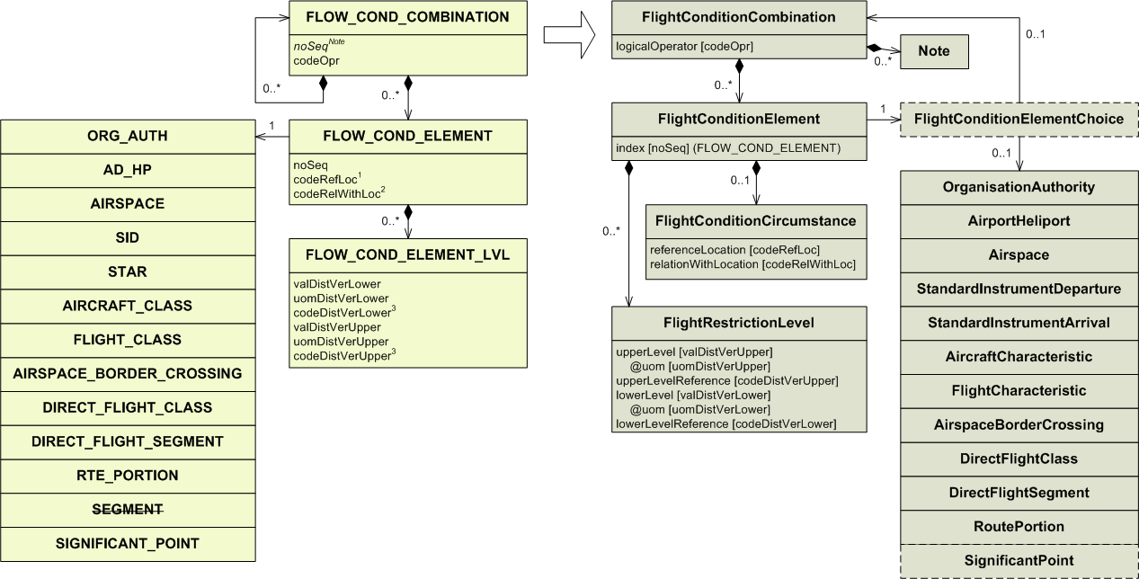

1) Conversion rules for codeRefLoc:

codeRefLoc | referenceLocation
Y  N | YES  NO

2) Conversion rules for codeRelWithLoc:

codeRelWithLoc | relationWithLocation
DEP  XNG  ARR  ACT  AVB | DEP  XNG  ARR  ACT  AVBL

3) Conversion rules for codeDistVerXxx:

codeDistVerXxx | xxxLimitReference
HEI  ALT  W84  QFE*  QNH*  STD  OTHER | SFC  MSL  W84  SFC  MSL  STD  OTHER

* These values were not supposed to be used with this entity. It is likely this is a mistake.

FLOW_COND_ELEMENT

See the FLOW_COND_COMBINATION section.

FLOW_COND_ELEMENT_LVL

See the FLOW_COND_COMBINATION section.

FREQUENCY

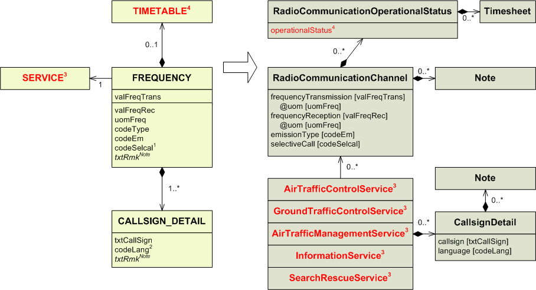
1) Conversion rules for codeSelcal:

codeSelcal | selectiveCall
Y  N | YES  NO

2) Conversion rules for codeLang:

the “language” attribute takes any lowercase, three characters words. However it is recommended to use the following codes, as specified in ISO 639-2.

codeLang | language
AF  AR  BG  CH  CZ  DA  EN  ES  FI  FR  GE  GR  HE  HO  HU  IT  JA  KO  MA  NO  PE  PL  PT  RO  RU  SC  SU  TU  XX | afr  ara  bul  chi  cze  dan  eng  spa  fin  fre  ger  gre  heb  dut  hun  ita  jpn  kor  mac  nor  per  pol  por  rum  rus  hbs  swe  tur  xxx

3) SERVICE may be mapped into five different types of service. See the SERVICE section for more details.

4) Conversion rules for TIMETABLE:

codeWorkHr in TIMETABLE | Attached TIMESHEET | operationalStatus | Additional mapping required. See the TIMETABLE section for more details.
H24 | No | NORMAL | No
Any other case |  | LIMITED | Yes

FUEL

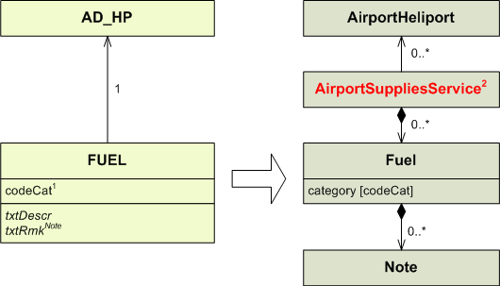

1) Conversion rules for codeCat:

codeCat | category
OCT73  OCT80  OCT80-87  OCT82UL  OCT91-98  AVGAS  AVGAS-LL  OCT100-130  OCT108-135  OCT115-145  MOGAS  JET  A  A1  A1+  B  JP1  JP2  JP3  JP4  JP5  JP6  JPTS  JP7  JP8  JP8+100  JP9  JP10  F-18  F-34  F-35  F-40  F-44  TR0  TR4  TS-1  RT  ALL  OTHER | OCT73  OCT80  OCT80_87  OCT82UL  OCT91_98  AVGAS  AVGAS_LL  OCT100_130  OCT108_135  OCT115_145  MOGAS  JET  A  A1  A1_PLUS  B  JP1  JP2  JP3  JP4  JP5  JP6  JPTS  JP7  JP8  JP8_HIGHER  JP9  JP10  F18  F34  F35  F40  F44  TR0  TR4  TS1  RT  ALL  OTHER

2) In AIXM 5.1, Fuel is associated with an AirportSupplyService. This association does not exist in AIXM 4,5. For automatic conversion, a separate empty AirportSupplyServices should be created and associated with each Fuel related with an airport. It is not possible to re-use the AirportSupplyService eventually created through the mapping of AD_HP_GND_SER of type FUEL (see section 2.4) because it is not known how the different supplies are grouped by service provider, This was a limitation of the AIXM 4.5 model.

GATE_STAND

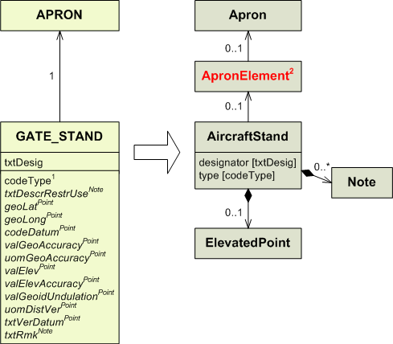

1) Conversion rules for codeType:

codeType | type
NI  ANG-NI  ANG-NO  PAR  RMT  ISOL  UKN  OTHER | NI  ANG_NI  ANG_NO  PARL  RMT  ISOL  OTHER  OTHER

2) AircraftStand cannot be directly associated to an Apron. An ApronElement entity shall be created and associated to both the Apron and the AircraftStand to account for the association. For automatic conversion, a single ApronElement with no associated geometry shall be instantiated in the AIXM 5.1 output.
In the rare situations where AD_HP_SURFACE_BORDER data exists in AIXM 4.5, this ApronElement may have been already created while mapping existing AD_HP_SURFACE_BORDER. However, this is unlikely to exist in AIXM 4.5 data sources.

GEO_BORDER

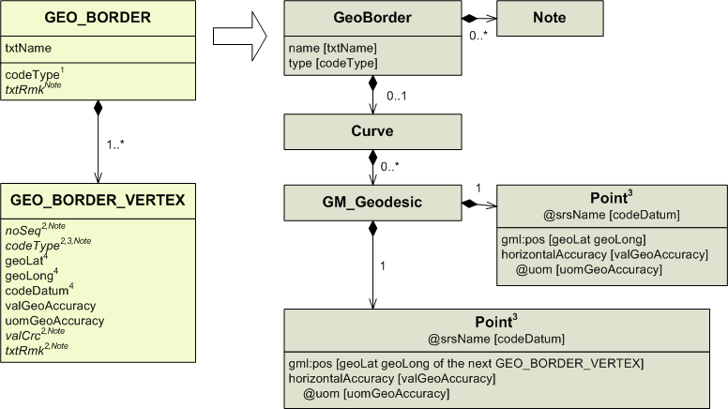
1) Conversion rules for codeType:

codeType | type
ST  TW  CS  RW  RB  OTHER | STATE  WATER  COAST  RIVER  BANK  OTHER

2) Point is associated to Note, so the “codeType”, “noSeq”, “valCrc” and “txtRmk” attributes from GEO_BORDER_VERTEX can be saved in a Note of Point as follows:
“GEO_BORDER_VERTEX-noSeq:(actual value of the “noSeq” attribute)-codeType:(actual value of the “codeType” attribute) -valCrc:(value as defined in the Mapping of “valCrc” attributes section in the Annex) -txtRmk:(actual value of the “txtRmk” attribute)”.

3) Geographical borders are no longer defined point by point; they are defined segment by segment. Because of this, every GEO_BORDER_VERTEX shall be mapped into a GM_Geodesic. All the GM_Geodesic are in turn part of the same Curve.
The GM_Geodesics also use the GEO_BORDER_VERTEX coming next after the one being mapped as the end of the segment. Because of this every GEO_BORDER_VERTEX is used twice, except for the first one, which will not be an end point for any segment, and the last one (with codeType = END), which will not have a segment of its own and will just be used as the ending point of the segment starting with the penultimate GEO_BORDER_VERTEX of the sequence.
codeType | Object to use | Coordinates
GRC | a GM_Geodesic | first Point: geoLat geoLong  second Point: geoLat geoLong from the next AIRSPACE_CLINE_VERTEX
END | not to be mapped | The ending point is only used as the second point of the last segment. It is not to be mapped in a segment of its own.

4) See the Mapping of geographical coordinates section in the Annex about how to format the “geoLat”, “geoLong” and “codeDatum” attributes.

HOLDING_PROCEDURE
IMPORTANT NOTE: the model for instrument approach procedures, SID and STAR in AIXM 4.5 was relatively simplistic and oriented towards providing data for procedure charting. Therefore, automatic conversion of AIXM 4.5 PROCEDURE_LEG, SID, STAR, IAP and HOLDING entities results in only partial Procedure data in AIXM 5.1. The resulting Procedure data shall be further checked and completed with data from the official sources (AIP), which was not possible to be encoded in AIXM 4.5.

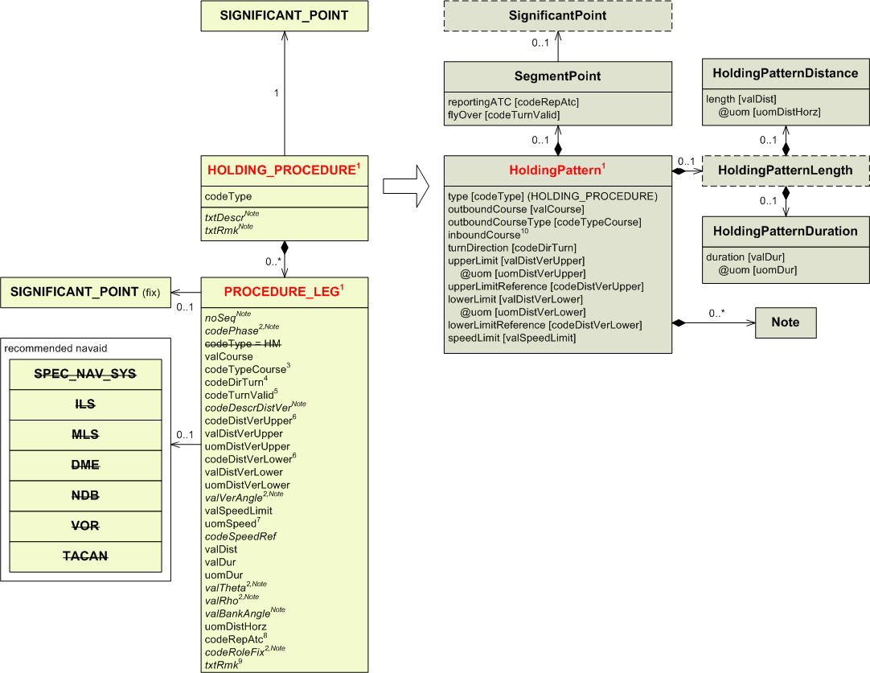

1) A HOLDING_PROCEDURE is meant to be defined by only one PROCEDURE_LEG. However, it is possible to associate several PROCEDURE_LEG to the same HOLDING_PROCEDURE. In such a case, only the attributes from the first PROCEDURE_LEG shall be mapped into HoldingPattern, HoldingPatternDistance, HoldingPatternDuration and SegmentPoint. The attributes from the other PROCEDURE_LEG shall be saved into Notes. Such Note entities shall clearly state from which PROCEDURE_LEG their information comes from, by concatenating the value of the noSeq of the PROCEDURE_LEG with the name/value of each attribute, each on a separate line.

2) These attributes are mapped into Note because they make no sense for a holding procedure.

3) Conversion rules for codeTypeCourse :

codeTypeCourse | courseType
TT  MT  TBRG  MBRG  HDG  RAD  OTHER | TRUE_TRACK  MAG_TRACK  TRUE_BRG  MAG_BRG  HDG  RDL  OTHER

4) Conversion rules for codeDirTurn:

codeDirTurn | turnDirection
L  R  E | LEFT  RIGHT  EITHER

5) Conversion rules for codeTurnValid:

codeTurnValid | flyOver
Y  N | NO*  YES*

* Not a mistake. The value should really be swapped.

6) Conversion rules for codeDistVerXxx:

codeDistVerXxx | xxxLimitReference
HEI  ALT  W84  QFE*  QNH*  STD  OTHER | SFC  MSL  W84  SFC  MSL  STD  OTHER

* These values were not supposed to be used with this entity. It is likely this is a mistake.

7) Conversion rules for uomSpeed:

uomSpeed | uom
KM/H  KT  MACH  M/MIN  FT/MIN  M/SEC  FT/SEC | KM_H  KT  MACH  M_MIN  FT_MIN  M_SEC  FT_SEC

8) Conversion rules for codeRepAtc:

codeRepAtc | reportingATC
C  R  N  OTHER | COMPULSORY  ON_REQUEST  NO_REPORT  OTHER

9) This “txtRmk” attribute has to be saved into a Note associated to HoldingPattern. If a “txtRmk” attribute has already been mapped from HOLDING_PROCEDURE, the “txtRmk” attribute from PROCEDURE_LEG will have to be mapped into a separate Note with an empty propertyName.

10) The “inboundCourse” attribute may be populated with valCourse +- 180.

IAP
IMPORTANT NOTE: the model for instrument approach procedures, SID and STAR in AIXM 4.5 was relatively simplistic and oriented towards providing data for procedure charting. Therefore, automatic conversion of AIXM 4.5 PROCEDURE_LEG, SID, STAR, IAP and HOLDING entities results in only partial Procedure data in AIXM 5.1. The resulting Procedure data shall be further checked and completed with data from the official sources (AIP), which was not possible to be encoded in AIXM 4.5.
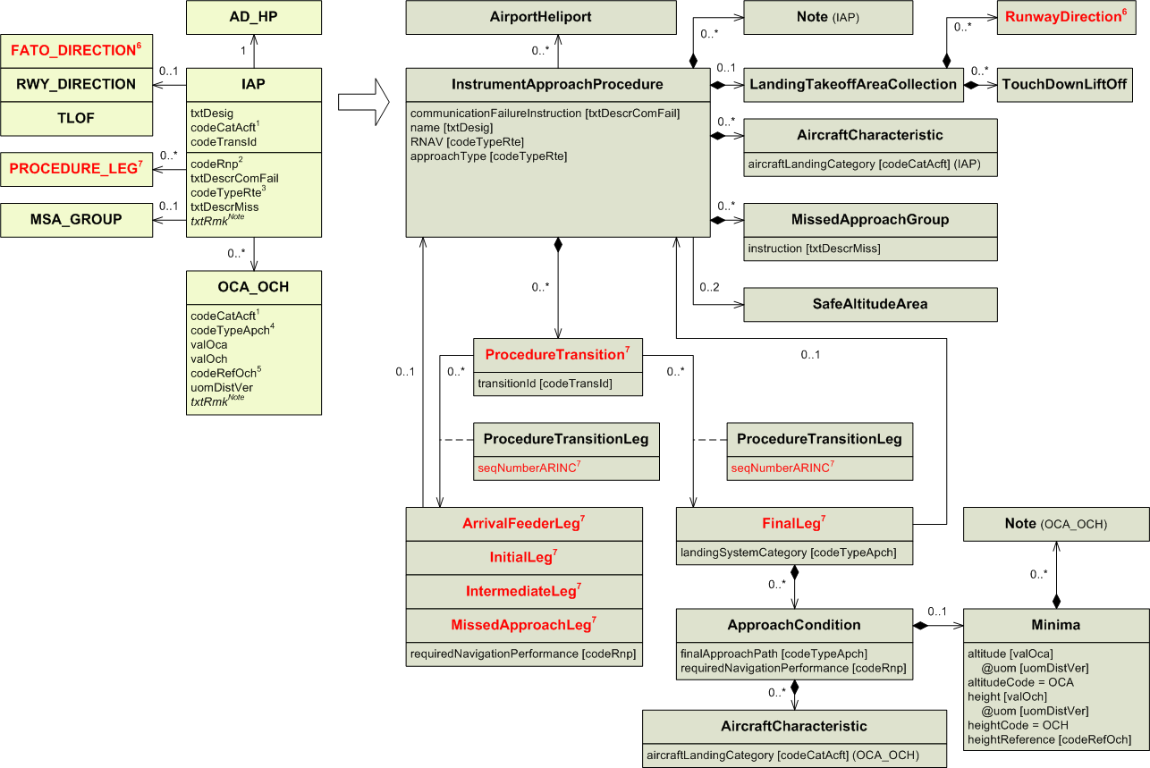
1) Conversion rules for codeCatAcft:

codeCatAcft | aircraftLandingCategory
A  B  C  D  E  H  ABCDEF  OTHER | A  B  C  D  E  H  ALL  OTHER

For codeCatAcft values such as AB, several AircraftCharacteristic entities (one for each letter) will have to be created and associated to the InstrumentApproachProcedure.

2) In AIXM 5.1 it is now possible for each procedure leg to have its own required navigation performance. The “codeRnp” attribute shall then be mapped into every procedure leg associated to the procedure.

3) Conversion rules for codeTypeRte:

codeTypeRte | approachType
B  E*  F  G  H  I  J*  K*  L  M  N  P  R  T  U  V  W**  Y**  OTHER | LOC_BC  RNAV, GPS*  OTHER:FMS  IGS  OTHER:HELICOPTER  ILS  GPS  GPS  LOC  MLS  NDB  GPS  RNAV  TACAN  SDF  VOR  MLS  MLS  OTHER

*Both values may be used.
** These values are not the exact translation of the AIXM 4.5 values.

4) Conversion rules for codeTypeApch:

codeTypeApch | finalApproachPath | landingSystemCategory
STA  STA1  STA2  STA3A  STA3B  STA3C  CA  OTHER | STRAIGHT_IN  STRAIGHT_IN  STRAIGHT_IN  STRAIGHT_IN  STRAIGHT_IN  STRAIGHT_IN  CIRCLING  OTHER | NON_PRECISION  ILS_PRECISION_CAT_I*  ILS_PRECISION_CAT_II*  ILS_PRECISION_CAT_IIIA*  ILS_PRECISION_CAT_IIIB*  ILS_PRECISION_CAT_IIIC*

* These values imply that an ILS is used. “MLS_PRECISION” is also an available value for the “landingSystemCategory” attribute.

5) Conversion rules for codeRefOch:

codeRefOch | heightReference
ARP  THR  OTHER | HAA  HAT  OTHER

6) FATO_DIRECTION is mapped into a RunwayDirection. See the FATO_DIRECTION section for more details.

7) When mapping from AIXM 4.5, one ProcedureTransition should be created for each group of associated PROCEDURE_LEG having the same codePhase value. Every procedure leg also has to be directly associated to the instrument approach procedure.
PROCEDURE_LEG associated to the IAP may be mapped into five different types of procedure legs. Further details about what type of leg shall be created is provided in the mapping section for PROCEDURE_LEG, rule 10.
When mapping a PROCEDURE_LEG, the “seqNumberARINC” attribute belonging to the association class ProcedureTransitionLeg should be populated. It is assumed that the position of the PROCEDURE_LEG within all the legs associated to the procedure is its actual position within the branch. The “seqNumberARINC” attribute should be populated with this position.
The “codeTypeApch” attribute can only be mapped this way if at least one FinalLeg is associated to the InstrumentApproachProcedure. Otherwise is has to be mapped into a Note.

IAP_USAGE

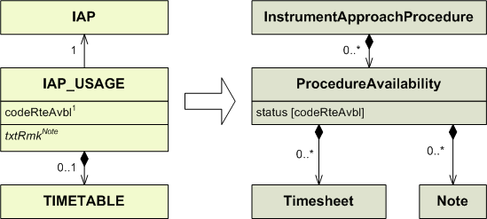

1) Conversion rules for codeRteAvbl:

codeRteAvbl | status
NONFUA  CDR1  CDR2  CDR3  SPEC  CLSD | USABLE  OTHER:CDR1  OTHER:CDR2  OTHER:CDR3  OTHER:SPEC  UNUSABLE

ILS
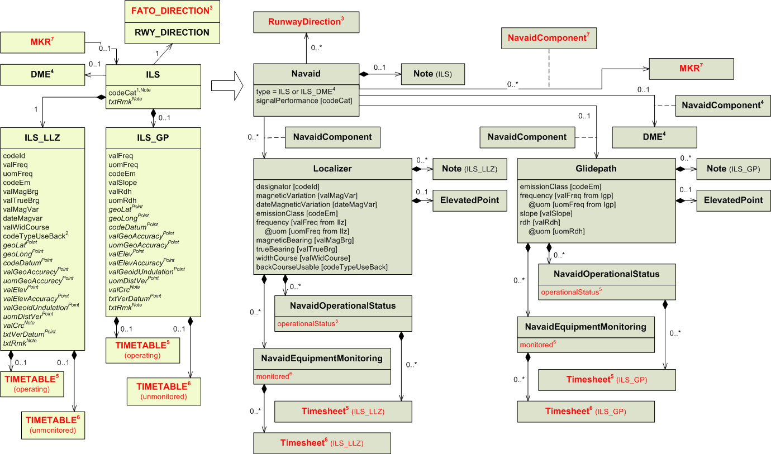
1) Conversion rules for codeCat:

codeCat | signalPerformance | additional piece of information to be saved in a Note
I  II  III  IIIA  IIIB  IIIC  NOCAT | I  II  III  III  III  III  OTHER:NOCAT | A  B  C

2) Conversion rules for codeTypeUseBack:

codeTypeUseBack | backCourseUsable
Y  N  R | YES  NO  RSTR

3) FATO_DIRECTION is mapped into a RunwayDirection. See the FATO_DIRECTION section for more details.

4) If ILS is associated to a DME, then the attribute “type” in Navaid shall receive the value ILS_DME. Otherwise, it shall receive the value ILS.

5) Conversion rules for TIMETABLE (operating):

codeWorkHr in TIMETABLE | Attached TIMESHEET | operationalStatus | Additional mapping required. See the TIMETABLE section for more details.
H24  NOTAM  NOTAM | No  No  Yes | OPERATIONAL  CONDITIONAL  CONDITIONAL | No  No  Yes
Any other case |  |  | Yes

6) Conversion rules for TIMETABLE (unmonitored):

codeWorkHr in TIMETABLE | Attached TIMESHEET | monitored | Additional mapping required. See the TIMETABLE section for more details.
H24 | No | NO | No
Any other case |  | YES | Yes

7) For each MKR that is associated with the ILS in AIXM 4.5, an association between the ILS Navaid and the corresponding MarkerBeacon shall be created in AIXM 5.1.

MKR

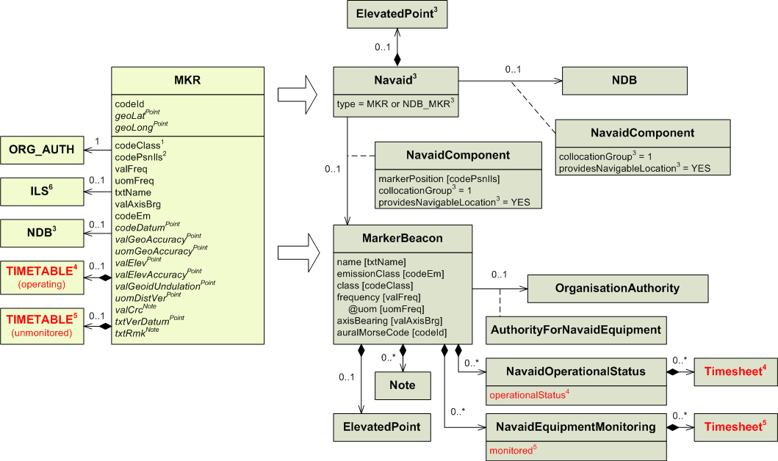
1) Conversion rules for codeClass:

codeType | type
FM  LFM  Z  OTHER | FAN  LOW_PWR_FAN  Z  OTHER

2) Conversion rules for codePsnIls:

codePsnIls | markerPosition
O  M  I  C  OTHER | OUTER  MIDDLE  INNER  BACKCOURSE  OTHER

3) A Navaid has to be created in addition to the MarkerBeacon (NavaidEquipment) as follows:
AIXM 4.5 | AIXM 5.1 Navaid
MKR is collocated with NDB | type=NDB_MKR  designator – use NDB.codeId  name – use NDB.txtName  ElevatedPoint – use geoLat, geoLong, codeDatum of the NDB  providesNavigableLocation = YES on the NavaidComponent that is associated with the NDB  collocationGroup=1 on both associations with MarkerBeacon and NDB
MKR is not collocated with NDB. (note that if collocated with ILS, then the ILS Mapping in 2.52 needs to take care of this collocation). | type= MKR  designator – leave empty  name – use MKR.txtName  ElevatedPoint – use geoLat, geoLong, codeDatum of the MKR  providesNavigableLocation = YES on the NavaidComponent that is associated with the MKR  collocationGroup – leave empty

A NavaidOperationalStatus should also be encoded for the resulting Navaid. However, automatic generation is difficult as in some situations the MKR and NDB might have different operational hours and/or unmonitored hours. Therefore, it is recommended that the NavaidOperationalStatus for the resulting Navaid is left empty.

4) Conversion rules for TIMETABLE (operating):

codeWorkHr in TIMETABLE | Attached TIMESHEET | operationalStatus | Additional mapping required. See the TIMETABLE section for more details.
H24  NOTAM  NOTAM | No  No  Yes | OPERATIONAL  CONDITIONAL  CONDITIONAL | No  No  Yes
Any other case |  |  | Yes

5) Conversion rules for TIMETABLE (unmonitored):

codeWorkHr in TIMETABLE | Attached TIMESHEET | monitored | Additional mapping required. See the TIMETABLE section for more details.
H24 | No | NO | No
Any other case |  | YES | Yes

6) The association between MKR and ILS is dealt with as part of the ILS mapping (the association navigability is reversed in AIXM 5.1).

MLS
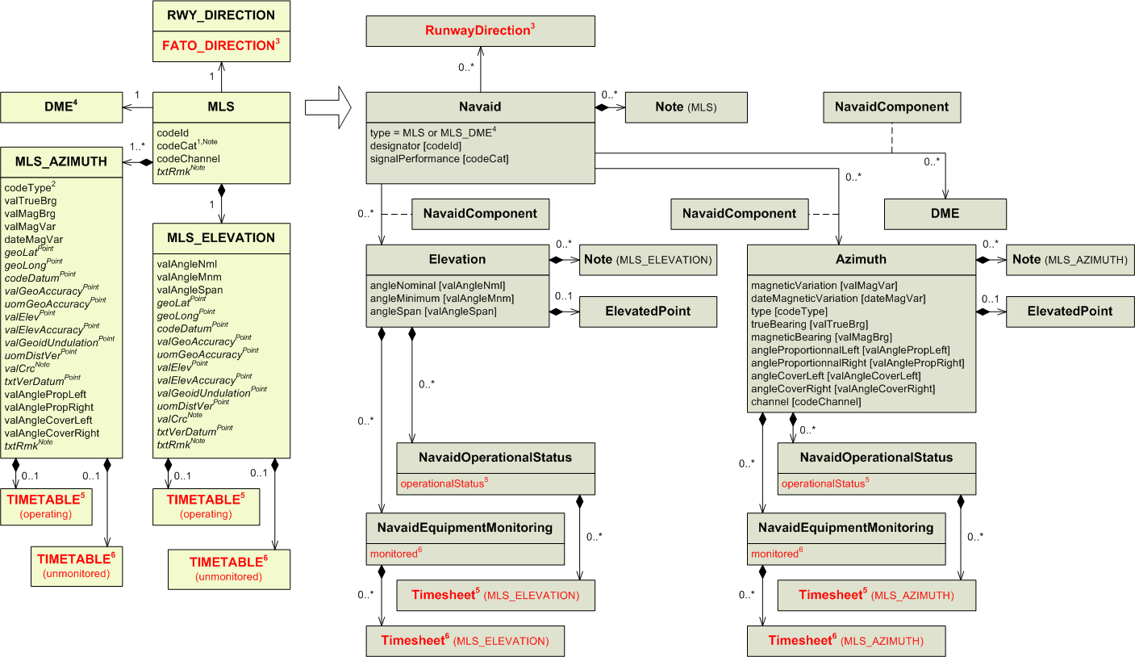
1) Conversion rules for codeCat:

codeCat | signalPerformance | Additional piece of information to be saved in a Note
I  II  III  IIIA  IIIB  IIIC  NOCAT | I  II  III  III  III  III  OTHER:NOCAT | A  B  C

2) Conversion rules for codeType:

codeType | type
F  B  OTHER | FWD  BWD  OTHER

3) FATO_DIRECTION is mapped into a RunwayDirection. See the FATO_DIRECTION section for more details.

4) If MLS is associated to a DME, then the attribute “type” in Navaid shall received the value MLS_DME. Otherwise, it shall receive the value MLS.

5) Conversion rules for TIMETABLE (operating):

codeWorkHr in TIMETABLE | Attached TIMESHEET | operationalStatus | Additional mapping required. See the TIMETABLE section for more details.
H24  NOTAM  NOTAM | No  No  Yes | OPERATIONAL  CONDITIONAL  CONDITIONAL | No  No  Yes
Any other case |  |  | Yes

6) Conversion rules for TIMETABLE (unmonitored):

codeWorkHr in TIMETABLE | Attached TIMESHEET | monitored | Additional mapping required. See the TIMETABLE section for more details.
H24 | No | NO | No
Any other case |  | YES | Yes

MSA

See the MSA_GROUP section.

MSA_GROUP

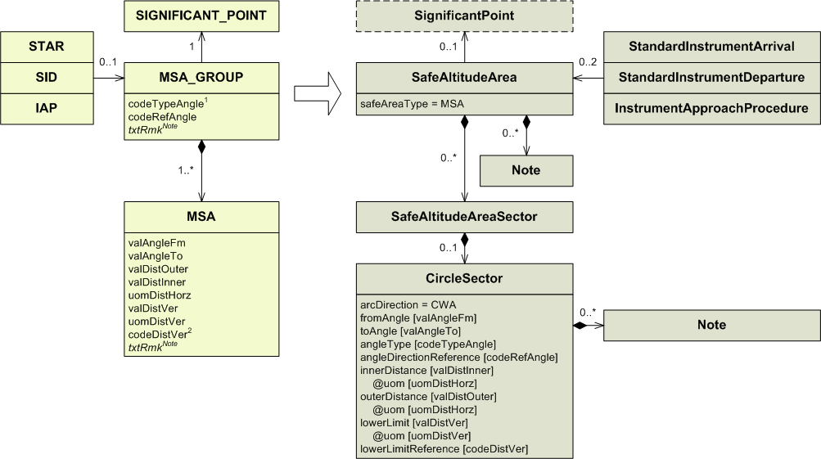

1) Conversion rules for codeTypeAngle:

codeTypeAngle | angleType
TRUE  MAG  RAD  OTHER | TRUE  MAG  RDL  OTHER

2) Conversion rules for codeDistVer:

codeDistVer | lowerLimitReference
HEI  ALT  W84  QFE*  QNH*  STD  OTHER | SFC  MSL  W84  SFC  MSL  STD  OTHER

* These values were not supposed to be used with this entity. It is likely this is a mistake.

NAVAID_LIMITATION

See the DME_USAGE_LIMIT, NDB_USAGE_LIMIT, TACAN_USAGE_LIMIT and VOR_USAGE_LIMIT sections.

NAV_SYS_CHECKPOINT

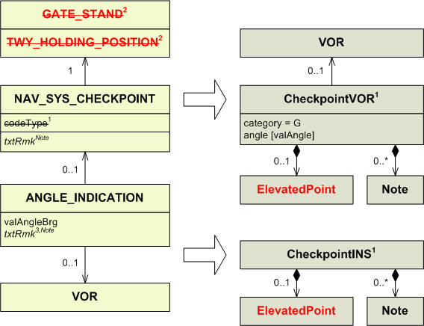

1) Conversion rules for codeType:

codeType | Entity to use
INS  GNSS*  VOR  DME*  TACAN*  NDB*  OTHER* | CheckpointINS  CheckpointVOR

* Since these values were not actually used in AIXM 4.5, they have been removed from the model.
For this reason, it no longer makes sense to map a DISTANCE_INDICATION associated to a NAV_SYS_CHECKPOINT.
For the same reason, having an ANGLE_INDICATION associated to a NAV_SYS_CHECKPOINT only makes sense if it is associated to a VOR. That is why it is the only navaid association represented. If several ANGLE_INDICATIONs associated to a VOR refer to the same NAV_SYS_CHECKPOINT, each one of them should be mapped into a different CheckpointVOR.
A CheckpointINS does not require any navaid since the position of the checkpoint if enough to calibre the inertial navigation system.

2) In AIXM 5.1 checkpoints can no longer be associated to a taxi holding position or to a stand. To preserve these information, the coordinates from TWY_HOLDING_POSITION or GATE_STAND should be mapped into the ElevatedPoint associated to the checkpoint.

3) This “txtRmk” attribute has to be saved into a Note associated to CheckpointVOR/CheckpointINS. If a “txtRmk” attribute has already been mapped from NAV_SYS_CHECKPOINT, the “txtRmk” attribute from ANGLE_INDICATION will have to be mapped into a Note with propertyName = txtRmk from ANGLE_INDICATION.

NDB

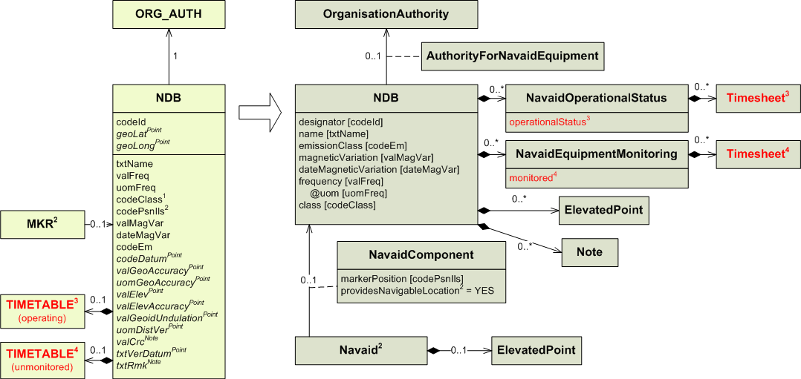
1) Conversion rules for codeClass:

codeClass | class
B  L  M  OTHER | ENR  L  MAR  OTHER

2) A Navaid has to be created in addition to the NDB (NavaidEquipment) as follows:
AIXM 4.5 | AIXM 5.1 Navaid
MKR is collocated with NDB | See the MKR section, mapping note no. 3
NDB is stand-alone | type= NDB  designator – use NDB.codeId  name – use NDB.txtName  ElevatedPoint – use geoLat, geoLong, codeDatum of the NDB  providesNavigableLocation = YES on the NavaidComponent that is associated with the NDB  collocationGroup – leave empty

A NavaidOperationalStatus should also be encoded for the resulting Navaid. However, automatic generation is difficult as in some situations the MKR and NDB might have different operational hours and/or unmonitored hours. Therefore, it is recommended that the NavaidOperationalStatus for the resulting Navaid is left empty.

Conversion rules for codePsnIls:

codePsnIls | markerPosition
O  M  I  C  OTHER | OUTER  MIDDLE  INNER  BACKCOURSE  OTHER

3) Conversion rules for TIMETABLE (operating):

codeWorkHr in TIMETABLE | Attached TIMESHEET | operationalStatus | Additional mapping required. See the TIMETABLE section for more details.
H24  NOTAM  NOTAM | No  No  Yes | OPERATIONAL  CONDITIONAL  CONDITIONAL | No  No  Yes
Any other case |  |  | Yes

4) Conversion rules for TIMETABLE (unmonitored):

codeWorkHr in TIMETABLE | Attached TIMESHEET | monitored | Additional mapping required. See the TIMETABLE section for more details.
H24 | No | NO | No
Any other case |  | YES | Yes

NDB_USAGE_LIMIT

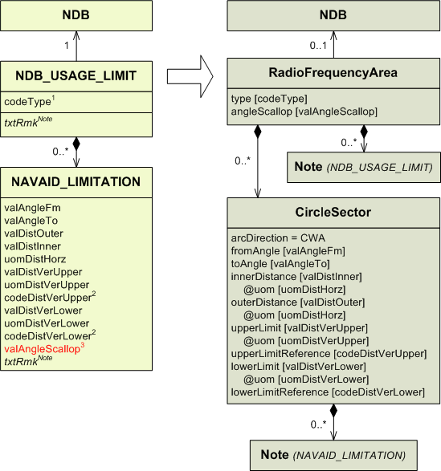

1) Conversion rules for codeType:

codeType | type
CVR  SCL  RHG  UNL  RES  UUS  OUT  TCVR  OTHER | COV  SCL  RHG  UNREL  RES  UUS  OUT  T_COV  OTHER

2) Conversion rules for codeDistVerXxx:

codeDistVerXxx | xxxLimitReference
HEI  ALT  W84  QFE*  QNH*  STD  OTHER | SFC  MSL  W84  SFC  MSL  STD  OTHER

* These values were not supposed to be used with this entity. It is likely this is a mistake.

3) Since the “angleScallop” attribute belongs to RadioFrequencyArea, there can no longer be a different value for each sector. If there were NAVAID_LIMITATION belonging to the same NDB_USAGE_LIMIT with different valAngleScallop values, one shall be chosen to populate the “angleScallop” attribute in RadioFrequencyArea.

NITROGEN

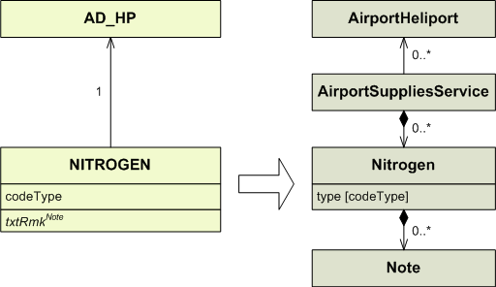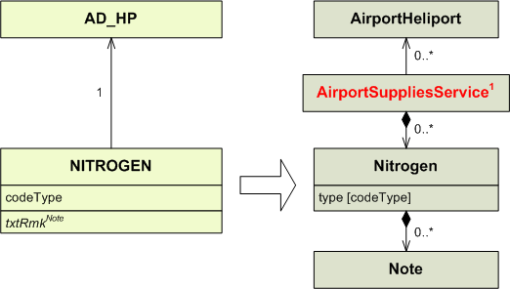

1) In AIXM 5.1, Nitrogen is associated with an AirportSupplyService. This association does not exist in AIXM 4,5. For automatic conversion, a separate AirportSupplyServices should be created for each Nitrogen related with an airport. It is not known how the different supplies are grouped by service provider, This was a limitation of the AIXM 4.5 model.

OBSTACLE

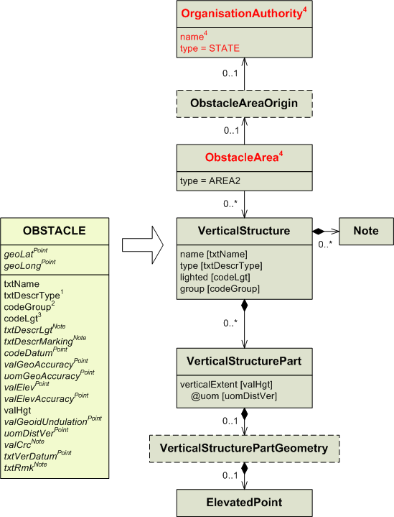

1) If the value from “txtDescrType” belongs to the default list of allowable values for the “type” attribute (see below), then it shall be mapped as it is. If not, it shall be mapped preceded by “OTHER:” and with all spaces removed. “OTHER:” may only be followed by as many as 58 characters, so if the original value, once spaces removed, is longer than this, it shall also be mapped, without any alteration, into a Note. The value shall then be truncated to 58 characters and mapped into the “type” attribute.
List of allowable values for the “type” attribute:
AG_EQUIP
ANTENNA
ARCH
BRIDGE
BUILDING
CABLE_CAR
CATENARY
COMPRESSED_AIR_SYSTEM
CONTROL_MONITORING_SYSTEM
CONTROL_TOWER
COOLING_TOWER
CRANE
DAM
DOME
ELECTRICAL_EXIT_LIGHT
ELECTRICAL_SYSTEM
ELEVATOR
FENCE
FUEL_SYSTEM
GATE
GENERAL_UTILITY
GRAIN_ELEVATOR
HEAT_COOL_SYSTEM
INDUSTRIAL_SYSTEM
LIGHTHOUSE
MONUMENT
NATURAL_GAS_SYSTEM
NATURAL_HIGHPOINT
NAVAID
NUCLEAR_REACTOR
POLE
POWER_PLANT
REFINERY
RIG
SALTWATER_SYSTEM
SIGN
SPIRE
STACK
STADIUM
STORM_SYSTEM
TANK
TETHERED_BALLOON
TOWER
TRAMWAY
TRANSMISSION_LINE
TREE
URBAN
VEGETATION
WALL
WASTEWATER_SYSTEM
WATER_SYSTEM
WATER_TOWER
WINDMILL
WINDMILL_FARMS

2) Conversion rules for codeGroup:

codeGroup | group
Y  N | YES  NO

3) Conversion rules for codeLgt:

codeLgt | lighted
Y  N | YES  NO

4) If the mapping concerns the data of a single State, then it is possible to consider by default that all VerticalStructures in AIXM 5.1, which are not associated with an Airport or a Runway, belong to Area 1:
- If OBSTACLE is not associated to either an AD_HP_OBSTACLE, a FATO_DIRECTION_OBSTACLE or a RWY_DIRECTION_OBSTACLE, then the VerticalStructure shall be associated, through an ObstacleAreaOrigin with type = AREA1, to an OrganisationAuthority with type = STATE and name = [name of the State].
If the mapping concerns data from a regional or multi-national database, then it is not possible to directly associate VerticalStructures with the ObstacleArea (Area 1) of each State. A soatial query could be envisaged. Otherwise, the association with ObstacleArea shall be left empty.

OIL

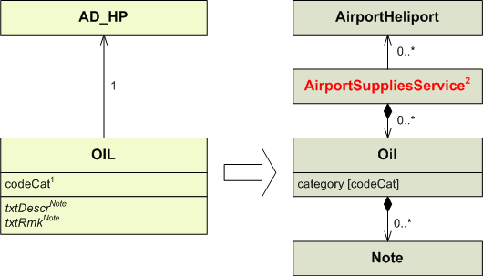

1) Conversion rules for codeCat:

codeCat | category
PISTON  TURBO  HYD  OTHER | PISTON  TURBO  HYDRAULIC  OTHER

2) In AIXM 5.1, Oil are associated with an AirportSupplyService. This association does not exist in AIXM 4,5. For automatic conversion, a separate AirportSupplyServices should be created for each Oil related with an airport. It is not known how the different supplies are grouped by service provider, This was a limitation of the AIXM 4.5 model..

ORG_AUTH

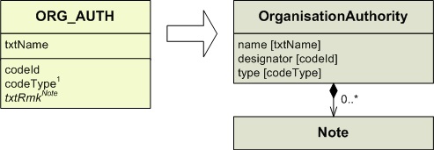

1) Conversion rules for codeType:

codeType | type
S  GS  O  IO  AOA  ATS  HA  A  OTHER | STATE  STATE_GROUP  ORG  INTL_ORG  ACFT_OPR  ATS  HANDLING_AGENCY  NTL_AUTH  OTHER

ORG_AUTH_ASSOC

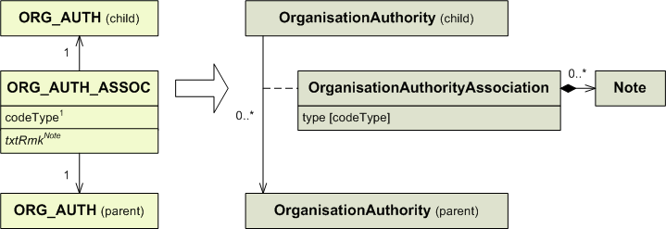

1) Conversion rules for codeType:

codeType | type
OWN  MBR  OTHER | OWNED_BY  MEMBER  OTHER

OXYGEN

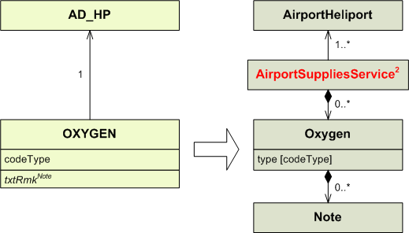
1) In AIXM 5.1, Nitrogen is associated with an AirportSupplyService. This association does not exist in AIXM 4,5. For automatic conversion, a separate AirportSupplyServices should be created for each Nitrogen related with an airport. It is not known how the different supplies are grouped by service provider, This was a limitation of the AIXM 4.5 model

PASSENGER_FACILITY

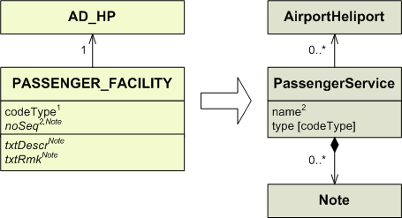

1) Conversion rules for codeType:

codeType | type
HOTEL  TRANS  REST  INFO  BANK  POST  MEDIC  OTHER | HOTEL  TRANSPORT  REST  INFO  BANK  POST  MEDIC  OTHER

2) The “noSeq” attribute from PASSENGER_FACILITY should be mapped in a Note, except if there are several PassengerService of the same type associated to the same AirportHeliport. In such a case, it may be mapped into the “name” attribute of PassengerService to help differentiate them.

PREDEFINED_LVL

See the PREDEFINED_LVL_TABLE section.

PREDEFINED_LVL_COLUMN

See the PREDEFINED_LVL_TABLE section.

PREDEFINED_LVL_TABLE

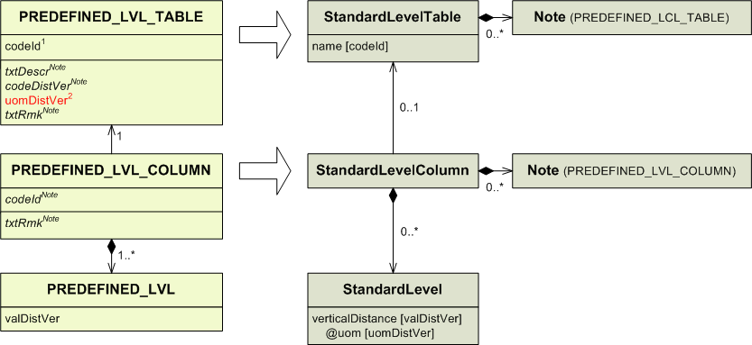
1) Conversion rules for codeId:

codeId | name
I  IR  IM  IRM  V  VR  VM  VRM | IFR  IFR_RVSM  IFR_METRES  IFR_METRES_RVSM  VFR  VFR_RVSM  VFR_METRES  VFR_METRES_RVSM

2) the “uomDistVer” attribute is not mappable in a StandardLevelTable entity, however its value is mandatory to map any PREDEFINED_LVL of the PREDEFINED_LVL_COLUMN associated to the PREDEFINED_LVL_TABLE.

PROCEDURE_LEG
IMPORTANT NOTE: the model for instrument approach procedures, SID and STAR in AIXM 4.5 was relatively simplistic and oriented towards providing data for procedure charting. Therefore, automatic conversion of AIXM 4.5 PROCEDURE_LEG, SID, STAR, IAP and HOLDING entities results in only partial Procedure data in AIXM 5.1. The resulting Procedure data shall be further checked and completed with data from the official sources (AIP), which was not possible to be encoded in AIXM 4.5.
This diagram does not apply to PROCEDURE_LEG associated to HOLDING_PROCEDURE. PROCEDURE_LEG associated to HOLDING_PROCEDURE are mapped in the HOLDING_PROCEDURE section.

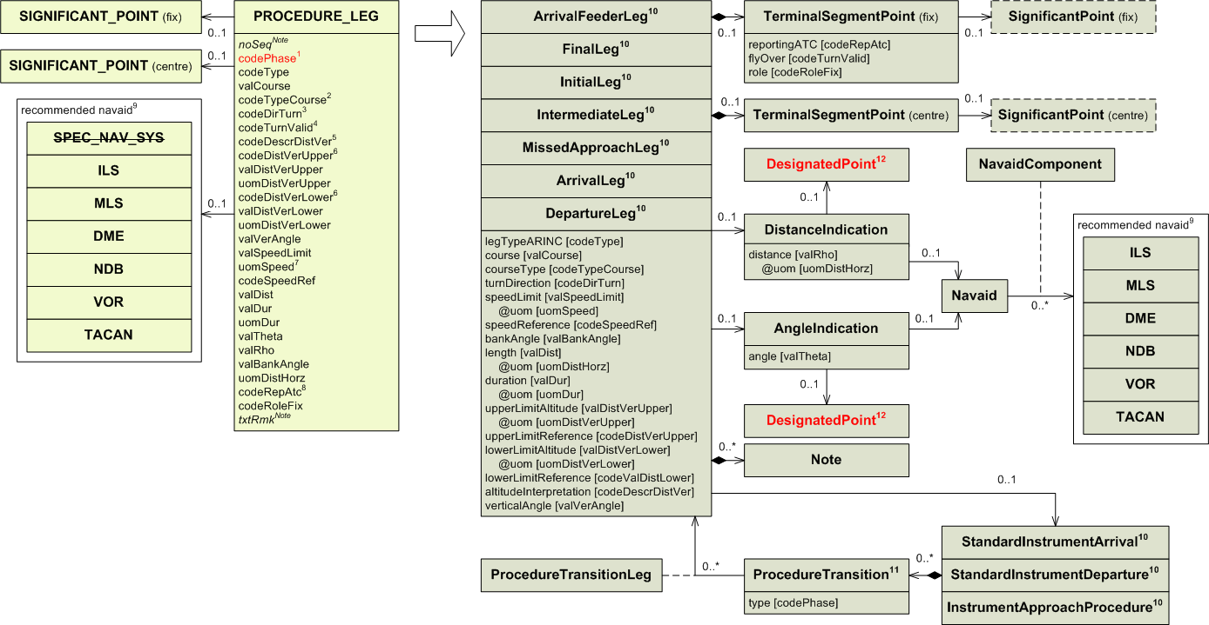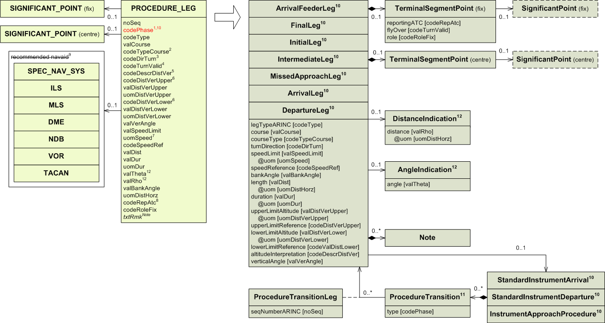
1) PROCEDURE_LEG that are associated with the same IAP in AIXM 4.5 and have the same codePhase values, are grouped in an association with the same ProcedureTransition.

Conversion rules for codePhase:

codePhase | type  when the procedure is a SID | type  when the procedure is a STAR | type  when the procedure is an IAP
0  1  2  3  4  5  6  7  8  9  F  M  S  T  V  A  Z  P  R  OTHER | ENGINE_OUT  RWY  COMMON  EN_ROUTE  RWY  COMMON  EN_ROUTE  EN_ROUTE  COMMON  RWY  RWY  COMMON  EN_ROUTE  RWY  EN_ROUTE  MISSED_P  MISSED_S  OTHER | EN_ROUTE  COMMON  RWY  EN_ROUTE  COMMON  RWY  EN_ROUTE  COMMON  RWY  EN_ROUTE  COMMON  RWY  MISSED_P  MISSED_S  OTHER | COMMON  COMMON  EN_ROUTE  COMMON  RWY  COMMON  APPROACH  MISSED  MISSED_P  MISSED_S  OTHER

2) Conversion rules for codeTypeCourse :

codeTypeCourse | courseType
TT  MT  TBRG  MBRG  HDG  RAD  OTHER | TRUE_TRACK  MAG_TRACK  TRUE_BRG  MAG_BRG  HDG  RDL  OTHER

3) Conversion rules for codeDirTurn:

codeDirTurn | turnDirection
L  R  E | LEFT  RIGHT  EITHER

4) Conversion rules for codeTurnValid:

codeTurnValid | flyOver
Y  N | NO*  YES*

* Not a mistake. The value should really be swapped.

5) Conversion rules for codeDescrDistVer:

codeDescrDistVer | altitudeInterpretation
LA  BH  L  B  OTHER | ABOVE_LOWER  BELOW_UPPER  AT_LOWER  BETWEEN  OTHER

6) Conversion rules for codeDistVerXxx:

codeDistVerXxx | xxxLimitReference
HEI  ALT  W84  QFE*  QNH*  STD  OTHER | SFC  MSL  W84  SFC  MSL  STD  OTHER

* These values were not supposed to be used with this entity. It is likely this is a mistake.

7) Conversion rules for uomSpeed:

uomSpeed | uom
KM/H  KT  MACH  M/MIN  FT/MIN  M/SEC  FT/SEC | KM_H  KT  MACH  M_MIN  FT_MIN  M_SEC  FT_SEC

8) Conversion rules for codeRepAtc:

codeRepAtc | reportingATC
C  R  N  OTHER | COMPULSORY  ON_REQUEST  NO_REPORT  OTHER

9) It is quite unlikely that this data exists in AIXM 4.5 data sources, as the concept of recommended navaid does not exist in State AIP. It was introduced in AIXM 4.5 for facilitating that mapping to ARINC 424. For automated data conversions between AIXM 4.5 and AIXM 5.1, it shall be mapped into a Note with value “Recommended navaid” followed by the type of AIXM 4.5 navaid and by its designator (codeId),

10) In AIXM 5.1 there are several types of segment leg. Which one shall be used depends on the type of procedure and the type of procedure leg.

Type of procedure | codePhase | Procedure leg entity to use
StandardInstrumentArrival  StandardInstrumentDeparture  InstrumentApproachProcedure | any value  any value  7, OTHER  9  A  2, 5, 8,  Z, P, S | ArrivalLeg  DepartureLeg  ArrivalFeederLeg*  FinalLeg*  InitialLeg*  IntermediateLeg*  MissedApproachLeg*

* There is no absolutely safe way to identify the type of a leg, because of the limitations of AIXM 4.5. The mapping recommended here is based on the codePhase value. However, the resulting data shall be checked against the official data sources (AIP):
.

11) In AIXM 5.1 there are two associations between a segment leg and its procedure.
One is from the segment to its procedure.
The other is from the procedure to the segment through a ProcedureTransition entity. Although a procedure may have several ProcedureTransition, PROCEDURE_LEG depending on the same procedure should only be mapped into segment legs associated to one ProcedureTransition. The ProcedureTransition can then have as many segment legs as necessary. The available segment leg types are limited by the procedure type, as detailed in 10).

12) AngleIndication and DistanceIndication have to be associated to a DesignatedPoint and a Navaid. However, due to the AIXM 4.5 limitations, this information cannot be retrieved through automatic mapping. Therefore, only these associations shall be left empty.

RTE_PORTION

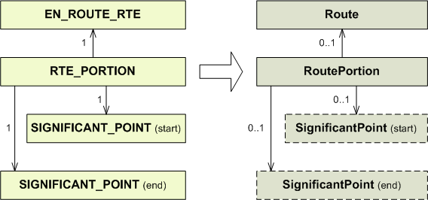

RTE_SEG

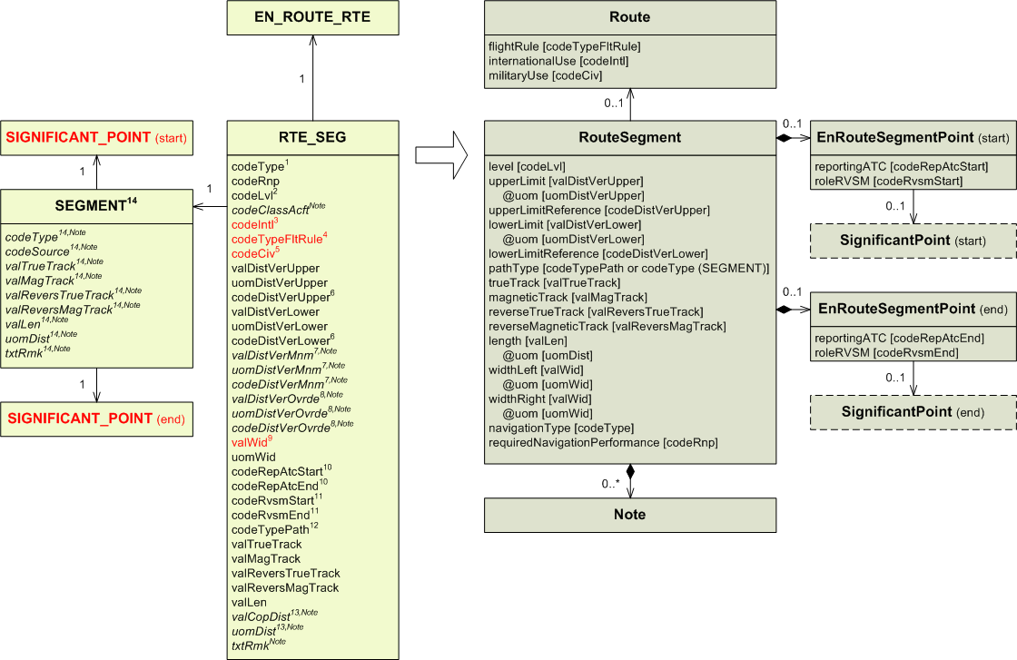
1) Conversion rules for codeType:

codeType | navigationType
CONV  RNAV  DCTATS  TRUNK  POLAR  SSN  TACAN  ADV  OTHER | CONV  RNAV  OTHER:DCTATS  OTHER:TRUNK  OTHER:POLAR  OTHER:SUPERSONIC  TACAN  OTHER:ADVISORY  OTHER

2) Conversion rules for codeLvl:

codeLvl | level
U  L  B | UPPER  LOWER  BOTH

3) Since the “internationalUse” attribute belongs to Route, there can no longer be a different value for each route segment. If there were route segments belonging to the same route with different codeIntl values, the “internationalUse” attribute in Route shall be populated with the value “OTHER:MIXED”. In this case, the original value of the “codeLvl” attribute shall be saved in a Note of RouteSegment.

Conversion rules for codeIntl:

codeIntl | internationalUse
I (all RTE_SEG)  D (all RTE_SEG)  OTHER  Mixed I, D or not specified for some RTE_SEG | INTL  DOM  OTHER  OTHER:MIXED

4) Since the “flightRule” attribute belongs to Route, there can no longer be a different value for each route segment. If there were route segments belonging to the same route with different codeTypeFltRule values, the “flightRule” attribute in Route shall be populated with the value “OTHER:MIXED”. In this case, the original value of the “codeTypeFlightRule” attribute shall be saved in a Note of RouteSegment.

Conversion rules for codeTypeFltRule:

codeTypeFltRule | flightRule
I (all RTE_SEG)  V (all RTE_SEG)  IV (all RTE_SEG)  Mixed I, V, IV or not specified for some RTE_SEG | IFR  VFR  ALL  OTHER:MIXED

5) Since the “militaryUse” attribute belongs to Route, there can no longer be a different value for each route segment. If there were route segments belonging to the same route with different codeCiv values, the “militaryUse” attribute in Route shall be populated with the value “OTHER:MIXED”. In this case, the original value of the “codeCiv” attribute shall be saved in a Note of RouteSegment.

codeCiv | militaryUse
C (all RTE_SEG)  M (all RTE_SEG)  B (all RTE_SEG)  OTHER  Mixed C, M B or not specified for some RTE_SEG | CIVIL  MIL  ALL  OTHER  OTHER:MIXED

6) Conversion rules for codeDistVerXxx

codeDistVerXxx | xxxLimitReference
HEI  ALT  W84  QFE*  QNH*  STD  OTHER | SFC  MSL  W84  SFC  MSL  STD  OTHER

* These values were not supposed to be used with this entity. It is likely this is a mistake.

7) These three values should be mapped into the same Note, with value, unit and code in this order and separated by a space. Note: In principle, these values could be mapped to minimumEnrouteAltitude in AIXM 5.1. However, the AIXM 4.5 definition of the valDistVerMnm does not guarantee that the values recorded correspond exactly to the minimum en-route altitude. As a wrong minimum en-route altitude value can have safety implications, automatic conversion is not recommended for this property.

8) These three values should be mapped into the same Note as above, with value, unit and code in this order and separated by a space.

9) The “widthLeft” and “widthRight” attributes should both be filled with half of the value of the “valWid” attribute.

10) Conversion rules for codeRefAtcXxx:

codeRefAtcXxx | reportingATC
C  R  N  OTHER | COMPULSORY  ON_REQUEST  NO_REPORT  OTHER

11) Conversion rules for codeRvsmXxx:

codeRvsmXxx | roleRVSM
IN  OUT  INOUT  OTHER | IN  OUT  IN_OUT  OTHER

12) The “codeTypePath” attribute is directly mappable into the “pathType” attribute, however the value RHL should not have been used in AIXM 4.5. It is strongly recommended to convert it to GRC or GDS.

13) These two values should be mapped into the same Note and separated by a space. Note: In principle, it could be mapped to the ChangeOverPoint feature in AIXM 5.1 (an ad-hoc RoutePortion object is created, equal to the RTE_SEG from AIXM 4.5). However, for most AIXM 4.5 data sources it is not worth the effort as COP values tend to disappear from AIP data.

14) According to the AIXM 4.5 model, every RTE_SEG must be associated to a SEGMENT. However, all attributes from SEGMENT except “codeSource” also exist in RTE_SEG. This makes the associations of SEGMENT to SIGNIFICANT_POINT the only real usage of that class. It is likely that most implementations did not include SEGMENT and its duplicated attributes, and instead directly associated RTE_SEG to SIGNIFICANT_POINT. That is what the XSD/XML implementation of AIXM 4.5 did. So in most cases, the SEGMENT entity may be ignored.
In cases where the SEGMENT entity was implemented, the duplicated attributes may be used to populate the attributes of RouteSegment only if the corresponding attributes of RTE_SEG were left empty. The “codeSource” and “txtRmk” attributes have no equivalent in AIXM 5.1 and shall be saved in a Note anyway. If the attributes of RTE_SEG and SEGMENT where populated with different values, RouteSegment shall be populated with the values from RTE_SEG and the values from SEGMENT saved in a Note. In such a case, data consistency should be checked.

RTE_SEG_USE

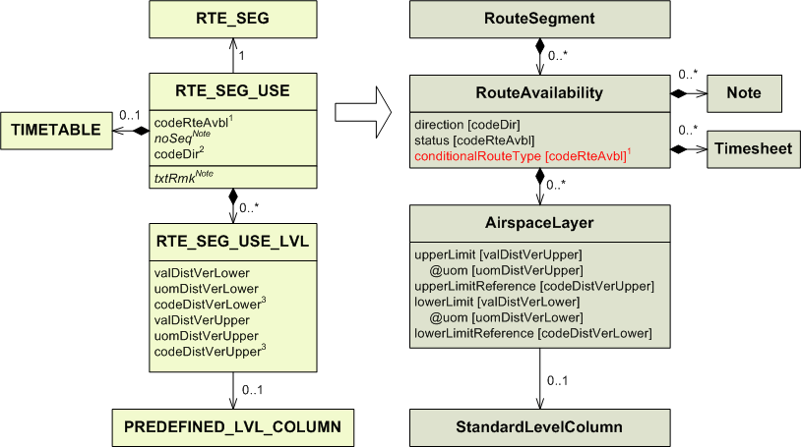
1) Conversion rules for codeRteAvbl:

codeRteAvbl | status | conditionalRouteType*
NONFUA  CDR1*  CDR2*  CDR3*  SPEC  CLSD | OPEN  COND  COND  COND  COND  CLSD | CDR_1  CDR_2  CDR_3

* The “conditionalRouteType” attribute is only available through EUROCONTROL’s eASM (www.aixm.aero/schema/5.1/extensions/EUR/eASM) or ADR-18 (http://www.aixm.aero/schema/5.1/extensions/EUR/ADR-18) extensions. If the extension is not available, then the value shall be saved into a Note.

2) Conversion rules for codeDir:

codeDir | direction
F  B | FORWARD  BACKWARD

3) Conversion rules for codeDistVerXxx

codeDistVerXxx | xxxLimitReference
HEI  ALT  W84  QFE*  QNH*  STD  OTHER | SFC  MSL  W84  SFC  MSL  STD  OTHER

* These values were not supposed to be used with this entity. It is likely this is a mistake.

RTE_SEG_USE_LVL

See the RTE_SEG_USE section.

RWY

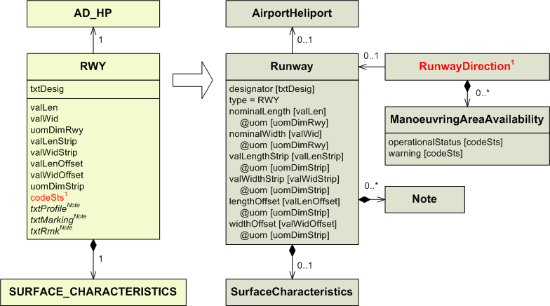
1) ManoeuvringAreaAvailability is associated to RunwayDirection. To map the “codeSts” attribute from RWY, a ManoeuvringAreaAvailability shall be created for every RunwayDirection associated to the Runway into which RWY has been mapped.
However, these RunwayDirection will only be created after mapping the corresponding RWY_DIRECTION, which in turn can only be mapped after RWY. That is why the “codeSts” attribute from RWY cannot be mapped at the same time as the other attributes of RWY. It has to be mapped after the RWY_DIRECTION have been mapped.

Conversion rules for codeSts:

codeSts | operationalStatus | warning
WIP  PARKED  CLSD  FAILAID  SPOWER  OTHER | CLOSED  OTHER | WIP  PARKED_ACFT  OTHER:FAILAID  OTHER:SECONDARY_POWER

RWY_CLINE_POINT

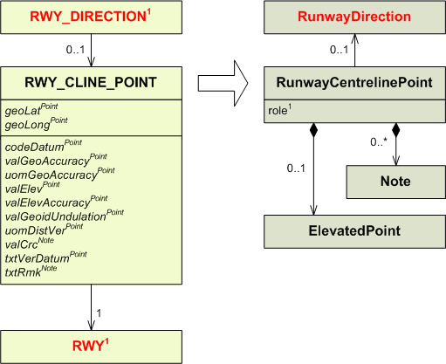

1) If RWY_CLINE_POINT is associated to a RWY_DIRECTION, it means it is the threshold for that direction. In this case the “role” attribute is populated with the value THR (or DISTHR if there exists a RWY_DIRECTION_DECL_DIST of type=DPLM and a value higher than 0 for that RWY_DIRECTION, i.e. the threshold is displaced).
If RWY_CLINE_POINT is only associated to a RWY, the “role” attribute remains empty, and RunwayCentrelinePoint should be duplicated in the output and associated to each RunwayDirection associated to the Runway into which RWY has been mapped.

RWY_DIRECTION

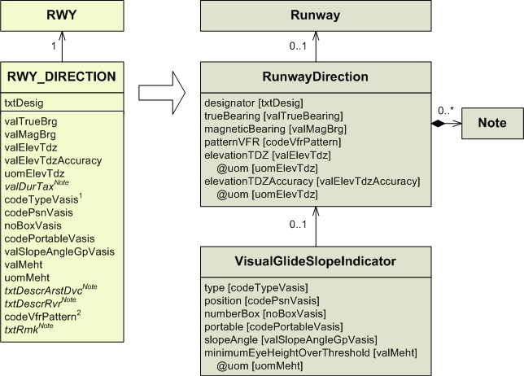
1) Conversion rules for codeTypeVasis:

codeTypeVasis | type
PAPI  APAPI  HAPI  VASIS  AVASIS  TVASIS  ATVASIS  3B-VASIS  3B-AVASIS  3B-ATVASIS  PVASI  TRCV  PNI  ILU  OLS  LCVASI  OTHER | PAPI  APAPI  HAPI  VASIS  AVASIS  TVASIS  ATVASIS  3B_VASIS  3B_AVASIS  3B_ATVASIS  PVASI  TRCV  PNI  ILU  OLS  LCVASI  OTHER

2) Conversion rules for codeVfrPattern:

codeVfrPattern | patternVFR
L  R  E | LEFT  RIGHT  EITHER

RWY_DIRECTION_ALS

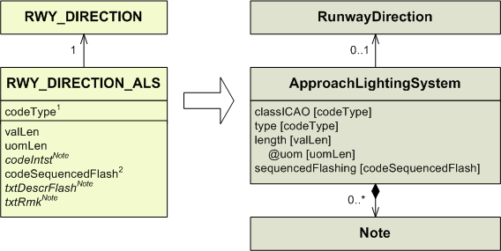

1) Conversion rules for codeType:

codeType | classICAO | type
A  B  C  D  E  F  G  ALSAF  MALS  MALSR  SALS  SSALS  SSALR  LDIN  ODALS  AFOVRN  MILOVRN  OTHER | CAT1  CAT23  CAT23  CAT23  SIMPLE  CIRCLING  OTHER:VISUAL | ALSAF  MALS  MALSR  SALS  SSALS  SSALR  LDIN  ODALS  AFOVRN  MILOVRN  OTHER

2) Conversion rules for codeSequencedFlash:

codeSequencedFlash | sequencedFlashing
Y  N | YES  NO

RWY_DIRECTION_DECL_DIST

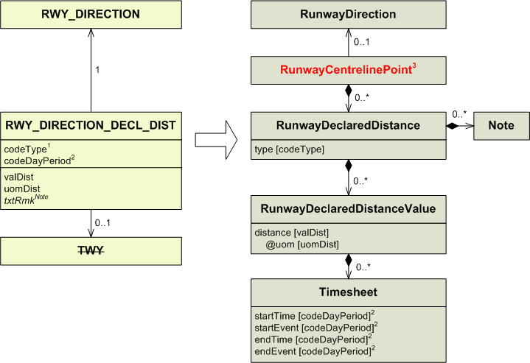
1) Conversion rules for codeType:

codeType | type
LDA  TORA  TODA  ASDA  DPLM  OTHER | LDA  TORA  TODA  ASDA  DTHR  OTHER

2) Conversion rules for codeDayPeriod:

codeDayPeriod | startTime | startEvent | endTime | endEvent
D  N  A  OTHER | 00:00  Due to the AIXM 4.5 limitation, probably the schedule was encoded as txtRmk, therefore it will appear as a Note in AIXM 5.1. For automatic conversion, a Note with propertyName=timeInterval and value “Other schedule” shall be encoded. | SR  SS | 24:00 | SS  SR

3) RunwayDeclaredDistance has to be associated to a RunwayCentrelinePoint. It should be the centreline point from which the distance is starting.
It may have been already created while mapping existing RWY_CLINE_POINT. For this reason, it is strongly advised to map all RWY_CLINE_POINTs before any RWY_DIRECTION_DECL_DISTANCE.
See the RWY_CLINE_POINT section for more details.

RWY_DIRECTION_LGT_SYS

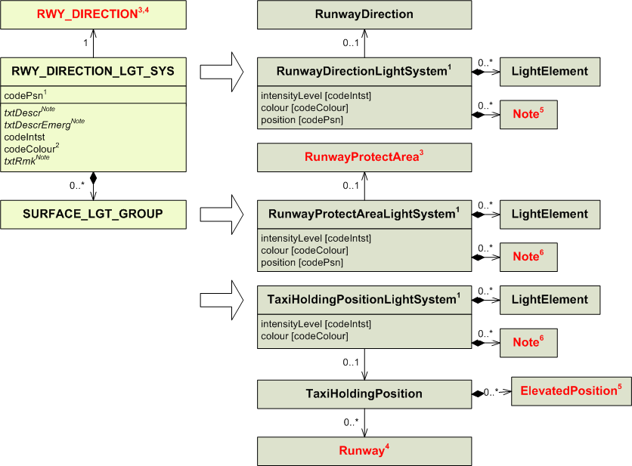
1) Conversion rules for codePsn:

codePsn | Entity to use | position
TDZ  AIM  CL  EDGE  THR  SWYEDGE  DESIG  AFTTHR  DISPTHR  SWYCL  END  SWYEND  TWYINT  HOLDBAY  RTWYINT  OTHER | RunwayDirectionLightSystem  RunwayDirectionLightSystem  RunwayDirectionLightSystem  RunwayDirectionLightSystem  RunwayDirectionLightSystem  RunwayProtectAreaLightSystem  RunwayDirectionLightSystem  RunwayDirectionLightSystem  RunwayDirectionLightSystem  RunwayProtectAreaLightSystem  RunwayDirectionLightSystem  RunwayProtectAreaLightSystem  RunwayDirectionLightSystem  TaxiHoldingPositionLightSystem  RunwayDirectionLightSystem  RunwayDirectionLightSystem | TDZ  AIM  CL  EDGE  THR  EDGE  DESIG  AFT_THR  DTHR  CL  END  END  TWY_INT  RPD_TWY_INT  OTHER

2) Conversion rules for codeColour:

codeColour | colour
YEL  RED  WHI  BLU  GRN  PRP  OTHER | YELLOW  RED  WHITE  BLUE  GREEN  PURPLE  OTHER

3) RunwayProtectAreaLightSystem mapped from RWY_DIRECT_LGT_SYS is associated to a RunwayProtectArea.
This RunwayProtectArea may have been already created while mapping RWY_PROTECT_AREA. For this reason, it is strongly advised to map all RWY_PROTECT_AREA before any RWY_DIRECTION_LGT_SYS.
See the RWY_PROTECT_AREA section for more details.

4) TaxiHoldingPositionLightSystem mapped from RWY_DIRECTION_LGT_SYS are associated to a Runway (through a TaxiHoldingPosition). See the RWY section for more details.

5) A TaxiHoldingPosition must have an ElevatedPosition. If the TaxiHoldingPosition was mapped from a TWY_HOLDING_POSITION, it should already have a position. Otherwise, the barycentre of all the SURFACE_LIGHT_GROUP associated to the TWY_LGT_SYS may be used.

6) Note may be populated with information from SURFACE_LGT_GROUP. See the SURFACE_LGT_GROUP section for more details.

RWY_DIRECTION_OBSTACLE

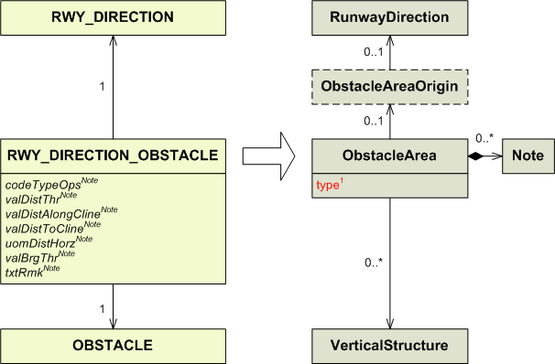

1) By default, each RWY_DIRECTION_OBSTACLE from AIXM 4.5 shall be considered an AREA2 obstacle in AIXM 5.1. Therefore, the corresponding VerticalStructure in AIXM 5.1 shall be associated with the ObstacleArea type-AREA2 associated with the corresponding AirprotHeliport.

RWY_DIRECTION_STAR

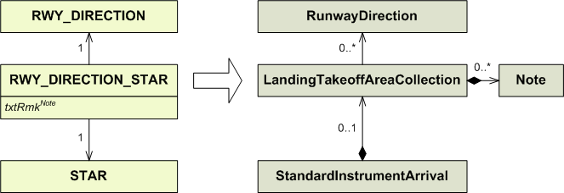

RWY_PROTECT_AREA

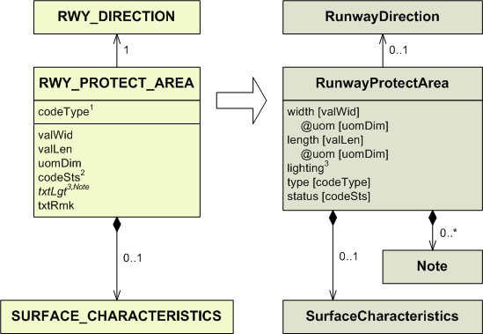

1) Conversion rules for codeType:

codeType | type
CWY  SAFE  OFZ  OFS  ILS  OTHER | CWY  RESA  OFZ  OFZ  ILS  OTHER

2) Conversion rules for codeSts:

codeSts | status
WIP  PARKED  CLSD  FAILAID  SPOWER | WORK_IN_PROGRESS  DOWNGRADED  UNSERVICEABLE  DOWNGRADED  DOWNGRADED
OTHER | OTHER

3) The ”lighting” attribute in “RunwayProtectArea” may be set to YES or NO according to the content of the “txtLgt” attribute. However, this is not recommended for automatic conversion, in which case only a Note with propertyName=lighting and purpose=REMARK shall be created.

SEGMENT

See the RTE_SEG section for more details.

SERVICE

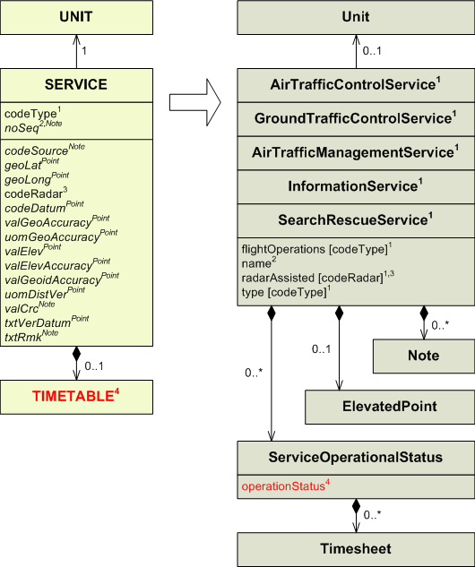

1) Conversion rules for codeType:

codeType | Entity to use | type | flightOperations
ACS  ADS  ADVS  AFIS  AFS  AIS  ALRS  AMS  AMSS  APP  APP-ARR  APP-DEP  ARTCC  ATC  ATFM  ATIS  ATIS-ARR  ATIS-DEP  ATM  ATS  BOF  BS*  COM  CTAF  DVDF  EFAS  FCST  FIS  FISA  FSS  GCA  OAC  NOF  MET  PAR  RAC  RADAR  RAF  RCC  SAR  SIGMET  SMC  SMR  SRA  SSR  TAR  TWEB  TWR  UAC  UDF  VDF  VOLMET  VOT  OVERFLT  ENTRY  EXIT  INFO  OTHER | AirTrafficControlService  AirTrafficControlService*  AirTrafficControlService  InformationService  InformationService*  InformationService  SearchRescueService  InformationService*  InformationService*  AirTrafficControlService  AirTrafficControlService  AirTrafficControlService  AirTrafficControlService  AirTrafficControlService  AirTrafficManagementService  InformationService  InformationService  InformationService  AirTrafficManagementService  AirTrafficControlService*  InformationService  InformationService  InformationService*  AirTrafficControlService  InformationService*  AirTrafficControlService  InformationService*  InformationService  InformationService  InformationService*  AirTrafficControlService  InformationService  InformationService*  InformationService  InformationService  InformationService  InformationService  InformationService  SearchRescueService  SearchRescueService  InformationService  GroundTrafficControlService  InformationService  InformationService  InformationService  InformationService  InformationService  GroundTrafficControlService  AirTrafficControlService  InformationService  InformationService  InformationService  InformationService  AirTrafficManagementService  AirTrafficManagementService  AirTrafficManagementService  InformationService  InformationService (as the most neutral choice available) shall be used for automatic conversions. Manual analysis of the data might enable a better mapping, the use of OTHER was very likely due to the AIXM 4.5 limitations. | ACS  OTHER:ADS  ADVS  AFIS  OTHER:AFS  AIS  ALRS  OTHER:AMS  OTHER:AMSS  APP  APP  APP  OTHER:ARTCC  ATFM  ATIS  ATIS  ATIS  OTHER:ATS  BRIEFING  OTHER:  COMMERCIAL_  BROADCAST  OTHER:COM  CTAF  OTHER:DVDF  EFAS  OTHER:FCST  FIS  FIS  OTHER:FSS  OTHER:GCA  OACS  NOTAM*  OTHER:MET  OTHER:PAR  OTHER:RAC  OTHER:RADAR  RAF  RCC  SAR  SIGMET  SMGCS  OTHER:SMR  OTHER:SRA  OTHER:SSR  OTHER:TAR  TWEB  TWR  UAC  OTHER:UDF  OTHER:VDF  VOLMET  OTHER:VOT  CLEARANCE  CLEARANCE  CLEARANCE  INFO  OTHER | ARR  DEP  ARR  DEP  OVERFLY

* These conversions do not match completely the original types.

2) The “noSeq” attribute from SERVICE should be mapped in a Note, except if there are several Service of the same type associated to the same Unit. In such a case, it may be mapped into the “name” attribute of any Service to help differentiate them.

3) The “radarAssisted” attribute is only available for AirTrafficControlService and GroundTrafficControlService.

Conversion rules for codeRadar:

codeRadar | radarAssisted
Y  N | YES  NO

4) Conversion rules for TIMETABLE:

codeWorkHr in TIMETABLE | Attached TIMESHEET | operationalStatus | Additional mapping required. See the TIMETABLE section for more details.
H24 | No | NORMAL | No
Any other case |  | LIMITED | Yes

SERVICE_AT_AD_HP

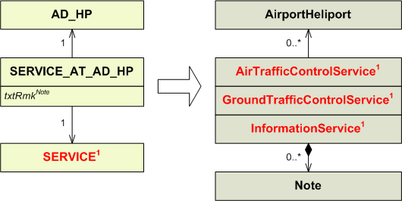

1) SERVICE may be mapped, according to its codeType, into either an AirTrafficControlService, a GroundTrafficControlService, an AirTrafficManagementService, an InformationService or a SearchRescueService. However, only AirTrafficControlService, GroundTrafficControlService and InformationService can be associated to AirportHeliport.
SERVICE_AT_AD_HP associated to a SERVICE that should be mapped into an AirTrafficManagementService or a SearchRescueService cannot be mapped. See the SERVICE section for more details.

SERVICE_IN_AIRSPACE

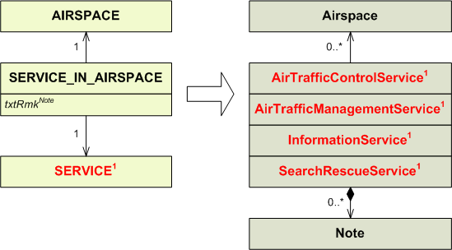

1) SERVICE may be mapped, according to its codeType, into either an AirTrafficControlService, a GroundTrafficControlService, an AirTrafficManagementService, an InformationService or a SearchRescueService. However, only AirTrafficControlService, AirTrafficManagementService, InformationService and SearchRescueService can be associated to Airspace.
SERVICE_IN_AIRSPACE associated to a SERVICE that should be mapped into an GroundTrafficControlService cannot be mapped. See the SERVICE section for more details.

SERVICE_ON_HOLDING_PROC

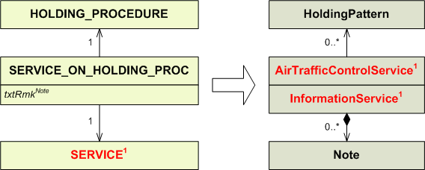

1) SERVICE should only be of codeType = ADVS, ALRS, ATC, ATFM, ATS, CTAF, DVDF, EFAS, FIS, FISA, RADAR, UDF or VDF. SERVICE with codeType = ATFM has to be mapped into an AirTrafficManagementService, and SERVICE with codeType = ALRS has to be mapped into a SearchRescueService. However, only AirTrafficControlService and InformationService can be associated to HoldingPattern.
SERVICE_IN_HOLDING_PROC associated to a SERVICE with codeType = ATFM or ALRS cannot be mapped. See the SERVICE section for more details.

SERVICE_ON_IAP

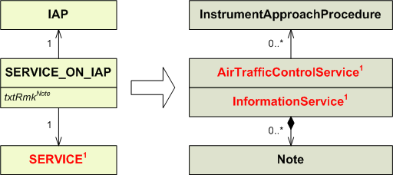

1) SERVICE should only be of codeType = ADVS, ALRS, ATC, ATFM, ATS, CTAF, DVDF, EFAS, FIS, FISA, RADAR, UDF or VDF. SERVICE with codeType = ATFM has to be mapped into an AirTrafficManagementService, and SERVICE with codeType = ALRS has to be mapped into a SearchRescueService. However, only AirTrafficControlService and InformationService can be associated to InstrumentApproachProcedure.
SERVICE_ON_IAP associated to a SERVICE with codeType = ATFM or ALRS cannot be mapped. See the SERVICE section for more details.

SERVICE_ON_RTE_SEG

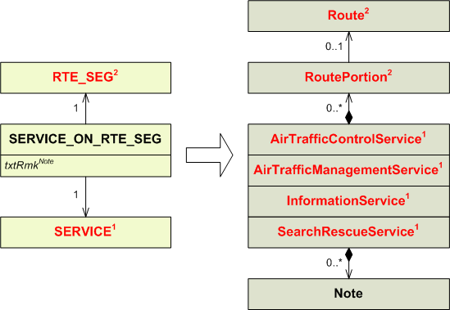

1) SERVICE may be mapped, according to its codeType, into either an AirTrafficControlService, a GroundTrafficControlService, an AirTrafficManagementService, an InformationService or a SearchRescueService. However, only AirTrafficControlService, AirTrafficManagementService, InformationService and SearchRescueService can be associated to a Route through RoutePortion.
SERVICE_ON_RTE_SEG associated to a SERVICE that should be mapped into an GroundTrafficControlService cannot be mapped. See the SERVICE section for more details.

2) Services are now associated to a route (through a RoutePortion) instead of a segment of the route.

SERVICE_ON_SID

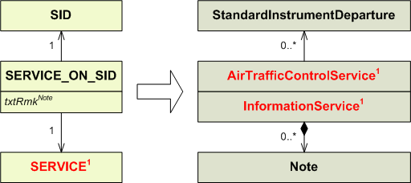

1) SERVICE should only be of codeType = ADVS, ALRS, ATC, ATFM, ATS, CTAF, DVDF, EFAS, FIS, FISA, RADAR, UDF or VDF. SERVICE with codeType = ATFM has to be mapped into an AirTrafficManagementService, and SERVICE with codeType = ALRS has to be mapped into a SearchRescueService. However, only AirTrafficControlService and InformationService can be associated to StandardInstrumentDeparture.
SERVICE_IN_HOLDING_PROC associated to a SERVICE with codeType = ATFM or ALRS cannot be mapped. See the SERVICE section for more details.

SERVICE_ON_STAR

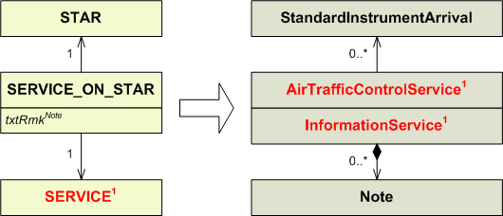

1) SERVICE should only be of codeType = ADVS, ALRS, ATC, ATFM, ATS, CTAF, DVDF, EFAS, FIS, FISA, RADAR, UDF or VDF. SERVICE with codeType = ATFM has to be mapped into an AirTrafficManagementService, and SERVICE with codeType = ALRS has to be mapped into a SearchRescueService. However, only AirTrafficControlService and InformationService can be associated to StandardInstrumentArrival.
SERVICE_IN_HOLDING_PROC associated to a SERVICE with codeType = ATFM or ALRS cannot be mapped. See the SERVICE section for more details.

SID
IMPORTANT NOTE: the model for instrument approach procedures, SID and STAR in AIXM 4.5 was relatively simplistic and oriented towards providing data for procedure charting. Therefore, automatic conversion of AIXM 4.5 PROCEDURE_LEG, SID, STAR, IAP and HOLDING entities results in only partial Procedure data in AIXM 5.1. The resulting Procedure data shall be further checked and completed with data from the official sources (AIP), which was not possible to be encoded in AIXM 4.5.

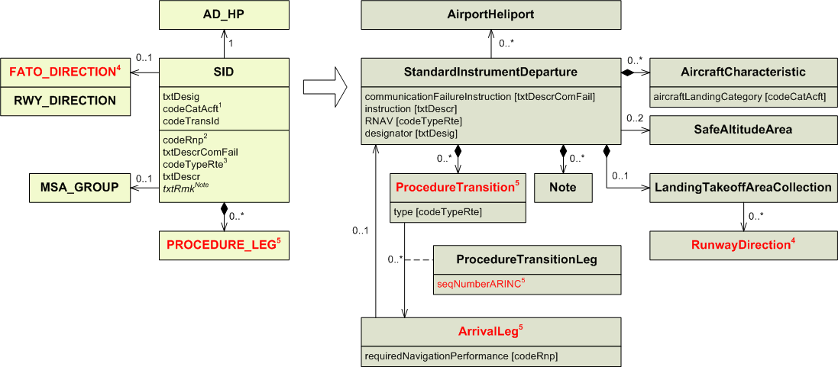
1) Conversion rules for codeCatAcft:

codeCatAcft | aircraftLandingCategory
A  A20  A30  B  A35  C  D  E  AB  CD  CDE  BCD  ABCD  DE  ABC  H  OTHER | A  OTHER:A20  OTHER:A30  B  OTHER:A35  C  D  E  A, B in 2 different AircraftCharacteristic*  C, D in 2 different AircraftCharacteristic*  C, D, E in 3 different AircraftCharacteristic*  B, C, D in 3 different AircraftCharacteristic*  A, B, C ,D in 4 different AircraftCharacteristic*  D, E in 2 different AircraftCharacteristic*  A, B, C in 3 different AircraftCharacteristic*  H  OTHER

* For codeCatAcft values such as AB, several AircraftCharacteristic entities (one for each letter) will have to be created and associated to the StandardInstrumentDeparture.

2) In AIXM 5.1 it is now possible for each procedure leg to have its own required navigation performance. The “codeRnp” attribute shall then be mapped into every procedure leg associated to the procedure.

3) Conversion rules for codeTypeRte:

codeTypeRte | RNAV | type
O  C  R  F  OTHER | NO  NO  YES | ENGINE_OUT

4) FATO_DIRECTION is mapped into a RunwayDirection. See the FATO_DIRECTION section for more details.

5) When mapping from AIXM 4.5, one ProcedureTransition should be created for each group of associated PROCEDURE_LEG having the same codePhase value. Every procedure leg also has to be directly associated to the standard instrument departure.
PROCEDURE_LEG associated to the SID may only be mapped into DepartureLeg.
When mapping a PROCEDURE_LEG, the “seqNumberARINC” attribute belonging to the association class ProcedureTransitionLeg should be populated. It is assumed that the position of the PROCEDURE_LEG within all the legs associated to the procedure is its actual position within the branch. The “seqNumberARINC” attribute should be populated with this position.

SID_USAGE

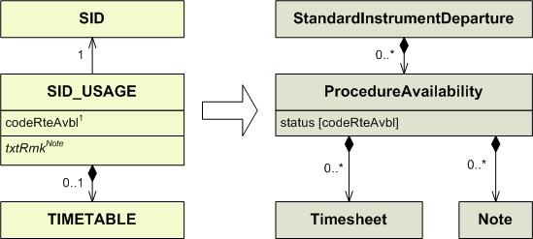

1) Conversion rules for codeRteAvbl:

codeRteAvbl | status
NONFUA  CDR1  CDR2  CDR3  SPEC  CLSD | USABLE  OTHER:CDR1  OTHER:CDR2  OTHER:CDR3  OTHER:SPEC  UNUSABLE

SIGNIFICANT_POINT
Note that SignificantPoint does not appear as an element in either AIXM 4.5 or in AIXM 5.1 XML Schema. However, because of its key role in the associations between various features (routes, procedures, etc,) and navaids/designated points, it’s mapping is detailed here.

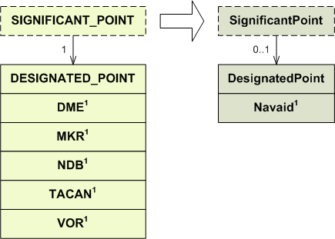

- The following mapping procedure shall be used (depending on what type of Navaid was created from the corresponding AIXM 4.5 navaid.
AIXM 4.5 navaid that is used as SIGNIFICANT_POINT | AIXM 5.1 Navaid (look-up procedure)
DME  Note: a DME is probably never used as significant point. Such an association is probably an encoding error. | VOR_DME or DME  (see DME mapping, rule 2)
MKR | NDB_MKR or MKR  (see MKR mapping, rule 2)
NDB | NDB_MKR or NDB  (see NDB mapping, rule 2)
TACAN | VORTAC or TACAN  (see TACAN mapping, rule 1)
VOR | VOR_DME, VORTAC or VOR  (see VOR mapping, rule 4)

SIGNIFICANT_POINT_IN_AS

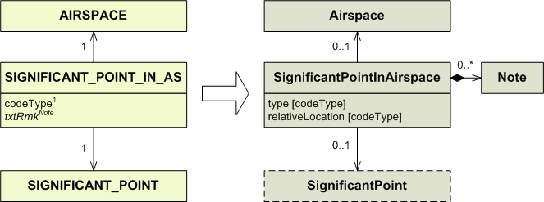

1) Conversion rules for codeType:

codeType | type | relativeLocation
EN  EX  EE  IN  B  OTHER | ENTRY  EXIT  ENTRY_EXIT  OTHER | IN  BORDER

SPECIAL_DATE

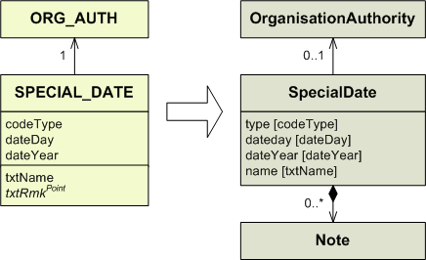

1) Conversion rules for codeType:

codeType | type
HOL  BFRI  OTHER | HOL  BUSY_FRI  OTHER

SPEC_NAV_STATION

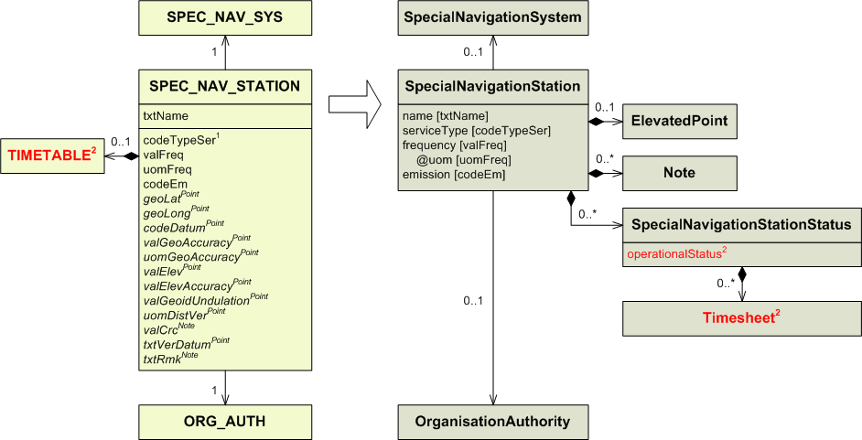

1) Conversion rules for codeTypeSer:

codeTypeSer | serviceType
M  S  RS  GS  PS  OTHER | MASTER  SLAVE  RED_SLAVE  GREEN_SLAVE  PURPLE_SLAVE  OTHER

2) Conversion rules for TIMETABLE:

codeWorkHr in TIMETABLE | Attached TIMESHEET | operationalStatus | Additional mapping required. See the TIMETABLE section for more details.
H24  NOTAM | No  Yes/No | OPERATIONAL  CONDITIONAL | No  No
Any other case |  |  | Yes

SPEC_NAV_SYS

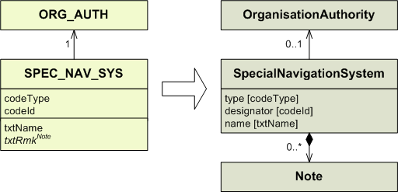

STAR
IMPORTANT NOTE: the model for instrument approach procedures, SID and STAR in AIXM 4.5 was relatively simplistic and oriented towards providing data for procedure charting. Therefore, automatic conversion of AIXM 4.5 PROCEDURE_LEG, SID, STAR, IAP and HOLDING entities results in only partial Procedure data in AIXM 5.1. The resulting Procedure data shall be further checked and completed with data from the official sources (AIP), which was not possible to be encoded in AIXM 4.5.

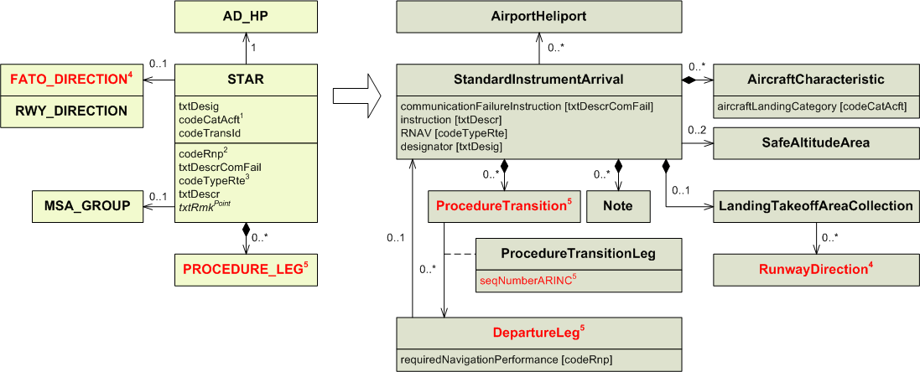
1) Conversion rules for codeCatAcft:

codeCatAcft | aircraftLandingCategory
A  A20  A30  B  A35  C  D  E  AB  CD  CDE  BCD  ABCD  DE  ABC  H  OTHER | A  OTHER:A20  OTHER:A30  B  OTHER:A35  C  D  E  A, B in 2 different AircraftCharacteristic*  C, D in 2 different AircraftCharacteristic*  C, D, E in 3 different AircraftCharacteristic*  B, C, D in 3 different AircraftCharacteristic*  A, B, C ,D in 4 different AircraftCharacteristic*  D, E in 2 different AircraftCharacteristic*  A, B, C in 3 different AircraftCharacteristic*  H  OTHER

* For codeCatAcft values such as AB, several AircraftCharacteristic entities (one for each letter) will have to be created and associated to the StandardInstrumentArrival.

2) In AIXM 5.1 it is now possible for each procedure leg to have its own required navigation performance. the “codeRnp” attribute shall then be mapped into every procedure leg associated to the procedure.

3) Conversion rules for codeTypeRte:

codeTypeRte | RNAV
O  C  R  F  OTHER | NO  NO  YES

4) The association is no longer from the procedure to the MSA_GROUP. Instead it is from SafeAltitudeArea to the procedure.

5) When mapping from AIXM 4.5, one ProcedureTransition should be created for each group of associated PROCEDURE_LEG having the same codePhase value. Every procedure leg also has to be directly associated to the standard instrument arrival.
PROCEDURE_LEG associated to the STAR may only be mapped into ArrivalLeg.
When mapping a PROCEDURE_LEG, the “seqNumberARINC” attribute belonging to the association class ProcedureTransitionLeg should be populated. It is assumed that the position of the PROCEDURE_LEG within all the legs associated to the procedure is its actual position within the branch. The “seqNumberARINC” attribute should be populated with this position.

STAR_USAGE

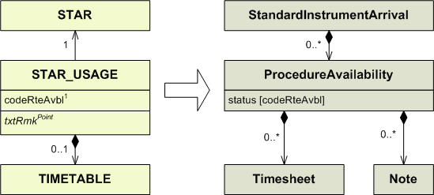

1) Conversion rules for codeRteAvbl:

codeRteAvbl | status
NONFUA  CDR1  CDR2  CDR3  SPEC  CLSD | USABLE  OTHER:CDR1  OTHER:CDR2  OTHER:CDR3  OTHER:SPEC  UNUSABLE

SURFACE_CHARACTERISTICS

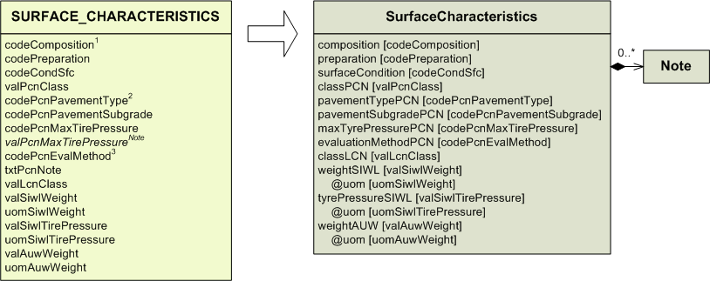
1) Conversion rules for codeComposition:

codeComposition | composition
ASPH  ASP+GRS  BITUM  BRICK  CLAY  CONC  CONC+ASPH  CONC+GRS  CORAL  GRADE  GRASS  GRAVE  ICE  LATERITE  MACADAM  MATS  MEMBRANE  METAL  PSP  SAND  SNOW  STONE  WATER  WOOD  OTHER | ASPH  ASPH_GRASS  BITUM  BRICK  CLAY  CONC  CONC_ASPH  CONC_GRS  CORAL  EARTH  GRASS  GRAVEL  ICE  LATERITE  MACADAM  MATS  MEMBRANE  METAL  PIERCED_STEEL  SAND  SNOW  STONE  WATER  WOOD  OTHER

2) Conversion rules for codePcnPavementType:

codePcnPavementType | pavementTypePCN
R  F | RIGID  FLEXIBLE

3) Conversion rules for codePcnEvalMethod :

codePcnEvalMethod | evaluationMethodPCN
T  U | TECH  ACFT

SURFACE_LGT_GROUP

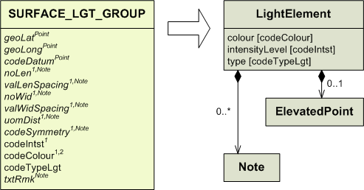

1) These values should be concatenated into the information that is found in an AIP. The exact format depends on the entity the SURFACE_LGT_SYS is associated to, and the “codePsn” attribute of this same entity.
As an example, if the SURFACE_LGT_GROUP is associated to a RWY_DIRECTION_LGT_SYS with codePsn = CL, the corresponding information may be found in AD 2.14, 6th column with the format [Length], [spacing], [colour], [INTST].
The actual information may look like this:
2800 M, 7.5 M, White, LIH; (as there is no attribute for the length, it must be obtained with (noLen – 1) * valLenSpacing)
FM 1900 M – 2500M, Red/White;
FM 2500 M, Red

In this case the “noWid”, “valWidSpacing” and “codeSymmetry” attributes are not used. It really depends on the entity the SURFACE_LGT_GROUP is associated to, and on its “codePsn” attribute.

Once the concatenation is realised, it should not be mapped into a Note belonging to LightElement. Instead it should be mapped in a Note of the entity into which the entity SURFACE_LGT_GROUP depends on has been mapped into. This may be either ApronLightSystem, RunwayDirectionLightSystem, RunwayProtectAreaLightSystem, TaxiHoldingPositionLightSystem, TaxiwayLightSystem or TouchDownLiftOffLightSystem. See the APRON_LGT_SYS, FATO_DIRECTION_LGT_SYS, RWY_DIRECTION_LGT_SYS, TLOF_LGT_SYS or TWY_LGT_SYS. section for more details.

2) Conversion rules for codeColour:

codeColour | colour
YEL  RED  WHI  BLU  GRN  PRP  OTHER | YELLOW  RED  WHITE  BLUE  GREEN  PURPLE  OTHER

SWY

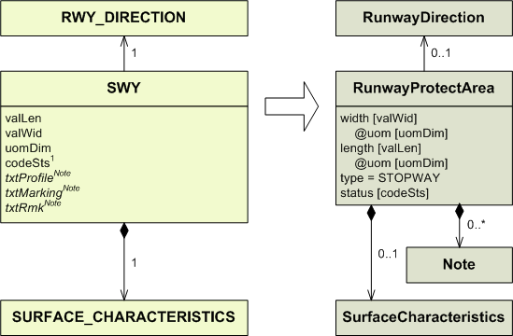

1) Conversion rules for codeSts:

codeSts | status
WIP  PARKED  CLSD  FAILAID  SPOWER | WORK_IN_PROGRESS  DOWNGRADED  UNSERVICEABLE  DOWNGRADED  DOWNGRADED
OTHER | OTHER

TACAN

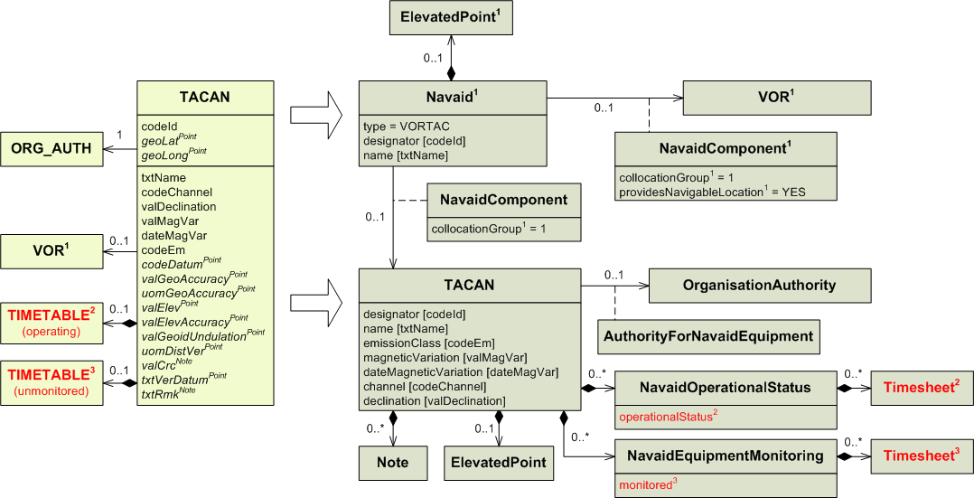
1) A Navaid has to be created in addition to the TACAN (NavaidEquipment) as follows:
AIXM 4.5 | AIXM 5.1 Navaid
TACAN is collocated with standalone VOR (that VOR is not collocated with a DME) | type= VORTAC  designator – use VOR.codeId  name – use VOR.txtName  ElevatedPoint – use geoLat, geoLong, codeDatum of the VOR  providesNavigableLocation = YES on the NavaidComponent that is associated with the VOR  collocationGroup=1 for both associations, between Navaid and TACAN/VOR  Note: this mapping is done with a focus on civil aviation, where routes are defined by VOR, even if a TACAN is present at the same location. Civil aircraft can typically use the distance indication part of the TACAN, in case there is no DME available.
TACAN is standalone or collocated with a VOR/DME | type= TACAN  designator – use TACAN.codeId  name – use TACAN.txtName  ElevatedPoint – use geoLat, geoLong, codeDatum of the TACAN  providesNavigableLocation = YES on the NavaidComponent that is associated with the TACAN  collocationGroup – leave empty

A NavaidOperationalStatus should also be encoded for the resulting Navaid. However, automatic generation is difficult as in some situations the TACAN and VOR might have different operational hours and/or unmonitored hours. Therefore, it is recommended that the NavaidOperationalStatus for the resulting Navaid is left empty.

2) Conversion rules for TIMETABLE (operating):

codeWorkHr in TIMETABLE | Attached TIMESHEET | operationalStatus | Additional mapping required. See the TIMETABLE section for more details.
H24  NOTAM  NOTAM | No  No  Yes | OPERATIONAL  CONDITIONAL  CONDITIONAL | No  No  Yes
Any other case |  |  | Yes

3) Conversion rules for TIMETABLE (unmonitored):

codeWorkHr in TIMETABLE | Attached TIMESHEET | monitored | Additional mapping required. See the TIMETABLE section for more details.
H24 | No | NO | No
Any other case |  | YES | Yes

TACAN_USAGE_LIMIT

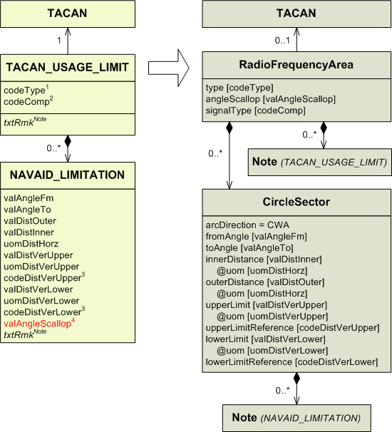

1) Conversion rules for codeType:

codeType | type
CVR  SCL  RHG  UNL  RES  UUS  OUT  TCVR  OTHER | COV  SCL  RHG  UNREL  RES  UUS  OUT  T_COV  OTHER

2) Conversion rules for codeComp:

codeComp | signalType
DIST  AZMT | DISTANCE  AZIMUTH

3) Conversion rules for codeDistVerXxx:

codeDistVerXxx | xxxLimitReference
HEI  ALT  W84  QFE*  QNH*  STD  OTHER | SFC  MSL  W84  SFC  MSL  STD  OTHER

* These values were not supposed to be used with this entity. It is likely this is a mistake.

4) Since the “angleScallop” attribute belongs to RadioFrequencyArea, there can no longer be a different value for each sector. If there were NAVAID_LIMITATION belonging to the same TACAN_USAGE_LIMIT with different valAngleScallop values, one shall be chosen to populate the “angleScallop” attribute in RadioFrequencyArea.

TFC_FLOW_RESTR

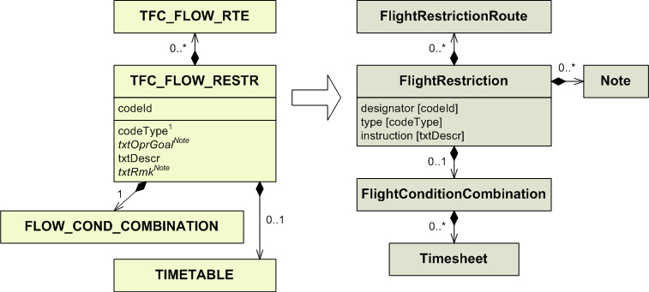

1) Conversion rules for codeType:

codeType | type
F  M  C | FORBID  MANDATORY  CLOSED

TFC_FLOW_RTE

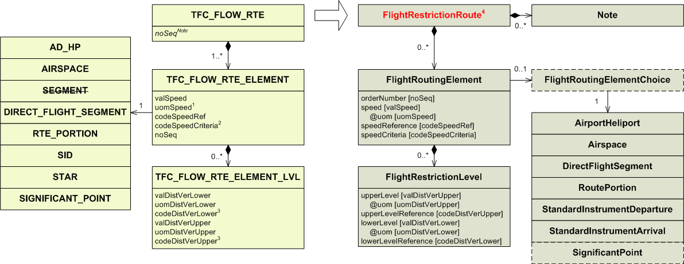

1) Conversion rules for codeSpeedCriteria:

codeSpeedCriteria | speedCriteria
L  LE  E  GE  G | LESS  LESS_OR_EQUAL  EQUAL  GREATER_OR_EQUAL  GREATER

2) Conversion rules for uomSpeed:

uomSpeed | uom
KM/H  KT  MACH  M/MIN  FT/MIN  M/SEC  FT/SEC | KM_H  KT  MACH  M_MIN  FT_MIN  M_SEC  FT_SEC

3) Conversion rules for codeDistVerXxx:

codeDistVerXxx | xxxLimitReference
HEI  ALT  W84  QFE*  QNH*  STD  OTHER | SFC  MSL  W84  SFC  MSL  STD  OTHER

* These values were not supposed to be used with this entity. It is likely this is a mistake.

4) TFC_FLOW_RTE has to be mapped into a FlightRestrictionRoute. This FlightRestrictionRoute is not a <<feature>> but an <<object>> of FlightRestriction. It is the same FlightRestriction into which TFC_FLOW_RESTR was mapped.

TFC_FLOW_RTE_ELEMENT

See the TFC_FLOW_RTE section.

TFC_FLOW_RTE_ELEMENT_LVL

See the TFC_FLOW_RTE section.

TIMESHEET

See the TIMETABLE section.

TIMETABLE

In AIXM 5.1, the TIMETABLE entity no longer exists. Instead Timesheet is directly associated to the abstract class PropertiesWithSchedule, and classes that need timesheets inherit from PropertiesWithSchedule.
4.5 TIMESHEET shall be mapped into 5.1 Timesheet while taking into account the value of the “codeWorkHr” attribute from TIMETABLE. codeWorkHr itself shall be mapped into a Note.
A different mapping may be indicated in other diagrams for TIMETABLE associated to certain entities, with a certain codeWorkHr and without any associated TIMESHEET. Such cases overrule what is described in this section.

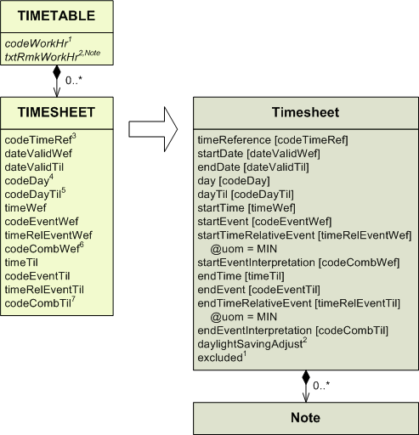

1) Conversion rules for codeWorkHour:

codeWorkHr | excluded
H24 | Meaning: continuous service, 24 hours out of 24, excluding the periods specified in the timesheets.  All timesheets (if any) shall be mapped with excluded = YES. Then an additional timesheet shall be created, with only startTime= 00:00, endTime = 24:00 and excluded = NO.
HJ | Meaning: sunrise to sunset, excluding the periods specified in the timesheets.  All timesheets (if any) shall be mapped with excluded = YES. Then an additional timesheet shall be created, with only startEvent = SR, endEvent = SS and excluded = NO.
HN | Meaning: sunset to sunrise, excluding the periods specified in the timesheets.  All timesheets (if any) shall be mapped with excluded = YES. Then an additional timesheet shall be created, with only startEvent = SS, endEvent = SR and excluded = NO.
HX | Meaning: no specific working hours.  First, a Note shall be created and associated to the class inheriting from PropertiesWithSchedule. The “propertyName” attribute of the Note shall have the value “timeInterval”. The “purpose” attribute shall receive the value “WARNING”. The “note” attribute shall receive the value “HX (no specific working hours)”.  All eventually associated Timesheets shall be mapped with excluded=NO.
HO | Meaning: service available to meet operational requests.  First, a Note shall be created and associated to the class inheriting from PropertiesWithSchedule. The “propertyName” attribute of the Note shall have the value “timeInterval”. The “purpose” attribute shall receive the value “WARNING”. The “note” attribute shall receive the value “HO (service available to meet operational requests)”.  All eventually associated timesheets shall be mapped with excluded = NO.
NOTAM | Meaning: activity periods to be published by NOTAM.  First, a Note shall be created and associated to the class inheriting from PropertiesWithSchedule. The “propertyName” attribute of the Note shall have the value “timeINterval”. The “purpose” attribute shall receive the value “WARNING”. The “note” attribute shall receive the value “activity periods to be published by NOTAM”.  All eventually associated timesheets shall be mapped with excluded = NO.
TIMSH | Meaning: as specified in the related timesheets.  All timesheets shall be mapped with excluded = NO.
OTHER | A Note shall be created within the feature / object property bearing the PropertiesWithSchedule, with propertyName = “timeInterval” and with purpose = "WARNING", with the corresponding LinguisticNote note = “OTHER”

2) The “txtRmkWrkHr” attribute shall be mapped into a Note associated to the entity Timesheet is depending on (this entity is not shown on the diagram). The “propertyName” attribute of the Note shall have the value “timeINterval”. The “purpose” attribute shall receive the value “WARNING”. The “note” attribute shall receive the value of the txtRmkWkHr.

3) Conversion rules for codeTimeRef:

codeTimeRef | timeReference | daylightSavingAdjust
UTC  UTCW | UTC  UTC | NO  YES

4) Conversion rules for codeDay:

codeDay | day
MON  TUE  WED  THU  FRI  SAT  SUN  WD  PHD  AWD  LH  PLH  ALH  ANY | MON  TUE  WED  THU  FRI  SAT  SUN  WORK_DAY  BEF_WORK_DAY  AFT_WORK_DAY  HOL  BEF_HOL  AFT_HOL  ANY

5) Conversion rules for codeDayTil:

codeDayTil | dayTil
MON  TUE  WED  THU  FRI  SAT  SUN  WD  PHD  AWD  LH  PLH  ALH  ANY | MON  TUE  WED  THU  FRI  SAT  SUN  WORK_DAY  BEF_WORK_DAY  AFT_WORK_DAY  HOL  BEF_HOL  AFT_HOL  ANY

6) Conversion rules for codeCombWef:

codeCombWef | startEventInterpretation
E  L | EARLIEST  LATEST

7) Conversion rules for codeCombTil:

codeCombTil | endEventInterpretation
E  L | EARLIEST  LATEST

TLOF

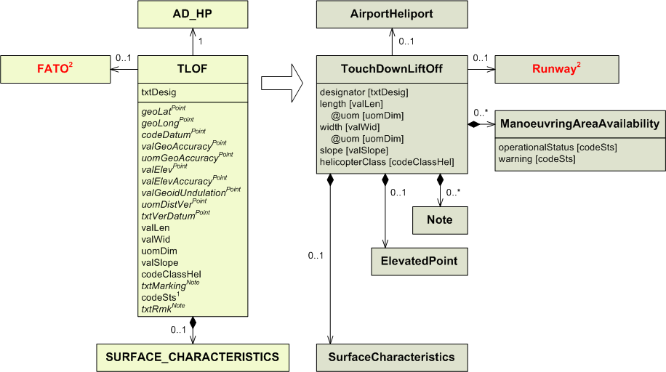
1) Conversion rules for codeSts:

codeSts | operationalStatus | warning
WIP  PARKED  CLSD  FAILAID  SPOWER  OTHER | CLOSED  OTHER | WIP  PARKED_ACFT  OTHER:FAILAID  OTHER:SECONDARY_POWER

2) FATO is mapped into a Runway. See the FATO section for more details.

TLOF_LGT_SYS

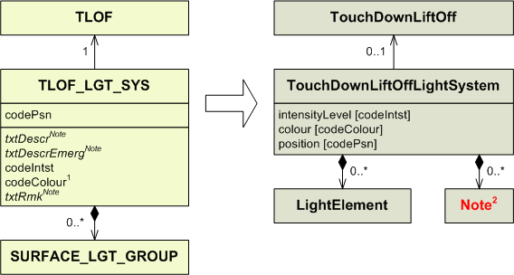
1) Conversion rules for codeColour:

codeColour | colour
YEL  RED  WHI  BLU  GRN  PRP  OTHER | YELLOW  RED  WHITE  BLUE  GREEN  PURPLE  OTHER

2) Note may be populated with information from SURFACE_LGT_GROUP. See the SURFACE_LGT_GROUP section for more details.

TLOF_SAFE_AREA

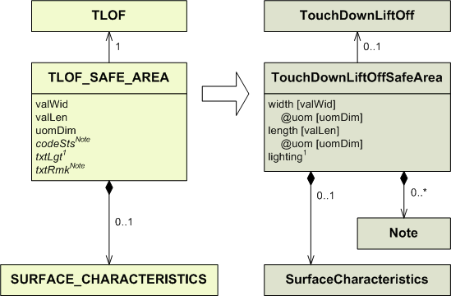

1) The “lighting” attribute in TouchDownLiftOffSafeArea may be set to YES or NO according to the content of the “txtLgt” attribute.

TWY

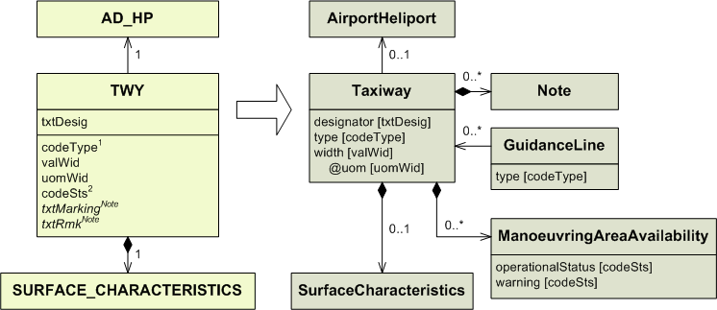
1) Conversion rules for codeType:

codeType | type in Taxiway | type in GuidanceLine
AIRTWY  GNDTWY  EXIT  FASTEXIT  STUB  T-AROUND  PAR  BYPASS  APRON  S-TLINE  LI-TLINE  LO-TLINE  OTHER | AIR  GND  EXIT  FASTEXIT  STUB  TURN_AROUND  PARALLEL  BYPASS  OTHER | APRON*  GATE_TLANE*  LI_TLANE*  LO_TLANE*

* Only in these cases shall the GuidanceLine be created. The only raison for GuidanceLine to be created is to map the “codeType” attribute when it has one of these values.

2) Conversion rules for codeSts:

codeSts | operationalStatus | warning
WIP  PARKED  CLSD  FAILAID  SPOWER  OTHER | CLOSED  OTHER | WIP  PARKED_ACFT  OTHER:FAILAID  OTHER:SECONDARY_POWER

TWY_CLINE_POINT

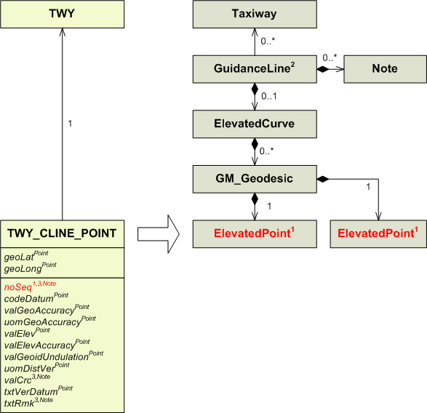

1) Taxiway centrelines are no longer defined point by point, but segments by segments. Because of this, every TWY_CLINE_POINT shall be mapped into a gml:Geodesic. The gml:Geodesic is in turn part of an ElevatedCurve.
The GM_Geodesic also use the TWY_CLINE_POINT coming next (according to the “noSeq” attribute) after the one being mapped as the end of the segment. Because of this every TWY_CLINE_POINT is used twice, except the first one, which will not be an end point for any segment, and the last one, which will not have a segment of its own and will just be used as the ending point of the segment starting with the penultimate TWY_CLINE_POINT of the sequence.

2) Because the ElevatedCurve and ElevatedPoint into which TWY_CLINE_POINT is mapped are not directly associated to Taxiway, a GuidanceLine shall be created and associated to the Taxiway into which TWY has been mapped.
According to the value of the “codeType” attribute of TWY (not shown on this diagram), GuidanceLine may have been already created when mapping TWY. In this case the same GuidanceLine must be used. See the TWY section for more details.
Other issues related to GuidanceLine may be encountered when mapping TWY_HOLDING_POSITION and TWY_LGT_SYS. To make sure that only one GuidanceLine is created per Taxiway, it is recommended to map TWY_CLINE_POINT before TWY_HOLDING_POSITION and TWY_LGT_SYS. TWY_LGT_SYS itself should be mapped after TWY_HOLDING_POSITION.

3) ElevatedPoint is not associated to Note, so attributes than cannot be directly mapped into Point shall be mapped into a Note associated to GuidanceLine. This includes the “noSeq” and “txtRmk” attributes. In such a case the Note used shall clearly state from which Point it comes from.
The “valCrc” attributes shall be mapped into Notes associated to GuidanceLine. Such Note entities shall clearly state from which Point their information comes from. “valCrc” attributes shall not be mapped as they are, but according to the rules defined in the Mapping of “valCrc” attributes section in Annex.

TWY_HOLDING_POSITION
It is recommended to map all TWY_CLINE_POINT before mapping TWY_HOLDING_POSITION. See remark 1) for more details.

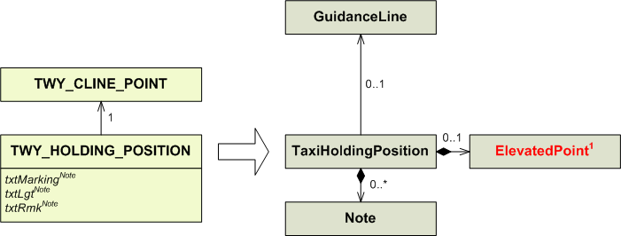
1) In AIXM 4.5 TWY_HOLDING_POSITION is associated to a TWY_CLINE_POINT. The location of TWY_HOLDING_POSITION is contained within this TWY_CLINE_POSITION, TWY_HOLDING_POSITION does not contain its own location. This TWY_CLINE_POINT shall be mapped into an ElevatedPoint associated to a GuidanceLine, as detailed in the TWY_CLINE_POINT section.
In AIXM 5.1 TaxiHoldingPosition is directly associated to an ElevatedPoint and thus contains its own location. TaxiHoldingPosition is not associated to a centreline point, but is instead associated to a GuidanceLine. This GuidanceLine is the same one as the GuidanceLine into which were mapped the TWY_CLINE_POSITION. Thus a taxi holding position may be different from the points defining the GuidanceLine, while still being associated to that GuidanceLine. However, it is very likely that the TaxiHoldingPosition will be located on the GuidanceLine, even if it is not one of its defining points, as shown on the schema below.

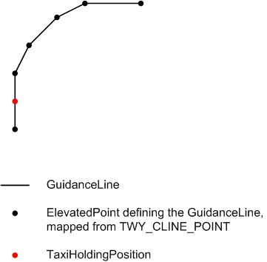

TaxiHoldingPosition on a GuidanceLine

This GuidanceLine is created when mapping TWY_CLINE_POINT. That is why it is recommended to map TWY_CLINE_POINT first, thus creating the GuidanceLine. Then, when mapping TWY_HOLDING_POSITION into TaxiHoldingPosition, it becomes possible to associate TaxiHoldingPosition to the already existing GuidanceLine.

TWY_INTERSECTION

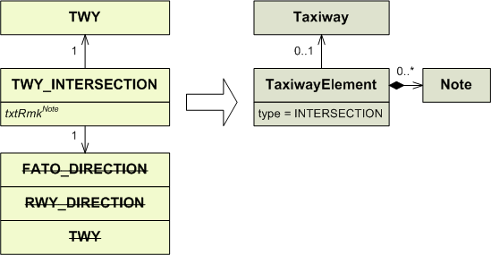

TWY_LGT_SYS
.

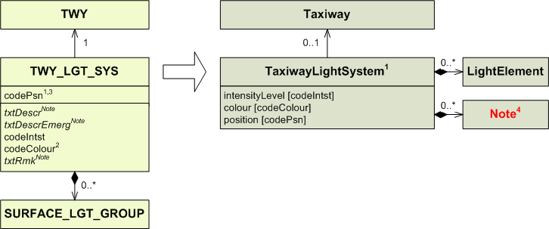
1) Conversion rules for codePsn:

codePsn | Entity to use | position
CL  EDGE  END  RWY  HOLD  OTHER | TaxiwayLightSystem  TaxiwayLightSystem  TaxiwayLightSystem  TaxiwayLightSystem  TaxiwayLightSystemTaxiwayLightSystem | CL  EDGE  END  RWY_INT  OTHER  OTHER

2) Conversion rules for codeColour:

codeColour | colour
YEL  RED  WHI  BLU  GRN  PRP  OTHER | YELLOW  RED  WHITE  BLUE  GREEN  PURPLE  OTHER

3) When codePsn = HOLD, it means that the lighting system is located precisely on a taxiway holding position. However, due to the complexity of the mapping it is not recommended for automatic conversions to try to identify the exact holding position where that lighting is located. The AIXM 4.5 codePsn attribute just indicates that lighting of holding positions is provided.

4) Note may be populated with information from SURFACE_LGT_GROUP. See the SURFACE_LGT_GROUP section for more details.

UNIT

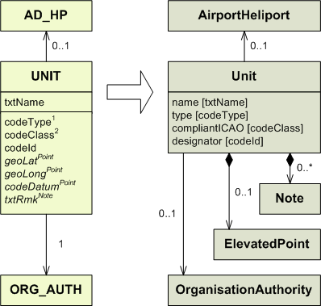

1) Conversion rules for codeType:

codeType | type
ACC  ADSU  ADVC  ALPS  AOF  APP  APP-ARR  APP-DEP  ARO  ATCC  ATFMU  ATMU  ATSU  BOF  BS  COM  FCST  FIC  GCA  MET  MWO  NOF  OAC  PAR  RAD  RAFC  RCC  RSC  SAR  SMC  SMR  SRA  SSR  TAR  TWR  UAC  UDF  UIC  VDF  WAFC  ARTCC  FSS  TRACON  MIL  MILOPS  OTHER | ACC  ADSU  ADVC  ALPS  AOF  APP  APP_ARR  APP_DEP  ARO  ATCC  ATFMU  ATMU  ATSU  BOF  BS  COM  FCST  FIC  GCA  MET  MWO  NOF  OAC  PAR  RAD  RAFC  RCC  RSC  SAR  SMC  SMR  SRA  SSR  TAR  TWR  UAC  UDF  UIC  VDF  WAFC  ARTCC  FSS  TRACON  MIL  MILOPS  OTHER

2) Conversion rules for codeClass:

codeClass | compliantICAO
ICAO  OTHER | YES  NO

UNIT_ASSOC

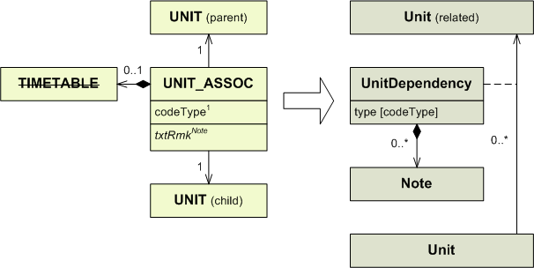
1) Conversion rules for codeType:

codeType | type
CL  SER  SUB  OTHER | OTHER  PROVIDER  OWNER  OTHER

VOR

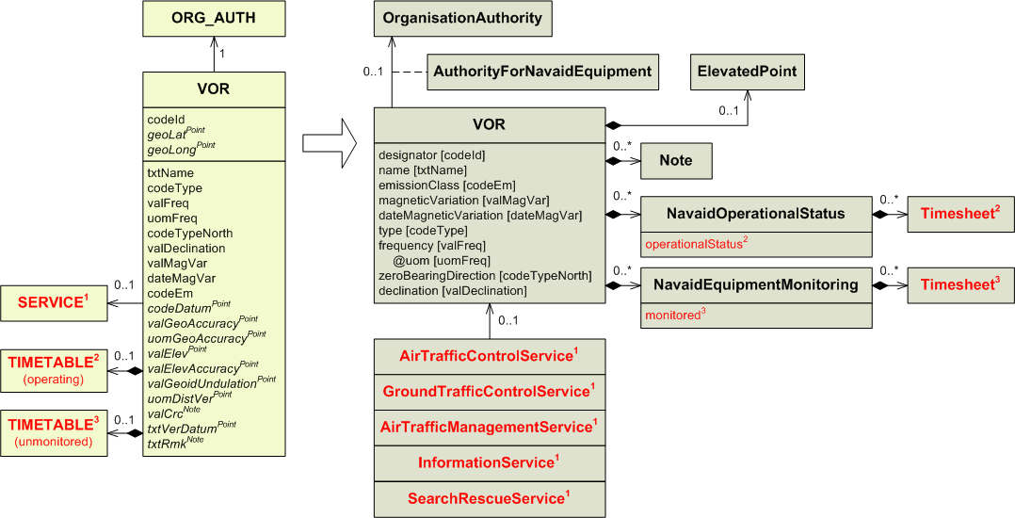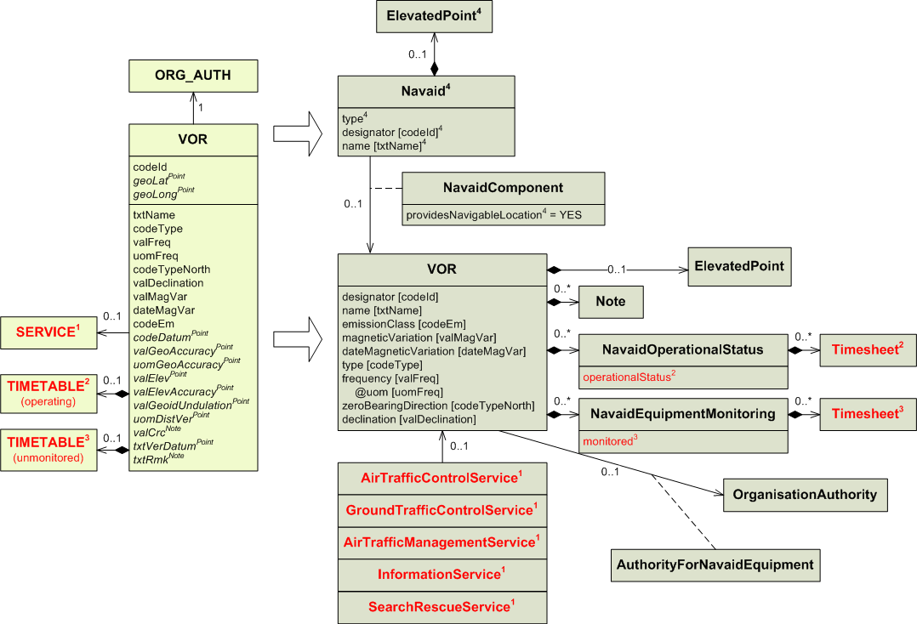
1) The association between the VOR and the service is now from the service to the VOR.
SERVICE may be mapped into five different types of service. See the SERVICE section for more details.

2) Conversion rules for TIMETABLE (operating):

codeWorkHr in TIMETABLE | Attached TIMESHEET | operationalStatus | Additional mapping required. See the TIMETABLE section for more details.
H24  NOTAM  NOTAM | No  No  Yes | OPERATIONAL  CONDITIONAL  CONDITIONAL | No  No  Yes
Any other case |  |  | Yes

3) Conversion rules for TIMETABLE (unmonitored):

codeWorkHr in TIMETABLE | Attached TIMESHEET | monitored | Additional mapping required. See the TIMETABLE section for more details.
H24 | No | NO | No
Any other case |  | YES | Yes

4) A Navaid has to be created in addition to the VOR (NavaidEquipment) as follows:
AIXM 4.5 | AIXM 5.1 Navaid
VOR is collocated with DME (regardless if it is also collocated with TACAN) | See the DME section, mapping note no. 2
VOR is collocated with TACAN, but not with DME | See the TACAN section mapping note no. 1
VOR is stand-alone | type= VOR  designator – use VOR.codeId  name – use VOR.txtName  ElevatedPoint – use geoLat, geoLong, codeDatum of the VOR  providesNavigableLocation = YES on the NavaidComponent that is associated with the VOR  collocationGroup – leave empty

A NavaidOperationalStatus should also be encoded for the resulting Navaid. However, automatic generation is difficult as in some situations the VOR and DME/TACAN might have different operational hours and/or unmonitored hours. Therefore, it is recommended that the NavaidOperationalStatus for the resulting Navaid is left empty.

VOR_USAGE_LIMIT

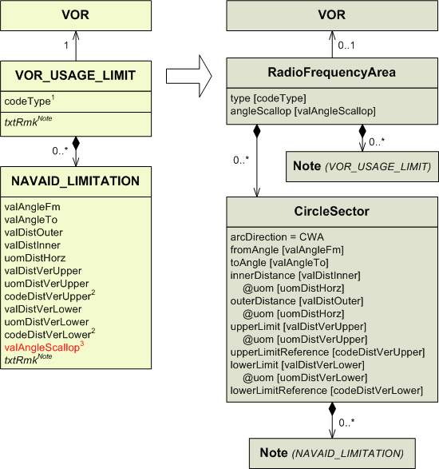

1) Conversion rules for codeType:

codeType | type
CVR  SCL  RHG  UNL  RES  UUS  OUT  TCVR  OTHER | COV  SCL  RHG  UNREL  RES  UUS  OUT  T_COV  OTHER

2) Conversion rules for codeDistVerXxx:

codeDistVerXxx | xxxLimitReference
HEI  ALT  W84  QFE*  QNH*  STD  OTHER | SFC  MSL  W84  SFC  MSL  STD  OTHER

* These values were not supposed to be used with this entity. It is likely this is a mistake.

3) Since the “angleScallop” attribute belongs to RadioFrequencyArea, there can no longer be a different value for each sector. If there were NAVAID_LIMITATION belonging to the same VOR_USAGE_LIMIT with different valAngleScallop values, one shall be chosen to populate the “angleScallop” attribute in RadioFrequencyArea.

- Additional mapping
  - Mapping of geographical coordinates

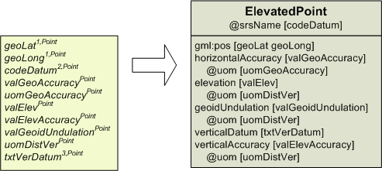

1) geoLat and GeoLong are mapped into the same gml:pos attribute, separated by a blank space. The following conversion rules apply:
For geoLat:
- If expressed in degrees North (N), the latitude shall be positive (Lat > 0); if expressed in degrees South (S), the latitude shall be negative (Lat < 0).
- If expressed in degrees with decimals (DD.ddd), the latitude shall inherit the value as it is.
- If expressed in degrees and minutes with decimals (DDMM.ddd), the latitude shall be transformed in degrees with a number of (3 + the number of decimals in geoLat) decimals.
- If expressed in degrees, minutes and seconds with decimals (DDmmss.ddd), the latitude shall be transformed in degrees with a number of (5 + the number of decimals in geoLat) decimals.
For geoLong:
- If expressed in degrees East (E), the longitude shall be positive (Long > 0); if expressed in degrees West (W), the longitude shall be negative (Long < 0).
- If expressed in degrees with decimals (DDD.ddd), the longitude shall inherit the value as it is; the leading zero(s) shall be removed.
- If expressed in degrees and minutes with decimals (DDDMM.ddd), the longitude shall be transformed in degrees with a number of (3 + the number of decimals in geoLong) decimals; the leading zero(s) shall be removed.
- If expressed in degrees, minutes and seconds with decimals (DDDmmss.ddd), the longitude shall be transformed in degrees with a number of (5 + the number of decimals in geoLong) decimals; the leading zero(s) shall be removed.
These rules are aimed at not giving a false impression of precision that the original data did not have.

Examples:

Original value | Converted value
12,500N | 12.500 (as it is)
08°07.5S | -08.1250 (3 + 1 digits)
08°07.663 | -08.127717 (3 + 3 digits)
008.143W | -8.143 (as it is)
088°24’35“W | -88.40972 (5 + 0 digits)
143°57’13.358E | 143.95371056 (5 + 3 digits)

2) AIXM 5.1 uses Uniform Resource Name from the European Petroleum Survey Group to identify the datum. These URNs have been endorsed by the Open Geospatial Consortium. Some datums have another URN directly attributed by the OGC and different from the EPSG one. Such URNs shall not be used, only the EPSG URNs shall be used in this mapping. The EPSG convention for gml:pos is latitude first then longitude, while for OGC it is the other way around. Only the EPSG convention shall be used.
Conversion rules for codeDatum:

codeDatum | srsName
WGE  WGC  EUS  EUT  ANS  BEL  BRN  CHI  DGI  IGF  POT  GRK  HJO  IRL  ROM  IGL  OGB  DLX  PRD  RNB  STO  NAS  NAW  U | urn:ogc:def:crs:EPSG::4326  urn:ogc:def:crs:EPSG::4322  urn:ogc:def:crs:EPSG::4230  urn:ogc:def:crs:EPSG::4668  urn:ogc:def:crs:EPSG::4312  urn:ogc:def:crs:EPSG::4215  urn:ogc:def:crs:EPSG::4801  urn:ogc:def:crs:EPSG::4149  urn:ogc:def:crs:EPSG::4326  urn:ogc:def:crs:EPSG::4275  urn:ogc:def:crs:EPSG::4746  urn:ogc:def:crs:EPSG::4121  urn:ogc:def:crs:EPSG::4658  urn:ogc:def:crs:EPSG::4299  urn:ogc:def:crs:EPSG::4806  urn:ogc:def:crs:EPSG::4326  urn:ogc:def:crs:EPSG::4277  urn:ogc:def:crs:EPSG::4207  urn:ogc:def:crs:EPSG::4274  urn:ogc:def:crs:EPSG::4313  urn:ogc:def:crs:EPSG::4124  urn:ogc:def:crs:EPSG::4267  urn:ogc:def:crs:EPSG::4269  “unknown” (could be assumed as urn:ogc:def:crs::EPSG::4326 for graphical display or spatial queries, but not for safety critical applications such as procedure design or air navigation!)

3) Values provided with AIXM 5.1 for verticalDatum are: EGM_96, AHD, NAVD88. Other values may still be used as part of the codelist, in the format “OTHER:(actual value of the “txtVerDatum” attribute).
  - Mapping of an attribute into Note

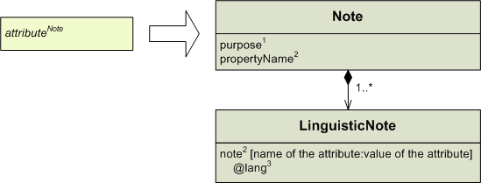

1) The “purpose” attribute shall be populated according to the name of the AIXM 4.5 attribute that is being saved into the Note. The value of “purpose” shall be decided according to the following priorities. These priorities never take into account the name of the entity the AIXM 4.5 attribute belongs to, the name of the attribute itself is the only thing that matters.
- if the AIXM 4.5 attribute is txtRmk, then “purpose” shall be populated with the value “REMARK”.
- if the name of the AIXM 4.5 attribute starts with “txt…” but is not txtRmk (i.e. if the attribute is a free text one but is not a remark, like “txtDescr”), then “purpose” shall be populated with the value “DESCRIPTION”.
- otherwise “purpose” shall be populated with “OTHER:AIXM45_MAPPING”

The following table summarises these rules:

Name of the attribute | purpose
txtRmk  Other text attributes (txtDescr,…)  Other attributes | REMARK  DESCRIPTION  OTHER:AIXM45_MAPPING

Depending on the content of the attribute, other values may be used.

2) Note in AIXM 5.1 has a “propertyName” attribute meant to be populated with the name of the attribute to which the Note refers. However “propertyName” is supposed to be populated only with AIXM 5.1 attribute names, so when mapping from AIXM 4.5, the name of the AIXM 4.5 attribute has to be saved in the “note” attribute itself. The content of the attribute shall be saved right after and separated by a colon.

3) It is recommended to use the encoding from ISO 639-2 for languages. Examples may be found in the FREQUENCY section.
  - Mapping of “valCrc” attributes
The CRC values are not directly supported in AIXM 5.1. There are on-going discussions whether CRC values should be considered as ‘metadata’ or whether they should be dealt with outside the data model, as part of the data storage and exchange processes.
In AIXM 4.5, the calculation of the CRC values depends on the format of the latitude and longitude values (DDMMSS.ss…). This format changes in AIXM 5.1 as explained in section A1.1. Therefore, the CRC value would change as well in the mapping process, if it was to calculate it similarly to how it was done in AIXM 4.5. Therefore, preserving the AIXM 4.5 CRC value is of no real use once the data is converted into AIXM 5.1, since the new data cannot be checked against the old CRC.
For the moment, it is proposed that all “valCrc” attributes shall be mapped into a Note. This Note shall be associated to the AIXM 5.1 entity the 4.5 entity is being mapped into. The sections dedicated to these entities explain where to map the “valCrc” attributes in these cases, and how to record from which geographical object (a vertex or a point) the “valCrc” attribute comes from. The following formatting rules apply to “valCrc” attributes anyway.

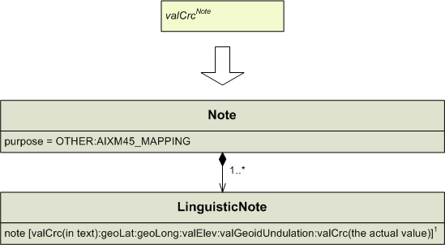

1) The Note shall not only record the “valCrc” attribute, it shall also record the values which were used to produce it. Since the geographical coordinates are converted into decimal values during the mapping, their original value shall be saved with the CRC.
The four AIXM 4.5 attributes that were used to produce the CRC are “geoLat”, “geoLong”, “valElev”, “valGeoidUndulation”. They will be concatenated together and preceded by the attribute name “valCrc”, with a colon to separate them. “valElev” and “valGeoidUndulation” may not be always provided. In such a case no blank space shall be left between the colons. The value of the “valCrc” attribute itself shall be concatenated after the four other attributes, as shown on the diagram.

  - Mapping of AIRSPACE_VERTEX and AD_HP_SURFACE_VERTEX
    - codeType = ABE

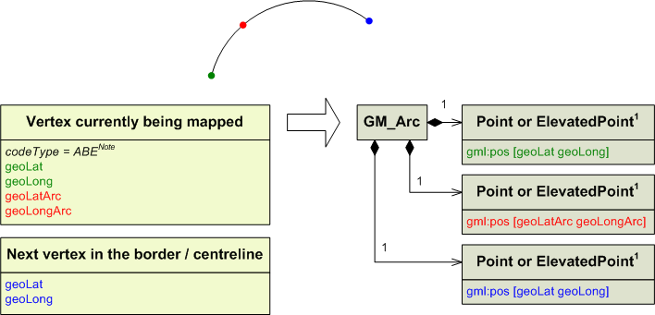

1) The order of the (Elevated)Points is significant. The coordinates in green shall be mapped into the first one, the coordinates in red into the second one and the coordinates in blue into the third one.

    - codeType = CCA
First case: the CCA vertex is not preceded by a CWA/CCA arc.
The attributes geoLat and geoLong from the considered vertex (in green) are saved as the ending point of the previous segment and do not need to be saved again.
The attributes geoLat and geoLong from the next vertex (in blue) will be saved as the starting point of the next segment and do not need to be saved in this segment.

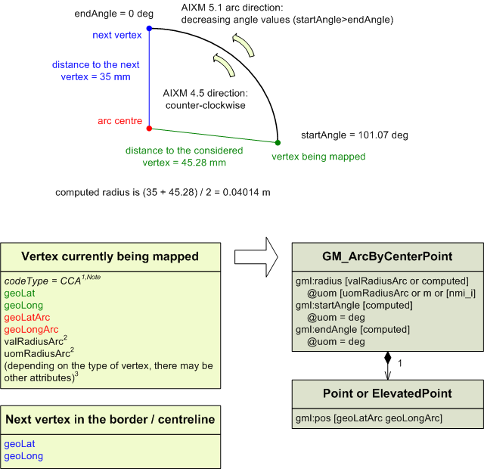

1) Customised guidelines about how to save the codeType attribute in a Note are given into each section dealing with CWA/CCA vertices.

2) AD_HP_BORDER_VERTEX do not have the valRadiusArc and uomRadiusArc attributes. AIRSPACE_BORDER_VERTEX and AIRSPACE_CLINE_VERTEX have them, but not as mandatory attributes.
In the radius value and unit of measurement are provided in the AIXM 4.5 data, they shall be mapped as they are into the corresponding AIXM 5.1 attributes. If not, the radius shall be computed as the arithmetic mean of the starting and ending radii. This computed radius shall be expressed in meters if the vertex is an AD_HP_BORDER_VERTEX and in nautical miles if it is an AIRSPACE_BORDER_VERTEX or an AIRSPACE_CLINE_VERTEX. If the radius is expressed in nautical miles, the uom attribute under gml:radius shall be populated with [nmi_i].

3) Other attributes of the vertex that are not represented here follow the mapping rules provided in the dedicated sections.

Second case: the CCA vertex is preceded by a CWA/CCA arc.
The attributes geoLat and geoLong from the considered vertex (in green) are saved in a GM_LineStringSegment as both the starting point and the ending point. This GM_LineStringSegment is actually just a point, since its starting and ending points have the same location.
The attributes geoLat and geoLong from the previous vertex (in blue) are saved as the ending point of the segment before (not represented on the schema) and do not need to be saved again.

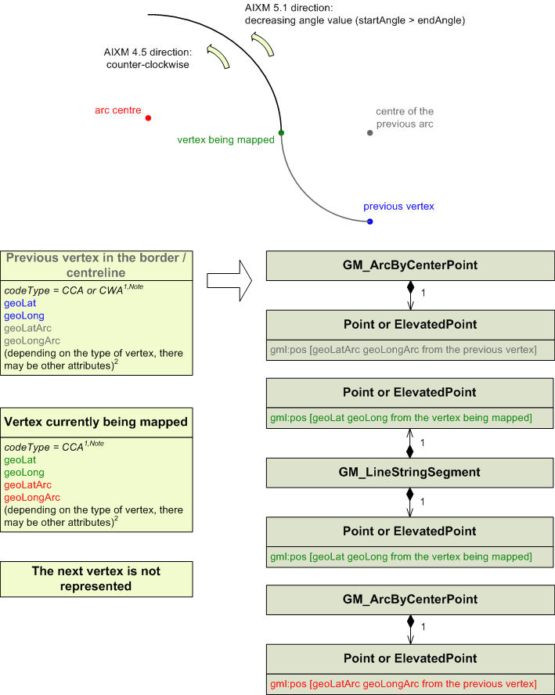

1) Customised guidelines about how to save the codeType attribute in a Note are given into each section dealing with CWA/CCA vertices.

2) Other attributes of the vertex that are not represented here follow the mapping rules provided in the dedicated sections. The valRadiusArc and uomRadiusArc attributes follow the rules developed above in the first part of Annex 1.4.2.

    - codeType = CWA
First case: the CWA vertex is not preceded by a CWA/CCA arc.
The attributes geoLat and geoLong from the considered vertex (in green) are saved as the ending point of the previous segment and do not need to be saved again.
The attributes geoLat and geoLong from the next vertex (in blue) will be saved as the starting point of the next segment and do not need to be saved in this segment.

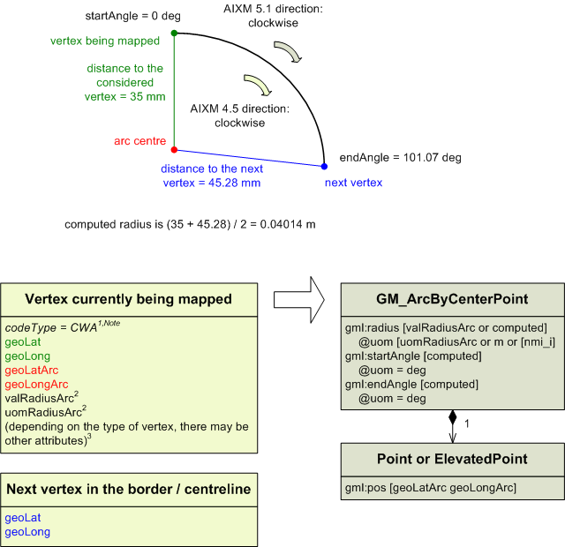

1) Customised guidelines about how to save the codeType attribute in a Note are given into each section dealing with CWA/CCA vertices.

2) AD_HP_BORDER_VERTEX do not have the valRadiusArc and uomRadiusArc attributes. AIRSPACE_BORDER_VERTEX and AIRSPACE_CLINE_VERTEX have them, but not as mandatory attributes.
In the radius value and unit of measurement are provided in the AIXM 4.5 data, they shall be mapped as they are into the corresponding AIXM 5.1 attributes. If not, the radius shall be computed as the arithmetic mean of the starting and ending radii. This computed radius shall be expressed in meters if the vertex is an AD_HP_BORDER_VERTEX and in nautical miles if it is an AIRSPACE_BORDER_VERTEX or an AIRSPACE_CLINE_VERTEX. If the radius is expressed in nautical miles, the uom attribute under gml:radius shall be populated with [nmi_i].

3) Other attributes of the vertex that are not represented here follow the mapping rules provided in the dedicated sections.

Second case: the CWA vertex is preceded by a CWA/CCA arc.
The attributes geoLat and geoLong from the considered vertex (in green) are saved in a GM_LineStringSegment as both the starting point and the ending point. This GM_LineStringSegment is actually just a point, since its starting and ending points have the same location.
The attributes geoLat and geoLong from the previous vertex (in blue) are saved as the ending point of the segment before (not represented on the schema) and do not need to be saved again.

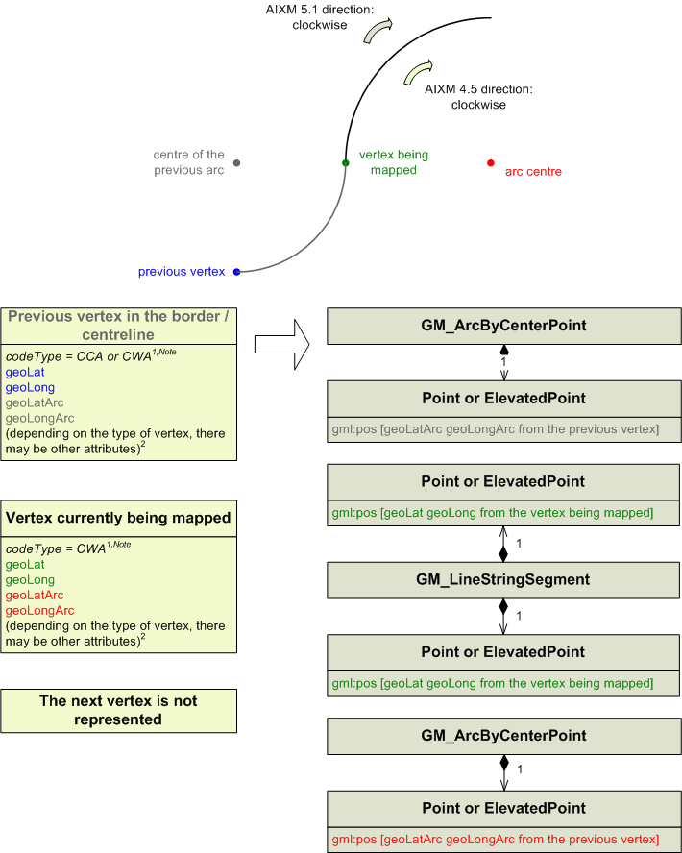

1) Customised guidelines about how to save the codeType attribute in a Note are given into each section dealing with CWA/CCA vertices.

2) Other attributes of the vertex that are not represented here follow the mapping rules provided in the dedicated sections. The valRadiusArc and uomRadiusArc attributes follow the rules developed above in the first part of Annex 1.4.2.
    - codeType = FNT

REFERENCES

AICM 4.5 – Entity-Relationship report
AIXM 5.1 – UML (simple HTML view)
AIXM 4.5 schema files
AIXM 5.1 schema files

ABBREVIATIONS

ADR: Airspace Data Repository (Eurocontrol project)
AIXM : Aeronautical Information eXchange Model
CRC : Cyclic Redundancy Check
eASM : electronic Airspace Management Information
GML : Geography Markup Language
UML : Unified Modeling Language
uom : unit of measurement
XML : eXtensible markup Language

Except the abstract classes: AIRSPACE_VERTEX, DIRECT_FLIGHT, LANDING_PROTECTION_AREA and SURFACE_LGT_SYS.
The XML implementation of the AIXM 4.5 entity-relationship model changed all attribute names in the same way (lowerCamelCase).

