AIXM

Digital NOTAM Event Specification
- Increment 1 -

Aeronautical Information Exchange Model
(AIXM)

Copyright: 2011 - EUROCONTROL and Federal Aviation Administration
All rights reserved.
This document and/or its content can be download, printed and copied in whole or in part, provided that the above copyright notice and this condition is retained for each such copy.
For all inquiries, please contact:
Deborah COWELLl – deborah.cowell@faa.gov
Eduard POROSNICU - eduard.porosnicu@eurocontrol.int

Edition | Status | Issue Date | Reason for Change
0.1 | Working Draft | 16 JUN 2010 | Working draft for review by the Eurocontrol Digital NOTAM Focus Group
0.2 | Working Draft | 29 JUN 2010 | Partially updated after Focus Group meeting, for presentation at the EAD Digital NOTAM Trial Workshop
0.3 | Working Draft | 04 JUL 2010 | Most scenarios updated based on Focus Group members review. Extracted from the Work Area for public review (AIXM Forum).
0.4 | Working Draft | 10 OCT 2010 | Added scenario for New Obstacle
0.5 | Working Draft | 15 NOV 2011 | Updated scenarios after discussions in FG. Added scenarios for Route Closure and Route Opening.
0.51 | Working Draft | 29 NOV 2011 | Small updates after the FG meeting in Madrid: airspace activation and ad-hoc airspace scenarios.
0.6 | Working Draft | 31 JAN 2011 | Event Schema completely re-drafted. Template for schedules. Updated XML example, in line with the latest XML Event Schema.
0.7 | Working Draft | 06 April 2011 | Intermediate version, containing only the scenarios that are planned for the EAD implementation in 2012. Limited circulation – EAD.
0.7.1 | Working Draft | 15 April 2011 | Intermediate version, containing only the scenarios that are planned for the EAD implementation in 2012. Added the missing route opening/closure scenarios. Limited circulation – EAD.
0.8 | Draft | 27 April 2011 | Draft, preparing the baseline for the EAD implementation of the Digital NOTAM scenarios intended for Release 7, OGC test bed OWS-8, SESAR WP 13.2.2 and other early adoption projects.
0.9 | Draft | 10 May 2011 | Proposed Release for the scenarios planned for EAD Release 7 implementation.
0.9.1 | Draft | 16 May 2011 | Added scenario for Navaid unserviceable, provided only to OWS-8 participants.
1.0 | Proposed Release | 08 June 2011 | Added scenarios for obstacle, airport closure and runway closure. Add rules for decoding of vertical limits. Allow levels per route portion in the route closure and opening scenarios. Various small corrections in other scenarios.

Notes about future versions:
- Version 1.1 is likely to be issued in October 2011, providing corrections and improvements to version 1.0, based on feedback from the developers that will use this specification in the frame of the EAD, OWS-8, SESAR WP 13.2.2, etc.
- Version 2.0 containing additional scenarios, in particular those developed and implemented by the United Stated Federal Aviation Administration in the Digital NOTAM Submission project is planned for end 2012.

Table of Contents
1. Introduction 6
1.1 Digital NOTAM concept 6
1.2 Purpose of this document 6
1.3 Status of this document 7
1.4 Contributors 7
2. General requirements 9
2.1 AIXM 5.1 Baseline Data 9
2.2 Solution Completeness 9
2.3 NOTAM content versus digital data 9
2.4 Event filtering capabilities 10
2.5 Event identification 10
2.6 Data synchronisation requirements 11
3. AIXM Event Schema 12
3.1 Introduction 12
3.2 Event Schema Definition 12
3.3 Data encoding rules 16
3.4 Scenario identification 16
4. Event scenarios 18
4.1 Editorial notes 18
4.2 Published special activity area – activation [SAA.ACT] 19
4.3 Published ATS airspace - activation or deactivation [ATSA.ACT] 33
4.4 Ad-hoc special activity area – creation [SAA.NEW] 43
4.5 Ad-hoc ATS airspace – creation [ATSA.NEW] 57
4.6 Route portion closure [RTE.CLS] 67
4.7 Route portion opening [RTE.OPN] 75
4.8 Aerodrome closure [AD.CLS] 83
4.9 Runway closure [RWY.CLS] 95
Navaid unserviceable [NAV.UNS] 108
4.10 New obstacle [OBS.NEW] 122
4.11 Withdrawn obstacle [OBS.WDN] 131
4.12 Taxiway closure [TWY.CLS] 131
4.13 Airport surface contamination [AD.CONT] 131
4.14 Other Event [OTHER] 132
5. Data encoding rules 133
5.1 Events with estimated end time 133
5.2 Events with schedule 135
5.3 Encoding of geometrical and geographical data 141
5.4 Rules for encoding/decoding vertical limits 152
5.5 Encoding annotations 154
5.6 Event Update 155
5.7 NIL values 162
5.8 Bounding Box 163
6. References 164

Introduction

Digital NOTAM concept
The current NOTAM is a text note, which can be distributed by basic teletype networks such as AFTN. The NOTAM is intended to be read by pilots, controllers and other operational personnel involved in flight operations.
By contrast, a Digital NOTAM is a small data set, made available through more advanced communication networks (such as AMHS, TypeX, etc.). It is intended to be read and processed by automated systems, which in turn will convert it into text and graphical formats for presentation to humans. Digital NOTAM can be used for example in order to present an updated airport chart to the pilot or to the air traffic controller, containing graphical depictions of the work in progress areas, closed taxiways or runways, temporary obstacles, etc. A Digital NOTAM might also trigger automated actions, such as determine procedures impacted by the unavailability of a navaid.
In order to encode the NOTAM information digitally, all the data currently exchanged by NOTAM needs to be modelled and specified in a data exchange format. This was achieved with the Aeronautical Information Exchange Model (AIXM) version 5. In addition to the model, a number of rules and guidelines are necessary in order to harmonise the encoding of the different categories of NOTAM events, as identified in this document.
For many years, Digital NOTAM will be issued in parallel with the classical text NOTAM. For this reason the automatic generation of the classical text NOTAM is also in the scope of this specification, in order to avoid its manual creation on a different system. Digital NOTAM will also be implemented incrementally: the most common types of NOTAM will be supported first, in order to match the gradual implementation by the end-user of their capabilities for digital NOTAM processing. Therefore, the Event Specification document will also be developed incrementally.

Purpose of this document
The Digital NOTAM Event Specification defines the rules for harmonised encoding as AIXM data sets (version 5.1 or later) of the information currently published through NOTAM messages. This document is intended primarily to system developers, as most of these rules will have to be translated into computer code that results in database structures, human-machine interfaces, data validation rules, etc. However, the document is developed with significant input from operational experts, in order to capture all the rules and requirements that will guarantee safe, efficient and reliable Digital NOTAM operations.
The main goal of the document is to enable the interoperability of the different systems that produce, transform, transmit and consume Digital NOTAM data, as part of the digital aeronautical information is general. The application of common rules is also expected to reduce the cost of the implementations because it minimises the need for mapping and adaptation of the data coming from different sources.
The rules specified for different events (scenarios) describe the minimal information necessary to be provided on short notice. In certain situations, this might be supplemented later with more detailed information in order to provide all the detail necessary for recording a permanent change of the aeronautical feature concerned and which is not available for the initial notification.
The Event Specification is likely to evolve in future towards covering all the data necessary for an aeronautical information updates, including changes of lasting duration to aeronautical "static" data.

Status of this document
This document shall be considered as guidance material, not as a normative specification. It provides a common baseline for developers of both Digital NOTAM production systems and digital data user systems. After sufficient experience is gained with practical implementations, the Digital NOTAM scenarios might evolve towards a normative specification status.
While the final objective is to have an exhaustive description of all possible scenarios and situations, it must be recognised that this cannot be achieved from the first step. Therefore, the initial editions of this document will focus on describing the most common situations and rules. In particular, the current version of the document contains the scenarios selected by the Digital NOTAM Event Specification Focus Group for the Increment 1 of the digital NOTAM implementation in Europe.
Implementers might be confronted with the requirement to support scenarios that slightly deviate or that are not fully described in this document. The Digital NOTAM encoding scenarios might need to be adapted and extended in order to match the local needs. However, if these deviations and extension stay within the framework and the follow the patterns provided in this document, the interoperability between different systems is preserved.

Contributors
This document is the result of collective work, which involved NOTAM and digital data experts from the EUROCONTROL Agency, Federal Aviation Administration (FAA) of United States, ECAC Member States, industry, airlines, etc., as listed in the table below (in alphabetical order). Their contribution is hereby acknowledged.
Name | Organisation
BEWLEY Jennifer | CNA, in support of FAA, US
BUFTEA Laurentiu | Romatsa, Romania
COX Jocelyn | CNA, in support of FAA, US
DAEHLER Andreas | Skyguide, Switzerland
DE HONDT Piet | LVNL, Netherlands
DIGERNES Jan-Ove | Group EAD
EGIDI Alessandro | ENAV, Italy
FENOLL Javier | AENA, Spain
GARRIHY Edel | Irish Aviation Authority
HÄBERLI Sandra | Skyguide, Switzerland
JEWORREK Frank | Eurowings, Germany
KRAUSS Dagmar | DFS, Germany
KUNZE Christoph | Lufthansa System Aeronautics
MCCORD Donna | FAA, United States
OMAHNE Ales | Slovenia Control
POROSNICU Eduard (editor) | EUROCONTROL
REBER Ralf | Lufthansa System Aeronautics
SARIC Edin | Directorate of Civil Aviation of Bosnia and Herzegovina
SCHULZ Hans-Bodo | DFS, Germany
STANDAR Åsa | EUROCONTROL
TEBBENHOFF Elena | EUROCONTROL
VAN WANGHE Hugo | Belgocontrol, Belgium
VEMBAR Navin | FAA, United States
VERMEULEN Luc | EUROCONTROL
WOODS David | Fedex, United States
ZABOTKIENE Jolanta | SE "Oro Navigacija", Lituania

General requirements

AIXM 5.1 Baseline Data
The Digital NOTAM encoding is based on the general temporality rules of AIXM 5.1, as detailed in the Temporality Concept document. Thus, most Digital NOTAM encodings will produce TEMPDELTA TimeSlices for the affected AIXM features. For example, a temporary navaid out of service event will be encoded as a new TimeSlice with interpretation=TEMPDELTA for the corresponding Navaid and including a property operationalStatus=UNSERVICEABLE.
Therefore, a pre-requisite for any Digital NOTAM application is the availability of the corresponding static data, in the form of AIXM 5.1 BASELINE TimeSlices. In the example given above, it is required that the Navaid BASELINE TimeSlice is available both to the application that will generate the Digital NOTAM encoding and to the clients who will receive the AIXM 5.1 data.
The BASELINE data can exist locally or in a remote reference database. Some Event Scenarios explicitly indicate that certain data has to be taken from the corresponding feature BASELINE. Although it is theoretically possible to manually input such information, when needed, such an approach would significantly increase the risk of data encoding errors and reduce the quality of the Digital NOTAM data. Therefore, it is considered a critical pre-requisite that all BASELINE data necessary for the encoding of the Event Scenarios described in this Specification is available in AIXM 5.1 format.

Solution Completeness
In order to balance the implementation costs with the expected benefits, an incremental approach is likely to be followed by a large majority of the Digital NOTAM adopters. This raises a potential difficulty, as data users might need to consult two data sources:
- an AIXM 5.1 data source for those events that are already provided as digital NOTAM
- a text NOTAM data source for the rest of the NOTAM, which are not already available in digital AIXM 5.1 format.
To avoid this difficulty, the Event Specification needs to support from the beginning a complete solution. The NOTAM that are not yet provided as fully structured digital encodings shall be also made available through the AIXM 5.1 data source. As a minimum, all text NOTAM shall be provided as "text notes" of the AIXM 5.1 feature concerned. This is supported by the AIXM Event Schema, in structured format.

NOTAM content versus digital data
As the information is becoming more complex, it becomes increasingly difficult to provide all the details in a NOTAM text. For example, providing the details of a new 'polygon' obstacle through NOTAM text would require very long and very complex E fields. The NOTAM messages were not intended to contain such detailed geometrical information. The introduction of digital NOTAM will offer a solution to this problem. Only the information necessary for a human to identify the event will continue to be published by NOTAM. Very detailed geometrical information could be provided by the AIXM encoding only.

Event filtering capabilities
In AIXM, it was not possible to have a unified handling of the locations of features because many aeronautical features have specific geometries or even no geometry at all. An airspace is a collection of polygons, an airport has a reference point but also a "boundary" polygon, an instrument approach procedure has a complex 3D flying trajectory, while services typically do not have any geometry of their own, etc.
Obviously, this complicates the spatial queries. However, a spatial query alone will probably not satisfy the future digital NOTAM client applications. The text NOTAM messages of today and their Q line already enable spatial filtering. The result is what is called a "narrow route bulletin". However, the current pre-flight information bulletins contain on average 50% NOTAM messages that are irrelevant because it is not possible filter out, for example, information that does not concern that type of aircraft or that flight. Filtering out such things requires interpreting the feature properties affected by the event. If the only filtering applied will continue to be a spatial query, this does not really justify the investment made in digital NOTAM. More intelligent queries will be needed in order to filter better the information that is presented to the pilot and maybe each feature type will probably need it's own selection criteria.
Pure spatial filtering might still be applied as an initial pre-selection of the Events that need to be transmitted to a client. Therefore, the AIXM Event schema needs to support the provision of a basic "bounding box" geometry, to be used in those scenarios that require basic spatial filtering. This is actually the case, because the Event is an AIXM feature and it has a bounding box as any other GML feature. Details about the calculation of the bounding box size are provided in a specific data encoding rule.

Event identification
Each situation for which a Digital NOTAM can be encoded and issued is defined in the form of an "event scenario". It contains the description of the rules applied when encoding the data using the AIXM model and also the rules that may be applied in order to automatically generate the ICAO NOTAM text. The rules are specific to each scenario and it is very likely that each scenario will need a specific user interface in a data provider / data user application. Therefore, it is necessary to uniquely identify each scenario in order to enable recipient applications to automatically decide which user interface and which rules should be applied for processing that scenario.
This is done by allocating to each scenario an identifier. In the current version, this is composed of two groups of letters:
- the first group identifying the feature affected, such as AD - aerodrome, RTE - route, etc.
- the second group identifying the situation that is subject to the scenario, such as CLS - closure, NEW - new object of that kind, etc.
These identifiers are included in the title of section that describes each scenario. In an AIXM file that contains an event encoding, the identifier shall also include the version of the Event Specification according to which the encoding was done. The exact location of scenario and specification version identifier in the Event schema is discussed in the AIXM Event Schema chapter.

Data synchronisation requirements
Missing a Digital NOTAM may be safety critical. This is not a new aspect. Missing a text NOTAM can also lead to safety hazards. To prevent such risks, the text NOTAM production and distribution systems have mechanisms (sequential numbering, checklists, etc.) that enable a user to check if they are in possession of all applicable NOTAM messages. Similar mechanisms must be put in place when working with digital NOTAM. However, these mechanisms are allowed to be different from the mechanisms used for the synchronisation of NOTAM text message sets. The requirements may also be different, as Digital NOTAM synchronisation requires both:
- the synchronisation of the BASELINE data, without which the TEMPDELTA TimeSlices cannot be processed correctly;
- the synchronisation of the PERMDELTA and TEMPDELTA data itself;
This could be supported through reports that contain the list of all valid TimeSlices - sequence number and correction number for each feature, identified by UUID or by a SNAPSHOT TimeSlice containing feature identifying properties (natural key). An AIXM BasicMessage could be used for this purpose.

AIXM Event Schema

Introduction
A specific AIXM application schema is defined for Digital NOTAM encoding. Technically, it is an extension of the AIXM 5.1 model, under a dedicated "event" namespace. The design of this extension was done with the following objectives in mind:
- to enable associating the digital encoding of the event (AIXM features and TimeSlices) with the corresponding Text NOTAM message. This should facilitate the migration from Text NOTAM to Digital NOTAM and the issuing in parallel of the two, during the transition period;
- to enable a basic digital encoding of the data contained in NOTAM messages that are not digital; such NOTAM can be encoded as free text notes associated with the feature affected. This should enable the digital data users to work with a single source of data and will avoid the need to consult text NOTAM for those information items that are not yet available digitally;
- to enable the storage and the unique identification of the events, in order to be able to update a previously issued event and the corresponding NOTAM messages.
In addition, the Event schema was designed as a general purpose encoding for aeronautical information updates, including not only the NOTAM messages but also the information published as AIP Supplement, AIP Amendment or AIC.

Event Schema Definition
The UML model that defines the Event schema type is shown in the following diagram.
The diagram shows that a dedicated "Event" feature is defined by the extension schema used for the encoding of Digital NOTAM. This class has three attributes:
- name = an optional title or designator by which the event may be referred in aeronautical operations;
- encoding = an indication of the extent by which the event information is provided as digital data versus free text notes and which can take the following values:
  - DIGITAL = the information is digitally structured to the maximum possible extent allowed by the AIXM model;
  - MIXED = the information is partially digitally structured. Some information is provided as a text Note, although the model has the capability to support the digital encoding of that piece of information;
  - ANNOTATION = the information is provided as a free text Note associated with the feature and eventually the property concerned.
- scenario = the identifier of the scenario that was followed for the data encoding, including the version of the specification;
- revision = the most recent date and time when the information encoded in the Event was updated.
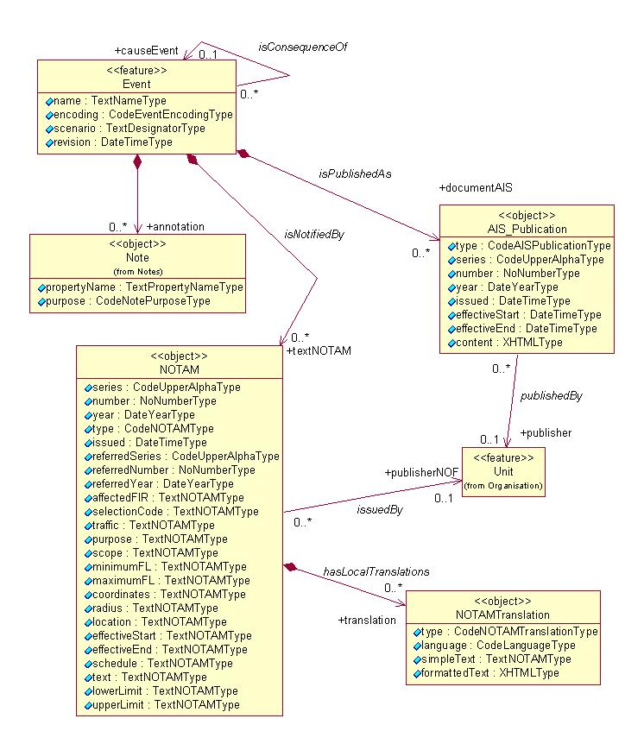
Applications are likely to frequently filter Events by the date when the Event was communicated or received, in order to update the user with the new information. For this purpose, the "revision" attribute was included in the Event class. This will avoid relying on the Metadata schema, which is complex and would unnecessarily complicate the queries, as demonstrated during early trials, in particular when using Web Feature Services (WFS). The metadata is primarily intended to be used for data discovery scenarios, not for operational data queries.
In the diagram, it is visible that each Event may be associated with zero or more NOTAM. This association enables to include the text of the NOTAM message in the AIXM encoding. This was one of the design objectives of the Event Schema, in order to facilitate the transition from Text NOTAM towards Digital NOTAM.
In general, each Event is associated with only one NOTAM. However, there are current NOTAM practices that can trigger several NOTAM to be associated with the Event. For example, if a Navaid is used for approach/departure/arrival procedures at several closely located airports, then the current practice in many States is to publish a "navaid unserviceable" NOTAM for each airport that is affected, with the corresponding airport designator in item A. This ensures that the corresponding NOTAM will appear in the airport section of the Pre-Flight Information Bulletins (PIB), for the concerned airport. Therefore, the same event and its single AIXM 5.1 encoding will have several NOTAM associated.
Note that, when the validity of an Event is extended or shortened, this will result in an additional PERMDELTA TimeSlice for the Event feature, including the text of the NOTAM R or C that is published on that occasion. The initial TimeSlice remains associated with the original NOTAM New, while the new TimeSlice is associated with the NOTAM R or C.
Another possibility is to have an Event associated with an AIS Publication, such as an AIP AMDT. There is no reason to limit the use of the Event schema only for the encoding of information provided by NOTAM. Information provided by AIP AMDT can also be encoded, although this is likely to require the definitions of more complex scenarios. The purpose of the AISPublication class is to point to that document, not to contain it in full. This is why the AIS_Publication is not a feature, but a complex property associated with the Event. It contains the information necessary to identify the AIP AMDT, AIP SUP or AIC concerned (number, issuing authority, start of validity, etc.). Several Events could include information about the same AIP AMDT for example. The same Event could be published in two or more AIP, in case it affects features located on the State border, for example. Therefore, the association allows many AIS_Publications to be linked with the Event.
The Event also has a "self-association" that allows encoding event trees, in which one event is the cause of other events. For example, the temporary displacement of a runway threshold could trigger changes in approach and departure procedures, which could be encoded as separate events.
The information about the actual change brought by the Event to the properties of the affected AIXM features is encoded as TimeSlices of the relevant AIXM features. This is the real digital NOTAM part of the schema. In order to relate the AIXM feature TimeSlices with the Event to which they belong, an extension for each AIXM feature is declared in the "event" namespace. This consists in an association from the feature TimeSlice towards the Event class, as shown in the diagram below.
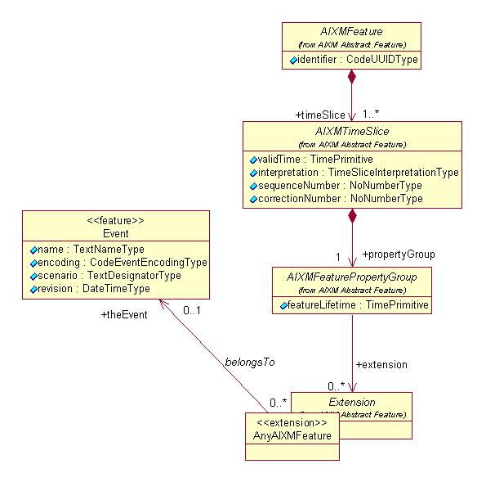
Note that because the link with the Event is provided through an extension of each AIXM Feature, this mechanism has to also be applied in any other extension that creates new features required for Digital NOTAM encoding.
Most events will need a single feature TimeSlice to be provided. For example, the activation of a temporary restricted area will require a single Airspace TimeSlice of type TEMPDELTA. However, there might exist events that require several TEMPDELTA TimeSlices to be encoded in several different features. For example, the establishment of a new obstacle (temporary or permanent) requires two AIXM features to be encoded or modified:
- first, a new VerticalStructure needs to be encoded;
- second, associations between the affected ObstacleArea(s) and the new VerticalStructure might need to be established.
No specific message was created for transporting an Event and the associated data. The AIXMBasicMessage can be used for this purpose, because the Event feature is also an abstract AIXMFeature. Thus, it can be used as child of hasMember elements.
It shall be noted that the Event is a regular AIXM feature, therefore it has TimeSlices. This allows updating an Event:
- each Event will be first encoded as a PERMDELTA/BASELINE TimeSlice pair;
- an eventual change in the Event information (the equivalent of a NOTAM Replacement or Cancellation) shall be encoded as an additional Event TimeSlice (PERMDELTA and modified BASELINE).

Data encoding rules
The most important principle to be applied for the digital encoding of the event data is that only the changed data elements shall be provided. There is no need to include in a TEMPDELTA TimeSlice the data that is part of the BASELINE and which does not change. For example, if a Navaid is temporarily unserviceable, only the operational status of the Navaid shall be part of the AIXM encoding. However, this rule shall consider the rules stated in the AIXM Temporality Concept, which indicates that "delta" can be communicated only for a first level feature property. For example, this means that in the case of a partial modified time schedule, the complete set of Timesheets shall be included in the TEMPDELTA TimeSlice.
The TEMPDELTA or PERMDELTA TimeSlices of the AIXM features affected by the event have their own start and (if applicable) end date. The Event also has start of life/validity and end of life/validity dates. The following temporal consistency rule is defined:
- an AIXM feature TimeSlice that "belongsTo" an Event should have the same start of validity as the Event lifetime start and the same end of validity as the Event lifetime end. This rule is true for most events, but exceptions are possible because complex events (such as an airshow), involving many features, could have slightly different start/end dates for the TimeSlices of the affected AIXM features;

Scenario identification
In practice, it might be necessary to indicate in the AIXM/XML file the scenario that was followed for the encoding of the Event. This will enable recipient applications to automatically decide which user interface and which rules should be applied for processing the data. For this purpose, each scenario has an identifier, which is composed of two groups of letters followed by the version of the Event Specification according to which the encoding was done. For example:
- "SAA.NEW.1.0" - indicates that the ending was done according to the Ad-hoc special activity area - creation scenario as defined in the Digital NOTAM Event Specification version 1.0.
This value shall be put in the "scenario" attribute of the Event feature. It is also possible to develop data validation rules, using Schematron, in order to verify that the Event really follows the rules of the indicated scenario.

Event scenarios
The purpose of defining "event scenarios" is to capture the rules that are specific to each category of aeronautical information events. By event, it is meant a situation that affects one or more aeronautical features, by altering their properties, either temporarily or permanently. In the current phase of the Event Specification development, the focus is on temporary changes. Each scenario includes the definition of the data expected from the authorised originator, the encoding rules, automatic data validation rules, rules for the automatic creation of text NOTAM, etc.

Editorial notes
The data usually provided by the data originators for each event category is presented in the form of a "Template", using EBNF (Extended Backus Naur Form). The same notation is used for the production rule for the E item of the NOTAM text. The document includes graphical representations of the EBNF rules, as described below. The EBNF raw files may be provided on request.
Note: The graphical representation of the EBNF rules was created with the free EBNF Visualizer 1.1

Published special activity area – activation [SAA.ACT]

Definition
The activation of a pre-existing (published) restricted, danger, prohibited, reserved or similar airspace.
Notes:
- the term "special activity area" is used in order to encompass P, D, R and other areas of similar nature; this term comes from FAA and it is considered suitable for adoption, as no equivalent ICAO term could be identified;
- this scenario also includes the activation of an area beyond its baseline vertical limits, e.g. below its lower limit or above its upper limit;
- this scenario does not include the change of the horizontal limits of an area that is normally active nor the activation beyond these horizontal limits; such events will be dealt with as a separate scenario;
- this scenario does not include the permanent modification of the activation status of an area; such events will be dealt with as a separate scenario;
- this scenario does not include the occasional de-activation of an area that is normally active;
- this scenario does not include the temporary modification of the activation schedule, in case such a schedule is part of the BASELINE data; that will be dealt with by a separate scenario: Published special activity area - schedule modification (to be developed);
- this scenario does not include the activation/de-activation of CTR and other ATS airspace; see the dedicated scenario: Published ATS airspace - activation or deactivation.

Event data
The following diagram identifies the information items that are usually provided by a data originator for this kind of event.
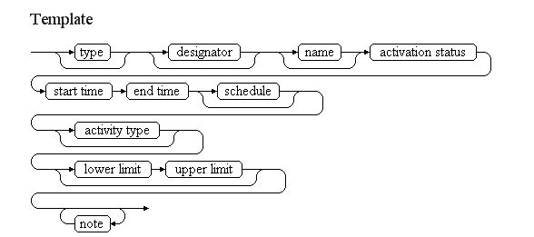
Examples of such events:
TRA EAR23 active
TRA EAR23 DONLON EAST active
From 10 JUL 2010 07:00 till 10 JUL 2010 16:00.
Military exercise taking place.
For further information please contact DONLON ACC on phone (12) 123 45 67.
TOWNSVILLE R736AB active
TOWNSVILLE Airspace R736AB active
From 13 JUN 2010 23:00 till 01 JUL 2010 08:00, daily 23:00-08:00
Due to military activities.
Between SFC and FL420
EBD04 Activity
DANGER AREA EBD04 (ELSENBORN) Activity Program.
On 30 JUN 2010 from 06:00 till 15:30
Between GND and FL170
In between firing periods UAV-unmanned aerial vehicle activity will take place.
Prohibited for all manned military and civilian aircraft during UAV activity.
More info can be obtained via EBMIZGZF or phone 0032 (0) 27524452.
Note: This is an interesting example because the area changes its nature, it becomes prohibited to all flights at certain times. A specific encoding rule (ER-06) is included in the scenario for this case.
EGD128 active above normal level
DANGER AREA EG D128 EVERLEIGH activated above normal level.
On 30 JUN 2010 from 14:00 till 16:00
Between SFC and 2000 FT AMSL
LFD186 changed activity
LF-D186 AREA activation with changes in hours and type of activity:
Lateral Limits : same as LF-D186
From 02 JUL 2010 06:00 till 30 JUL 2010 18:00 each Friday from 06:00-18:00
Between SFC and 2000 FT AMSL
Drone Flights
Phone Camp de Souge : +33 5 56 68 40 46
Info : AQUITAINE APP : 118.600MHZ
ATIS BORDEAUX MERIGNAC : 131.150MHZ
MERIGNAC TWR : 118.300MHZ
Compulsory bypass for every ACFT except ACFT performing emergency or public safety mission when bypass is not possible.
Services provided : ALERT INFO TO AUTHORIZED ACFT
The table below provides more details about each information item contained in the diagram. It also provided the mapping of each information item within the AIXM 5.1 structure. The name of the variable (first column) is recommended for use as label of the data field in human-machine interfaces (HMI).
Data item | Description | AIXM mapping
type | The type of airspace concerned. Examples are D (Danger), R (Restricted), D-OTHER (Other activity of Dangerous nature), TSA (Temporary Segregated Area), TRA (Temporary Reserved Area), etc. | Airspace.type with this list of values CodeAirspaceType. Not to be encoded, just used to identify the airspace concerned.
designator | The published designator of the airspace concerned. If not provided, then the airspace is identified by its name. | Airspace.designator. Not to be encoded, just used to identify the airspace concerned.
name | The published name of the area | Airspace.name. Not to be encoded, just used to identify the airspace concerned.
activation status | The activation status. The typical term is "active". Systems that provide tactical level data might also use the term "in use", when the airspace is effectively used for the activity for which it was reserved. | Airspace/AirspaceActivation.status with this list of valuesCodeStatusAirspaceType
start time | The effective date & time when the airspace becomes active. This might be further detailed in a "schedule". | Airspace/AirspaceTimeSlice/TimePeriod.beginPosition, Event/EventTimeSlice.validTime/timePosition and Event/EventTimeSlice.featureLifetime/beginPosition
end time | The end date & time when the airspace activation ends. It might be an estimated value, if the exact end of activation is unknown. | Airspace/AirspaceTimeSlice/TimePeriod.endPosition and Event/EventTimeSlice.featureLifetime/endPosition also applying the rules for Event with estimated termination
schedule | A schedule might be provided, in case the area is only active according to a regular timetable, within the period between the start time and the end time. | Airspace/AirspaceActivation/Timesheet/... according to the rules for Event Schedules
activity type | The kind of activity that takes place in the airspace | Airspace/AirspaceActivation.activity with this list of values CodeAirspaceActivityType. See also the data encoding rules further down, which indicate additional "OTHER:..." values for this data item.
lower limit | The vertical level above which and including that level the airspace becomes active; this may be different from the published lower limit of the airspace Baseline(i.e.: could be higher or lower) | Airspace/AirspaceActivation/AirspaceLayer.lowerLimit and lowerLimitReference
upper limit | The vertical level below which and including that level the airspace becomes active; this may be different from the published upper limit of the airspace Baseline(i.e.: could be higher or lower) | Airspace/AirspaceActivation/AirspaceLayer.upperLimit and upperLimitReference
note | A free text note that provides further instructions concerning the area activation, such as the authority to be contacted for further information, the possibility of crossing at ATC discretion, etc. | Airspace/AirspaceActivation.annotation according to the rules for encoding annotations
Notes:
- The activity taking place in the airspace during its activation (if specified) is expected to be either identical or at least of the same nature as the activity specified in the Baseline data, if specified. In order to avoid re-typing effort and to enable a the operator to check the coherence between the Digital NOTAM and the Baseline data, it is recommended that the baseline activity data is pre-loaded from the Baseline data in the data input field used for the Digital NOTAM encoding. However, the operator shall be allowed to leave this field empty (in case no specific activity is provided for the Digital NOTAM).

Assumptions for baseline data
- It is assumed that information about the area already exists in the form of an Airspace Baseline, which contains as a minimum the horizontal shape of the airspace, its vertical limits, its designator and its type;
- If the Baseline data includes a schedule associated with the AirspaceActivation, then this should not leave any gaps. If any gaps exist, then the status of the AirspaceActivation at the levels/times concerned is considered "undefined". See the AIXM Temporality Concept (versions 1.0) sections 3.4 and 3.5;
- If an area has sectors, it is assumed that each sector was encoded separately, as an airspace with its own designator, so that it can be activated individually. The collapsed area should not exist as a Baseline airspace, just the sectors. If the area becomes active, the digital data encoding should activate the individual sectors, all in a single Event.

Data encoding rules
The data encoding rules provided in this section shall be followed in order to ensure the harmonisation of the digital encodings provided by different sources. The compliance with some of these encoding rules can be checked with automatic data validation rules (see next section).
Identifier | Data encoding rule
ER-01 | The activation of an airspace shall be encoded as:  - a new Event, for which PERMDELTA and subsequent BASELINE TimeSlice shall be created; and  - a TimeSlice of type TEMPDELTA for the corresponding Airspace feature, for which the "event:theEvent" property points to the Event instance created above; the TEMPDELTA shall contain one or more AirspaceActivation objects.
ER-02 | If the whole airspace becomes active, from floor to ceiling, then the Airspace TEMPDELTA should use the values "FLOOR, uom=OTHER" for lowerLimit and "CEILING, uom=OTHER" for the upperLimit of the AirspaceLayer property associated with the AirspaceActivation.
ER-03 | If the airspace becomes active beyond its vertical limits (as defined in the Airspace BASELINE), then the Airspace TEMPDELTA TimeSlice shall also include the necessary AirspaceGeometryComponents with the modified upper and/or lower limits.
ER-04 | If the area activation is limited to a discrete schedule within the overall time period between the "start time" and the "end time", then this shall be encoded using as many as necessary timeInterval/Timesheet properties for the AirspaceActivation of the Airspace TEMPDELTA Timeslice. See the rules for Event Schedules.
ER-05 | In accordance with the AIXM Temporality Concept (see sections 3.4 and 3.5 in version 1.0), the AirspaceActivation associated with the TEMPDELTA completely replaces all the BASELINE AirspaceActivation information, during the TEMPDELTA time of applicability. Therefore, if the activation only concerns certain times and/or levels, the other times and/or levels, when the airspace eventually remains with the same status as in the Baseline data, shall be explicitly included in the TEMPDELTA. The calculation of the necessary additional AirspaceActivation elements to be included in the TEMPDELTA shall be automatically done by the applications implementing this specification. All AirspaceActivation elements that are copied from the BASELINE data for completeness sake shall get an associated Note with purpose=REMARK and the text="Baseline data copy. Not included in the NOTAM text generation". This is based on the current NOTAM practice which consists of including in the NOTAM only the changed information and not explicitly including the static data that remains valid during the NOTAM applicability.It is recommended that the input interface provides a "calendar/level" view of the airspace activation, enabling the operator to graphically check the status of the airspace activation at different times and levels, such as in the example below: 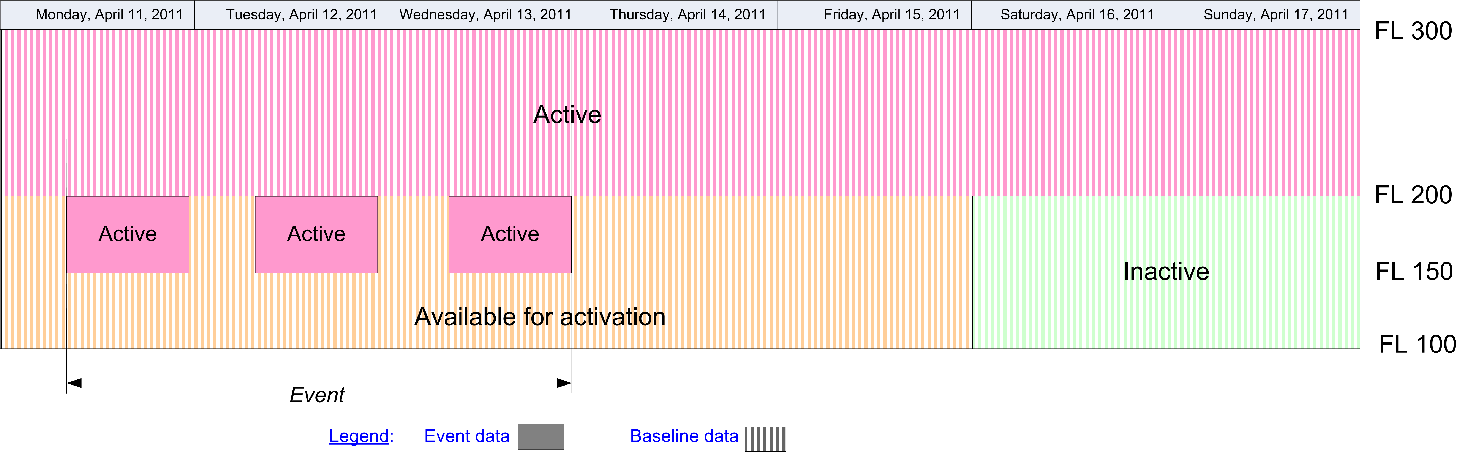In the calendar view, the Baseline information that remains valid during the Event validity time shall be visibly identified from the information that is specific to the Event, for example by using a different colour fill pattern.
ER-06 | If the BASELINE Airspace has a type different from P (Prohibited) and the information received from the originator indicates that the area is "prohibited", "compulsory bypass", "no fly zone" or equivalent during its activation, then the Airspace TEMPDELTA TimeSlice shall also modify the Airspace type="P". This shall be done even if the prohibition concerns only certain flights, aircraft types, a part of the airspace, etc. This will facilitate the automatic detection of partially or totally prohibited areas by data users. Some might require manual interpretation of the detailed information provided as Notes.In the data provider HMI, this should be supported with a check-box - "Area is prohibited for certain flights". When this box is checked, the application would automatically set the type to P. The check box should only be enabled for Airspace that have the Baseline type different from "P".
ER-07 | The activity types that do not match a pre-defined value in the CodeAirspaceActivityType shall be encoded as follows:  - captive balloon -> activity=OTHER:CAPTIVE_BALLOON  - kite activities -> activity=OTHER:KITE  - demolition using explosive devices -> activity=OTHER:DEMOLITION  - mass movement of aircraft ->activity=OTHER:ACFT_MASS_MOVEMENT  - aerial survey / photogrammetic flights -> activity=OTHER:AERIAL_SURVEY  - flying in formation -> activity=OTHER:ACFT_FORMATION  - model flying -> OTHER:MODEL

Automatic data validation rules
These validation rules apply to the AIXM encoded data:
Title | Definition | Category | Error level
Minimal data requirements | As a minimum, in addition to the AIXM mandatory properties gml:validTime and aixm:interpretation, the Airspace TEMPDELTA TimeSlice shall contain at least aixm:sequenceNumber and one aixm:activation element with at least the aixm:status, aixm:upperLimit, aixm:lowerLimit descendant elements specified (not NIL). | Minimal data | error
Non-duplication with other Events | There should not exist another Airspace TEMPDELTA with an overlapping (partially or totally) gml:validTime and which also contains aixm:activation elements. | Data consistency | warning
Airspace type consistent with the scenario | The value of the Airspace BASELINE aixm:type shall be either "P", "R", "D", "TSA", "TRA", "D_OTHER", "W", "PROTECT" (as any other value would be in conflict with the purpose of this scenario). | Data consistency | error
Activation status consistent with scenario | The value of the aixm:status (activation status) shall be either "ACTIVE", "IN_USE" or "INTERMITTENT" (as any other value would be in conflict with the purpose of this scenario). | Data consistency | error
Activity consistent with scenario | The value of the aixm:activity (activity taking place) shall not have the values:  - "AD_TFC", "HELI_TFC" "ATS", "PROCEDURE" (as these values are specific to the ATS Airspace activation scenario);  - "MILOPS", "FIRE_FIGHTING", "BIRD", "BIRD_MIGRATION" (as these are expected to be subject of ad-hoc areas only);  - "LASER", "HI_LIGHT" (as these are expected to be reasons for caution around airports, announced only by ad-hoc areas if necessary). | Data consistency | error
Upper limit change | If the Airspace TEMPDELTA AirspaceActivation includes an AirspaceLayer that has upperLimit bigger than the any of the AirspaceGeometryComponent.upperLimit of that Airspace BASELINE, then the TEMPDELTA shall also include an equal number of AirspaceGeometryComponent (copied from BASELINE) but with upperLimit equal with that of the TEMPDELTA AirspaceActivation (that temporarily re-defines the vertical extent of the airspace). | Data consistency | error
Lower limit change | If the Airspace TEMPDELTA AirspaceActivation includes an AirspaceLayer that has lowerLimit smaller than the any of the AirspaceGeometryComponent.lowerLimit of that Airspace BASELINE, then the TEMPDELTA shall also include an equal number of AirspaceGeometryComponent (copied from BASELINE) but with lowerLimit equal with that of the TEMPDELTA AirspaceActivation (that temporarily re-defines the vertical extent of the airspace). | Data consistency | error
Activation inside pre-defined schedule | If in the BASELINE Airspace data includes one or more activation elements with the aixm:status="AVBL_FOR_ACTIVATION" associated with one or more aixm:timeInterval (schedules), then the time periods described by Airspace TEMPDELTA TimeSlice (gml:validTime and the eventual included aixm:timeInterval when the aixm:status="ACTIVE" or "IN_USE") shall be within time defined by the BASELINE schedule | Data consistency | warning
Baseline data copy correctness | For each AirspaceActivation included in the TEMPDELTA that has an associated annotation with purpose=REMARK and the text="Baseline data copy. Not included in the NOTAM text generation", there shall exist an equivalent AirspaceActivation in the BASELINE data, having:  - the same aixm:activity and aixm:status;  - equal or smaller aixm:levels/lowerLimit value;  - equal or higher aixm:levels/upperLimit value;  - an encompassing aixm:timeInterval. | Data consistency | error

Text NOTAM production rules
This section provides rules for the automated production of the text NOTAM message items, based on the AIXM 5.1 data encoding of the Event. Therefore, AIXM specific terms are used, such as names of features and properties, types of TimeSlices, etc:
- the abbreviation BL. indicates that the corresponding data item must be taken from the Airspace BASELINE, which is valid at the start time of the Event;
- the abbreviation TD. indicates that the corresponding data item must be taken from the Airspace TEMPDELTA that was created for the Event.
  - Important note: According to encoding rule ER-05, the TEMPDELTA might also include AirspaceActivation elements that have been copied from the BASELINE data for compliance with the AIXM Temporality rules. The current practice is to not include such static information in the NOTAM text. Therefore, all AirspaceActivation that have an associated annotation with purpose=REMARK and the text="Baseline data copy. Not included in the NOTAM text generation" shall be excepted from the text NOTAM generation algorithm!
In general, the ICAO DOC 8126 and the OPADD rules shall be followed. These have not been copied in this document in order to avoid duplication with those documents. Only instructions that are specific to the AIXM encoding of this event are stated here.

Item A
The item A shall be generated according to the geographical location of the Airspace, following the ICAO DOC 8126 and the OPADD rules.

Q code
The following mapping shall be used:
BL.type | TD.AirspaceActivation.activity (if not specified, refer to BL.AirspaceActivation.activity) | Recommended Q code
P | any | QRPCA
R | any | QRRCA
D | any | QRDCA
TSA | any | QRRCA or QRTCA
TRA | any | QRRCA or QRTCA
W | any | QWELW
D-OTHER, A or OTHER | AERIAL_WORK, OTHER:AERIAL_SURVEY, CROP_DUSTING, HI_RADIO | QRDCA
D-OTHER, A or OTHER | none specified | QRDCA
D-OTHER, A or OTHER | AIRSHOW | QWALW
D-OTHER, A or OTHER | SPORT, AEROBATICS | QWBLW
D-OTHER, A or OTHER | EXERCISE, NAVAL_EXER, TRAINING, JET_CLIMBING | QWELW
D-OTHER, A or OTHER | REFUEL | QWFLW
D-OTHER, A or OTHER | GLIDING | QWGLW
D-OTHER, A or OTHER | BLASTING, WATER_BLASTING | QWHLW
D-OTHER, A or OTHER | BALLOON, RADIOSONDE | QWLLW
D-OTHER, A or OTHER | TOWING | QWJLW
D-OTHER, A or OTHER | MISSILES, AIR_GUN, ARTILLERY, SHOOTING, ANTI_HAIL, FIREWORK, SPACE_FLIGHT | QWMLW
D-OTHER, A or OTHER | PARACHUTE, PARAGLIDER, HANGGLIDING, ULM, AIR_DROP | QWPLW
D-OTHER, A or OTHER | CHEMICAL, NUCLEAR, REFINERY, TECHNICAL | QWRLW
D-OTHER, A or OTHER | GAS, OIL | QWSLW
D-OTHER, A or OTHER | UAV | QWULW
D-OTHER, A or OTHER | OTHER:DEMOLITION | QWDLW
D-OTHER, A or OTHER | OTHER:CAPTIVE_BALLOON, OTHER:KITE | QWCLW
D-OTHER, A or OTHER | OTHER:ACFT_MASS_MOVEMENT | QWTLW
D-OTHER, A or OTHER | OTHER:ACFT_FORMATION | QWVLW
D-OTHER, A or OTHER | OTHER:MODEL | QWZLW
PROTECT | NATURE, FAUNA, NO_NOISE, ACCIDENT, POPULATION, VIP, VIP_PRES, VIP_VICE | QROLP
Notes:
- If the TEMPDELTA TimeSlice also changes the type of airspace into "P" (see Data Encoding Rule ER-05), then the Q code QRPCA shall be used whatever the activity or the baseline type.
- In the situations where two or more Q code alternatives are provided in the table above, the first one should be used as default in a data provider interface. The operator shall have the possibility to select an alternative one or even to change it completely (for example, by using "XX").

Items B, C and D
- In item B, insert the value of the TD.validTime.TimePeriod.beginPosition formatted according to the NOTAM syntax for this field: yymmddhhmm;
- In item C, insert the value of the TD.validTime.TimePeriod.endPosition formatted according to the NOTAM syntax for this field: yymmddhhmm.
- If TD.validTime.TimePeriod.endPosition@indeterminatePosition has the value "unknown", "before" or "after" (the Event has an estimated end of validity), then append "EST" at the end of the item C value.
- If at least one TD.activation.AirspaceActivation.timeInterval exists (the Event has an associated schedule), then it shall be represented in item D according to the general NOTAM conversion rules for Event schedules.

Item E
The following pattern should be used for automatically generating the E field text from the AIXM data:
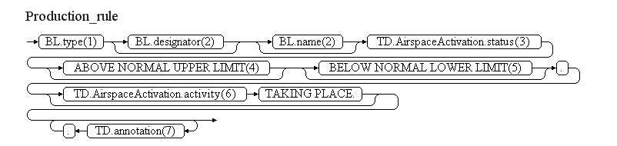
Reference | Rule
(1) | The area type shall be included according to the following decoding table:
  BL.type | Text recommended for item E
  P | "PROHIBITED AREA"
  R | "RESTRICTED AREA"
  D | "DANGER AREA"
  TSA | "TEMPORARY SEGREGATED AREA"
  TRA | "TEMPORARY RESERVED AREA"
  W | "WARNING AREA"
  A | "ALERT AREA"
  D-OTHER | "(WARNING) AREA"
  OTHER | "AREA"
  PROTECT | "PROTECTION AREA"
(2) | The designator and the name of the area shall be included if present in the BASELINE data
(3) | The activation status code shall be translated into readable text, as follows:  - ACTIVE => "ACTIVE"  - IN_USE => "IN USE"  - INTERMITTENT => "ACTIVE INTERMITTENTLY"
(4) | If the TD.AirspaceActivation includes an AirspaceLayer that has upperLimit bigger than the any of the BL.AirspaceGeometryComponent.upperLimit, then the following text shall be inserted here: "ABOVE NORMAL UPPER LIMIT". Otherwise, this item shall be left empty.
(5) | If the TD.AirspaceActivation includes an AirspaceLayer that has lowerLimit smaller than the any of the BL.AirspaceGeometryComponent.lowerLimit, then the following text shall be inserted here: "BELOW NORMAL LOWER LIMIT". Note that an " AND " shall be appended before this text if the condition stated in the previous rule is also met. Otherwise, this item shall be left empty.
(6) | The activity code shall be translated into readable text, as in the following examples:  - ACCIDENT => "FLIGHT ACCIDENT SITE"  - AERIAL_WORK => "AERIAL WORK"  - AEROBATICS => "AEROBATICS"  - AIR_DROP => "AIR DROP"  - AIR_GUN => "AIR GUN"  - AIRSHOW => "AIRSHOW"  - ANTI_HAIL => "ANTI HAIL MISSILES"  - ARTILLERY => "ARTILLERY ACTIVITIES"  - BALLOON => "BALLOON FLIGHTS"  - BIRD => "BIRD PRESENCE"  - BIRD_MIGRATION => "BIRD MIGRATION"  - BLASTING => "EXPLOSIVES BLASTING"  - CHEMICAL => "CHEMICAL HAZARD"  - CROP_DUSTING => "CROP SPRAYING"  - EXERCISE => "MILITARY EXERCISE"  - FAUNA => "FAUNA PROTECTION"  - FIRE_FIGHTING => "FIRE FIGHTING"  - FIREWORK => "FIREWORKS"  - GAS => "GAS HAZARD"  - GLIDING => "GLIDING ACTIVITIES"  - HANGGLIDING => "HANGGLIDING ACTIVITIES"  - HI_RADIO => "HIGH POWER RADIO TRANSMISSIONS"  - JET_CLIMBING => "JET CLIMBING"  - LASER => "LASER HAZARD"  - MILOPS => "MILITARY OPERATIONS"  - MISSILES => "MISSILES LAUNCHING"  - NATURE => "NATURE PROTECTION"  - NAVAL_EXER => "NAVAL EXERCISE"  - NO_NOISE => "NOISE PREVENTION"  - NUCLEAR => "NUCLEAR HAZARD"  - OIL => "OIL HAZARD"  - OTHER => "UNSPECIFIED HAZARD"  - OTHER:ACFT_FORMATION => "ACFT FORMATION"  - OTHER:ACFT_MASS_MOVEMENT => "MASS MOVEMENT OF ACFT"  - OTHER:AERIAL_SURVEY => "AERIAL SURVEY FLIGHTS"  - OTHER:BIO_HAZARD => "AIRBORNE SPREAD OF DESEASES"  - OTHER:CAPTIVE_BALLOON => "CAPTIVE BALLOON"  - OTHER:DEMOLITION => "DEMOLITION USING EXPLOSIVE DEVICES"  - OTHER:STRIKE => "INDUSTRIAL ACTION"  - OTHER:KITE => "KITE ACTIVITIES"  - OTHER:MODEL => "MODEL FLYING"  - PARACHUTE => "PARACHUTE JUMPING EXERCISE"  - PARAGLIDER => "PARAGLIDER ACTIVITIES"  - POPULATION => "POPULATION PROTECTION"  - RADIOSONDE => "RADIOSONDE ACTIVITIES"  - REFINERY => "REFINERY HAZARD"  - REFUEL => "AERIAL REFUELING"  - SHOOTING => "SHOOTING ACTIVITIES"  - SPACE_FLIGHT => "SPACE FLIGHT"  - SPORT => "SPORT FLIGHTS"  - TECHNICAL => "TECHNICAL ACTIVITIES"  - TOWING => "TOWING ACTIVITIES"  - TRAINING => "TRAINING ACTIVITIES"  - UAV => "UAV FLIGHTS"  - ULM => "ULM FLIGHTS"  - VIP => "VIP PROTECTION"  - VIP_PRES => "HEAD OF STATE PROTECTION"  - VIP_VICE => "VICE-HEAD OF STATE PROTECTION"  - WATER_BLASTING => "WATER BLASTING"
(7) | Annotations shall be translated into free text according to the following encoding rules.
Note: The objective is to full automatic generation, without human intervention. However, the implementers of the specification might consider reducing the cost of a fully automated generation by allowing the operator to fine-tune the text in order to improve its readability (with the inherent risk for human error, when re-typing is allowed).

Items F & G
The values to be inserted in item F and G depend on the values of the TD.activation.AirspaceActivation.levels.
- If lowerLimit="FLOOR" then item F shall get the lowest value between all BL.geometryComponent.lowerLimit of the parent Airspace;
- If lowerLimit has any other value, then item F shall get that value (including its reference and unit of measurement);
- If upperLimit="CEILING" then item G shall get the highest value between all BL.geometryComponent.upperLimit of the parent Airspace;
- If upperLimit has any other value, then item G shall get that value (including its reference and unit of measurement).
In all situations, the values in items F and G shall be formatted according to decoding rules for vertical limits.

Event Update
The eventual update of this type of event shall be encoded following the general rules for Event updates, which provide instructions for all NOTAM fields, except for item E and the condition part of the Q code, in the case of a NOTAMC
If a NOTAMC is produced, then the 4th and 5th letters (the "condition") of the Q code shall be "CN" and the following pattern should be used for automatically generating the E field text from the AIXM data:
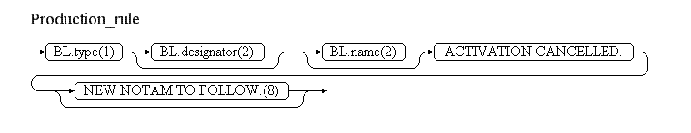
Reference | Rule
(8) | If the NOTAM will be followed by a new NOTAM concerning the same situation, then the operator shall have the possibility to specify "NEW NOTAM TO FOLLOW" and this text shall be appended at the end of item E of the NOTAM C.

Published ATS airspace - activation or deactivation [ATSA.ACT]

Definition
The activation or deactivation of published (pre-existing) CTR, CTA, TMA or similar airspaces.
Notes:
- the term "Published ATS Airspace" is used to encompass CTR, CTA, TMA or other airspaces of similar nature;
- this scenario includes both the temporary activation and the temporary deactivation of pre-existing ATS Airspace;
- this scenario includes the possibility to provide an activation schedule, but only "ACTIVE" times will be translated into NOTAM text;
- this scenario does not include the temporary modification of the ATS Airspace classification;
- this scenario does not include temporary modification of vertical limits of published ATS Airspace nor the activation beyond these vertical limits;
- this scenario does not include temporary modification of horizontal limits of published ATS Airspace nor the activation beyond these horizontal limits;
- this scenario does not include the permanent modification of activity status of published ATS Airspace.

Event data
The following diagram identifies the information items that are usually provided by a data originator for this kind of event.
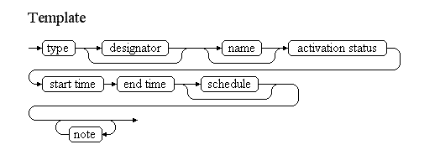
Examples of such events:
CTR DEAUVILLE ACTIVATION
CTR DEAUVILLE (LFRG) activated
On 16 JUNE 2010 from 03:45 till 20:00
Outside these hours, CTR downgraded to class G
CTR NEW BRIVE SOUILLAC DE-ACTIVATION
NEW BRIVE SOUILLAC CTR not active.
From 07 April 2010 23:59 till 14 June 2010 at 23:59
Class G Airspace.
EICM CTR HOURS OF SERVICE
CTR EICM
between 01 SEP 2007 at 06:50 and 09 SEP 2007 at 19:47
Hours of service as follows:
MON 0515-0700, 0810-1445, 1545-1900, 2010-2220
TUE 0515-0700, 0740-1445, 1545-1900, 2010-2220
WED 0515-0700, 0810-1445, 1545-1900, 2010-2220
THU 0515-0700, 0740-1415, 1500-1855, 1925-2220
FRI 0515-0700, 0810-1430, 1500-1900, 2010-2220
SAT 0650-0810, 1000-1530, 1630-1710, 1740-1900, 2005-2100
SUN 0735-0950, 1100-1640, 1730-1845, 1945-2220
REF AIP EICM AD 2.1
The table below provides more details about each information item contained in the diagram. It also provided the mapping of each information item within the AIXM 5.1 structure. The name of the variable (first column) is recommended for use as label of the data field in human-machine interfaces (HMI).
Data item | Description | AIXM mapping
type | The type of airspace concerned. Typical examples are CTR and TMA. | Airspace.type with this list of values CodeAirspaceType. Not to be encoded, just used to identify the airspace concerned.
designator | The published designator of the airspace concerned. If not provided, then the airspace is identified by its name. | Airspace.designator. Not to be encoded, just used to identify the airspace concerned.
name | The published name of the area. | Airspace.name. Not to be encoded, just used to identify the airspace concerned.
activation status | The activation/de-activation status. | Airspace/AirspaceActivation.status with this list of valuesCodeStatusAirspaceType
start time | The effective date & time when the activation/de-activation starts. This might be further detailed in a "schedule". | Airspace/AirspaceTimeSlice/TimePeriod.beginPosition, Event/EventTimeSlice.validTime/timePosition and Event/EventTimeSlice.featureLifetime/beginPosition
end time | The end date & time when the activation/de-activation ends. It might be an estimated value, if the exact end of activation is unknown. | Airspace/AirspaceTimeSlice/TimePeriod.endPosition and Event/EventTimeSlice.featureLifetime/endPosition also applying the rules forEvent with estimated termination
schedule | A schedule might be provided, in case the area is only active according to a regular timetable, within the period between the start time and the end time. | Airspace/AirspaceActivation/Timesheet/... according to the rules for Event Schedules
note | A free text note that provides further instructions concerning the area activation, such as the authority to be contacted for further information, the possibility of crossing at ATC discretion, etc. | Airspace/AirspaceActivation.annotation according to the rules for encoding annotations
Notes:
- It is recommended that data input applications allow the operator to visualise graphically the horizontal shape and the vertical extent of the ATS airspace activation, in the context of the overall airspace structure of the region. If a schedule is used, the graphical interface should also have a "time slider" that allows the operator to see when the airspace is actually active;

Assumptions for baseline data
- It is assumed that information about the area already exists in the form of an Airspace Baseline, which contains as a minimum the horizontal shape of the airspace, its vertical limits, its designator and its type;
- If the Baseline data includes a schedule associated with the AirspaceActivation, then this should not leave any gaps. If any gaps exist, then the status of the AirspaceActivation at the levels/times concerned is considered "undefined". See the AIXM Temporality Concept (versions 1.0) sections 3.4 and 3.5;
- If an area has sectors, it is assumed that each sector was encoded separately, as an airspace with its own designator, so that it can be activated individually. The collapsed area should not exist as a Baseline airspace, just the sectors. If the area becomes active, the digital data encoding should activate the individual sectors as part of one event;
- If the Airspace concerned has BASELINE type=CLASS, then it is assumed that it contains a single AirspaceLayerClass child element. Otherwise, the algorithm for the automatic generation of the item E will not work properly.

Data encoding rules
The data encoding rules provided in this section shall be followed in order to ensure the harmonisation of the digital encodings provided by different sources. The compliance with some of these encoding rules can be checked with automatic data validation rules (see next section).
Identifier | Data encoding rule
ER-01 | The activation of an airspace shall be encoded as:  - a new Event, for which PERMDELTA and subsequent BASELINE TimeSlice shall be created; and  - a TimeSlice of type TEMPDELTA for the corresponding Airspace feature, for which the "event:theEvent" property points to the Event instance created above; the TEMPDELTA shall contain one or more AirspaceActivation objects.
ER-02 | The Airspace TEMPDELTA should use the values "FLOOR, uom=OTHER" for lowerLimit and "CEILING, uom=OTHER" for the upperLimit of the AirspaceLayer property associated with the AirspaceActivation.
ER-03 | If the area activation/de-activation is limited to a discrete schedule within the overall time period between the "start time" and the "end time", then this shall be encoded using as many as necessary timeInterval/Timesheet properties for the AirspaceActivation of the Airspace TEMPDELTA Timeslice. See the rules for Event Schedules. It is recommended that the HMI of a data provider application allows to provide a schedule only in relation with active times, because only these will be translated into NOTAM text.
ER-04 | In accordance with the AIXM Temporality Concept (see sections 3.4 and 3.5 in version 1.0), the AirspaceActivation associated with the TEMPDELTA completely replaces all the BASELINE AirspaceActivation information, during the TEMPDELTA time of applicability. Therefore, if the activation/deactivation only concerns certain times, then the other times (when the airspace eventually remains with the same status as in the Baseline data) shall be explicitly included in the TEMPDELTA. The calculation of the necessary additional AirspaceActivation elements to be included in the TEMPDELTA shall be automatically done by the applications implementing this specification. All AirspaceActivation elements that are copied from the BASELINE data for completeness sake shall get an associated Note with purpose=REMARK and the text="Baseline data copy. Not included in the NOTAM text generation". This is based on the current NOTAM practice which consists of including in the NOTAM only the changed information and not explicitly including the static data that remains valid during the NOTAM applicability. It is recommended that the input interface provides a "calendar/level" view of the airspace activity, enabling the operator to graphically check the status of the airspace at different times and levels, such as in the example below: 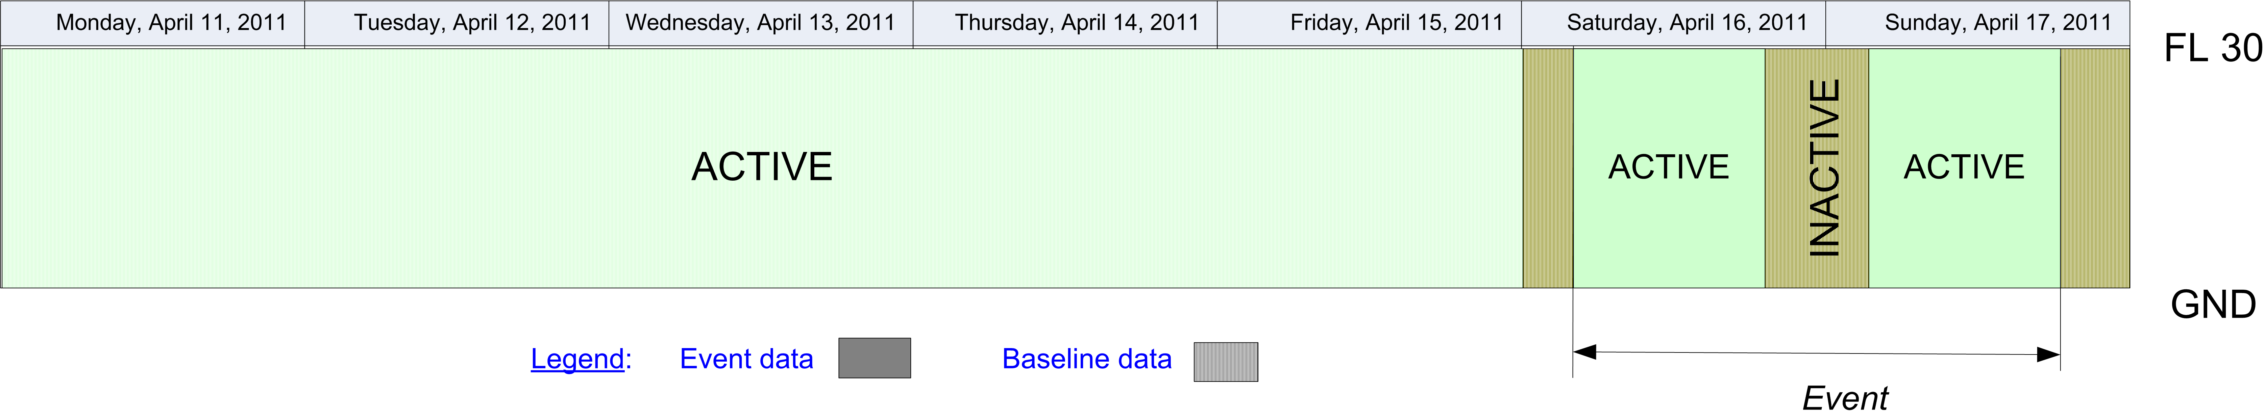In the calendar view, the Baseline information that remains valid during the Event validity time shall be visibly identified from the information that is specific to the Event, for example by using a different colour fill pattern.

Automatic data validation rules
These validation rules apply to the AIXM encoded data:
Title | Definition | Category | Error level
Minimal data requirements | As a minimum, in addition to the AIXM mandatory properties gml:validTime and aixm:interpretation, the Airspace TEMPDELTA TimeSlice shall contain at least aixm:sequenceNumber and one aixm:activation element with at least the aixm:status, aixm:upperLimit, aixm:lowerLimit descendant elements specified (not NIL). | Minimal data | error
Non-duplication with other Events | There should not exist another Airspace TEMPDELTA with an overlapping (partially or totally) gml:validTime and which also contains aixm:activation elements. | Data consistency | warning
Airspace type consistent with the scenario | The value of the Airspace BASELINE aixm:type shall be either "CTA", "CTA_P", "OCA", "OCA_P", "UTA", "UTA_P", "TMA", "TMA_P", "CTR", "CTR_P", "OTA", "OTA_P", "SECTOR", "SECTOR_C", "RAS", "ADIZ", "CLASS", "ADV", "UADV", "ATZ", "ATZ_P", "HTZ", "OTHER:TIA", "OTHER:TIZ" or "OTHER:FIZ" (as any other value would be in conflict with the purpose of this scenario). | Data consistency | error
Schedule requires ACTIVE times to be specified | If in the TEMPDELTA Airspace data includes one or more activation elements associated with one or more aixm:timeInterval (schedules), then at least one of these shall have the aixm:status="ACTIVE". | Minimal data | error
Activation inside pre-defined schedule | If in the BASELINE Airspace data includes one or more activation elements with the aixm:status="AVBL_FOR_ACTIVATION" associated with one or more aixm:timeInterval (schedules), then the time periods described by Airspace TEMPDELTA TimeSlice (gml:validTime and the eventual included aixm:timeInterval when the aixm:status="ACTIVE") shall be within time defined by the BASELINE schedule | Data consistency | warning
Baseline data copy correctness | For each AirspaceActivation included in the TEMPDELTA that has an associated annotation with purpose=REMARK and the text="Baseline data copy. Not included in the NOTAM text generation", there shall exist an equivalent AirspaceActivation in the BASELINE data, having:  - the same aixm:activity and aixm:status;  - equal or smaller aixm:level/lowerLimit value;  - equal or higher aixm:levels/upperLimit value;  - an encompassing aixm:timeInterval. | Data consistency | error

Text NOTAM Production Rules
This section provides rules for the automated production of the text NOTAM message items, based on the AIXM 5.1 data encoding of the Event. Therefore, AIXM specific terms are used, such as names of features and properties, types of TimeSlices, etc:
- the abbreviation BL. indicates that the corresponding data item must be taken from the Airspace BASELINE, which is valid at the start time of the Event;
- the abbreviation TD. indicates that the corresponding data item must be taken from the Airspace TEMPDELTA that was created for the Event.
  - Important note: According to encoding rule ER-04, the TEMPDELTA might also include AirspaceActivation elements that have been copied from the BASELINE data for compliance with the AIXM Temporality rules. The current practice is to not include such static information in the NOTAM text. Therefore, all AirspaceActivation that have an associated annotation with purpose=REMARK and the text="Baseline data copy. Not included in the NOTAM text generation" shall be excepted from the text NOTAM generation algorithm!
In general, the ICAO DOC 8126 and the OPADD rules shall be followed. These have not been copied in this document in order to avoid duplication with those documents. Only instructions that are specific to the AIXM encoding of this event are stated here.

Item A
The item A shall be generated according to the geographical location of the Airspace, following the ICAO DOC 8126 and the OPADD rules.
Notes:
- If BL.type=CTR, then item A shall contain the ICAO code of the airport that is located in the CTR and that has the same designator as the Airspace. It is assumed that CTR have the same ICAO designator as the main airport within the CTR;
- If BL.type=TMA, then the current practice in many States is to publish as many as necessary airport NOTAM, with the corresponding airport designator(s) in item A. This ensures that the corresponding NOTAM will appear in the airport section of the Pre-Flight Information Bulletins (PIB), for the concerned airport.

Q code
The following mapping shall be used:
TD.AirspaceActivation values | Recommended Q code
a unique BL.AirspaceActivation with status=INACTIVE
  BL.type | code
  CTR or CTR_P | QACCD
  ADIZ | QADCD
  CTA or CTA_P | QAECD
  UTA or UTA_P | QAHCD
  OCA or OCA_P | QAOCD
  TMA or TMA_P | QATCD
  ADV | QAVCD
  UDAV | QAVCD
  ATZ or ATZ_P | QAZCD
  any other | QXXCD
at least one BL.AirspaceActivation with status=ACTIVE
  BL.type | code
  CTR or CTR_P | QACCA
  ADIZ | QADCA
  CTA or CTA_P | QAECA
  UTA or UTA_P | QAHCA
  OCA or OCA_P | QAOCA
  TMA or TMA_P | QATCA
  ADV | QAVCA
  UDAV | QAVCA
  ATZ or ATZ_P | QAZCA
  any other | QXXCA

Items B, C and D
- In item B, insert the value of the TD.validTime.TimePeriod.beginPosition formatted according to the NOTAM syntax for this field: yymmddhhmm;
- In item C, insert the value of the TD.validTime.TimePeriod.endPosition formatted according to the NOTAM syntax for this field: yymmddhhmm.
- If TD.validTime.TimePeriod.endPosition@indeterminatePosition has the value "unknown", "before" or "after" (the Event has an estimated end of validity), then append "EST" at the end of the item C value.
- Item D shall be left empty. An eventual schedule shall be decoded in item E.

Item E
One of the following patterns should be used for automatically generating the E field text from the AIXM data:
De-activation: If TD.AirspaceActivation contains a single BL.AirspaceActivation and this one has status=INACTIVE
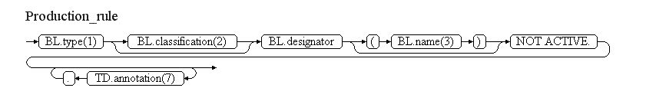
Activation (eventually with schedule): If TD.AirspaceActivation contains at least one BL.AirspaceActivation with status=ACTIVE
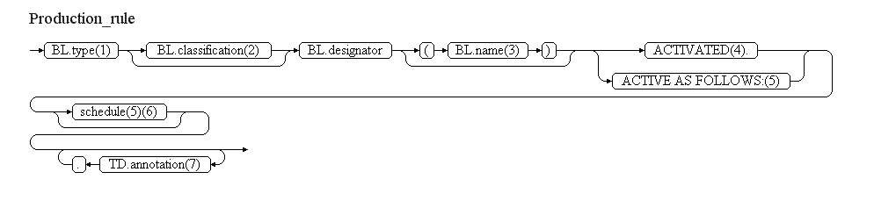
Reference | Rule
(1) | The area type shall be included according to the following decoding table:
  BL.type | Text recommended for item E
  CTA | "CONTROL AREA"
  CTA_P | "PART OF CONTROL AREA"
  OCA | "OCEANIC CONTROL AREA"
  OCA_P | "PART OF OCEANIC CONTROL AREA"
  UTA | "UPPER CONTROL AREA"
  UTA_P | "PART OF UPPER CONTROL AREA"
  TMA | "TMA"
  TMA_P | "PART OF TMA"
  CTR | "CTR"
  CTR_P | "PART OF CTR"
  OTA | "OCEANIC TRANSITION AREA"
  SECTOR | "ATS SECTOR"
  SECTOR_C | "COLLAPSED ATS SECTOR"
  RAS | "REGULATED ATS AIRSPACE"
  ADIZ | "ADIZ"
  CLASS | "AIRSPACE CLASS"
  ADV | "ADVISORY AREA"
  UADV | "UPPER ADVISORY AREA"
  ATZ | "AIRPORT TRAFFIC ZONE"
  ATZ_P | "PART OF AIRPORT TRAFFIC ZONE"
  HTZ | "HELICOPTER TRAFFIC ZONE"
  OTHER:TIA | "TRAFFIC INFORMATION AREA"
  OTHER:TIZ | "TRAFFIC INFORMATION ZONE"
  OTHER:FIZ | "FLIGHT INFORMATION ZONE"
(2) | If BL.type=CLASS, then insert the value of the classification attribute
(3) | The name of the area shall be included if present in the BASELINE data
(4) | Use this element if there exists a unique TD.AirspaceActivity and it has status=ACTIVE
(5) | Use these elements if there exist more than one TD.AirspaceActivity (some with status=ACTIVE, some with status=INACTIVE)
(6) | Collect all TD.activation.AirspaceActivation.timeInterval that are associated with TD.AirspaceActivation with status=ACTIVE and decode according to the general decoding rules for Event schedules
(7) | Annotations shall be translated into free text according to the following encoding rules.
Note: The objective is to full automatic generation, without human intervention. However, the implementers of the specification might consider reducing the cost of a fully automated generation by allowing the operator to fine-tune the text in order to improve its readability (with the inherent risk for human error, when re-typing is allowed).

Items F & G
Item F and item G shall be left empty.
Note: Values for item F & G are only required for Navigation Warnings (QW) and Airspace Reservations (QR). Inclusion of applicable vertical limits in Item E) for changes of Airspace organisation (QA) can be considered, but is not applicable for this scenario as it does not cover modification of vertical changes.

Event Update
The eventual update of this type of event shall be encoded following the general rules for Event updates, which provide instructions for all NOTAM fields, except for item E and the condition part of the Q code, in the case of a NOTAMC
If a NOTAMC is produced, then the 4th and 5th letters (the "condition") of the Q code shall be "CN" and the following pattern should be used for automatically generating the E field text from the AIXM data:
- De-activation cancelled: If TD.AirspaceActivation contains a single BL.AirspaceActivation and this one has status=INACTIVE 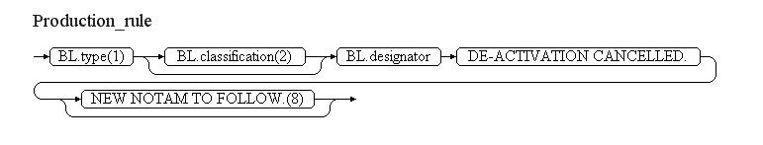
- Activation cancelled: If TD.AirspaceActivation contains at least one BL.AirspaceActivation with status=ACTIVE
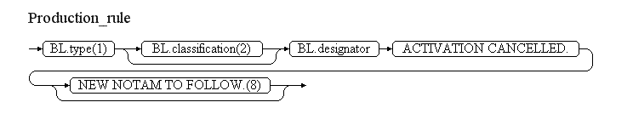

Reference | Rule
(8) | If the NOTAM will be followed by a new NOTAM concerning the same situation, then the operator shall have the possibility to specify "NEW NOTAM TO FOLLOW" and this text shall be appended at the end of item E of the NOTAM C.

Ad-hoc special activity area – creation [SAA.NEW]

Definition
The establishment of a new restricted, dangerous, prohibited, etc. area or navigation warning, which did not exist as a published (static data) airspace.
Notes:
- the term "special activity area" is used in order to encompass P, D, R and other areas of similar nature;
- this scenario does not include the establishment of temporary ATS airspace (such as a temporary CTR or airspace with a specified class); see the dedicated scenario: Ad-hoc ATS airspace - creation;
- the creation of a permanent D or R area by NOTAM shall be an exceptional situation, as such events are expected to be managed as static data amendments. However, this is supported in this scenario as the same data requirements and rules apply and it helps ensuring that all the airspace created by NOTAM are made available digitally, not only the temporary ones;
- this scenario does not support the use of geographical or administrative features (such as State borders, rivers, sea shores, etc.) in the definition of horizontal projection. If operationally necessary, this can by done by providing a simplified polygon larger than the area and excluding a neighboring FIR, for example.
- this scenario does not cover the encoding of mobile airspace reservations, such as for aerial refueling areas that move along a specified trajectory.

Event data
The following diagram identifies the information items that are usually provided by a data originator for this kind of event.
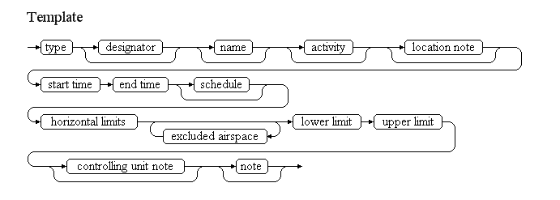

Examples of such events:
Restricted area North of Sjaellands Odde
TEMPORARY RESTRICTED AREA IS ESTABLISHED
daily from 08:00-17:00 between 07 NOV and 17 NOV
AS FOLLOWS NORTH OF SJAELLANDS ODDE:
560028N 0111656E - 560643N 0111026E - 561500N 0112400E -
561500N 0113600E -560112N 0114736E - 555730N 0113830E - 560028N 0111656E.
between SFC and 60000 FT AMSL
RELEVANT ATS UNITS REF. AIP DENMARK ENR 5.1 ITEM 3:
AARHUS APP/TWR, ACC KOEBENHAVN.
Danger Area due to SAR activity
TEMPORARY DANGER AREA.
OWING TO THE EMERGENCY AT GLYDER FACH A TEMPORARY DANGER AREA TO BE KNOWN AS EGD399Q HAS BEEN ESTABLISHED
ON 29 JUN 2010 from 17:31 TILL 19:00
BY A CIRCLE RADIUS 3NM CENTERED ON 5306N 00400W.
BETWEEN SFC and 500 FT AMSL
TO ENSURE THEIR OWN SAFETY AND TO AVOID INTERFERENCE WITH CONTROL AND SAR ACTIVITES, PILOTS ARE URGENTLY REQUESTED NOT TO FLY IN OR NEAR THE AREA WITHOUT THE PERMISSION OF AERONAUTICAL RESCUE AND COORDINATION CENTRE EMERGENCY CONTROLLING AUTHORITY) TELEPHONE 01309 678302/678303. PILOTS ARE FURTHER WARNED THAT ACTION MAY BE TAKEN AT ANY TIME TO IMPOSE RESTRICTIONS OF FLYING REGULATIONS UNDER ARTICLE 161 OF THE AIR NAVIGATION ORDER 2009. ATC UNITS CLOSE TO THE INCIDENT AREA ARE REQUESTED TO ADVISE ACFT ON THEIR FREQUENCIES OF THE CONTENTS OF THIS NOTAM.
Danger Area within RAPTOR ATCAA
DANGER AREA ACTIVATED
On 30 JUN 2010 from 21:00 till 22:45
Within the following airspace: 2802N8500W TO 2805N8331W TO 2706N8331W TO 2720N8500W TO BEGINNING
From FL400 to FL600
RAPTOR ATCAA
Aerobatics at Pferdsfeld
AEROBATICS VMC on 07 OCT from 1330 till 1430
2NM AROUND 4952N 00737E PFERDSFELD 10NM E KIRN VOR KIR)
between GND and 6000FT AMSL)
The table below provides more details about each information item contained in the diagram. It also provided the mapping of each information item within the AIXM 5.1 structure. The name of the variable (first column) is recommended for use as label of the data field in human-machine interfaces (HMI).
Data item | value | AIXM mapping
type | The type of area, although this is not always explicit; it may be implicit, due to the kind of activity taking place. Typical examples are D (danger), R (restricted), P (prohibited), D-OTHER (other activity of dangerous nature). | Airspace.type with this list of values CodeAirspaceType
designator | A designator allocated to the area. However, it is unlikely that such designators are provided by the data originator. It is more likely that the designator will be allocated by the publication office. | Airspace.designator
name | The name of a geographical feature or location, which is also used for identifying the area | Airspace.name
activity | The kind of activity that takes place in the area | Airspace/AirspaceActivation.activity with this list of values CodeAirspaceActivityType. See also the Q code mapping rules for NOTAM generation further down, which indicate additional "OTHER:..." values for this data item.
start time | The effective date & time when the area becomes established and active. This might be further detailed in a "schedule". | Airspace/AirspaceTimeSlice.featureLifetime/beginPosition, Airspace/AirspaceTimeSlice/validTime/timePosition, Event/EventTimeSlice.validTime/timePosition and Event/EventTimeSlice.featureLifetime/beginPosition
end time | The end date & time when the area ceases to exist. It might be an estimated value, if the exact end of activation is unknown. It may also be indeterminate for a permanent area. | Airspace/AirspaceTimeSlice.featureLifetime/endPosition Event/EventTimeSlice.featureLifetime/endPosition also applying the rules for Event with estimated termination
schedule | A schedule might be provided in case the area is only active according to a regular timetable, within the overall period when it exists. | Airspace/AirspaceActivation/Timesheet/... according to the rules for Event Schedules
location note | A free text note that indicates the location of the area in relation with relevant geographical or aeronautical features, such as "NORTH OF SJAELLANDS", "10NM E KIRN VOR KIR", "INSIDE DONLON TMA", etc. | Airspace.annotation with propertyName="geometryComponent" and purpose="REMARK"
horizontal limit | The horizontal shape of the area or of one of its composing volumes (if the area is an aggregation of different volumes with different vertical limits). | Airspace/AirspaceVolume.horizontalProjection following the guidelines for the encoding of geometrical and geographical data. The AirspaceGeometryComponent shall have operation="BASE" and operationSequence="1". Only geometries of type Polygon, Circle or Corridor are allowed in this scenario."
excluded airspace | A reference (type, designator, name) to one or more airspace that are excluded (subtracted) from the volume described by the aggregation of the horizontal limits specified for the area; for example: "EXCLUDING THE HEATHROW CTR". | Airspace/AirspaceVolume.contributorAirspace
lower limit | The lower limit (value, unit of measurement and vertical reference) of the area. | Airspace/AirspaceVolume.lowerLimit and lowerLimitReference
upper limit | The upper limit (value, unit of measurement and vertical reference) of the area. | Airspace/AirspaceVolume.upperLimit and upperLimitReference
controlling unit note | A free text note that provides information about the unit or service that controls the area or that can authorise the penetration of the area. | Airspace/AirspaceActivation.annotation with propertyName="status" and purpose="REMARK"
note | A free text note that provides further instructions concerning the special activity area area, such as about possible future changes to the area, detailed description of the reason that led to the area establishment, etc. | Airspace/AirspaceActivation.annotation according to the rules for encoding annotations
Notes:
- It is recommended that data input applications allow the operator to visualise graphically the horizontal shape and the vertical extent of the special activity area. If a schedule is used, the graphical interface should also have a "time slider" that allows the operator to see when the area is actually active.

Assumptions for baseline data
- It is assumed that no baseline data exists for this area.

Data encoding rules
The data encoding rules provided in this section shall be followed in order to ensure the harmonisation of the digital encodings provided by different sources. The compliance with some of these encoding rules can be checked with automatic data validation rules (see next section).
Identifier | Data encoding rule
ER-01 | The special activity area shall be encoded as:  - a new Event, for which PERMDELTA and subsequent BASELINE TimeSlices shall be created; and  - a new Airspace, for which PERMDELTA and subsequent BASELINE TimeSlices shall be created; the property "event:theEvent" of the Airspace TimeSlices shall refer to the Event mentioned above.
ER-02 | The Airspace BASELINE shall contain one AirspaceActivation object with status=ACTIVE, IN_USE or INTERMITTENT (as appropriate) which shall also include the "activity" data and the values "FLOOR, uom=OTHER" for lowerLimit and "CEILING, uom=OTHER" for the upperLimit of the associated AirspaceLayer.
ER-03 | If the area activity is limited to a discrete schedule within the overall time period between the "start time" and the "end time", then this shall be encoded using as many as necessary timeInterval/Timesheet properties for the AirspaceActivation with status ACTIVE/IN_USE/INTERMITTENT of the BASELINE Timeslice. See also the rules for Event Schedules.
ER-04 | If a schedule is provided, then the Airspace BASELINE shall contain a second AirspaceActivation object with status=INACTIVE, which shall explicitly specify the times not covered by the activity schedule. This shall be done automatically by the system and should not be visible to the operator. The "INACTIVE" times shall not be translated into NOTAM text. See also the rules for Event Schedules.
ER-05 | If one or more "exclude airspace" are specified, each shall be encoded as an AirspaceGeometryComponent with operation=SUBTR, operationSequence as dictated by the order of the element, contributorAirspace/AirspaceVolumeDependency.dependency=FULL_GEOMETRY and pointing to the airspace concerned. In addition, when the AIXM 5.1 encoded data is provided to a client, the data corresponding to the AirspaceVolume(s) of the controbutorAirspace (lowerLimit, lowerLimitReference, upperLimit, upperLimitReference, horizontalProjection, etc.) shall be copied in the AirspaceVolume(s) of the current Airspace. This will provide a complete description of the current Airspace, eliminating the need to traverse the xlink:href in order to get the full geometrical information.
ER-06 | The activity types that do not match a pre-defined value in the CodeAirspaceActivityType shall be encoded as follows:  - captive balloon -> activity=OTHER:CAPTIVE_BALLOON  - kite activities -> activity=OTHER:KITE  - demolition using explosive devices -> activity=OTHER:DEMOLITION  - mass movement of aircraft ->activity=OTHER:ACFT_MASS_MOVEMENT  - flying in formation -> activity=OTHER:ACFT_FORMATION  - aerial survey/photogrammetric flights -> activity=OTHER:AERIAL_SURVEY  - model flying -> OTHER:MODEL  - airborne spread of diseases -> activity=OTHER:BIO_HAZARD  - industrial action -> activity=OTHER:STRIKE  - volcanic activity, possibly indication imminent eruption -> activity=OTHER:VOLCANO_ACTIVE  - confirmed volcanic eruption -> activity=OTHER:VOLCANO_ERUPTION  - volcanic ash area of high contamination -> activity=OTHER:ASH_HIGH  - volcanic ash area of medium contamination -> activity=OTHER:ASH_MEDIUM  - volcanic ash area of low contamination -> activity=OTHER:ASH_LOW  - unspecified hazard -> activity=OTHER
ER-07 | If the type is not provided by the data originator, then the following encoding rules shall be applied in order to give a value to "type" attribute of the Airspace BASELINE TimeSlice:  - if the notes encoded for the area indicate that the area is "prohibited", "compulsory bypass", "no fly zone" or equivalent for certain flights or aircraft, partially or totally, then the type "P" shall be allocated;  - if the notes encoded for the area indicate that the area may be crossed following approval from a specified authority, then type "R" shall be allocated;  - if the activity encoded is one of the following, then the type "D-OTHER" shall be allocated: AERIAL_WORK, CROP_DUSTING, FIRE_FIGHTING, NAVAL_EXER, BIRD, BIRD_MIGRATION, LASER, HI_RADIO, HI_LIGHT, SPORT, AEROBATICS, TRAINING, JET_CLIMBING, REFUEL, GLIDING, BLASTING, WATER_BLASTING, BALLOON, RADIOSONDE, TOWING, MISSILES, AIR_GUN, ARTILLERY, SHOOTING, ANTI_HAIL, FIREWORK, SPACE_FLIGHT, PARACHUTE, PARAGLIDER, HANGGLIDING, ULM, AIR_DROP, CHEMICAL, NUCLEAR, REFINERY, TECHNICAL, GAS, OIL, UAV, OTHER:DEMOLITION, OTHER:CAPTIVE_BALLOON, OTHER:KITE, OTHER:ACFT_MASS_MOVEMENT, OTHER:ACFT_FORMATION, OTHER:AERIAL_SURVEY, OTHER:VOLCANO_ACTIVE, OTHER:VOLCANO_ERUPTION, OTHER:ASH_HIGH, OTHER:ASH_MEDIUM, OTHER:ASH_LOW, OTHER:MODEL;  - if the activity encoded is one of the following, then the type "PROTECT" shall be allocated: ACCIDENT, POPULATION, NATURE, FAUNA, NO_NOISE, VIP, VIP_PRES, VIP_VICE;
ER-08 | It is recommended that an alphanumeric designator is allocated to a temporary area, in order to facilitate it's identification on graphical representations (such as airspace activity maps) and verbal communication. The composition rule is derived from the ICAO Annex 15 rules for P, D, R area designators: CCLnnnn-yy, where:  - CC is the Country Code; this could be expanded into a full FIR identifier if necessary to have a finer granularity of the airspace reference;  - L is a letter that corresponds to the area type;  - nnnn is a number, unduplicated during the same year, within the State or territory concerned; this could also be the NOTAM number;  - yy are the last two digits of the year date when the area becomes effective.

Automatic data validation rules
These validation rules apply to the AIXM encoded data:
Title | Definition | Category | Error level
Minimal data requirements | As a minimum, in addition to the AIXM mandatory properties gml:validTime and aixm:interpretation, the Airspace BASELINE TimeSlice shall contain at least aixm:sequenceNumber, aixm:type, aixm:geometryComponent (including aixm:horizontalProjection, aixm:lowerLimit, aixm:lowerLimitReference, aixm:upperLimit, aixm:upperLimitReference) and at least one aixm:activation element with at least the aixm:status descendant element specified (not NIL). | Minimal data | error
Non-duplication with other Events | There should not exist another Airspace BASELINE with the same aixm:geometryComponent and an overlapping (partially or totally) gml:validTime. | Data consistency | warning
Activity consistent with scenario | The value of the aixm:activity (activity taking place) shall be not have the values "AD_TFC", "HELI_TFC" "ATS", "PROCEDURE" (as these values are specific to the Ad-hoc ATS Airspace establishment scenario). | Data consistency | error
PJE not allowed within TMA/CTR | If aixm:type=PJE, then the geometry of the area should not intersect the geometry of an existing Airspace with type "CTR" or "TMA". (Note that this is an example of an operational rule observed in some States. The initial version of this specification does not contain many such rules. Many more such operational rules are expected to be identified with the time and added as additional data quality checks.) | Operational rule | warning
Uniqueness of designator | There should not exist any other Airspace with the same aixm:designator value. (Note that this is an example of an operational rule observed for P, D, R areas and which can be extended to ad-hoc areas that get a temporary designator. The initial version of this specification does not contain many such rules. Many more such operational rules are expected to be identified with the time and added as additional data quality checks.) | Operational rule | warning

Text NOTAM production rules
This section provides rules for the automated production of the text NOTAM message items, based on the AIXM 5.1 data encoding of the Event. Therefore, AIXM specific terms are used, such as names of features and properties, types of TimeSlices, etc:
- the abbreviation BL. indicates that the corresponding data item must be taken from the Airspace BASELINE that is created by the Event;
In general, the ICAO DOC 8126 and the OPADD rules shall be followed. These have not been copied in this document in order to avoid duplication with those documents. Only instructions that are specific to the AIXM encoding of this event are stated here.

Several NOTAM possible
Note that if an ad-hoc special activity area is located in the vicinity of one or more airports or affects more than one FIR, there are special provision in the OPADD (v3.0, section 2.3.9.2) with regard to the NOTAM that need to be issued in order to ensure that the NOTAM appear correctly in the relevant en-route and airport Pre-Flight Information Bulletins (PIB). From a Digital NOTAM point of view, this requires that an Event can have several NOTAM associated, which is supported by the AIXM Event schema. In order to facilitate the work of the operator, the Digital NOTAM data provider interface should include the following functionality:
- automatically identify the FIR in which the area is located and if more than one is found, generate a NOTAM with scope W and with all the FIR identified in item A;
- automatically identify CTR and TMA that are intersected by the area; then identify the AirportHeliport that are located in those CTR/TMA and that also have a value for their locationIndicatorICAO attribute; according to the OPADD rules, propose that a single NOTAM with scope AW and/or additional NOTAM with scope A are issued for these airports;
- if the area does not intersect any TMA or CTR but it's lowerLimit is equal or less than 1000 FT from SFC, then automatically identify the AirportHeliport that have their ARP (reference point) located within 5 NM (this might need to be a configurable parameter) and also have a value for their locationIndicatorICAO attribute; according to the OPADD rules, propose that a single NOTAM with scope AW and/or additional NOTAM with scope A are issued for these airports;
In all situations, the operator shall be allowed to take the final decision by selecting the airports/FIR for which a NOTAM is really generated. This might include additional ones, which have not been identified automatically by the spatial checks but have an operationally significant relation with the area.

Item A
The item A shall be generated according to the geographical location of the Airspace, following the ICAO DOC 8126 and the OPADD rules.

Q code
The following mapping shall be used:
BL.type | BL.AirspaceActivation.activity | Recommended Q code
P | any (except MILOPS) | QRPCA
R | any (except MILOPS) | QRRCA
D | any (except MILOPS) | QRDCA
TSA | any (except MILOPS) | QRRCA or QRTCA
TRA | any (except MILOPS) | QRRCA or QRTCA
any | MILOPS | QRMLP
W | any | QWELW
D-OTHER, A or OTHER | AERIAL_WORK, OTHER:AERIAL_SURVEY, CROP_DUSTING, FIRE_FIGHTING, BIRD, BIRD_MIGRATION, LASER, HI_RADIO, HI_LIGHT | QRDCA
D-OTHER, A or OTHER | none specified | QRDCA
D-OTHER, A or OTHER | AIRSHOW | QWALW
D-OTHER, A or OTHER | SPORT, AEROBATICS | QWBLW
D-OTHER, A or OTHER | EXERCISE, NAVAL_EXER, TRAINING, JET_CLIMBING | QWELW
D-OTHER, A or OTHER | REFUEL | QWFLW
D-OTHER, A or OTHER | GLIDING | QWGLW
D-OTHER, A or OTHER | BLASTING, WATER_BLASTING | QWHLW
D-OTHER, A or OTHER | BALLOON, RADIOSONDE | QWLLW
D-OTHER, A or OTHER | TOWING | QWJLW
D-OTHER, A or OTHER | MISSILES, AIR_GUN, ARTILLERY, SHOOTING, ANTI_HAIL, FIREWORK, SPACE_FLIGHT | QWMLW
D-OTHER, A or OTHER | PARACHUTE, PARAGLIDER, HANGGLIDING, ULM, AIR_DROP | QWPLW
D-OTHER, A or OTHER | CHEMICAL, NUCLEAR, REFINERY, TECHNICAL | QWRLW
D-OTHER, A or OTHER | GAS, OIL | QWSLW
D-OTHER, A or OTHER | UAV | QWULW
D-OTHER, A or OTHER | OTHER:DEMOLITION | QWDLW
D-OTHER, A or OTHER | OTHER:CAPTIVE_BALLOON, OTHER:KITE | QWCLW
D-OTHER, A or OTHER | OTHER:ACFT_MASS_MOVEMENT | QWTLW
D-OTHER, A or OTHER | OTHER:ACFT_FORMATION | QWVLW
D-OTHER, A or OTHER | OTHER:VOLCANO_ACTIVE, OTHER:VOLCANO_ERUPTION, OTHER:ASH_HIGH, OTHER:ASH_MEDIUM, OTHER:ASH_LOW | QWWLW
D-OTHER, A or OTHER | OTHER:MODEL | QWZLW
PROTECT | NATURE, FAUNA, NO_NOISE, ACCIDENT, POPULATION, VIP, VIP_PRES, VIP_VICE | QROLP
Notes:
- In the situations where two or more Q code alternatives are provided in the table above, the first one should be used as default in a data provider interface. The operator shall have the possibility to select an alternative one or even to change it completely (for example, by using "XX").

Items B, C and D
- In item B, insert the value of the BL.validTime.TimePeriod.beginPosition formatted according to the NOTAM syntax for this field: yymmddhhmm;
- If BL.validTime.TimePeriod.endPosition is NIL and BL.validTime.TimePeriod.endPosition@indeterminatePosition has the value "unknown" (the area is permanent), then insert "PERM" as item C value.
- If BL.validTime.TimePeriod.endPosition is not NIL, then insert its value in item C formatted according to the NOTAM syntax for this field: yymmddhhmm.
- If BL.validTime.TimePeriod.endPosition is not NIL and BL.validTime.TimePeriod.endPosition@indeterminatePosition has the value "unknown", "before" or "after" (the Event has an estimated end of validity), then append "EST" at the end of the item C value.
- If at least one BL.activation.AirspaceActivation.timeInterval exists (the Event has an associated schedule), then it shall be represented in item D according to the general NOTAM conversion rules for Event schedules.
  - Important Note: timeInterval(s) that appear as child of BL.activation.AirspaceActivation with status=INACTIVE shall not be translated (because this was created for the completeness of the digital data encoding, see rule ER-04.

Item E
The following pattern should be used for automatically generating the E field text from the AIXM data:
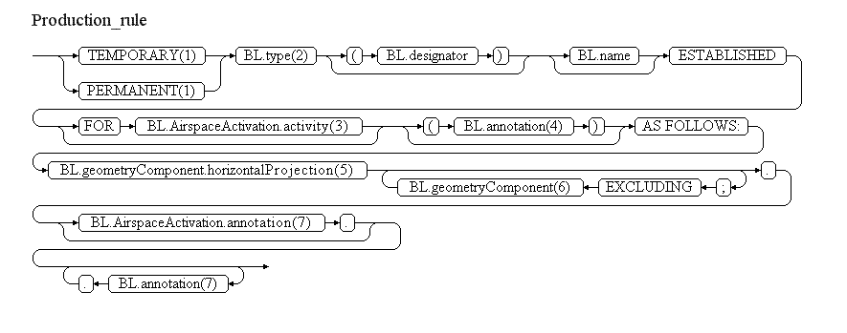

Reference | Rule
(1) | If BL.validTime.TimePeriod.endPosition is NIL and BL.validTime.TimePeriod.endPosition@indeterminatePosition has the value "unknown" (the area is permanent), then insert the word "PERMANENT". Otherwise insert the word "TEMPORARY".
(2) | The area type shall be included according to the following decoding table:
  BL.type | Text recommended for item E
  P | "PROHIBITED AREA"
  R | "RESTRICTED AREA"
  D | "DANGER AREA"
  D-OTHER | "(WARNING) AREA"
  TSA | "SEGREGATED AREA"
  TRA | "RESERVED AREA"
  W | "WARNING AREA"
  A | "ALERT AREA"
  PROTECT | "PROTECTION AREA"
  OTHER | "AREA"
(3) | The activity, if specified, shall be translated into readable text, as in the following examples:  - ACCIDENT => "FLIGHT ACCIDENT SITE"  - AERIAL_WORK => "AERIAL WORK"  - AEROBATICS => "AEROBATICS"  - AIR_DROP => "AIR DROP"  - AIR_GUN => "AIR GUN"  - AIRSHOW => "AIRSHOW"  - ANTI_HAIL => "ANTI HAIL MISSILES"  - ARTILLERY => "ARTILLERY ACTIVITIES"  - BALLOON => "BALLOON FLIGHTS"  - BIRD => "BIRD PRESENCE"  - BIRD_MIGRATION => "BIRD MIGRATION"  - BLASTING => "EXPLOSIVES BLASTING"  - CHEMICAL => "CHEMICAL HAZARD"  - CROP_DUSTING => "CROP SPRAYING"  - EXERCISE => "MILITARY EXERCISE"  - FAUNA => "FAUNA PROTECTION"  - FIRE_FIGHTING => "FIRE FIGHTING"  - FIREWORK => "FIREWORKS"  - GAS => "GAS HAZARD"  - GLIDING => "GLIDING ACTIVITIES"  - HANGGLIDING => "HANGGLIDING ACTIVITIES"  - HI_RADIO => "HIGH POWER RADIO TRANSMISSIONS"  - JET_CLIMBING => "JET CLIMBING"  - LASER => "LASER HAZARD"  - MILOPS => "MILITARY OPERATIONS"  - MISSILES => "MISSILES LAUNCHING"  - NATURE => "NATURE PROTECTION"  - NAVAL_EXER => "NAVAL EXERCISE"  - NO_NOISE => "NOISE PREVENTION"  - NUCLEAR => "NUCLEAR HAZARD"  - OIL => "OIL HAZARD"  - OTHER => "UNSPECIFIED HAZARD"  - OTHER:ACFT_FORMATION => "ACFT FORMATION"  - OTHER:ACFT_MASS_MOVEMENT => "MASS MOVEMENT OF ACFT"  - OTHER:AERIAL_SURVEY => "AERIAL SURVEY FLIGHTS"  - OTHER:ASH_HIGH => "VOLCANIC ASH OF HIGH CONTAMINATION"  - OTHER:ASH_MEDIUM => "VOLCANIC ASH OF MEDIUM CONTAMINATION"  - OTHER:ASH_HIGH => "VOLCANIC ASH OF LOW CONTAMINATION"  - OTHER:BIO_HAZARD => "AIRBORNE SPREAD OF DESEASES"  - OTHER:CAPTIVE_BALLOON => "CAPTIVE BALLOON"  - OTHER:DEMOLITION => "DEMOLITION USING EXPLOSIVE DEVICES"  - OTHER:STRIKE => "INDUSTRIAL ACTION"  - OTHER:KITE => "KITE ACTIVITIES"  - OTHER:MODEL => "MODEL FLYING"  - OTHER:VOLCANO_ACTIVE => "VOLCANIC ACTIVITY, POSSIBLY INDICATION IMMINENT ERUPTION"  - OTHER:VOLCANO_ERUPTION => "CONFIRMED VOLCANIC ERUPTION"  - PARACHUTE => "PARACHUTE JUMPING EXERCISE"  - PARAGLIDER => "PARAGLIDER ACTIVITIES"  - POPULATION => "POPULATION PROTECTION"  - RADIOSONDE => "RADIOSONDE ACTIVITIES"  - REFINERY => "REFINERY HAZARD"  - REFUEL => "AERIAL REFUELING"  - SHOOTING => "SHOOTING ACTIVITIES"  - SPACE_FLIGHT => "SPACE FLIGHT"  - SPORT => "SPORT FLIGHTS"  - TECHNICAL => "TECHNICAL ACTIVITIES"  - TOWING => "TOWING ACTIVITIES"  - TRAINING => "TRAINING ACTIVITIES"  - UAV => "UAV FLIGHTS"  - ULM => "ULM FLIGHTS"  - VIP => "VIP PROTECTION"  - VIP_PRES => "HEAD OF STATE PROTECTION"  - VIP_VICE => "VICE-HEAD OF STATE PROTECTION"  - WATER_BLASTING => "WATER BLASTING"
(4) | If specified, insert here only the BL.annotation that has propertyName="geometryComponent", which represents the encoding of the "location note" information. Annotations shall be translated into free text according to the following encoding rules.
(5) | The GML encoding of the horizontalProjection (gml:Surface) shall be translated into human readable text, using latitude/longitude values.
(6) | If specified as a BL.geometryComponent with operation="SUBTR", insert here the designator and the type of the BL.geometryComponent.contributorAirspace. This requires interpreting the xlink:href value in order to recuperate the relevant data from the contributorAirspace BASELINE. If more than one airspace is excluded from the preceding horizontalProjection, then the word "AND" shall be included before the second, third, etc. exclusion.
(7) | Annotations shall be translated into free text according to the following encoding rules.
Note: The objective is to full automatic generation, without human intervention. However, the implementers of the specification might consider reducing the cost of a fully automated generation by allowing the operator to fine-tune the text in order to improve its readability (with the inherent risk for human error, when re-typing is allowed).

Items F & G
- insert in item F the value (including the its reference and unit of measurement) of the BL.geometryComponent.lowerLimit;
- insert in item G the value (including the its reference and unit of measurement) of the BL.geometryComponent.upperLimit.
The values in item F and G shall be formatted according to the decoding rules for vertical limits.

Event Update
The eventual update of this type of event shall be encoded following the general rules for Event updates, which provide instructions for all NOTAM fields, except for item E and the condition part of the Q code, in the case of a NOTAMC
If a NOTAMC is produced, then the 4th and 5th letters (the "condition") of the Q code shall be "CN" and the following pattern should be used for automatically generating the E field text from the AIXM data:
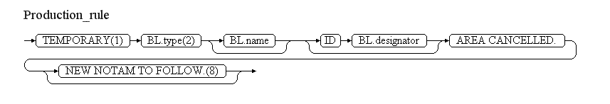
Reference | Rule
(8) | If the NOTAM will be followed by a new NOTAM concerning the same situation, then the operator shall have the possibility to specify "NEW NOTAM TO FOLLOW" and this text shall be appended at the end of item E of the NOTAM C.

Ad-hoc ATS airspace – creation [ATSA.NEW]

Definition
The establishment of a new temporary ATS area, which did not exist as a published (static data) airspace.
Notes:
- this can take the form of either a specified airspace type (such as a CTR) or an airspace with a specified class (such as a class A airspace);
- this scenario does not include the establishment of temporary P, D, R or similar areas; see the dedicated scenario: Ad-hoc special activity area - creation.
- the creation of a permanent ATS area by NOTAM shall be an exceptional situation, as such events are expected to be managed through static data amendments. However, this is supported in this scenario as the same data requirements and rules apply and it helps ensuring that all the airspace created by NOTAM are made available digitally, not only the temporary ones;
- this scenario does not support the use of geographical or administrative features (such as State borders, rivers, sea shores, etc.) in the definition of horizontal projection. If operationally necessary, this can by done by providing a simplified polygon larger than the area and excluding a neighbouring FIR, for example;
- this scenario is limited to the creation of a temporary area with a unique airspace class value for the whole area.

Event data
The following diagram identifies the information items that are usually provided by a data originator for this kind of event.
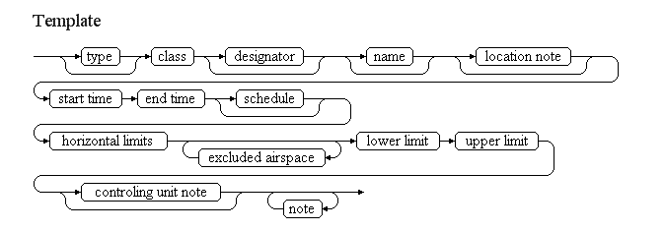
Examples of such events:
TEMPORARY CLASS A AIRSPACE EXCLUDING CTR
Temporary class A Airspace established
From 07 OCT 2010 at 07:45 till 17 OCT 2010 at 08:45
Circle radius 10NM centred on 5117N 00047W (FARNBOROUGH), but excluding HEATHROW CTR.
From SFC up to FL050
Controlling AUTH FARNBOROUGH ATC/LTCC.
AUS 07-10-0088/4283/AS4
Temporary AWY established
TEMPORARY CONTROLLED AIRSPACE (CLASS A) ESTABLISHED
ON 01 NOV 14:05 TILL 15:10
TEMPORARY AWY FM LOSSIEMOUTH TO GOW (555223N 0042674W) FL050/FL245 UNTIL 5720N THEN FL100/FL245.
CONTROL AUTHORITY SCACC.
AUS 07-11-0183/4740/AS6
The table below provides more details about each information item contained in the diagram. It also provided the mapping of each information item within the AIXM 5.1 structure. The name of the variable (first column) is recommended for use as label of the data field in human-machine interfaces (HMI).
Data item | Description | AIXM mapping
type | The type of area, although this is rarely provided. Typical examples are CTR, AWY or "no type". | Airspace.type with this list of values CodeAirspaceType
class | The airspace classification of the area | Airspace/AirspaceLayerClass.classification with this list of values CodeAirspaceClassificationType.
designator | A designator allocated to the area. However, it is unlikely that such designators are provided by the data originator. It is more likely that the designator will be allocated by the publication office. | Airspace.designator
name | The name of a geographical feature or location, which is also used for identifying the area | Airspace.name
start time | The effective date & time when the area becomes established and active. This might be further detailed in a "schedule". | Airspace/AirspaceTimeSlice.featureLifetime/beginPosition, Airspace/AirspaceTimeSlice/validTime/timePosition, Event/EventTimeSlice.validTime/timePosition and Event/EventTimeSlice.featureLifetime/beginPosition
end time | The end date & time when the area ceases to exist. It might be an estimated value, if the exact end of activation is unknown. It may also be indeterminate for a permanent area. | Airspace/AirspaceTimeSlice.featureLifetime/endPosition Event/EventTimeSlice.featureLifetime/endPosition also applying the rules for Event with estimated termination
schedule | A schedule might be provided in case the area is only active according to a regular timetable, within the overall period when it exists. | Airspace/AirspaceActivation/Timesheet/... according to the rules for Event Schedules
location note | A free text note that indicates the location of the area in relation with relevant geographical or aeronautical features, such as "AT FARNBOROUGH AIRFIELD", etc. | Airspace.annotation with propertyName="geometryComponent" and purpose="REMARK"
horizontal limit | The horizontal shape of the area or of one of its composing volumes (if the area is an aggregation of different volumes with different vertical limits). | Airspace/AirspaceVolume.horizontalProjection following the guidelines for the encoding of geometrical and geographical data. The AirspaceGeometryComponent shall have operation="BASE" and operationSequence="1". Only geometries of type Polygon, Circle or Corridor are allowed in this scenario."
excluded airspace | A reference (type, designator, name) to one or more airspace that are excluded (subtracted) from the volume described by the aggregation of the horizontal limits specified for the area; for example: "EXCLUDING THE HEATHROW CTR". | Airspace/AirspaceVolume.contributorAirspace
lower limit | The lower limit (value, unit of measurement and vertical reference) of the area. | Airspace/AirspaceVolume.lowerLimit and lowerLimitReference
upper limit | The upper limit (value, unit of measurement and vertical reference) of the area. | Airspace/AirspaceVolume.upperLimit and upperLimitReference
controlling unit note | A free text note that provides information about the unit or service that provides ATS services in the area. | Airspace/AirspaceActivation.annotation with propertyName="status" and purpose="REMARK"
note | A free text note that provides further instructions concerning the area, such as the reason that led to the area establishment, etc. | Airspace/AirspaceActivation.annotation according to the rules for encoding annotations
Notes:
- It is recommended that data input applications allow the operator to visualise graphically the horizontal shape and the vertical extent of the special activity area. If a schedule is used, the graphical interface should also have a "time slider" that allows the operator to see when the area is actually active.

Assumptions for baseline data
- It is assumed that no baseline data exists for this area.

Data encoding rules
The data encoding rules provided in this section shall be followed in order to ensure the harmonisation of the digital encodings provided by different sources. The compliance with some of these encoding rules can be checked with automatic data validation rules (see next section).
Identifier | Data encoding rule
ER-01 | The special activity area shall be encoded as:  - a new Event, for which PERMDELTA and subsequent BASELINE TimeSlices shall be created; and  - a new Airspace, for which PERMDELTA and subsequent BASELINE TimeSlices shall be created; the property "event:theEvent" of the Airspace TimeSlices shall refer to the Event mentioned above.
ER-02 | The Airspace BASELINE shall contain one AirspaceActivation object with status=ACTIVE, IN_USE or INTERMITTENT (as appropriate) which shall have the values "FLOOR, uom=OTHER" for lowerLimit and "CEILING, uom=OTHER" for the upperLimit of the associated AirspaceLayer.
ER-03 | The Airspace BASELINE shall contain one AirspaceLayerClass object which shall have the values "FLOOR, uom=OTHER" for lowerLimit and "CEILING, uom=OTHER" for the upperLimit of the associated AirspaceLayer.
ER-04 | If the area activity is limited to a discrete schedule within the overall time period between the "start time" and the "end time", then this shall be encoded using as many as necessary timeInterval/Timesheet properties for the AirspaceActivation with status ACTIVE/IN_USE/INTERMITTENT of the BASELINE Timeslice. See also the rules for Event Schedules.
ER-05 | If a schedule is provided, then the Airspace BASELINE shall contain a second AirspaceActivation object with status=INACTIVE, which shall explicitly specify the times not covered by the activity schedule. This shall be done automatically by the system and should not be visible to the operator. The "INACTIVE" times shall not be translated into NOTAM text. See also the rules for Event Schedules.
ER-06 | If one or more "exclude airspace" are specified, each shall be encoded as an AirspaceGeometryComponent with operation=SUBTR, operationSequence as dictated by the order of the element, contributorAirspace/AirspaceVolumeDependency.dependency=FULL_GEOMETRY and pointing to the airspace concerned. In addition, when the AIXM 5.1 encoded data is provided to a client, the data corresponding to the AirspaceVolume(s) of the controbutorAirspace (lowerLimit, lowerLimitReference, upperLimit, upperLimitReference, horizontalProjection, etc.) shall be copied in the AirspaceVolume(s) of the current Airspace. This will provide a complete description of the current Airspace, eliminating the need to traverse the xlink:href in order to get the full geometrical information.
ER-07 | If the type is not provided by the data originator, then it shall be encoded as a "CLASS" type airspace
ER-08 | It is recommended that an alphanumeric designator is allocated to a temporary area, in order to facilitate it's identification on graphical representations (such as airspace activity maps) and verbal communication. The composition rule is derived from the current AIS practice for CTR and TMA designators - "CCCCnnnn-yy", where:  - CCCC corresponds to one of the following (in this order of preference):  - the ICAO location indicator associated with the place (city, island, etc.) that appears in the "location note", then use that one as coded identifier (for example, FARNBOROUGH = 'EGLF')  - the ICAO location indicator of the ATC centre which provides air traffic control services in the airspace;  - the ICAO location indicator of one major airport situated within the airspace;  - a 4 letter code using the first two letters of the country code and the last two letters so that they are not duplicating another airspace identifier of the same type.  - (to be added only in case of a temporary area) nnnn is a number, unduplicated during the same year, within the State or territory concerned; this could also be the NOTAM number;  - (to be added only in case of a temporary area) yy are the last two digits of the year date when the area becomes effective.

Automatic data validation rules
These validation rules apply to the AIXM encoded data:
Title | Definition | Category | Error level
Minimal data requirements | As a minimum, in addition to the AIXM mandatory properties gml:validTime and aixm:interpretation, the Airspace BASELINE TimeSlice shall contain at least aixm:sequenceNumber, aixm:type, aixm:geometryComponent (including aixm:horizontalProjection, aixm:lowerLimit, aixm:lowerLimitReference, aixm:upperLimit, aixm:upperLimitReference) at least one aixm:class element with at least one aixm:classification descendant element specified (non NIL) and at least one aixm:activation element with at least the aixm:status descendant element specified (not NIL). | Minimal data | error
Non-duplication with other Events | There should not exist another Airspace BASELINE with the same aixm:geometryComponent and an overlapping (partially or totally) gml:validTime. | Data consistency | warning
Uniqueness of designator | There should not exist any other Airspace with the same aixm:designator value. (Note that this is an example of an operational rule observed for CTR, TMA, etc. and which can be extended to ad-hoc areas that get a temporary designator. The initial version of this specification does not contain many such rules. Many more such operational rules are expected to be identified with the time and added as additional data quality checks.) | Operational rule | warning
Area type consistency with scenario | The Airspace aixm:type shall have one of the following values: CTR, CTR_P, ADIZ, CTA, CTA_P, OCA, OCA_P, SECTOR, SECTOR_C, RAS, CLASS, HTZ, AWY, TMA, TMA_P, ADV, UADV, ATZ, ATZ_P or OTHER:...) | Operational rule | error

Text NOTAM production rules
This section provides rules for the automated production of the text NOTAM message items, based on the AIXM 5.1 data encoding of the Event. Therefore, AIXM specific terms are used, such as names of features and properties, types of TimeSlices, etc:
- the abbreviation BL. indicates that the corresponding data item must be taken from the Airspace BASELINE that is created by the Event;
In general, the ICAO DOC 8126 and the OPADD rules shall be followed. These have not been copied in this document in order to avoid duplication with those documents. Only instructions that are specific to the AIXM encoding of this event are stated here.

Several NOTAM possible
Note that if an ad-hoc ATS area is located in the vicinity of one or more airports or affects more than one FIR, there are special provision in the OPADD (v3.0, section 2.3.9.2) with regard to the NOTAM that need to be issued in order to ensure that the NOTAM appear correctly in the relevant en-route and airport Pre-Flight Information Bulletins (PIB). From a Digital NOTAM point of view, this requires that an Event can have several NOTAM associated, which is supported by the AIXM Event schema. In order to facilitate the work of the operator, the Digital NOTAM data provider interface should include the following functionality:
- automatically identify the FIR in which the area is located and if more than one is found, generate a NOTAM with scope W and with all the FIR identified in item A;
- automatically identify CTR and TMA that are intersected by the area; then identify the AirportHeliport that are located in those CTR/TMA and that also have locationIndicatorICAO="YES"; according to the OPADD rules, propose that a single NOTAM with scope AW and/or additional NOTAM with scope A are issued for these airports;
- if the area does not intersect any TMA or CTR but it's lowerLimit is equal or less than 1000 FT from SFC, then automatically identify the AirportHeliport that have their ARP (reference point) located within 5 NM (this might need to be a configurable parameter) and also have a value for their locationIndicatorICAO attribute; according to the OPADD rules, propose that a single NOTAM with scope AW and/or additional NOTAM with scope A are issued for these airports;
In all situations, the operator shall be allowed to take the final decision by selecting the airports/FIR for which a NOTAM is really generated. This might include additional ones, which have not been identified automatically by the spatial checks but have an operationally significant relation with the area.

Item A
The item A shall be generated according to the geographical location of the Airspace, following the ICAO DOC 8126 and the OPADD rules.

Q code
The following mapping shall be used:
BL.type values | Recommended Q code
CTR or CTR_P | QACCS
ADIZ | QADCA
CTA or CTA_P | QAECA
UTA or UTA_P | QAHCA
OCA or OCA_P | QAOCA
AWY | QARCS
TMA or TMA_P | QATCD
ADV | QAVCA
UDAV | QAVCA
ATZ or ATZ_P | QAZCS
any other | QXXCS
Notes:
- In the situations where two or more Q code alternatives are provided in the table above, the first one should be used as default in a data provider interface;
- The operator shall have the possibility to select an alternative one or even to change it completely (for example, by using "XX").

Items B, C and D
- In item B, insert the value of the BL.validTime.TimePeriod.beginPosition formatted according to the NOTAM syntax for this field: yymmddhhmm;
- If BL.validTime.TimePeriod.endPosition is NIL and BL.validTime.TimePeriod.endPosition@indeterminatePosition has the value "unknown" (the area is permanent), then insert "PERM" as item C value.
- If BL.validTime.TimePeriod.endPosition is not NIL, then insert its value in item C formatted according to the NOTAM syntax for this field: yymmddhhmm.
- If BL.validTime.TimePeriod.endPosition is not NIL and BL.validTime.TimePeriod.endPosition@indeterminatePosition has the value "unknown", "before" or "after" (the Event has an estimated end of validity), then append "EST" at the end of the item C value.
- Item D shall be left empty. An eventual schedule shall be decoded in item E.

Item E
The following pattern should be used for automatically generating the E field text from the AIXM data:
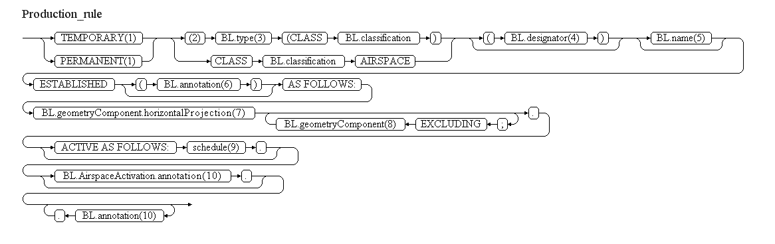
Reference | Rule
(1) | If BL.validTime.TimePeriod.endPosition is NIL and BL.validTime.TimePeriod.endPosition@indeterminatePosition has the value "unknown" (the area is permanent), then insert the word "PERMANENT". Otherwise insert the word "TEMPORARY".
(2) | If BL.type does not have the value "CLASS", then use this branch. Otherwise use the other branch, which inserts just the airspace classification.
(3) | The area type shall be included according to the following decoding table:
  BL.type | Text recommended for item E
  CTR | "CTR"
  CTR_P | "CTR PART"
  ADIZ | "AIR DEFENCE IDENTIFICATION ZONE (ADIZ)"
  CTA | "CONTROL AREA"
  CTA_P | "CONTROL AREA PART"
  UTA | "UPPER CONTROL AREA"
  UTA_P | "UPPER CONTROL AREA PART"
  OCA | "OCEANIC CONTROL AREA"
  OCA_P | "OCEANIC CONTROL AREA PART"
  AWY | "AIRWAY"
  SECTOR | "ATS SECTOR"
  SECTOR_C | "COLLAPSED ATS SECTOR"
  RAS | "REGULATED ATS AIRSPACE"
  ADIZ | "ADIZ"
  CLASS | "AIRSPACE CLASS"
  TMA | "TMA"
  TMA_P | "TMA PART"
  ADV | "ADVISORY AREA"
  UDAV | "UPPER ADVISORY AREA"
  ATZ | "AERODROME TRAFFIC ZONE"
  ATZ_P | "AERODROME TRAFFIC ZONE PART"
  HTZ | "HELICOPTER TRAFFIC ZONE"
  OTHER:TIA | "TRAFFIC INFORMATION AREA"
  OTHER:TIZ | "TRAFFIC INFORMATION ZONE"
  OTHER:FIZ | "FLIGHT INFORMATION ZONE"
  any other | "AREA"
(4) | If specified, insert here the BL.designator
(5) | If specified, insert here the BL.name
(6) | If specified, insert here only the BL.annotation that has propertyName="geometryComponent", which represents the encoding of the "location note" information. Annotations shall be translated into free text according to the following encoding rules.
(7) | The GML encoding of the horizontalProjection (gml:Surface) shall be translated into human readable text, using latitude/longitude values.
(8) | If specified as a BL.geometryComponent with operation="SUBTR", insert here the designator and the type of the BL.geometryComponent.contributorAirspace. This requires interpreting the xlink:href value in order to recuperate the relevant data from the contributorAirspace BASELINE. If more than one airspace is excluded from the preceding horizontalProjection, then the word "AND" shall be included before the second, third, etc. exclusion.
(9) | If at least one BL.activation.AirspaceActivation.timeInterval exists (the Event has an associated schedule), then it shall be inserted here according to the general NOTAM conversion rules for Event schedules. Attention: timeInterval(s) that appear as child of BL.activation.AirspaceActivation with status=INACTIVE shall not be translated (because this was created for the completeness of the digital data encoding, see rule ER-05
(10) | Annotations shall be translated into free text according to the following encoding rules.
Note: The objective is to full automatic generation, without human intervention. However, the implementers of the specification might consider reducing the cost of a fully automated generation by allowing the operator to fine-tune the text in order to improve its readability (with the inherent risk for human error, when re-typing is allowed).

Items F & G
- insert in item F the value (including the its reference and unit of measurement) of the BL.geometryComponent.lowerLimit;
- insert in item G the value (including the its reference and unit of measurement) of the BL.geometryComponent.upperLimit.
The values in item F and G shall be formatted according to the decoding rules for vertical limits.

Event Update
The eventual update of this type of event shall be encoded following the general rules for Event updates, which provide instructions for all NOTAM fields, except for item E and the condition part of the Q code, in the case of a NOTAMC
If a NOTAMC is produced, then the 4th and 5th letters (the "condition") of the Q code shall be "CN" and the following pattern should be used for automatically generating the E field text from the AIXM data:
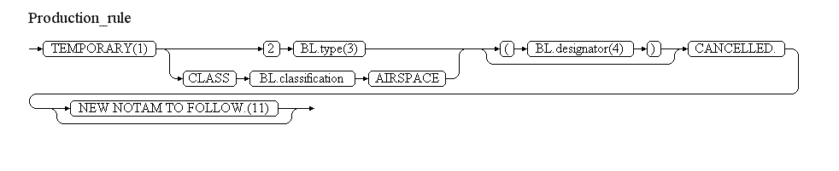
Reference | Rule
(11) | If the NOTAM will be followed by a new NOTAM concerning the same situation, then the operator shall have the possibility to specify "NEW NOTAM TO FOLLOW" and this text shall be appended at the end of item E of the NOTAM C.

Route portion closure [RTE.CLS]

Definition
The temporary closure of one or more route portions (could be on different routes) due to a common cause, such as the activation of a temporary restricted area.
Notes:
- the current practice in many NOTAM Offices is to issue a single NOTAM containing all route segment closures for a given period of time, such as the next 24 hours. This practice does not strictly comply with the ICAO principle for NOTAM of one subject and one condition per NOTAM. From a Digital NOTAM point of view it is recommended to group in a single Event (and issue one single NOTAM) for all the route segments closures that have a common cause, such as the activation of a given restricted area. In a digital environment, this would facilitate the automatic generation and processing of the Events. This might increase the number of NOTAM messages, but the advantage would be the clarity of the information. For example, this would also enable calculating more precise centre/radius of influence for these NOTAM;
- this scenario does not include the permanent modification of the availability of a route; such events will be dealt with as a separate scenario;
- this scenario does not include the unidirectional closure of a route; such events will be dealt with as a separate scenario;
- the encoding of this event requires the use of the "eASM" extension in order to know the BASELINE CDR status of the route segment concerned;

Event data
The following diagram identifies the information items that are usually provided by a data originator for this kind of event.
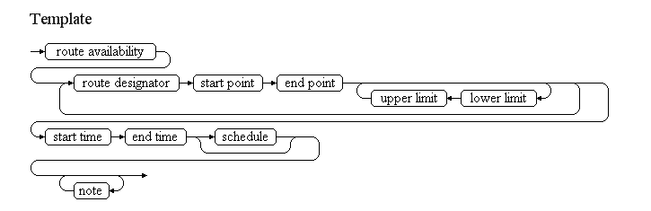
Examples of such events:
CDR 1 closure
Closed CDR1 routes:
P182 between EKLUS-BERVA from FL155 to FL245
Between 01 and 31 OCT as follows:
01-05 08-11 15-18 22-25 05:00-13:00
12 19 26 05:00-10:00,
29-31 06:00-14:00
Due to activation of LZR221A and LZR221B. REF ENR 3.3, ENR 5.1.2.)
ATS route portion closure
Closed ATS route segments
A804 MASUM - SOLODNIKI NDB (SL)
G128 SIROTINSKAYA NDB (ST) - KONSTANTINOVSK NDB (KA)
G481 LISMU - MASUM
Between 4500-5100M and 6900-7500M.
From 01 OCT till 01 NOV - Daily between 06:00-14:00
The table below provides more details about each information item contained in the diagram. It also provided the mapping of each information item within the AIXM 5.1 structure. The name of the variable (first column) is recommended for use as label of the data field in human-machine interfaces (HMI).
Data item | value | AIXM mapping
route availability | An explicit indication that the route portion is closed. | RouteSegment/RouteAvailability.status with the list of values CodeRouteAvailabilityType
route designator | The published designator of the route concerned. This information, in combination with the start/end point is used to identify the route segments concerned. | RouteSegment.routeFormed
start point | The designator and eventually the type (in the case of a Navaid) of the significant point from where the route availability is affected. This information, in combination with the route designator and the end point is used to identify the route segments concerned. | RouteSegment.start/EnRouteSegmentPoint.pointChoice
end point | The designator and eventually the type (in the case of a Navaid) of the significant point until where the route availability is affected. This information, in combination with the route designator and the start point is used to identify the route segments concerned. | RouteSegment.end/EnRouteSegmentPoint.pointChoice
lower limit | The vertical level above which and including that level is affected by the closure. | RouteSegment/RouteAvailability/AirspaceLayer.lowerLimit and lowerLimitReference
upper limit | The vertical level below which and including that level is affected by the closure. | RouteSegment/RouteAvailability/AirspaceLayer.upperLimit and upperLimitReference
start time | The effective date & time when the closure starts. This might be further detailed in a "schedule". | RouteSegment/RouteSegmentTimeSlice/TimePeriod.beginPosition, Event/EventTimeSlice.validTime/timePosition and Event/EventTimeSlice.featureLifetime/beginPosition
end time | The effective date & time when the closure ends. | RouteSegment/RouteSegmentTimeSlice/TimePeriod.endPosition and Event/EventTimeSlice.featureLifetime/endPosition also applying the rules for Event with estimated termination
schedule | A schedule might be provided in case the closure is only effective according to a regular timetable, within the period between the start time and the end time. | RouteSegment/RouteAvailability/Timesheet/...according to the rules for Event Schedules
note | A free text note that provides further details concerning the route closure, such as reason, alternate routes, etc. | Route/RouteAvailability.annotation according to the rules for encoding annotations
Notes:
- It is recommended that data input applications allow the operator to visualise graphically the route segments that are closed, in the context of the overall airspace structure.

Assumptions for baseline data
- It is assumed that information about the route segments concerned already exists in the form of RouteSegment Baseline, which contain as a minimum the start association with the Route and the start/end Significant Points;
- If the Baseline data includes a schedule associated with the RouteAvailability, then this should not leave any gaps. If any gaps exist, then the status of the RouteAvailability at the levels/times concerned is considered "undefined". See the AIXM Temporality Concept (versions 1.0) sections 3.4 and 3.5;
- It is assumed that all RouteSegment affected by the closure have a similar Baseline status, e.g. OPEN, CDR1.

Data encoding rules
The data encoding rules provided in this section shall be followed in order to ensure the harmonisation of the digital encodings provided by different sources. The compliance with some of these encoding rules can be checked with automatic data validation rules (see next section).
Identifier | Data encoding rule
ER-01 | The temporary closure of a route portion shall be encoded as:  - a new Event, for which PERMDELTA and subsequent BASELINE TimeSlices shall be created; and  - a new TEMPDELTA Timeslice for each individual RouteSegment that is located on the route portion specified in the event data. It is recommended that data provider interfaces allow the encoding of the route portion closure at once and that the application takes care of converting the information into Timeslices for the individual RouteSegment(s) concerned.
ER-02 | The "route designator" shall be used in order to identify the route concerned, in order to instantiate the value of the RouteSegment.routeFormed property. If multiple routes exist with that designator, then the "start point" and "end point" information shall also be considered in order to identify the route concerned.
ER-03 | A RouteAvailability object with status=CLSD, direction=BOTH and at least one associated level.AirspaceLayer object shall be included in the Tempdelta Timeslice for each RouteSegment concerned.
ER-04 | If no lower limit is specified in the Event data, then the associated level.AirspaceLayer should contain the values lowerLimit="FLOOR" (uom=OTHER").
ER-05 | If no upper limit is specified in the Event data, then the associated level.AirspaceLayer should contain the values lowerLimit="CEILING" (uom=OTHER").
ER-06 | Note that in accordance with the AIXM Temporality Concept (see sections 3.4 and 3.5 of the Temporality document version 1.0), the RouteAvailability associated with the TEMPDELTA completely replaces all the BASELINE RouteAvailability information, during the TEMPDELTA time of applicability. Therefore, if the temporary closure only concerns certain times and/or levels, the other times and/or levels, when the route eventually remains open/conditional, shall be explicitly included in the TEMPDELTA. The calculation of the necessary additional RouteAvailability elements to be included in the TEMPDELTA shall be automatically done by the applications implementing this specification.  All RouteAvailability elements that are copied from the BASELINE data for completeness sake shall get an associated Note with purpose=REMARK and the text="Baseline data copy. Not included in the NOTAM text generation". This is based on the current NOTAM practice which consists of including in the NOTAM only the changed information and not explicitly including the static data that remains valid during the NOTAM applicability.It is recommended that the input interface provides a "calendar/level" view of the route portion availability, enabling the operator to graphically check the status of the route availability at different times and levels, such as in the example below:  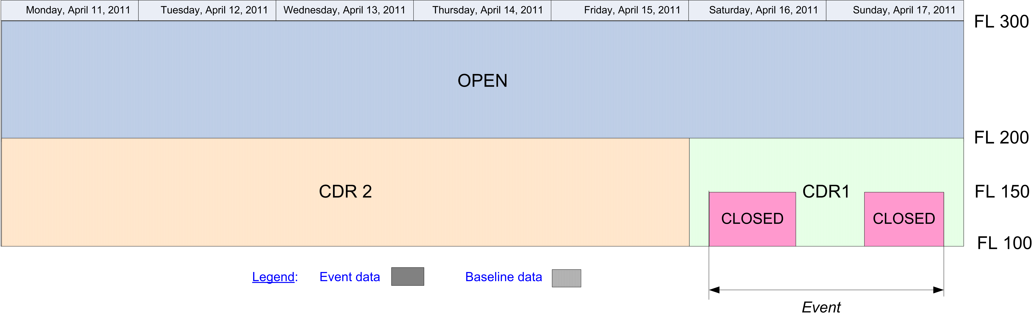In the calendar view, the Baseline information that remains valid during the Event validity time shall be visibly identified from the information that is specific to the Event, for example by using a different colour fill pattern.

Automatic data validation rules
These validation rules apply to the AIXM encoded data:
Title | Definition | Category | Error level
Minimal data requirements | As a minimum, in addition to the AIXM mandatory properties gml:validTime and aixm:interpretation, each RouteSegment TEMPDELTA TimeSlice shall contain at least one aixm:RouteAvailability with at least aixm:status, aixm:direction and aixm:levels specified (not NIL). | Minimal data | error
Non-duplication with other Events | For each RouteSegment TEMPDELTA created by the Event, there should not exist another RouteSegment TEMPDELTA with an overlapping (partially or totally) gml:validTime and containing aixm:RouteAvailability elements. | Data consistency | warning
Closure only possible for normally open routes | There should exist at least on BASELINE RouteAvailability with status=OPEN or COND for one of the levels and times (if specified in a Baseline schedule) affected by the TEMPDELTA. | Data consistency | warning
Baseline data copy correctness | For each RouteAvailability included in the TEMPDELTA that has an associated annotation with purpose=REMARK and the text="Baseline data copy. Not included in the NOTAM text generation", there shall exist an equivalent RouteAvailability in the BASELINE data, having:  - the same aixm:direction, aixm:cardinalDirection and aixm:status;  - equal or smaller aixm:levels/lowerLimit value;  - equal or higher aixm:levels/upperLimit value;  - an encompassing aixm:timeInterval. | Data consistency | error

Text NOTAM production rules
This section provides rules for the automated production of the text NOTAM message items, based on the AIXM 5.1 data encoding of the Event. Therefore, AIXM specific terms are used, such as names of features and properties, types of TimeSlices, etc:
- the abbreviation BL. indicates that the corresponding data item must be taken from the RouteSegment BASELINE which is valid at the start time of the Event;
- the abbreviation TD. indicates that the corresponding data item must be taken from the RouteSegment TEMPDELTA that was created for the Event;
  - Important note: According to encoding rule ER-06, the TEMPDELTA might also include RouteAvailability elements that have been copied from the BASELINE data for compliance with the AIXM Temporality rules. The current practice is to not include such static information in the NOTAM text. Therefore, all RouteAvailability that have an associated annotation with purpose=REMARK and the text="Baseline data copy. Not included in the NOTAM text generation" shall be excepted from the text NOTAM generation algorithm!
In general, the ICAO DOC 8126 and the OPADD rules shall be followed. These have not been copied in this document in order to avoid duplication with those documents. Only instructions that are specific to the AIXM encoding of this event are stated here.

Item A
The item A shall be generated according to the geographical location of the RouteSegments concerned by the Event, following the ICAO DOC 8126 and the OPADD rules.

Q line
The following mapping shall be used for the Q code:
BL.navigationType | Q code
RNAV or TACAN (for all RouteSegments concerned by the Event) | QANLC
otherwise | QARLC
Note that currently many NOTAM offices use 999 NM for radius of influence of the NOTAM, because it is difficult in a manual environment to calculate a containment circle for a set of route segments. It is recommended that the application implementing this specification calculates automatically centre and radius values for a circle that would include all concerned RouteSegment.

Items B, C and D
- In item B, insert the value of the TD.validTime.TimePeriod.beginPosition formatted according to the NOTAM syntax for this field: yymmddhhmm;
- In item C, insert the value of the TD.validTime.TimePeriod.endPosition formatted according to the NOTAM syntax for this field: yymmddhhmm.
- If TD.validTime.TimePeriod.endPosition@indeterminatePosition has the value "unknown", "before" or "after" (the Event has an estimated end of validity), then append "EST" at the end of the item C value.
- If at least one TD.RouteAvailability.timeInterval exists (the Event has an associated schedule), then select the TD.RouteAvailability.timeInterval(s) that have TD.RouteAvailability.status='CLSD' and represent them in item D according to the general NOTAM conversion rules for Event schedules. Note that only the closure schedules will be translated in the NOTAM Text. Eventual opening times described as schedules are considered to be copied from the BASELINE, for completeness sake (see ER-06).

Item E
The following pattern should be used for automatically generating the E field text from the AIXM data:
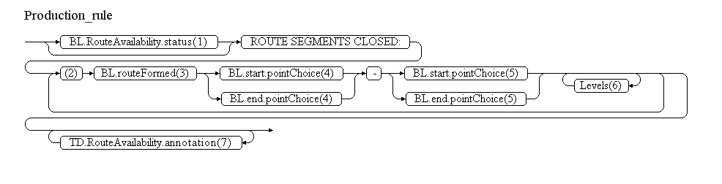
Reference | Rule
(1) | If for each and everyone of the TD.RouteSegment that are concerned by the Event, during the times (considering an eventual schedule) and at the vertical levels covered by TD having TD.RouteAvailability=CLSD the BL.RouteAvailability.status=COND and BL.RouteAvailability(extension).eASM:conditionalRouteType=CDR1, then insert the text "CDR1". Otherwise insert the text "ATS"
(2) | Identify the route portions concerned and repeat steps from 3 to 5 for each route portion. To identify the route portions, order the RouteSegments associated with the Event:  - first sort by the designatorPrefix, designatorSecondLetter, designatorNumber, multipleIdentifier of the Route that is referred to by the BL.routeFormed property;  - second order by identical values of BL.start/EnRouteSegmentPoint.pointChoice or BL.end/EnRouteSegmentPoint.pointChoice with another segment of the same Route. Attention that it is possible to have two distinct portions of the same route associated with the Event.
(3) | Insert here the concatenated values of the designatorPrefix, designatorSecondLetter, designatorNumber, multipleIdentifier of the Route portion identified above.
(4) | Insert here the DesignatedPoint.designator or the Navaid.designator or the AirportHeliport.designator that was identified as start of a route portion at point (2) above.
(5) | Insert here the DesignatedPoint.designator or the Navaid.designator or the AirportHeliport.designator that was identified as end of a route portion at point (2) above.
(6) | If any TD.RouteAvailability/AirspaceLayer has either lowerLevel different from "FLOOR" or upperLevel different from "CEILING" (the segment is not completely closed on the vertical), then insert here each pair lowerLevel - upperLevel of one TD.RouteAvailability.AirspaceLayer having status="CLSD" that exists identically on all TD.RouteAvailability with status "CLSD" of the RouteSegments of the affected route portion, decoded as indicated below:  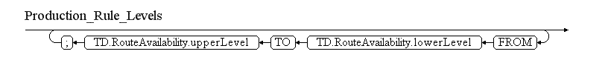  If the value "FLOOR" is used as TD.RouteAvailability/AirspaceLayer.lowerLimit, then use the BL.lowerLimit, BL.lowerLimit@uom and BL.lowerLimitReference instead. If the value "CEILING" is used as TD.RouteAvailability/AirspaceLayer.upperLimit, then use the BL.upperLimit, BL.upperLimit@uom and BL.upperLimitReference instead. In all situations the values shall be formatted according to the decoding ruled for vertical limits.
(7) | Annotations shall be translated into free text according to the following encoding rules.
Note: The objective is to full automatic generation, without human intervention. However, the implementers of the specification might consider reducing the cost of a fully automated generation by allowing the operator to fine-tune the text in order to improve its readability (with the inherent risk for human error, when re-typing is allowed).

Items F & G
According to the OPADD rules, item F & G shall be left empty.

Event Update
The eventual update of this type of event shall be encoded following the general rules for Event updates, which provide instructions for all NOTAM fields, except for item E and the condition part of the Q code, in the case of a NOTAMC
If a NOTAMC is produced, then the 4th and 5th letters (the "condition") of the Q code shall be "CN" and the following pattern should be used for automatically generating the E field text from the AIXM data:
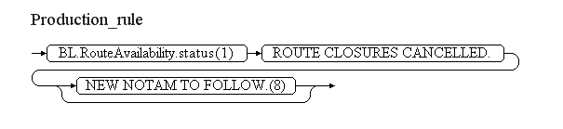
Reference | Rule
(8) | If the NOTAM will be followed by a new NOTAM concerning the same situation, then the operator shall have the possibility to specify "NEW NOTAM TO FOLLOW" and this text shall be appended at the end of item E of the NOTAM C.

Route portion opening [RTE.OPN]

Definition
The temporary opening of one or more route portions (could be on different routes) that are normally closed.
Notes:
- the current practice in many NOTAM Offices is to issue a single NOTAM containing all route segment openings for a given period of time, such as the next 24 hours. This practice does not strictly comply with the ICAO principle for NOTAM of one subject and one condition per NOTAM. From a Digital NOTAM point of view it is recommended to group in a single Event (and issue one single NOTAM) for all the route segments openings that have a common cause, such as the de-activation of a given segregated area. In a digital environment, this would facilitate the automatic generation and processing of the Events. This might increase the number of NOTAM messages, but the advantage would be the clarity of the information. For example, this would also enable calculating more precise centre/radius of influence for these NOTAM;
- this scenario does not include the permanent modification of the availability of a route; such events will be dealt with as a separate scenario;
- this scenario does not include the unidirectional opening of a route; such events will be dealt with as a separate scenario;
- the encoding of this event requires the use of the "eASM" extension in order to know the BASELINE CDR status of the route segment concerned;

Event data
The following diagram identifies the information items that are usually provided by a data originator for this kind of event.
Examples of such events:
CDR 2 temporary availability
Open CDR 2 routes:
L251 between ORBUS-TKN from FL155 to FL245
From FRI 08/11 17:00 till MON 11/11 07:30
The table below provides more details about each information item contained in the diagram. It also provided the mapping of each information item within the AIXM 5.1 structure. The name of the variable (first column) is recommended for use as label of the data field in human-machine interfaces (HMI).
Data item | value | AIXM mapping
route availability | An explicit indication that the route portion is open. | RouteSegment/RouteAvailability.status with the list of values CodeRouteAvailabilityType
route designator | The published designator of the route concerned. This information, in combination with the start/end point is used to identify the route segments concerned. | RouteSegment.routeFormed
start point | The designator and eventually the type (in the case of a Navaid) of the significant point from where the route availability is affected. This information, in combination with the route designator and the end point is used to identify the route segments concerned. | RouteSegment.start/EnRouteSegmentPoint.pointChoice
end point | The designator and eventually the type (in the case of a Navaid) of the significant point until where the route availability is affected. This information, in combination with the route designator and the start point is used to identify the route segments concerned. | RouteSegment.end/EnRouteSegmentPoint.pointChoice
lower limit | The vertical level above which and including that level is concerned by the opening. | RouteSegment/RouteAvailability/AirspaceLayer.lowerLimit and lowerLimitReference
upper limit | The vertical level below which and including that level is concerned by the opening. | RouteSegment/RouteAvailability/AirspaceLayer.upperLimit and upperLimitReference
start time | The effective date & time when the closure starts. This might be further detailed in a "schedule". | RouteSegment/RouteSegmentTimeSlice/TimePeriod.beginPosition, Event/EventTimeSlice.validTime/timePosition and Event/EventTimeSlice.featureLifetime/beginPosition
end time | The effective date & time when the closure ends. | RouteSegment/RouteSegmentTimeSlice/TimePeriod.endPosition and Event/EventTimeSlice.featureLifetime/endPosition also applying the rules for Event with estimated termination
schedule | A schedule might be provided in case the opening is only effective according to a regular timetable, within the period between the start time and the end time. | RouteSegment/RouteAvailability/Timesheet/...according to the rules for Event Schedules
note | A free text note that provides further instructions concerning the route opening, such as alternate routes, etc. | Route/RouteAvailability.annotation according to the rules for encoding annotations
Notes:
- It is recommended that data input applications allow the operator to visualise graphically the route segments that are closed, in the context of the overall airspace structure.

Assumptions for baseline data
- It is assumed that information about the route segments concerned already exists in the form of RouteSegment Baseline, which contain as a minimum the start association with the Route and the start/end Significant Points;
- If the Baseline data includes a schedule associated with the RouteAvailability, then this should not leave any gaps. If any gaps exist, then the status of the RouteAvailability at the levels/times concerned is considered "undefined". See the AIXM Temporality Concept (versions 1.0) sections 3.4 and 3.5;
- It is assumed that all RouteSegment affected by the opening have a similar Baseline status, e.g. CDR2.

Data encoding rules
The data encoding rules provided in this section shall be followed in order to ensure the harmonisation of the digital encodings provided by different sources. The compliance with some of these encoding rules can be checked with automatic data validation rules (see next section).
Identifier | Data encoding rule
ER-01 | The temporary opening of a route portion shall be encoded as:  - a new Event, for which PERMDELTA and subsequent BASELINE TimeSlices shall be created; and  - a new TEMPDELTA Timeslice for each individual RouteSegment that is located on the route portion specified in the event data. It is recommended that data provider interfaces allow the encoding of the route portion opening at once and that the application takes care of converting the information into Timeslices for the individual RouteSegment(s) concerned.
ER-02 | The "route designator" shall be used in order to identify the route concerned, in order to instantiate the value of the RouteSegment.routeFormed property. If multiple routes exist with that designator, then the "start point" and "end point" information shall also be considered in order to identify the route concerned.
ER-03 | A RouteAvailability object with status=OPEN, direction=BOTH and at least one associated level.AirspaceLayer object shall be included in the Tempdelta Timeslice for each RouteSegment concerned.
ER-04 | If no lower limit is specified in the Event data, then the associated level.AirspaceLayer should contain the values lowerLimit="FLOOR" (uom=OTHER").
ER-05 | If no upper limit is specified in the Event data, then the associated level.AirspaceLayer should contain the values lowerLimit="CEILING" (uom=OTHER").
ER-06 | Note that in accordance with the AIXM Temporality Concept (see sections 3.4 and 3.5 of the Temporality document version 1.0), the RouteAvailability associated with the TEMPDELTA replaces all the BASELINE RouteAvailability information, during the TEMPDELTA time of applicability. Therefore, if the temporary opening only concerns certain times and/or levels, the other times and/or levels, when the route eventually remains closed/conditional, shall be explicitly included in the TEMPDELTA. The calculation of the necessary additional RouteAvailability elements to be included in the TEMPDELTA shall be automatically done by the applications implementing this specification.  All RouteAvailability elements that are copied from the BASELINE data for completeness sake shall get an associated Note with purpose=REMARK and the text="Baseline data copy. Not included in the NOTAM text generation". This is based on the current NOTAM practice which consists of including in the NOTAM only the changed information and not explicitly including the static data that remains valid during the NOTAM applicability. It is recommended that the input interface provides a "calendar/level" view of the route portion availability, enabling the operator to graphically check the status of the route availability at different times and levels, such as in the example below:  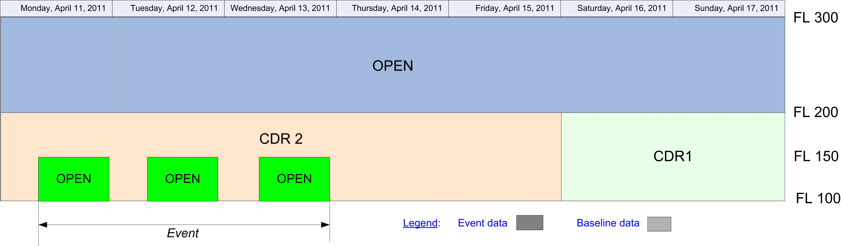In the calendar view, the Baseline information that remains valid during the Event validity time shall be visibly identified from the information that is specific to the Event, for example by using a different colour fill pattern.

Automatic data validation rules
These validation rules apply to the AIXM encoded data:
Title | Definition | Category | Error level
Minimal data requirements | As a minimum, in addition to the AIXM mandatory properties gml:validTime and aixm:interpretation, each RouteSegment TEMPDELTA TimeSlice shall contain at least one aixm:RouteAvailability with at least aixm:status, aixm:direction and aixm:levels specified (not NIL). | Minimal data | error
Non-duplication with other Events | For each RouteSegment TEMPDELTA created by the Event, there should not exist another RouteSegment TEMPDELTA with an overlapping (partially or totally) gml:validTime and containing aixm:RouteAvailability elements. | Data consistency | warning
Opening only possible for normally closed routes | There should exist at least on BASELINE RouteAvailability with status=CLSD or COND for one of the levels and times (if specified in a Baseline schedule) affected by the TEMPDELTA. | Data consistency | warning
Baseline data copy correctness | For each RouteAvailability included in the TEMPDELTA that has an associated annotation with purpose=REMARK and the text="Baseline data copy. Not included in the NOTAM text generation", there shall exist an equivalent RouteAvailability in the BASELINE data, having:  - the same aixm:direction, aixm:cardinalDirection and aixm:status;  - equal or smaller aixm:levels/lowerLimit value;  - equal or higher aixm:levels/upperLimit value;  - an encompassing aixm:timeInterval. | Data consistency | error

Text NOTAM production rules
This section provides rules for the automated production of the text NOTAM message items, based on the AIXM 5.1 data encoding of the Event. Therefore, AIXM specific terms are used, such as names of features and properties, types of TimeSlices, etc:
- the abbreviation BL. indicates that the corresponding data item must be taken from the RouteSegment BASELINE, which is valid at the start time of the Event;
- the abbreviation TD. indicates that the corresponding data item must be taken from the RouteSegment TEMPDELTA that was created for the Event;
  - Important note: According to encoding rule ER-06, the TEMPDELTA might also include RouteAvailability elements that have been copied from the BASELINE data for compliance with the AIXM Temporality rules. The current practice is to not include such static information in the NOTAM text. Therefore, all RouteAvailability that have an associated annotation with purpose=REMARK and the text="Baseline data copy. Not included in the NOTAM text generation" shall be excepted from the text NOTAM generation algorithm!
In general, the ICAO DOC 8126 and the OPADD rules shall be followed. These have not been copied in this document in order to avoid duplication with those documents. Only instructions that are specific to the AIXM encoding of this event are stated here.

Item A
The item A shall be generated according to the geographical location of the Airspace, following the ICAO DOC 8126 and the OPADD rules.

Q line
The following mapping shall be used for the Q code:
BL.navigationType | Q code
RNAV or TACAN (for all RouteSegments concerned by the Event) | QANCA
otherwise | QARCA
Note that currently many NOTAM offices use 999 NM for radius of influence of the NOTAM, because it is difficult in a manual environment to calculate a containment circle for a set of route segments. It is recommended that the application implementing this specification calculates automatically centre and radius values for a circle that would include all concerned RouteSegment.

Items B, C and D
- In item B, insert the value of the TD.validTime.TimePeriod.beginPosition formatted according to the NOTAM syntax for this field: yymmddhhmm;
- In item C, insert the value of the TD.validTime.TimePeriod.endPosition formatted according to the NOTAM syntax for this field: yymmddhhmm.
- If TD.validTime.TimePeriod.endPosition@indeterminatePosition has the value "unknown", "before" or "after" (the Event has an estimated end of validity), then append "EST" at the end of the item C value.
- If at least one TD.RouteAvailability.timeInterval exists (the Event has an associated schedule), then select the TD.RouteAvailability.timeInterval(s) that have TD.RouteAvailability.status='OPEN' and represent them in item D according to the general NOTAM conversion rules for Event schedules. Note that only the opening schedules will be translated in the NOTAM Text. Eventual closure times described as schedules are considered to be copied from the BASELINE, for completeness sake (see ER-06).

Item E
The following pattern should be used for automatically generating the E field text from the AIXM data:
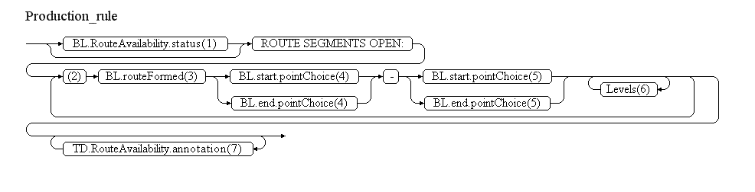
Reference | Rule
(1) | If for each and everyone of the TD.RouteSegment that are concerned by the Event, during the times (considering an eventual schedule) and at the vertical levels covered by TD having TD.RouteAvailability=OPEN the BL.RouteAvailability.status=COND and BL.RouteAvailability(extension).eASM:conditionalRouteType=CDR2, then insert the text "CDR2". Otherwise insert the text "ADDITIONAL ATS"
(2) | Identify the route portions concerned and repeat steps from 3 to 5 for each route portion. To identify the route portions, order the RouteSegments associated with the Event:  - first sort by the designatorPrefix, designatorSecondLetter, designatorNumber, multipleIdentifier of the Route that is referred to by the BL.routeFormed property;  - second order by identical values of BL.start/EnRouteSegmentPoint.pointChoice or BL.end/EnRouteSegmentPoint.pointChoice with another segment of the same Route. Attention that it is possible to have two distinct portions of the same route associated with the Event.
(3) | Insert here the concatenated values of the designatorPrefix, designatorSecondLetter, designatorNumber, multipleIdentifier of the Route portion identified above.
(4) | Insert here the DesignatedPoint.designator or the Navaid.designator or the AirportHeliport.designator that was identified as start of a route portion at point (2) above.
(5) | Insert here the DesignatedPoint.designator or the Navaid.designator or the AirportHeliport.designator that was identified as end of a route portion at point (2) above.
(6) | If any TD.RouteAvailability/AirspaceLayer has either lowerLevel different from "FLOOR" or upperLevel different from "CEILING" (the segment is not completely closed on the vertical), then insert here each pair lowerLevel - upperLevel of one TD.RouteAvailability.AirspaceLayer having status="OPEN" that exists identically on all TD.RouteAvailability with status "OPEN" of the RouteSegments of the affected route portion, decoded as indicated below:  If the value "FLOOR" is used as TD.RouteAvailability/AirspaceLayer.lowerLimit, then use the BL.lowerLimit, BL.lowerLimit@uom and BL.lowerLimitReference instead. If the value "CEILING" is used as TD.RouteAvailability/AirspaceLayer.upperLimit, then use the BL.upperLimit, BL.upperLimit@uom and BL.upperLimitReference instead. In all situations the values shall be formatted according to the decoding rules for vertical limits
(7) | Annotations shall be translated into free text according to the following encoding rules.
Note: The objective is to full automatic generation, without human intervention. However, the implementers of the specification might consider reducing the cost of a fully automated generation by allowing the operator to fine-tune the text in order to improve its readability (with the inherent risk for human error, when re-typing is allowed).

Items F & G
According to the OPADD rules, item F & G shall be left empty.

Event Update
The eventual update of this type of event shall be encoded following the general rules for Event updates, which provide instructions for all NOTAM fields, except for item E and the condition part of the Q code, in the case of a NOTAMC
If a NOTAMC is produced, then the 4th and 5th letters (the "condition") of the Q code shall be "CN" and the following pattern should be used for automatically generating the E field text from the AIXM data:
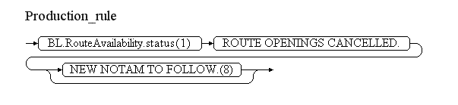
Reference | Rule
(8) | If the NOTAM will be followed by a new NOTAM concerning the same situation, then the operator shall have the possibility to specify "NEW NOTAM TO FOLLOW" and this text shall be appended at the end of item E of the NOTAM C.

Aerodrome closure [AD.CLS]

Definition
The temporary closure of an airport heliport. The closure can be total (any traffic is forbidden) or partial (with the exception of particular operations, flights or aircraft categories).
Notes:
- this scenario does not cover the temporary addition of a supplementary restriction to the Airport availability, such as "closed for aircraft heavier than...". This will be dealt with in a separate scenario “Airport/Heliport usage restriction”(tbd);
- this scenario does not cover the temporary change of the operational hours of an airport/heliport. Such situations will be covered by a different scenario;
- this scenario does not cover the situation when the airport is operating normally, but subject to a reason for caution (such as "grass cutting in progress", etc.). Such situations will be covered through a different scenario.

Event data
The following diagram identifies the information items that are usually provided by a data originator for this kind of event. Note that the "excepted operations" branch is optional, but can be more than once. A similar situation occurs for the aircraft/flight branch, where the "other combination" can be used to return and insert additional aircraft/flight conditions.
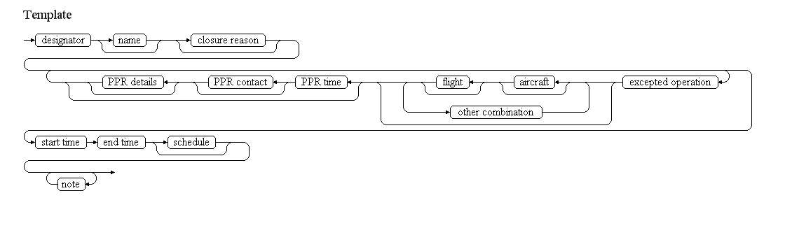
Examples of such events:
AD closed for all traffic
AD ENSO closed for all traffic.
From 15 DEC 2008 16:00 till 15 DEC 2008 17:00
For info, call +47 92665553)
AD closed except IFR
AD WALR closed for VFR flight due to WX below minim VIS.4000M
Except IFR flights
From 22 DEC 2008 00:00 till 22 DEC 2008 01:00 (Estimated)
AD closed except for special flights
AD LSGL closed except for based helicopters, SAR and medical helicopter flights.
From 13 APR 2011 11:57 till 13 APR 2011 14:08
AD closed with Schedule
AD EGUN closed
From 27 DEC 2008 23:00 till 30 DEC 2008 07:00 as follows: nightly 2300-0700.
The table below provides more details about each information item contained in the diagram. It also provided the mapping of each information item within the AIXM 5.1 structure. The name of the variable (first column) is recommended for use as label of the data field in human-machine interfaces (HMI).
Data item | value | AIXM mapping
designator | The published designator of the airport/heliport concerned. This information, in combination with eventually the name is used to identify the airport/heliport. | AirportHeliport.designator
name | The published name of the airport/heliport. This information, in combination with the designator is used to identify the airport/heliport. | AirportHeliport.name
closure reason | The reason for the airport/heliport closure | AirportHeliport/AirportHeliportAvailability.annotation with propertyName="operationalStatus" and purpose="REMARK". Note that the property "warning" of the AirportHeliportAvailability class is not used here because it represents a reason for caution when allowed to operate at the airport, not a reason for a closure.
excepted operation | The description of one or more operations (such as "alternate landing") that are exceptionally permitted at the airport/heliport during it's closure. | AirportHeliport/..Availability/..Usage.operation with the following list of values CodeOperationAirportHeliportType
flight | The description of one or more type of flight categories (such as "emergency") that are exceptionally permitted at the airport/heliport during it's closure. | AirportHeliport/..Availability/..Usage/../FlightCharacteristics
aircraft | The description of one or more aircraft (such as "helicopter") types that are exceptionally permitted at the airport/heliport during it's closure. | AirportHeliport/..Availability/..Usage/../AircraftCharacteristicsNote that only certain properties can be used in this scenario. See data validation rules for details.
other combination | Another combination of aircraft/flight characteristics that are excepted from the closure. | AirportHeliport/..Availability/..Usage/ConditionCombination.logicalOperator with its value set to "OR".
PPR time | The value (minutes, hours, days) of the advanced permission request associated with the permitted operation | AirportHeliport/..Availability/..Usage/.priorPermission
PPR details | Additional information concerning the prior permission requirement | AirportHeliport/..Availability/..Usage.annotation with propertyName="priorPermission" and purpose="REMARK"
start time | The effective date & time when the airport closure starts. This might be further detailed in a "schedule". | Airport/AirportTimeSlice/TimePeriod.beginPosition, Event/EventTimeSlice.validTime/timePosition and Event/EventTimeSlice.featureLifetime/beginPosition
end time | The end date & time when the airport closure ends. | Airport/AirportTimeSlice/TimePeriod.endPosition and Event/EventTimeSlice.featureLifetime/endPosition also applying the rules for Event with estimated termination
schedule | A schedule might be provided, in case the airport/heliport is effectively closed according to a regular timetable, within the overall closure period | AirportHeliport/..Availability/Timesheet/...according to the rules for Event Schedules
note | A free text note that provides further details concerning the airport closure | AirportHeliport/..Availability.annotation according to the rules for encoding annotations

Assumptions for baseline data
- It is assumed that information about the airport/heliport already exists in the form of an AirportHeliport BASELINE TimeSlice, which contains as a minimum its designator;
- It is assumed that the designator has as first two letters the Country Code of the State where the airport is located;
- It is assumed that the following principles have been followed for the encoding of BASELINE AirportHeliportAvailability data (if available in the BASELINE data):
  - the operationalStatus has the value "NORMAL" (meaning that the facility operates with nominal parameters) for all AirportHeliportAvailability that are part of the BASELINE data;
  - if there exist more than one AirportHeliportAvailability elements in the BASELINE, each has a different applicability schedule;
    - the union of the schedules that are part of the BASELINE data does not leave any gaps. If gaps exist, then the status of the Airport/Heliport availability at the times concerned is considered "undefined". See the AIXM Temporality Concept (versions 1.0) sections 3.4 and 3.5;
  - operations that are explicitly permitted have been encoded as AirportUsage with type=PERMIT or type=CONDITIONAL (in case a PPR is necessary);
  - operations that are explicitly forbidden have been encoded as AirportUsage with type=FORBID;
  - if the airport is exclusively reserved for certain operations, then the AirportHeliportAvailability that describes this condition contains only AirportUsage elements with type=RESERV;
  - in case of conflicts
    - the usages of type FORBID take precedence over usages of type PERMIT or RESERVE;
    - the usages of type PERMIT take precedence over the usages of type RESERVE;

Data encoding rules
The data encoding rules provided in this section shall be followed in order to ensure the harmonisation of the digital encodings provided by different sources. The compliance with some of these encoding rules can be checked with automatic data validation rules (see next section).
Identifier | Data encoding rule
ER-01 | The temporary closure of an airport/heliport shall be encoded as:  - a new Event, for which PERMDELTA and subsequent BASELINE TimeSlice shall be created; and  - a TimeSlice of type TEMPDELTA for the affected AirportHeliport feature, for which the "event:theEvent" property points to the Event instance created above; the TEMPDELTA shall contain one or more AirportHeliportAvailability objects.
ER-02 | One AirportHeliportAvailability element having operationalStatus=CLOSED shall be included in the TEMPDELTA. If the airport/heliport is "closed except for" specified operations, flight and/or aircraft categories, all specified excepted operations shall be encoded as AirportHeliportUsage child elements with:  - either type=PERMIT, if there is no prior permission requirement;  - or type=CONDITIONAL, if a prior permission requirement was specified. Note that this implies that a "closed" airport/heliport can still allow certain particular operations.
ER-03 | If a unique flight or aircraft are specified as being excepted, they shall be encoded as one ConditionCombination with logicalOperator="NONE".
ER-04 | Each pair of flight and aircraft conditions specified as being excepted shall be encoded as one ConditionCombination with logicalOperator="AND".
ER-05 | If the "other combination" branch is used, then a root ConditionCombinations element shall be encoded having logicalOperator="OR" and each pair of flight/aircraft included as a sub-condition (with logicalOperator="AND", see ER-04).
ER-06 | If the airport closure is limited to a discrete schedule within the overall time period between the "start time" and the "end time", then this shall be encoded using as many as necessary timeInterval/Timesheet properties for the AirportHeliportAvailability of the AirportHeliport TEMPDELTA Timeslice. See the rules for Event Schedules.
ER-07 | In accordance with the AIXM Temporality Concept (see sections 3.4 and 3.5 in version 1.0), the AirportHeliportAvailability elements included in the TEMPDELTA completely replace all the BASELINE AirportHeliportAvailability information, during the TEMPDELTA time of applicability. Therefore, if the closure only concerns certain times, then the other times, when the airport/heliport eventually remains subject to the availability conditions of the Baseline data, shall be explicitly included in the TEMPDELTA. The calculation of the necessary additional AirportHeliportAvailability elements to be included in the TEMPDELTA shall be automatically done by the applications implementing this specification.  All AirportHeliportAvailabilty elements that are copied from the BASELINE data for completeness sake shall get an associated Note with purpose=REMARK and the text="Baseline data copy. Not included in the NOTAM text generation". This is based on the current NOTAM practice which consists of including in the NOTAM only the changed information and not explicitly including the static data that remains valid during the NOTAM applicability.It is recommended that the input interface provides a "calendar" view of the airport closure, enabling the operator to graphically check the availability at different times, such as in the example below:  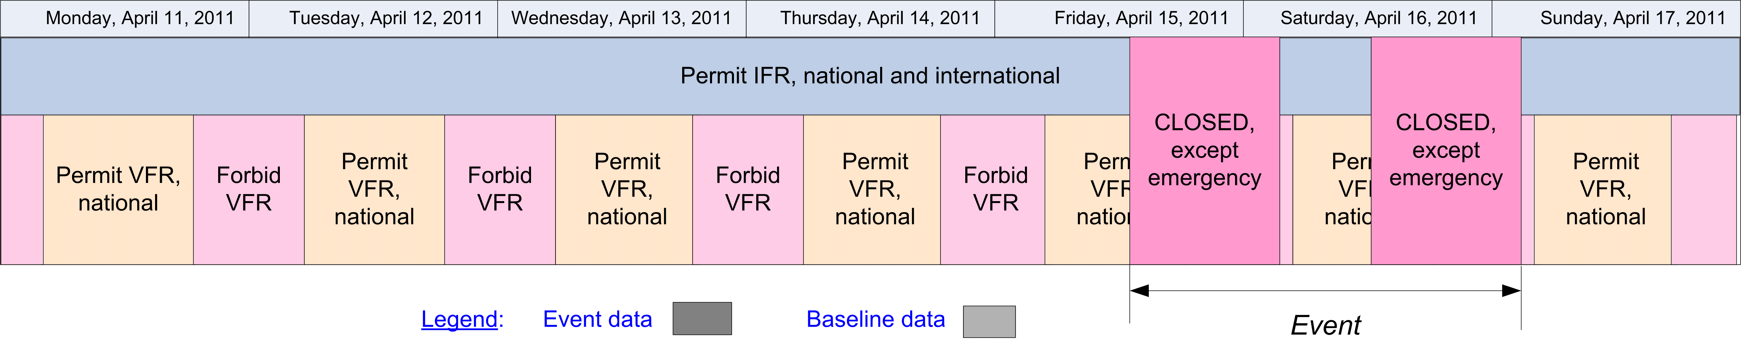  In the calendar view, the Baseline information that remains valid during the Event validity time shall be visibly identified from the information that is specific to the Event, for example by using a different colour fill pattern.

Automatic data validation rules
These validation rules apply to the AIXM encoded data:
Title | Definition | Category | Error level
Minimal data requirements | As a minimum, in addition to the AIXM mandatory properties gml:validTime and aixm:interpretation, the AirportHeliport TEMPDELTA TimeSlice shall contain at least aixm:sequenceNumber and one aixm:availability element with at least the aixm:operationalStatus descendant element specified (not NIL). | Minimal data | error
"ALL" operations only if additional conditions | For the AirportHeliportAvailability with operationalStatus=CLOSED included in the TEMPDELTA, if aixm:AirportHeliportUsage.operations=ALL, then aixm:priorPermission and/or aixm:type shall be specified (not NIL) | Data consistency | error
PPR only if "CONDITIONAL" | If aixm:AirportHeliportUsage.priorPermission is specified, then the aixm:AirportHeliportUsage.type shall be "CONDITIONAL" | Data consistency | error
Only "PERMIT" or conditional "CONDITIONAL" allowed in relation with a closure | For the AirportHeliportAvailability with operationalStatus=CLOSED included in the TEMPDELTA, any eventual child aixm:AirportHeliportUsage.type cannot have any other type than "PERMIT" or "CONDITIONAL". | Data consistency | error
"PERMIT" or "CONDITIONAL" require aircraft or flight | If aixm:AirportHeliportUsage.type is specified (not NIL), then at least one aixm:selection shall be specified (not NIL) | Data consistency | error
Aircraft characteristics consistent with scenario | Only the following properties of AircraftCharacteristics can be used in this scenario:  - type  - engine  - wingSpan and wingSpanInterpretation  - weight and weightInterpretation | Data consistency | error
Baseline data copy correctness | For each AirportHeliportAvailability included in the TEMPDELTA that has operationalStatus=NORMAL and an associated annotation with purpose=REMARK and the text="Baseline data copy. Not included in the NOTAM text generation", there shall exist an equivalent AirportHeliportAvailability in the BASELINE data, having:  - the same aixm:operationalStatus and aixm:warning values;  - the same aixm:usage (complex property);  - an encompassing aixm:timeInterval. | Data consistency | error

Text NOTAM production rules
This section provides rules for the automated production of the text NOTAM message items, based on the AIXM 5.1 data encoding of the Event. Therefore, AIXM specific terms are used, such as names of features and properties, types of TimeSlices, etc:
- the abbreviation BL. indicates that the corresponding data item must be taken from the AirportHeliport BASELINE;
- the abbreviation TD. indicates that the corresponding data item must be taken from the AirportHeliport TEMPDELTA that was created for the Event.
  - Important Note: According to encoding rule ER-07, the TEMPDELTA might also include AirportHeliportAvailability elements that have been copied from the BASELINE data for compliance with the AIXM Temporality rules. The current practice is to not include such static information in the NOTAM text. Therefore, all AirportHeliportAvailability that have operationalStatus=NORMAL (they also have an associated annotation with purpose=REMARK and the text="Baseline data copy. Not included in the NOTAM text generation") shall be excepted from the text NOTAM generation algorithm!
In general, the ICAO DOC 8126 and the OPADD rules shall be followed. These have not been copied in this document in order to avoid duplication with those documents. Only instructions that are specific to the AIXM encoding of this event are stated here.

Item A
The item A shall contain the BL.designator if BL.locationIndicatorICAO='YES'. If not, the first two letters of the BL.designator shall be used, followed by "XX".

Q code
The following mapping shall be used:
Closure status | Q code
CLOSED and there are no associated AirportUsage of type PERMIT or CONDITIONAL | QFALC
CLOSED but there also exist associated AirportUsage of type PERMIT or CONDITIONAL | QFALT

Items B, C and D
- In item B, insert the value of the TD.validTime.TimePeriod.beginPosition formatted according to the NOTAM syntax for this field: yymmddhhmm;
- In item_C, insert the value of the TD.validTime.TimePeriod.endPosition formatted according to the NOTAM syntax for this field: yymmddhhmm.
- If TD.validTime.TimePeriod.endPosition@indeterminatePosition has the value "unknown", "before" or "after" (the Event has an estimated end of validity), then append "EST" at the end of the item C value.
- If at least one TD.availability.AirportHeliportAvailability.timeInterval exists (the Event has an associated schedule), then it shall be represented in item D according to the general NOTAM conversion rules for Event schedules.

Item E
The following pattern should be used for automatically generating the E field text from the AIXM data:
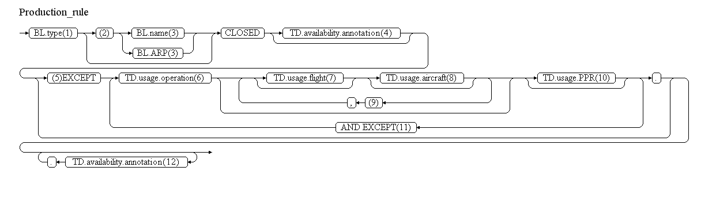
Reference | Rule
(1) | Insert here the type of the airport decoded as follows
  BL.type | Text to be inserted
  AD or AH | "AD"
  HP | "HELIPORT"
  LS or OTHER... | "LANDING SITE"
(2) | If BL.locationIndicatorICAO=YES, then ignore this branch.
(3) | If BL.name is not NIL, then insert it here. Otherwise, insert here the text "LOCATED AT " followed by the BL.ARP.ElevatedPoint decoded according to the text NOTAM production rules for aixm:Point
(4) | If there exists a TD.availability.annotation having propertyName="operationalStatus" and purpose="REMARK", then translate it into free text according to the decoding rules for annotations.
(5) | If there exist one or more TD.availability.usage then decode them following this branch, in the following order of priorities:  - TD.availability.usage that have operation="ALL"  - TD.availability.usage that have type="PERMIT"  - ... other situations ...  - TD.availability.usage that have priorPermission which is not NIL shall be decoded last.
(6) | Decode here the TD.availability.usage.operation as follows:
  TD.usage.operation | Text to be inserted
  LANDING | "FOR LANDING"
  TAKEOFF | "FOR TAKE-OFF"
  TOUCHGO | "FOR TOUCH AND GO"
  TRAIN_APPROACH | "FOR PRACTICE LOW APPROACHES"
  ALTN_LANDING | "AS ALTN"
  AIRSHOW | "FOR AIRSHOW PARTICIPATING ACFT"
  ALL | "FOR"
(7) | Decode here each FlightCharacteristics property that was specified, as detailed below. If more than one FlightCharacteristics property was used, insert blanks between consecutive properties.
  FlightCharacteristics.type | Text to be inserted
  OAT | "OAT"
  GAT | "GAT"
  ALL | "OAT/GAT"
  OTHER:MY_TEXT | "MY TEXT" (replace "_" with blanks)
  FlightCharacteristics.rule | Text to be inserted
  IFR | "IFR"
  VFR | "IFR"
  ALL | "IFR/VFR"
  OTHER:MY_TEXT | "MY TEXT" (replace "_" with blanks)
  FlightCharacteristics.status | Text to be inserted
  HEAD | "HEAD OF STATE"
  STATE | "STATE ACFT"
  HUM | "HUM FLTS"
  HOSP | "HOSP FLT"
  SAR | "SEARCH AND RESCUE"
  EMERGENCY | "EMERGENCY"
  ALL | "STATE/HUM/HOSP/SEARCH AND RESCUE/EMERGENCY FLT"
  OTHER:MY_TEXT | "MY TEXT" (replace "_" with blanks)
  FlightCharacteristics.military | Text to be inserted
  MIL | "MIL"
  CIVIL | "CIVIL"
  ALL | "CIVIL/MIL"
  OTHER:MY_TEXT | "MY TEXT" (replace "_" with blanks)
  FlightCharacteristics.origin | Text to be inserted
  NTL | "DOMESTIC FLT"
  INTL | "INTL FLT"
  HOME_BASED | "HOME BASED ACFT"
  ALL | "DOMESTIC/INTL"
  OTHER:MY_TEXT | "MY TEXT" (replace "_" with blanks)
  FlightCharacteristics.purpose | Text to be inserted
  SCHEDULED | "SCHED FLT"
  NON_SCHEDULED | "UNSCHED FLT"
  PRIVATE | "PRIV FLT"
  AIR_TRAINING | "TRAINING FLT"
  AIR_WORK | "AERIAL WORK"
  PARTICIPANT | "PARTICIPATING ACFT"
  ALL | "SCHED/UNSCHED/PRIV/TRAINING/AERIAL WORK/PARTICIPATING ACFT"
  OTHER:MY_TEXT | "MY TEXT" (replace "_" with blanks)
(8) | Decode here each AircraftCharacteristics property that was specified, as detailed below. If more than one AircraftCharacteristics property was used, insert blanks between consecutive properties.  AircraftCharacteristics.wingSpan - insert the value followed by the value of the uom attribute. Prefix with the value of AircraftCharacteristics.wingSpanInterpretation, decoded as indicated in the following table:  AircraftCharacteristics.weight - insert the value followed by the value of the uom attribute. Prefix with the value of AircraftCharacteristics.weightInterpretation, decoded as indicated in the following table:
  AircraftCharacteristics.type | Text to be inserted
  LANDPLANE | "LANDPLANES"
  SEAPLANE | "SEAPLANES"
  AMPHIBIAN | "AMPHIBIANS"
  HELICOPTER | "HELICOPTERS"
  GYROCOPTER | "GYROCOPTERS"
  TILT_WING | "TILT WING ACFTS"
  STOL | "SHORT TAKE-OFF AND LANDING AIRCRAFTS"
  GLIDER | "GLIDERS"
  HANGGLIDER | "HANG-GLIDERS"
  PARAGLIDER | "PARAGLIDERS"
  ULTRA_LIGHT | "ULTRA LIGHTS"
  BALLOON | "BALLOONS"
  UAV | "UAV"
  ALL | "ALL ACFT TYPES"
  OTHER:MY_TEXT | "MY TEXT" (replace "_" with blanks)
  AircraftCharacteristics.engine | Text to be inserted
  JET | "JET ACFT"
  PISTON | "PISTON ACFT"
  TURBOPROP | "TURBOPROP"
  ALL | "ALL ENGINE TYPES"
  OTHER:MY_TEXT | "MY TEXT" (replace "_" with blanks)
  AircraftCharacteristics. wingSpanInterpretation | Text to be inserted
  ABOVE | "ACFT WITH WINGSPAN LARGER THAN"
  AT_OR_ABOVE | "ACFT WITH WINGSPAN EQUAL OR LARGER THAN"
  AT_OR_BELOW | "ACFT WITH WINGSPAN EQUAL OR SMALLER THAN"
  BELOW | "ACFT WITH WINGSPAN SMALLER THAN"
  OTHER:MY_TEXT | "MY TEXT" (replace "_" with blanks)
  AircraftCharacteristics. weightInterpretation | Text to be inserted
  ABOVE | "ACFT MASS HEAVIER THAN"
  AT_OR_ABOVE | "ACFT MASS EQUAL OR HEAVIER THAN"
  AT_OR_BELOW | "ACFT MASS EQUAL OR LIGHTER THAN"
  BELOW | "ACFT MASS LIGHTER THAN"
  OTHER:MY_TEXT | "MY TEXT" (replace "_" with blanks)
(9) | If TD.usage.selection.logicalOperator=OR (there are more than one flight/aircraft combinations that are excepted), then select and decode each FlightCharacteristics/AircraftCharacteristics consecutively.
(10) | If TD.usage.priorPermission is not NIL, then insert here the decoding of the PPR information as detailed in the following diagram:  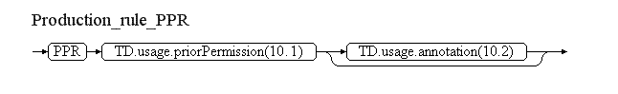
  Reference | Rule
  (10.1) | Insert here the value of the priotPermission attribute followed by the value of the uom attribute decoded as follows:
    uom value | Text to be inserted
    HR | "HOURS"
    MIN | "MINUTES"
    SEC | "SECONDS"
    OTHER:MY_TEXT | "MY TEXT" (replace "_" with blanks)
  (10.2) | Decode here the annotation with propertyName="priorPermission" and purpose="REMARK", according to the decoding rules for annotations.
(11) | If more than one TD.usage elements exist, decode the additional ones starting each time on a new line.
(12) | Annotations of TD.AirportHeliportAvailability shall be translated into free text according to the decoding rules for annotations.
Note: The objective is to full automatic generation, without human intervention. However, the implementers of the specification might consider reducing the cost of a fully automated generation by allowing the operator to fine-tune the text in order to improve its readability (with the inherent risk for human error, when re-typing is allowed).

Items F & G
Leave empty.

Event Update
The eventual update of this type of event shall be encoded following the general rules for Event updates, which provide instructions for all NOTAM fields, except for item E and the condition part of the Q code, in the case of a NOTAMC
If a NOTAMC is produced, then the 4th and 5th letters (the "condition") of the Q code shall be "CN" and the following pattern should be used for automatically generating the E field text from the AIXM data:
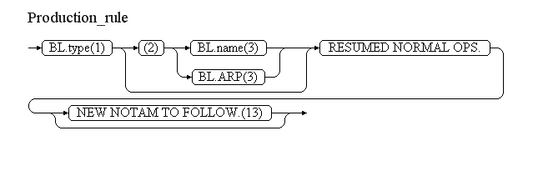
Reference | Rule
(13) | If the NOTAM will be followed by a new NOTAM concerning the same situation, then the operator shall have the possibility to specify "NEW NOTAM TO FOLLOW" and this text shall be appended at the end of item E of the NOTAM C.

Runway closure [RWY.CLS]

Definition
The temporary closure of a runway. The closure can be total (any traffic is forbidden) or partial (with the exception of particular operations, flights or aircraft categories).
Notes:
- this scenario covers the closure of both complete runways (all landing directions) and single landing directions;
- this scenario does not cover the temporary addition of a supplementary restriction to the runway availability, such as "closed for aircraft heavier than...". This will be dealt with in a separate scenario “Runway usage restrictions” (tbd);
- this scenario does not cover the temporary change of the operational hours of a runway. Such situations will be covered by a different scenario;
- this scenario does not cover the situation when the runway is operating normally, but subject to a reason for caution (such as "grass cutting in progress", etc.). Such situations will be covered through a different scenario.

Event data
The following diagram identifies the information items that are usually provided by a data originator for this kind of event. Note that the "excepted operations" branch is optional, but can be more than once. A similar situation occurs for the aircraft/flight branch, where the "other combination" can be used to return and insert additional aircraft/flight conditions.
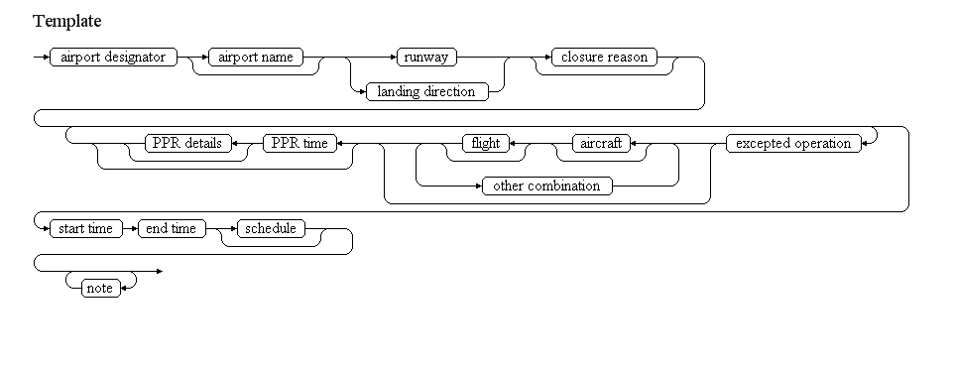
Examples of such events:
Runway closed both directions
At EDDS RWY 07/25 closed
From 22 NOV 2008 22:00 till 23 NOV 2008 04:00
Runway closed with schedule except emergency
At LFKF RWY 05/23 closed except for emergency and medical flights
From 01 OCT 2007 04:45 till 05 OCT 2007 09:15 as follows: DAILY 04:45-09:15.
Complex runway closure (schedule, different operations)
At LCPH RWY 11/29 closed due to work in progress.
From 28 MAR 2011 01:00 till 16 APR 2011 08:00
Daily MON 0100-0800, TUE 0000-0700 2300-0300, WED 2300-0700, FRI 0000-0300 AND SAT 0000-0800
Exceptions: RWY closures for specific days as follows:
- 31 MAR 0000-0700 for arrivals
- 31 MAR AND 12 APR 0100-0700 for departures
- 05 APR 2300-0300 RWY remains open.
The table below provides more details about each information item contained in the diagram. It also provided the mapping of each information item within the AIXM 5.1 structure. The name of the variable (first column) is recommended for use as label of the data field in human-machine interfaces (HMI).
Data item | value | AIXM mapping
airport designator | The published designator of the airport where the runway is located, used in combination with other elements in order to identify the runway concerned. | AirportHeliport.designator
airport name | The published name of the airport where the runway is located, used in order to identify the runway concerned. | AirportHeliport.name
runway | The published designator of the runway concerned. This information is used in combination with the airport designator/name in order to identify the runway, for which is assumed that both landing directions are concerned by the closure. | Runway.designator
landing direction | The published designator of the runway direction concerned. This information is used in combination with the airport designator/name in order to identify the runway and the concerned landing direction. | RunwayDirection.designator
closure reason | The reason for the runway closure | RunwayDirection/ManoeuvringAreaAvailability.operationalStatus with propertyName="operationalStatus" and purpose="REMARK". Note that the property "warning" of the ManoeuvringAreaAvailability class is not used here because it represents a reason for caution when allowed to operate on the runway, not a reason for a closure.
excepted operation | The description of one or more operations (such as "taxiing") that are exceptionally permitted on the runway during it's closure. | RunwayDirection/ManoeuvringAreaAvailability/..Usage.operation with the following list of values CodeOperationManoeuvringAreaType
flight | The description of one or more type of flight categories (such as "emergency") that are exceptionally permitted on the runway during it's closure. | RunwayDirection/ManoeuvringAreaAvailability/..Usage/../FlightCharacteristics
aircraft | The description of one or more aircraft (such as "helicopter") types that are exceptionally permitted on the runway during it's closure. | RunwayDirection/ManoeuvringAreaAvailability/..Usage/../AircraftCharacteristicsNote that only certain properties can be used in this scenario. See data validation rules for details.
other combination | Another combination of aircraft/flight characteristics that are excepted from the closure. | RunwayDirection/ManoeuvringAreaAvailability/..Usage/ConditionCombination.logicalOperator with its value set to "OR".
PPR time | The value (minutes, hours, days) of the advanced permission request associated with the permitted operation | RunwayDirection/ManoeuvringAreaAvailability/..Usage.priorPermission
PPR details | Additional information concerning the prior permission requirement | RunwayDirection/ManoeuvringAreaAvailability/..Usage.annotation with propertyName="priorPermission" and purpose="REMARK"
start time | The effective date & time when the runway closure starts. This might be further detailed in a "schedule". | RunwayDirection/RunwayDirectionTimeSlice/TimePeriod.beginPosition, Event/EventTimeSlice.validTime/timePosition and Event/EventTimeSlice.featureLifetime/beginPosition
end time | The end date & time when the runway closure ends. | RunwayDirection/RunwayDirectionTimeSlice/TimePeriod.endPosition and Event/EventTimeSlice.featureLifetime/endPosition also applying the rules for Event with estimated termination
schedule | A schedule might be provided, in case the runway is effectively closed according to a regular timetable, within the overall closure period | RunwayDirection/ManoeuvringAreaAvailability/Timesheet/...according to the rules for Event Schedules
note | A free text note that provides further details concerning the airport closure | RunwayDirection/ManoeuvringAreaAvailability.annotation according to the rules for encoding annotations

Assumptions for baseline data
- It is assumed that information about the runway already exists in the form of a RunwayDirection BASELINE TimeSlice, which contains as a minimum a designator and an associations with the Runway; the Runway also shall exist as a BASELINE and shall contain as a minimum its designator and an association with the AirportHeliport;
- It is assumed that the following principles have been followed for the encoding of BASELINE RunwayDirection.availability data (if available in the BASELINE data):
  - the operationalStatus has the value "NORMAL" (meaning that the facility operates with nominal parameters) for all RunwayDirection.ManoeuvringAreaAvailability that are part of the BASELINE data;
  - if there exist more than one RunwayDirection.ManoeuvringAreaAvailability elements in the BASELINE, each has a different applicability schedule;
    - the union of the schedules that are part of the BASELINE data does not leave any gaps. If gaps exist, then the status of the RunwayDirection availability at the times concerned is considered "undefined". See the AIXM Temporality Concept (versions 1.0) sections 3.4 and 3.5;
  - operations that are explicitly permitted have been encoded as ManoeuvringAreaUsage with type=PERMIT or type=CONDITIONAL (in case a PPR is necessary);
  - operations that are explicitly forbidden have been encoded as ManoeuvringAreaUsage with type=FORBID;
  - if the airport is exclusively reserved for certain operations, then the ManoeuvringAreaAvailability that describes this condition contains only ManoeuvringAreaUsage elements with type=RESERV;
  - in case of conflicts
    - the usages of type FORBID take precedence over usages of type PERMIT or RESERVE;
    - the usages of type PERMIT take precedence over the usages of type RESERVE;

Data encoding rules
The data encoding rules provided in this section shall be followed in order to ensure the harmonisation of the digital encodings provided by different sources. The compliance with some of these encoding rules can be checked with automatic data validation rules. When this is the case, the number of the encoding rule is mentioned in the data validation rule.
Identifier | Data encoding rule
ER-01 | The temporary closure of a runway shall be encoded as:  - a new Event, for which PERMDELTA and subsequent BASELINE TimeSlice shall be created; and  - a TimeSlice of type TEMPDELTA for each affected RunwayDirection feature, for which the "event:theEvent" property points to the Event instance created above; the TEMPDELTA shall contain one or more ManoeuvringAreaAvailability objects. Note that in case a full runway is concerned by the closure, then a TEMPDELTA shall be encoded for each of its RunwayDirections.
ER-02 | One ManoeuvringAreaAvailability element having operationalStatus=CLOSED shall be included in each RunwayDirection TEMPDELTA. If the runway is "closed except for" specified operations, flight and/or aircraft categories, all specified excepted operations shall be encoded as ManoeuvringAreaUsage child elements with:  - either type=PERMIT, if there is no prior permission requirement;  - or type=CONDITIONAL, if a prior permission requirement was specified. Note that this implies that a "closed" runway can still allow certain particular operations.
ER-03 | If a unique flight or aircraft are specified as being excepted, they shall be encoded as one ConditionCombination with logicalOperator="NONE".
ER-04 | Each pair of flight and aircraft conditions specified as being excepted shall be encoded as one ConditionCombination with logicalOperator="AND".
ER-05 | If the "other combination" branch is used, then a root ConditionCombinations element shall be encoded having logicalOperator="OR" and each pair of flight/aircraft included as a sub-condition (with logicalOperator="AND", see ER-04).
ER-06 | If the runway closure is limited to a discrete schedule within the overall time period between the "start time" and the "end time", then this shall be encoded using as many as necessary timeInterval/Timesheet properties for the ManoeuvringAreaAvailability of the RunwayDirection TEMPDELTA Timeslice. See the rules for Event Schedules.
ER-07 | In accordance with the AIXM Temporality Concept (see sections 3.4 and 3.5 in version 1.0), the ManoeuvringAreaAvailability elements included in the TEMPDELTA completely replace all the BASELINE ManoeuvringAreaAvailability information, during the TEMPDELTA time of applicability. Therefore, if the closure only concerns certain times, then the other times, when the runway eventually remains subject to the availability conditions of the Baseline data, shall be explicitly included in the TEMPDELTA. The calculation of the necessary additional ManoeuvringAreaAvailability elements to be included in the TEMPDELTA shall be automatically done by the applications implementing this specification.  All ManoeuvringAreaAvailability elements that are copied from the BASELINE data for completeness sake shall get an associated Note with purpose=REMARK and the text="Baseline data copy. Not included in the NOTAM text generation". This is based on the current NOTAM practice which consists of including in the NOTAM only the changed information and not explicitly including the static data that remains valid during the NOTAM applicability. It is recommended that the input interface provides a "calendar" view of each runway direction closure, enabling the operator to graphically check the availability at different times, such as in the example below:  In the calendar view, the Baseline information that remains valid during the Event validity time shall be visibly identified from the information that is specific to the Event, for example by using a different colour fill pattern.

Automatic data validation rules
These validation rules apply to the AIXM encoded data:
Title | Definition | Category | Error level
Minimal data requirements | As a minimum, in addition to the AIXM mandatory properties gml:validTime and aixm:interpretation, each RunwayDirection TEMPDELTA TimeSlice shall contain at least aixm:sequenceNumber and one aixm:availability element with at least the aixm:operationalStatus descendant element specified (not NIL). | Minimal data | error
"ALL" operations only if additional conditions | For the ManoeuvringAreaAvailability with operationalStatus=CLOSED included in the TEMPDELTA, if aixm:ManoeuvringAreaUsage.operations=ALL, then aixm:priorPermission and/or aixm:type shall be specified (not NIL) | Data consistency | error
PPR only if "CONDITIONAL" | If aixm:ManoeuvringAreaUsage.priorPermission is specified, then the aixm:ManoeuvringAreaUsage.type shall be "CONDITIONAL" | Data consistency | error
Only "PERMIT" or conditional "CONDITIONAL" allowed in relation with a closure | For the ManoeuvringAreaAvailability with operationalStatus=CLOSED included in the TEMPDELTA, any eventual child aixm:ManoeuvringAreaUsage.type cannot have any other type than "PERMIT" or "CONDITIONAL". | Data consistency | error
"PERMIT" or "CONDITIONAL" require aircraft or flight | If aixm:ManoeuvringAreaUsage.type is specified (not NIL), then at least one aixm:selection shall be specified (not NIL) | Data consistency | error
Aircraft characteristics consistent with scenario | Only the following properties of AircraftCharacteristics can be used in this scenario:  - type  - engine  - wingSpan and wingSpanInterpretation  - weight and weightInterpretation | Data consistency | error
Baseline data copy correctness | For each ManoeuvringAreaAvailability included in the TEMPDELTA that has operationalStatus=NORMAL and an associated annotation with purpose=REMARK and the text="Baseline data copy. Not included in the NOTAM text generation", there shall exist an equivalent ManoeuvringAreaAvailability in the BASELINE data, having:  - the same aixm:operationalStatus and aixm:warning values;  - the same aixm:usage (complex property);  - an encompassing aixm:timeInterval. | Data consistency | error
Identical closure for all runway directions | If more than one RunwayDirection has a TEMPDELTA TimeSlice associated with the Event (the runway itself is closed), then these TEMPDELTA shall have identical ManoeuvringAreaAvailability child elements. This rule concerns only the ManoeuvringAreaAvailability elements that are not copied from the BASELINE data - they do not have operationalStatus=NORMAL and do not have an associated annotation with purpose=REMARK and the text="Baseline data copy. Not included in the NOTAM text generation". | Minimal data | error

Text NOTAM production rules
This section provides rules for the automated production of the text NOTAM message items, based on the AIXM 5.1 data encoding of the Event. Therefore, AIXM specific terms are used, such as names of features and properties, types of TimeSlices, etc:
- the abbreviation BL. indicates that the corresponding data item must be taken from the RunwayDirection BASELINE;
- the abbreviation AD.BL. indicates that the corresponding data item must be taken from the AirportHeliport BASELINE associated with the Runway that is associated with the RunwayDirection concerned;
- the abbreviation TD. indicates that the corresponding data item must be taken from the RunwayDirection TEMPDELTA that was created for the Event.
  - Important Note: According to encoding rule ER-01, in case of a runway closure, a TEMPDELTA is encoded for each RunwayDirection concerned, but the closure information is identical for all directions. Therefore, if not specified otherwise, the TD. referred in the NOTAM production rules shall be the one of the RunwayDirection with the lowest designator number;
  - Important Note: According to encoding rule ER-07, the TEMPDELTA might also include ManoeuvringAreaAvailability elements that have been copied from the BASELINE data for compliance with the AIXM Temporality rules. The current practice is to not include such static information in the NOTAM text. Therefore, all ManoeuvringAreaAvailability that have operationalStatus=NORMAL (they also have an associated annotation with purpose=REMARK and the text="Baseline data copy. Not included in the NOTAM text generation") shall be excepted from the text NOTAM generation algorithm!
In general, the ICAO DOC 8126 and the OPADD rules shall be followed. These have not been copied in this document in order to avoid duplication with those documents. Only instructions that are specific to the AIXM encoding of this event are stated here.

Item A
The item A shall contain the AD.BL.designator is AD.BL.locationIndicatorICAO='YES'. If not, the first two letters of the AD.BL.designator shall be used, followed by "XX".

Q code
The following mapping shall be used:
Closure status | Q code
CLOSED and there are no associated AirportUsage of type PERMIT or CONDITIONAL | QMRLC
CLOSED but there also exist associated AirportUsage of type PERMIT or CONDITIONAL | QMRLT

Items B, C and D
- In item B, insert the value of the TD.validTime.TimePeriod.beginPosition formatted according to the NOTAM syntax for this field: yymmddhhmm;
- In item_C, insert the value of the TD.validTime.TimePeriod.endPosition formatted according to the NOTAM syntax for this field: yymmddhhmm.
- If TD.validTime.TimePeriod.endPosition@indeterminatePosition has the value "unknown", "before" or "after" (the Event has an estimated end of validity), then append "EST" at the end of the item C value.
- If at least one TD.availability.ManouevringAreaAvailability.timeInterval exists (the Event has an associated schedule), then it shall be represented in item D according to the general NOTAM conversion rules for Event schedules.

Item E
The following pattern should be used for automatically generating the E field text from the AIXM data:
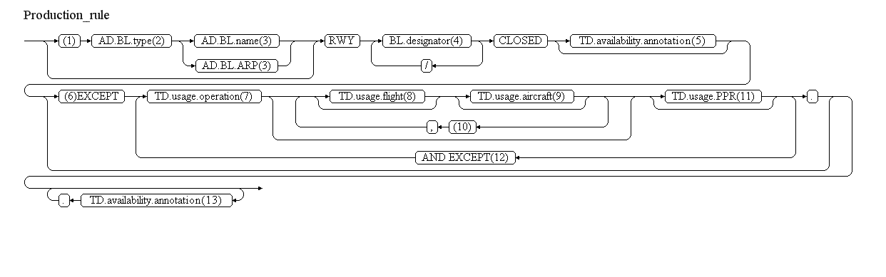
Reference | Rule
(1) | If AD.BL.locationIndicatorICAO=YES, then ignore this branch.
(2) | Insert here the type of the airport decoded as follows
  BL.type | Text to be inserted
  AD or AH | "AD"
  HP | "HELIPORT"
  LS or OTHER... | "LANDING SITE"
(3) | If AD.BL.name is not NIL, then insert it here. Otherwise insert here the text "LOCATED AT " followed by the AD.BL.ARP.ElevatedPoint decoded according to the text NOTAM production rules for aixm:Point
(4) | If more than one RunwayDirection has a TEMPDELTA associated with the Event, then insert the designator of each additional RunwayDirection, preceded by "/". In general, a runway has two landing directions, but there exist rare situations with 3-4 landing directions.
(5) | If there exists a TD.availability.annotation having propertyName="operationalStatus" and purpose="REMARK", then translate it into free text according to the decoding rules for annotations.
(6) | If there exist one or more TD.availability.usage then decode them following this branch, in the following order of priorities:  - TD.availability.usage that have operation="ALL"  - TD.availability.usage that have type="PERMIT"  - ... other situations ...  - TD.availability.usage that have priorPermission which is not NIL shall be decoded last.
(7) | Decode here the TD.availability.usage.operation as follows:
  TD.usage.operation | Text to be inserted
  LANDING | "FOR LANDING"
  TAKEOFF | "FOR TAKE-OFF"
  TOUCHGO | "FOR TOUCH AND GO"
  TRAIN_APPROACH | "FOR PRACTICE LOW APPROACHES"
  TAXIING | "FOR TAXIING"
  CROSSING | "FOR CROSSING"
  AIRSHOW | "FOR AIRSHOW PARTICIPATING ACFT"
  ALL | "FOR"
(8) | Decode here each FlightCharacteristics property that was specified, as detailed below. If more than one FlightCharacteristics property was used, insert blanks between consecutive properties.
  FlightCharacteristics.type | Text to be inserted
  OAT | "OAT"
  GAT | "GAT"
  ALL | "OAT/GAT"
  OTHER:MY_TEXT | "MY TEXT" (replace "_" with blanks)
  FlightCharacteristics.rule | Text to be inserted
  IFR | "IFR"
  VFR | "IFR"
  ALL | "IFR/VFR"
  OTHER:MY_TEXT | "MY TEXT" (replace "_" with blanks)
  FlightCharacteristics.status | Text to be inserted
  HEAD | "HEAD OF STATE"
  STATE | "STATE ACFT"
  HUM | "HUM FLTS"
  HOSP | "HOSP FLT"
  SAR | "SEARCH AND RESCUE"
  EMERGENCY | "EMERGENCY"
  ALL | "STATE/HUM/HOSP/SEARCH AND RESCUE/EMERGENCY FLT"
  OTHER:MY_TEXT | "MY TEXT" (replace "_" with blanks)
  FlightCharacteristics.military | Text to be inserted
  MIL | "MIL"
  CIVIL | "CIVIL"
  ALL | "CIVIL/MIL"
  OTHER:MY_TEXT | "MY TEXT" (replace "_" with blanks)
  FlightCharacteristics.origin | Text to be inserted
  NTL | "DOMESTIC FLT"
  INTL | "INTL FLT"
  HOME_BASED | "HOME BASED ACFT"
  ALL | "DOMESTIC/INTL"
  OTHER:MY_TEXT | "MY TEXT" (replace "_" with blanks)
  FlightCharacteristics.purpose | Text to be inserted
  SCHEDULED | "SCHED FLT"
  NON_SCHEDULED | "UNSCHED FLT"
  PRIVATE | "PRIV FLT"
  AIR_TRAINING | "TRAINING FLT"
  AIR_WORK | "AERIAL WORK"
  PARTICIPANT | "PARTICIPATING ACFT"
  ALL | "SCHED/UNSCHED/PRIV/TRAINING/AERIAL WORK/PARTICIPATING ACFT"
  OTHER:MY_TEXT | "MY TEXT" (replace "_" with blanks)
(9) | Decode here each AircraftCharacteristics property that was specified, as detailed below. If more than one AircraftCharacteristics property was used, insert blanks between consecutive properties.  AircraftCharacteristics.wingSpan - insert the value followed by the value of the uom attribute. Prefix with the value of AircraftCharacteristics.wingSpanInterpretation, decoded as indicated in the following table:  AircraftCharacteristics.weight - insert the value followed by the value of the uom attribute. Prefix with the value of AircraftCharacteristics.weightInterpretation, decoded as indicated in the following table:
  AircraftCharacteristics.type | Text to be inserted
  LANDPLANE | "LANDPLANES"
  SEAPLANE | "SEAPLANES"
  AMPHIBIAN | "AMPHIBIANS"
  HELICOPTER | "HELICOPTERS"
  GYROCOPTER | "GYROCOPTERS"
  TILT_WING | "TILT WING ACFTS"
  STOL | "SHORT TAKE-OFF AND LANDING AIRCRAFTS"
  GLIDER | "GLIDERS"
  HANGGLIDER | "HANG-GLIDERS"
  PARAGLIDER | "PARAGLIDERS"
  ULTRA_LIGHT | "ULTRA LIGHTS"
  BALLOON | "BALLOONS"
  UAV | "UAV"
  ALL | "ALL ACFT TYPES"
  OTHER:MY_TEXT | "MY TEXT" (replace "_" with blanks)
  AircraftCharacteristics.engine | Text to be inserted
  JET | "JET ACFT"
  PISTON | "PISTON ACFT"
  TURBOPROP | "TURBOPROP"
  ALL | "ALL ENGINE TYPES"
  OTHER:MY_TEXT | "MY TEXT" (replace "_" with blanks)
  AircraftCharacteristics. wingSpanInterpretation | Text to be inserted
  ABOVE | "ACFT WITH WINGSPAN LARGER THAN"
  AT_OR_ABOVE | "ACFT WITH WINGSPAN EQUAL OR LARGER THAN"
  AT_OR_BELOW | "ACFT WITH WINGSPAN EQUAL OR SMALLER THAN"
  BELOW | "ACFT WITH WINGSPAN SMALLER THAN"
  OTHER:MY_TEXT | "MY TEXT" (replace "_" with blanks)
  AircraftCharacteristics. weightInterpretation | Text to be inserted
  ABOVE | "ACFT MASS HEAVIER THAN"
  AT_OR_ABOVE | "ACFT MASS EQUAL OR HEAVIER THAN"
  AT_OR_BELOW | "ACFT MASS EQUAL OR LIGHTER THAN"
  BELOW | "ACFT MASS LIGHTER THAN"
  OTHER:MY_TEXT | "MY TEXT" (replace "_" with blanks)
(10) | If TD.usage.selection.logicalOperator=OR (there are more than one flight/aircraft combinations that are excepted), then select and decode each FlightCharacteristics/AircraftCharacteristics consecutively.
(11) | If TD.usage.priorPermission is not NIL, then insert here the decoding of the PPR information as detailed in the following diagram:  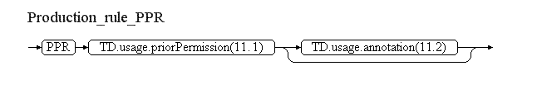
  Reference | Rule
  (11.1) | Insert here the value of the priotPermission attribute followed by the value of the uom attribute decoded as follows:
    uom value | Text to be inserted
    HR | "HOURS"
    MIN | "MINUTES"
    SEC | "SECONDS"
    OTHER:MY_TEXT | "MY TEXT" (replace "_" with blanks)
  (11.2) | Decode here the annotation with propertyName="priorPermission" and purpose="REMARK", according to the decoding rules for annotations.
(12) | If more than one TD.usage elements exist, decode the additional ones starting each time on a new line.
(13) | Annotations of TD.AirportHeliportAvailability shall be translated into free text according to the decoding rules for annotations.
Note: The objective is to full automatic generation, without human intervention. However, the implementers of the specification might consider reducing the cost of a fully automated generation by allowing the operator to fine-tune the text in order to improve its readability (with the inherent risk for human error, when re-typing is allowed).

Items F & G
Leave empty.

Event Update
The eventual update of this type of event shall be encoded following the general rules for Event updates, which provide instructions for all NOTAM fields, except for item E and the condition part of the Q code, in the case of a NOTAMC
If a NOTAMC is produced, then the 4th and 5th letters (the "condition") of the Q code shall be "CN" and the following pattern should be used for automatically generating the E field text from the AIXM data:
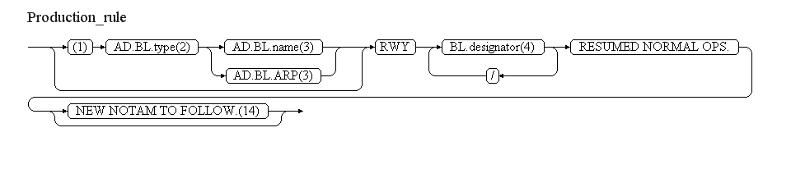
Reference | Rule
(14) | If the NOTAM will be followed by a new NOTAM concerning the same situation, then the operator shall have the possibility to specify "NEW NOTAM TO FOLLOW" and this text shall be appended at the end of item E of the NOTAM C.

Navaid unserviceable [NAV.UNS]

Definition
The unavailability of a ground based radio navigation equipment and service, both if used for en-route or for airport.
Notes:
- this scenario enables the encoding of the information about the unavailability (or limited availability) of a complete navaid or of one of its component equipments. In case a component is concerned, this is limited to the unavailability of a single component;
- in order to keep the digital encoding consistent with the current practices, the term "primary component" is used in the case of composite navaids (such as VOR/DME, ILS, etc. The principle applied for the encoding is that the unavailability of composite navaid is considered due to the unavailability of its primary components. The unavailability of a non-primary component (such as a MKR used by an ILS) needs to be encoded separately;
- the outage of a navaid is likely to trigger the unavailability of Procedures and Routes; these are defined as separate scenario and such scenario inter-dependencies will need to be further investigated;
- this scenario does not cover the downgrading of an ILS category; please see the dedicated scenario “ILS downgraded”(tbd) for that purpose;
- this scenario does not support the modification of information about navaid coverage/range. Although this data can be encoded digitally using AIXM 5.1, no immediate usage has been identified and therefore that scenario is left for being defined later.

Event data
The following diagram identifies the information items that are usually provided by a data originator for this kind of event.
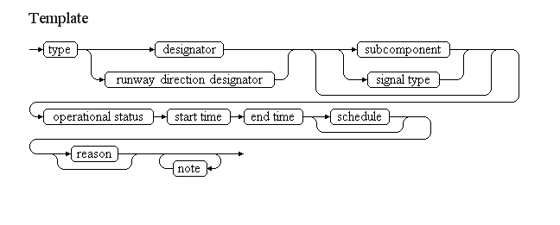

Examples of such events:
En-route navaid
ST PREX DVOR/DME SPR 113.900 MHZ/CH86X U/S
FROM 07 OCT 07:00 TILL 07 OCT 14:00
DUE TO MAINT. DO NOT USE, FALSE INDICATIONS POSS.)
Airport (runway) navaid
RWY 23 ILS U/S
FROM 07 OCT 10:00 TILL 07 OCT 14:00
DUE TO MAINTENANCE
Navaid equipment
E) ILS GP RWY11 U/S
FROM 06 SEP 08:30 TILL 07 SEP 06:58
The table below provides more details about each information item contained in the diagram. It also provides the mapping of each information item within the AIXM 5.1 structure. The name of the variable (first column) is recommended for use as label of the data field in human-machine interfaces (HMI).
Data item | value | AIXM mapping
type | The type of navaid service. In combination with other items, this is used to identify the Navaid and/or the NavaidEquipment concerned. | Navaid.type with this list of values CodeNavaidServiceType and/or one of the non-abstract subtypes of NavaidEquipment
designator | The published designator of the navaid. In combination with other items, this is used to identify the Navaid and/or NavaidEquipment concerned. | Navaid.designator and/or NavaidEquipment.designator
runway direction designator | The designator of the runway direction that is served by the navaid (especially for ILS). In combination with other items, this is used to identify the Navaid concerned. | Navaid.runwayDirection
subcomponent | A specific navaid equipment, used as part of a composed navaid service, in case the unserviceable status affects only this component. In combination with other items, this is used to identify the NavaidEquipment and eventually other Navaid(s) concerned. | One of the non-abstract subtypes of NavaidEquipment
signal type | A specific sub-signal of a composed navaid service, in case the unserviceable status affects only this signal type. In this scenario, this is limited to the Azimuth or Distance indication of a TACAN Navaid. | NavaidOperationalStatus.signalTypeThis can be specified only if the navaid is a TACAN or VORTAC and only the values "AZIMUTH" or "DISTANCE" may be used from its list of valuesCodeRadioSignalType
operational status | The operational status. The typical value is "unserviceable", also abbreviated "U/S". Other values are possible, such as "on test, do not use", "false indication possible", etc. | (NavaidEquipment and Navaid)/NavaidOperationalStatus.operationalStatus with this list of valuesCodeStatusNavaidType
start time | The effective date & time when the event starts | (Navaid and NavaidEquipment)/TimeSlice/TimePeriod.beginPosition, Event/EventTimeSlice.validTime/timePosition and Event/EventTimeSlice.featureLifetime/beginPosition
end time | The end date & time when the event ends. It might be an estimated value. | (Navaid and NavaidEquipment)/TimeSlice/TimePeriod.endPosition and Event/EventTimeSlice.featureLifetime/endPosition also applying the rules for Event with estimated termination
schedule | A schedule might be provided, in case the navaid status changes according to a regular timetable, within the period between the start time and the end time. | (Navaid and/or NavaidEquipment)/NavaidOperationalStatus/Timesheet/... according to the rules for Event Scheduled
reason | A reason for the navaid operational status change | (Navaid and/or NavaidEquipment)/NavaidOperationalStatus.annotation with propertyName="operationalStatus" and purpose="REMARK"
note | A free text note that provides further instructions concerning the navaid operational status situation. | (Navaid and/or NavaidEquipment)/NavaidOperationalStatus.annotation
Notes:
- The word "locator" is expected to be used for low power NDB in the operational language.

Assumptions for baseline data
- it is assumed that the Navaid(s) and NavaidEquipments(s) concerned (see the data encoding rules for details on how these are identified) exist as baseline data;
- it is assumed that no NavaidEquipment exists without being used as component for at least one Navaid;
- it is assumed that the the operationalStatus is specified as BASELINE data only for Navaid, but not for NavaidEquipment; however, the encoding rules can support all situations;
- it is assumed that all Navaid of type ILS or MLS are associated with at least one runway direction.

Data encoding rules
The data encoding rules provided in this section shall be followed in order to ensure the harmonisation of the digital encodings provided by different sources. The compliance with some of these encoding rules can be checked with automatic data validation rules (see next section).
Note that, in the case of composite Navaid (that have more than one navaid component) the term "primary components" has the following meaning:
Navaid type | Primary components  [for data encoding purpose in this scenario]
VOR, DME, NDB, TACAN, MKR, VORTAC, VOR_DME, NDB_DME, TLS, LOC, LOC_DME, NDB_MKR, DF, SDF, OTHER | All NavaidEquipment that compose the Navaid
ILS | Localizer and Glidepath
ILS_DME | Localizer, Glidepath and DME
MLS | Azimuth and Elevation
MLS_DME | Azimuth, Elevation and DME

Identifier | Data encoding rule
ER-01 | First, new Event shall be encoded, for which PERMDELTA and subsequent BASELINE TimeSlice shall be created
ER-02 | Second, identify the NavaidEquipment that are affected, as follows:  - if neither a subcomponent nor a signal type was not specified then it is assumed that all its primary components NavaidEquipment are affected;  - if a subcomponent was specified, then it is assumed that only the corresponding NavaidEquipment component is affected;  - if a signal type was specified (only possible for TACAN or VORTAC Navaids), then it is assumed that its TACAN NavaidEquipment component is affected only for that signal type. For each of these NavaidEquipment(s):  - encode a new TimeSlice of type TEMPDELTA, in which the "event:theEvent" property points to the Event instance created according to ER-01. The TEMPDELTA shall contain containing at least one NavaidOperationalStatus object with operationalStatus. Note that because the NavaidEquipment is an abstract type, in fact the TEMPDELTA shall be created for the appropriate non-abstract sub-type: VOR, DME, LLZ, etc. The rule ER-11 (special encoding in case of schedules) shall apply to each equipment individually).
ER-03 | Third, identify the Navaid affected by considering all Navaid that exist in the database and which use one or more of the NavaidEquipment identified applying ER-02 as primary component. For each of these Navaid(s):  - encode a new TimeSlice of type TEMPDELTA, in which the "event:theEvent" property points to the Event instance created according to ER-01. The TEMPDELTA shall contain containing at least one NavaidOperationalStatus
ER-04 | The value "PARTIAL" can be used only for the operationalStatus of a TACAN NavaidEquipment and only if just one of its signalType (AZIMUTH or DISTANCE) is affected.
ER-05 | The values "FALSE_POSSIBLE" and "CONDITIONAL" cannot be used in this scenario.
ER-06 | The value "UNSERVICEABLE" shall be used only if the navaid does not emit any signal. Otherwise, the value "ON_TEST" shall be used, which will be decoded as "ON TEST, DO NOT USE. FALSE INDICATION POSSIBLE".
ER-07 | In the case of a Navaid for which all its primary components NavaidEquipment are affected (have a temporarily changed operational status), then its NavaidOperationalStatus.operationalStatus attribute shall get the value specified by the "operational status" input parameter
ER-07 | In the case of a Navaid for which only some of its components NavaidEquipment are affected (have a temporarily changed operational status) but not all, then the TEMPDELTA TimeSlice of the Navaid shall have the value indicated in the following table (priority from top to bottom):
  NavaidEquipment operationalStatus | Recommended Navaid operationalStatus
  at least one FALSE_INDICATION | FALSE_INDICATION
  at least one ONTEST | ONTEST
  at least one UNSERVICEABLE | PARTIAL
  at least one INTERRUPT | INTERRUPT
  at least one PARTIAL or IN_CONSTRUCTION | PARTIAL
  at least one DISPLACED | DISPLACED
  at least one OTHER | OTHER For example, if a VOR (equipment) component of a VOR/DME navaid (service) is unserviceable, then the Navaid (of type VOR/DME) shall have a TEMPDELTA TimeSlice with operationalStatus="PARTIAL". In the same time, the VOR (NavaidEquipment) will have a TEMPDELTA TimeSlice with operationalStatus="UNSERVICEABLE".
ER-09 | In the case of a Navaid that has more than one NavaidEquipment component, if only some of its primary components NavaidEquipment are affected (have a temporarily changed operational status = UNSERVICEABLE, ON_TEST, FALSE_INDICATION or IN_CONSTRUCTION) but not all, then it is possible that the unavailability of one of the components changes the nature of the navaid service. If this is the case, then the TEMPDELTA TimeSlice encoded for the Navaid shall also temporarily change the type of the Navaid. For example, if the DME component of a VOR/DME navaid is unserviceable, then the Navaid TEMPDELTA TimeSlice shall also indicate that type="VOR" only and the operationalStatus shall be "PARTIAL". The table below provides more detailed rules:
  Navaid type | NavaidComponent operational status (UNSERVICEABLE, ON_TEST, FALSE_INDICATION or IN_CONSTRUCTION) | Navaid temporarily changed type
  VOR_DME | VOR | DME
  VOR_DME | DME | VOR
  NDB_MKR | MKR | NDB
  NDB_MKR | NDB | MKR
  VORTAC | VOR | TACAN
  VORTAC | TACAN | VOR
  NDB_DME | DME | NDB
  NDB_DME | NDB | DME
  ILS | Glidepath | LOC
  ILS_DME | Glidepath | LOC_DME
ER-10 | If the Navaid or NavaidEquipment status change is limited to a discrete schedule within the overall time period between the "start time" and the "end time", then this shall be encoded using as many as necessary timeInterval/Timesheet properties for the NavaidOperationalStatus of their TEMPDELTA Timeslice. See also the rules for Event Schedules.
ER-11 | In accordance with the AIXM Temporality Concept (see sections 3.4 and 3.5 in version 1.0), the NavaidOperationalStatus associated with the TEMPDELTA replaces all the BASELINE NavaidOperationalStatus information, during the TEMPDELTA time of applicability. Therefore, if the modified operational status only concerns certain times, the other times when the navaid or equipment eventually remains with the same status as in the Baseline data, shall be explicitly included in the TEMPDELTA. The calculation of the necessary additional NavaidOperationalStatus elements to be included in the TEMPDELTA shall be automatically done by the applications implementing this specification.  All NavaidOperationalStatus elements that are copied from the BASELINE data for completeness sake shall get an associated Note with purpose=REMARK and the text="Baseline data copy. Not included in the NOTAM text generation". This is based on the current NOTAM practice which consists of including in the NOTAM only the changed information and not explicitly including the static data that remains valid during the NOTAM applicability.It is recommended that the input interface provides a "calendar/level" view of the navaid/equipment unserviceability, enabling the operator to graphically check the navaid/equipment operational status at different times, such as in the example below:  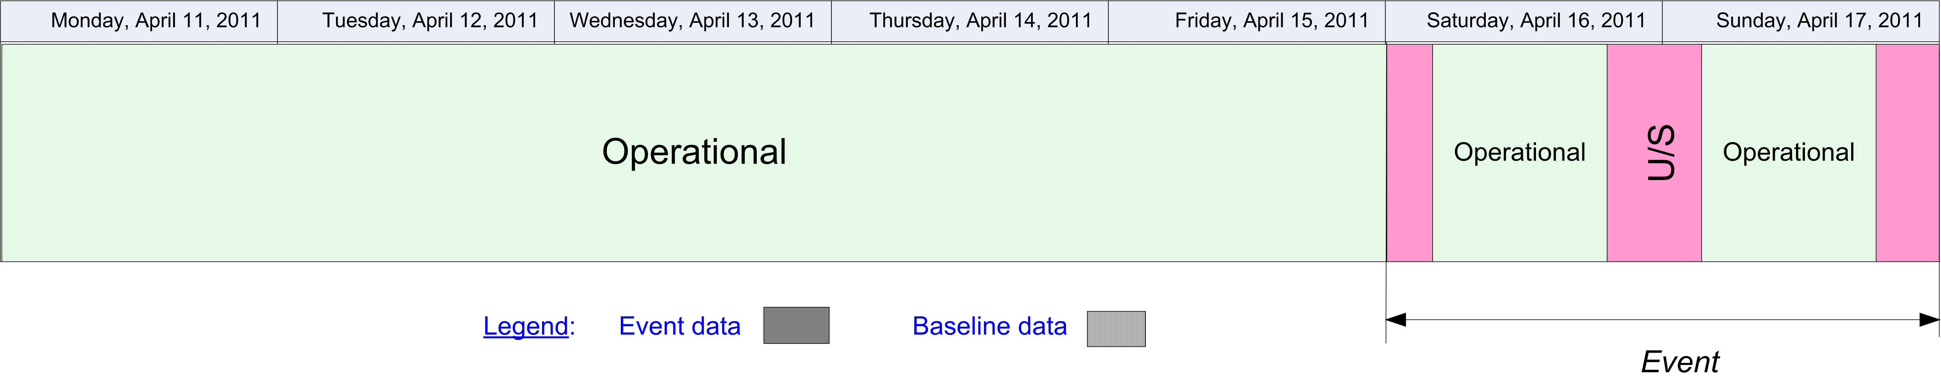  In the calendar view, the Baseline information that remains valid during the Event validity time shall be visibly identified from the information that is specific to the Event, for example by using a different colour fill pattern.

Automatic data validation rules
These validation rules apply to the AIXM encoded data:
Title | Definition | Category | Error level
Minimal data requirements | As a minimum, in addition to the AIXM mandatory properties gml:validTime and aixm:interpretation, the Navaid and NavaidEquipment TEMPDELTA TimeSlice shall contain at least aixm:operationalStatus | Minimal data | error
Operational status allowed values | The TEMPDELTA TimeSlice of a NavaidEquipment associated with the Event cannot have the values "FALSE_POSSIBLE" or "CONDITIONAL" for its aixm:operationalStatus. | Minimal data | error
Operational status PARTIAL only for TACAN | The value "PARTIAL" can appear only in a TEMPDELTA TimeSlice of a TACAN associated with the Event and only if the signalType has one of the values: "AZIMUTH" or "DISTANCE". | Minimal data | error
Single component Navaid status consistency | If a Navaid (BASELINE) has a single aixm:navaidEquipment and there exists a TEMPDELTA TimeSlice for that NavaidEquipment that has aixm:operationalStatus with one of the values UNSERVICEABLE, ONTEST, INTERRUPT, PARTIAL, FALSE_INDICATION, DISPLACED or OTHER, then the Navaid shall also have a TEMPDELTA TimeSlice with identical validity time and identical aixm:NavaidOperationalStatus data | Data Consistency | error
VOR/DME status consistency with VOR | If a VOR that is used (by xlink:href) as aixm:navaidEquipment for a Navaid of type VOR/DME has a TEMPDELTA TimeSlice with aixm:operationalStatus with one of the values UNSERVICEABLE, ONTEST, INTERRUPT, FALSE_INDICATION, DISPLACED, OTHER or IN_CONSTRUCTION, then the VOR/DME Navaid shall also have a TEMPDELTA TimeSlice with identical validity time, aixm:type="DME" and aixm:operationalStatus according to the mapping table of the rule ER-09 | Data Consistency | error
VOR/DME status consistency with DME | If a DME that is used (by xlink:href) as aixm:navaidEquipment for a Navaid of type VOR/DME has a TEMPDELTA TimeSlice with aixm:operationalStatus with one of the values UNSERVICEABLE, ONTEST, INTERRUPT, FALSE_INDICATION, DISPLACED, OTHER or IN_CONSTRUCTION, then the VOR/DME Navaid shall also have a TEMPDELTA TimeSlice with identical validity time, aixm:type="VOR" and aixm:operationalStatus according to the mapping table of the rule ER-09 | Data Consistency | error
ILS status consistency with Localizer | If a Localizer that is used (by xlink:href) as aixm:navaidEquipment for a Navaid of type ILS or ILS/DME has a TEMPDELTA TimeSlice with aixm:operationalStatus with one of the values UNSERVICEABLE, ONTEST, INTERRUPT, FALSE_INDICATION, DISPLACED, OTHER or IN_CONSTRUCTION, then the ILS or ILS/DME Navaid shall also have a TEMPDELTA TimeSlice with identical validity time, aixm:type="OTHER" and aixm:operationalStatus according to the mapping table of the rule ER-09 | Data Consistency | error
ILS status consistency with Glidepath | If a Glidepath that is used (by xlink:href) as aixm:navaidEquipment for a Navaid of type ILS or ILS/DME has a TEMPDELTA TimeSlice with aixm:operationalStatus with one of the values UNSERVICEABLE, ONTEST, INTERRUPT, FALSE_INDICATION, DISPLACED, OTHER or IN_CONSTRUCTION, then the ILS or ILS/DME Navaid shall also have a TEMPDELTA TimeSlice with identical validity time, aixm:type="LOC" or "LOC_DME" and aixm:operationalStatus according to the mapping table of the rule ER-09 | Data Consistency | error
A single temporary operational status | If the Navaid or NavaidEquipment TEMPDELTA TimeSlice includes an aixm:availability, then there should not exist any other TEMPDELTA for the same Navaid or NavaidEquipment that also includes an aixm:availability element and which intersects the validity of the current TEMPDELTA. | Data Consistency | error
Baseline data copy correctness | For each NavaidOperationalStatus included in the TEMPDELTA that has an associated annotation with purpose=REMARK and the text="Baseline data copy. Not included in the NOTAM text generation", there shall exist an equivalent NavaidOperationalStatus in the BASELINE data, having:  - the same aixm:operationalStatus and aixm:signalType (if applicable);  - an encompassing aixm:timeInterval. | Data consistency | error

Text NOTAM production rules
This section provides rules for the automated production of the text NOTAM message items, based on the AIXM 5.1 data encoding of the Event. Therefore, AIXM specific terms are used, such as names of features and properties, types of TimeSlices, etc:
- the abbreviation (N)BL. indicates that the corresponding data item must be taken from the Navaid BASELINE, which is valid at the start time of the Event;
- the abbreviation (N)TD. indicates that the corresponding data item must be taken from the Navaid TEMPDELTA;
- the abbreviation (E)BL. indicates that the corresponding data item must be taken from the NavaidEquipment BASELINE, which is valid at the start time of the Event;
- the abbreviation (E)TD. indicates that the corresponding data item must be taken from the NavaidEquipment TEMPDELTA;
  - Important note: According to encoding rule ER-06, the TEMPDELTA might also include NavaidOperationalStatus elements that have been copied from the BASELINE data for compliance with the AIXM Temporality rules. The current practice is to not include such static information in the NOTAM text. Therefore, all NavaidOperationalStatus that have an associated annotation with purpose=REMARK and the text="Baseline data copy. Not included in the NOTAM text generation" shall be excepted from the text NOTAM generation algorithm!
In general, the ICAO DOC 8126 and the OPADD rules shall be followed. These have not been copied in this document in order to avoid duplication with those documents. Only instructions that are specific to the AIXM encoding of this event are stated here.

Several NOTAM possible
There are two situations that can trigger the need to issue several NOTAM from one Digital NOTAM encoding:
- More than one Navaid affected - a separate NOTAM shall be created for each (N)TD associated with the Event for which at least one of its primary component NavaidEquipment also has a (E)TD associated with the same Event;
- Multiple airport Navaid - if a Navaid (for which a NOTAM is issued as result of the Event) is used for approach/departure/arrival procedures at several closely located airports, then the current practice in many States is to publish a "navaid unserviceable" NOTAM for each airport that is affected, with the corresponding airport designator in item A. This ensures that the corresponding NOTAM will appear in the airport section of the Pre-Flight Information Bulletins (PIB), for the concerned airport. This shall be left as an operator decision, if not possible to automatically identify all airports affected.
A better solution would be that such navaid outages are translated into one NOTAM with the FIR in item A. Then, separate Events and separate NOTAM should be published for the affected Procedures, having the airport identifier in item A. This approach will be considered for the further development of this Specification, when the scenario for Procedures unavailability will be included.

Item A
The item A shall be generated according to the geographical location of the Airspace, following the ICAO DOC 8126 and the OPADD rules.

Q code
The mapping provided in the tables below shall be used.
(N)BL.type | Recommended 2nd and 3rd Letters
ILS or ILS_DME | QIC - if both the Localizer and the Glidepath components have a (E)TD associated with the Event  QID - if only its DME component has (E)TD associated with the Event  QIG - if only its Glidepath component has (E)TD associated with the Event  QIL - if only its Localizer component has (E)TD associated with the Event  QII - if only its MKR component has (E)TD associated with the Event and its (N)BL.NavaidComponent.markerPosition=INNER  QIM - if only its MKR component has (E)TD associated with the Event and its (N)BL.NavaidComponent.markerPosition=MIDDLE  QIO - if only its MKR component has (E)TD associated with the Event and its (N)BL.NavaidComponent.markerPosition=OUTER  QIY - if only its NDB component has (E)TD associated with the Event and its (N)BL.NavaidComponent.markerPosition=MIDDLE  QIX - if only its NDB component has (E)TD associated with the Event and its (N)BL.NavaidComponent.markerPosition=OUTER
MLS or MLS_DME | QIW
NDB or NDB_MKR | QNB - if NDB component (E)BL.class=ENR  QNL - if NDB component (E)BL.class=L
LOC or LOC_DME | QIN
DME | QND
MKR | QNF
VOR_DME | QNM
TACAN | QNN
VORTAC | QNT
VOR | QNV
DF | QNX
NDB_DME, TLS or OTHER | QXX
and
(N)TD.operationalStatus | Recommended 4th and 5th Letters
UNSERVICEABLE | AS
ONTEST | CT
INTERRUPT | LS
PARTIAL | AS
FALSE_INDICATION | XX
DISPLACED | CM
IN_CONSTRUCTION | XX
OTHER | XX

Items B, C and D
- In item B, insert the value of the (N)TD.validTime.TimePeriod.beginPosition formatted according to the NOTAM syntax for this field: yymmddhhmm;
- In item C, insert the value of the (N)TD.validTime.TimePeriod.endPosition formatted according to the NOTAM syntax for this field: yymmddhhmm.
- If *(N) TD.validTime.TimePeriod.endPosition@indeterminatePosition has the value "unknown", "before" or "after" (the Event has an estimated end of validity), then append "EST" at the end of the item C value.
- If at least one (N)TD.NavaidOperationalStatus.timeInterval exists (the Event has an associated schedule), then it shall be represented in item D according to the general NOTAM conversion rules for Event schedules.

Item E
The following pattern should be used for automatically generating the E field text from the AIXM data:
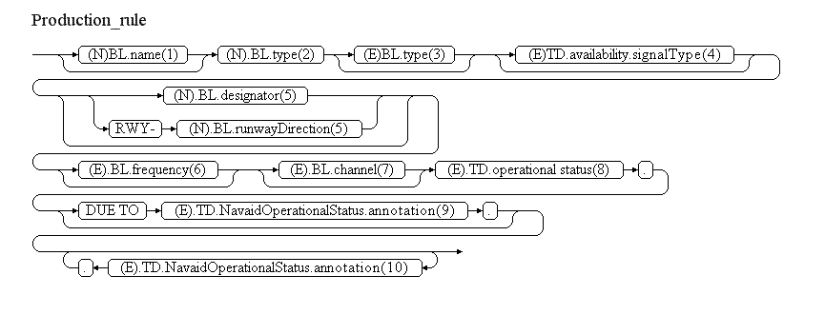
Reference | Rule
(1) | The name of the Navaid shall be included if present in the (N)BL data
(2) | Insert the type from the Navaid baseline, according to the following decoding rule:
  (N)BL | Recommended text
  VOR | "VOR"
  DME | "DME"
  NDB | If (E)BL.class=N then use the word "LOCATOR", otherwise use the word "NDB"
  TACAN | "TACAN"
  MKR | If used as NavaidComponent of an ILS or ILS_DME Navaid, then insert (N)BL.markerPosition first followed by "MKR", otherwise insert just the word "MKR"
  ILS | "ILS"
  ILS_DME | "ILS"
  MLS | "MLS"
  MLS_DME | "MLS"
  VORTAC | "VORTAC"
  VOR_DME | "VOR/DME"
  DNB_DME | "NDB/DME"
  TLS | "TRANSPONDER LANDING SYSTEM"
  LOC | "LOC"
  LOC_DME | "LOC/DME"
  NDB_MKR | "NDB/MKR"
  DF | "DF SERVICE"
  SDF | "SDF EQUIPMENT"
  OTHER | None
(3) | If the Navaid Baseline has several Navaid components and only one of its primary component NavaidEquipment has a (E)TD associated with the Event, then insert the type of that equipment, according to the following decoding rule:
  (E)BL | Recommended text
  DME | "DME PART"
  VOR | "VOR PART"
  TACAN | "TACAN"
  Glidepath | "GP"
  Localizer | "LOC"
  Azimuth | "AZIMUTH SIGNAL"
  Elevation | "ELEVATION SIGNAL"
  SDF | "SDF EQUIPMENT"
  DirectionFinder | "DF SERVICE"
  NDB | If (E)BL.class=N then use the word " LOCATOR", otherwise use the word "NDB"
  MarkerBeacon | If used as NavaidComponent of an ILS or ILS_DME Navaid, then insert (N)BL.NavaidComponent.markerPosition first followed by "MKR", otherwise insert just the word "MKR"
(4) | If (N)BL is TACAN or VORTAC and its (TACAN)TD.availability.signalType is specified, then insert its value here.
(5) | The following rules apply:  - If (N)BL.type has the value ILS, ILS_DME, LOC, LOC_DME, MLS or MLS_DME, then insert the RunwayDirection.BL.designator of the associated (N)BL.runwayDirection, if available;  - Otherwise, insert the (N)BL.designator, if available.
(6) | Apply the following rules:
  (N)BL.type | Use the following value
  VOR, VOR_DME, VORTAC | (VOR)BL.frequency followed by its uom value
  NDB, NDB_MKR, NDB_DME | (NDB)BL.frequency followed by its uom value
  SDF | (SDF)BL.frequency followed by its uom value
  any other | leave empty
(7) | Apply the following rules:
  (N)BL.type | Use the following value
  VOR_DME, DME, NDB_DME | (DME)BL.channel
  TACAN, VORTAC | (TACAN)BL.channel
  any other | leave empty
(8) | Insert the (E)TD.operationalStatus decoded as follows:
  (E)BL.availability/  operationalStatus | Recommended text
  UNSERVICEABLE | "U/S"
  ONTEST | "ON TEST, DO NOT USE. FALSE INDICATION POSSIBLE."
  INTERRUPT | "SUBJECT TO INTERRUPTION"
  PARTIAL | "UNSERVICEABLE" (note that this should only occur for TACAN components)
  FALSE_INDICATION | "FALSE INDICATION, DO NOT USE"
  DISPLACED | "DISPLACED"
  IN_CONSTRUCTION | "IN CONSTRUCTION, DO NOT USE"
  OTHER | "OPERATIONAL STATUS IS AFFECTED"
(9) | If specified, insert here only the (E)TD.NavaidOperationalStatus.annotation that has propertyName="operationalStatus" and purpose="REMARK", translated into free text according to the following encoding rules.
(10) | Annotations shall be translated into free text according to the following encoding rules.
Note: The objective is to full automatic generation, without human intervention. However, the implementers of the specification might consider reducing the cost of a fully automated generation by allowing the operator to fine-tune the text in order to improve its readability (with the inherent risk for human error, when re-typing is allowed).

Items F & G
Leave empty.

Event Update
The eventual update of this type of event shall be encoded following the general rules for Event updates, which provide instructions for all NOTAM fields, except for item E and the condition part of the Q code, in the case of a NOTAMC
If a NOTAMC is produced, then the 4th and 5th letters (the "condition") of the Q code shall be "AK" and the following pattern should be used for automatically generating the E field text from the AIXM data:
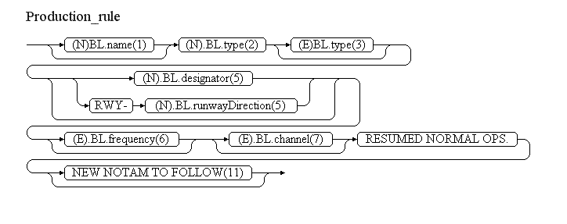
Reference | Rule
(11) | If the NOTAM will be followed by a new NOTAM concerning the same situation, then the operator shall have the possibility to specify "NEW NOTAM TO FOLLOW" and this text shall be appended at the end of item E of the NOTAM C.

New obstacle [OBS.NEW]

Definition
The establishment of a new temporary or permanent vertical obstacle.
Notes:
- This scenario includes the possibility to provide obstacle shapes of type point, line or polygon, but it does not support obstacles composed of multiple parts;
- This scenario includes mobile obstacles;
- This scenario includes groups of similar objects, closely located;
- This scenario includes both airport and en-route obstacles, although the later is rarely occurring in NOTAM messages;
- This scenario does not support encoding of obstacle with variable elevation; only a single elevation value can be provided; eventual reduced elevation information shall be provided as notes.

Event data
The following diagram identifies the information items that are usually provided by a data originator for this kind of event.
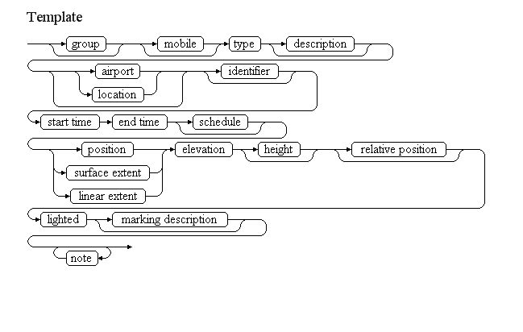

Examples of such events:
Temporary crane at the airport
Construction crane at ETAR
From 01 OCT 2007 05:31 till 30 OCT 2007 18:26
PSN 492623N 0073604E (500 FT South of Control Tower)
Maximum height 858 FT MSL / 85 FT GND.
Night marked.
Crane with schedule in FIR
High crane erected within EDGG FIR
From 01 OCT 2007 04:30 till 09 OCT 2007 14:29, daily 04:30-14:29.
Position: 513759N 0072024E with elevation 675FT/483FT GND.
ICAO marked.
Wind power plants
Group if 3 wind power plant erected at BREMERHAVEN/WEDDEWARDEN
From 01 OCT 2010 00:00 PERM
Psn 533523N 0083345E (WGS84) ELEV 499FT/493FT GND
Day and night marked.
Publication in the AIP ENR 5.4 and on related charts will follow.
Mobile obstacle
Mobile obstacle: Boat
From 01 AUG 2007 20:00 till 15 AUG 2007 04:00 as follows: daily 20:00 till next day 04:00
Floating south of AD between 200m to 1,5NM from Mike Helistop.
Height: 42M
Night marked
The table below provides more details about each information item contained in the diagram. It also provided the mapping of each information item within the AIXM 5.1 structure. The name of the variable (first column) is recommended for use as label of the data field in human-machine interfaces (HMI).
Data item | value | AIXM mapping
group | An indication whether the obstacle consists of a number of closely situated similar objects, for a simple lat/long position (and eventually radius) is provided. | VerticalStructure.group with this list of values CodeYesNoType
mobile | An indication whether the obstacle is expected to move around its nominal location | VerticalStructure/VerticalStructurePart.mobile with this list of values CodeYesNoType
type | A type of vertical structure | VerticalStructure.type and VerticalStructure/VerticalStructurePart.type with this list of values CodeVerticalStructureType
description | A textual description of the obstacle, such as the number of similar items for a group, etc. | VerticalStructure.annotation with propertyName="type" and purpose="DESCRIPTION"
airport | Information such as designator or name used to identify the airport where the obstacle is located | VerticalStructure.annotation with purpose="WARNING"
location | A named geographical location where or close to which the obstacle is located (especially for Area 1 obstacles) | VerticalStructure.name
identifier | An alphanumerical designator by which the obstacle is identified in the national obstacle database | VerticalStructure/VerticalStructurePart.designator
start time | The effective date & time when the obstacle starts to exist. This might be further detailed in a "schedule". | VerticalStructure/VerticalStructureTimeSlice.featureLifetime/beginPosition, VerticalStructure/VerticalStructureTimeSlice/validTime/timePosition, Event/EventTimeSlice.validTime/timePosition and Event/EventTimeSlice.featureLifetime/beginPosition
end time | The end date & time when the obstacle ceases to exist | VerticalStructure/VerticalStructureTimeSlice.featureLifetime/endPosition and Event/EventTimeSlice.featureLifetime/endPosition also applying the rules for Event with estimated termination
schedule | A schedule might be provided, in case the obstacle is only active according to a regular timetable, within the period between the start of life and the end of life. | VerticalStructure/VerticalStructurePart/Timesheet/...according to the rules for Event Schedules
position | The latitude, longitude and horizontal reference datum associated with the obstacle position. | VerticalStructure/VerticalStructurePart/ElevatedPoint
linear extent | Pairs of latitude/longitude values along a line, including the horizontal reference datum associated with the obstacle extent and location | VerticalStructure/VerticalStructurePart/ElevatedCurve
surface extent | Pairs of latitude/longitude values defining a polygon, including the horizontal reference datum associated with the obstacle extent and location | VerticalStructure/VerticalStructurePart/ElevatedSurface
elevation | The elevation (distance from Mean See Level) at the top of the obstacle. | VerticalStructure/VerticalStructurePart/ElevatedPoint or ElevatedSurface or ElevatedCurve
height | The distance between the uppermost and the lowermost parts of the obstacle. | VerticalStructure/VerticalStructurePart.verticalExtent
relative position | A free text description of the obstacle position in relation to relevant airport elements, such as a runway threshold or the control tower. | VerticalStructure/VerticalStructurePart.annotation with propertyName="horizontalProjection_location" and purpose="REMARK"
lighted | An indication if the obstacle is lighted. | VerticalStructure.lightedwith the following list of valuesCodeYesNoType
marking description | Further details of the obstacle lighting, such as times when lighting is available, compliance with the ICAO standards, etc. Also includes the description of visual markers (other than lights) that are installed on the obstacle, such as painting, flags, signs, etc. | VerticalStructure.annotation with propertyName="markingICAOStandard" and purpose="DESCRIPTION"
note | A free text note that provides further details about the obstacle, such as the reason for which it exists, reduced hight at certain times, etc. | VerticalStructure.annotation according to the rules for encoding annotations
Notes:
- It is recommended that data input applications allow the operator to visualise graphically the position and extent of the obstacle, overlaid on an airport map or on an FIR map, as appropriate. If a schedule is used, the graphical interface should also have a "time slider" that allows the operator to see when the obstacle is actually effective.

Assumptions for baseline data
- It is assumed that the Area 2 is available as BASELINE data for all airports that have an ICAO location designator and which are situated in the area of responsibility of the data provider.
  - Note that some airports might have special areas of interests for precise obstacle data, much larger than for 'normal' airports. For example: Innsbruck, Anchorage, etc. It is assumed that in such situations the extended areas are used as "Area 2";

Data encoding rules
The data encoding rules provided in this section shall be followed in order to ensure the harmonisation of the digital encodings provided by different sources. The compliance with some of these encoding rules can be checked with automatic data validation rules (see next section).
Notes:
- It is expected that the data users will evaluate themselves the precise location of the obstacle in relation with the the obstacle limitation surfaces of the airports situated in the vicinity of the new obstacle, using the position of the obstacle; the indication "located at airport XXXX" provided by the data originator shall be considered just as a hint and it is therefore encoded just as a text Note with purpose "WARNING";
- It is assumed that it is not necessary to associate obstacles announced by digital and text NOTAM with the Obstacle Areas identified in ICAO Annex 15 for Electronic Terrain and Obstacle Databases (eTOD). However, some of the data encoding, data validation and text NOTAM production rules depend on the location of the obstacle in relation with airports. For this purpose, the data encoding application shall automatically identify the airports for which the obstacle is located in the horizontal projection of their Area 2.
Identifier | Data encoding rule
ER-01 | The new obstacle shall be encoded as:  - a new Event, for which PERMDELTA and subsequent BASELINE TimeSlices shall be created; and  - a new VerticalStructurem, for which PERMDELTA and subsequent BASELINE TimeSlices shall be created; the property "event:theEvent" of the VerticalStructure TimeSlices shall refer to the Event mentioned above.
ER-02 | If the obstacle consists of a group of similar obstacles situated close to each other for which the individual positions/extents cannot be provided, then:  - if the obstacle is situated in the horizontal projection of Area 2 of an airport, then the overall extent of the obstacle group shall be provided as a surface extent;  - if the obstacle is not situated in the horizontal projection of Area 2 of an airport, then it is also acceptable to provide a single lat/long position for the whole group. In both situations, the "group" property of the VerticalStructure shall get the value "YES".
ER-03 | If the obstacle can change position or has mobile parts (such as a crane arm), then:  - if the obstacle is situated in the horizontal projection of Area 2 of an airport, then the overall area in which the obstacle or any part of it can be located shall be provided as a surface extent;  - if the obstacle is not situated in the horizontal projection of Area 2 of an airport, then it is also acceptable to provide a single lat/long position for the obstacle. In both situation, the "mobile" property of the VerticalStructure shall get the value "YES".
ER-04 | The type of the obstacle shall be encoded (same value) both in the VerticalStructure.type and in the VerticalStructurePart.type

Automatic data validation rules
These validation rules apply to the AIXM encoded data:
Title | Definition | Category | Error level
Minimal data requirements | As a minimum, in addition to the AIXM mandatory properties gml:validTime and aixm:interpretation, the VerticalStructure BASELINE TimeSlice shall contain at least aixm:sequenceNumber, aixm:type, aixm:lighted and one aixm:part. | Minimal data | error
Area for obstacle group at airport | If aixm:group="YES" and the VerticalStructure position intersects the horizontal projection of Area 2 of an airport, then aixm:part/aixm:VerticalStructurePart shall have horizontalProjection_surfaceExtent geometry and the associated ElevatedSurface shall have aixm:elevation | Minimal data | error
Area for mobile obstacle at airport | If aixm:mobile="YES" and the VerticalStructure position intersects the horizontal projection of Area 2 of an airport, then aixm:part/aixm:VerticalStructurePart shall have horizontalProjection_surfaceExtent geometry and the associated ElevatedSurface shall have aixm:elevation | Minimal data | error
Obstacle line elevation | If the aixm:part/aixm:VerticalStructurePart has horizontalProjection_linearExtent geometry, then the associated ElevatedCurve shall have aixm:elevation | Minimal data | error
Point if not area or line | If the aixm:part/aixm:VerticalStructurePart does have neither horizontalProjection_linearExtent nor horizontalProjection_linearExtent geometry, then it shall have horizontalProjection_location geometry and the associated ElevatedPoint shall have aixm:elevation | Minimal data | error

Text NOTAM production rules
This section provides rules for the automated production of the text NOTAM message items, based on the AIXM 5.1 data encoding of the Event. Therefore, AIXM specific terms are used, such as names of features and properties, types of TimeSlices, etc:
- the abbreviation BL. indicates that the corresponding data item must be taken from the VerticalStructure BASELINE;
In general, the ICAO DOC 8126 and the OPADD rules shall be followed. These have not been copied in this document in order to avoid duplication with those documents. Only instructions that are specific to the AIXM encoding of this event are stated here.

Several NOTAM possible
Note that if an obstacle is located in the vicinity of one or more airports, more than one NOTAM might need to be issued issued in order to ensure that the information appears in the relevant en-route and airport Pre-Flight Information Bulletins (PIB). From a Digital NOTAM point of view, this requires that an Event can have several NOTAM associated, which is supported by the AIXM Event schema. In order to facilitate the work of the operator, the Digital NOTAM data provider interface should include the following functionality:
- identify all AirportHeliport Area 2 that intersect the obstacle position or horizontal projection (BL.VerticalStructurePart.horizontalExtent_...); also identify the AirportHeliport that do not have an Area 2 defined but they have their ARP (reference point) located within 5 NM (this might need to be a configurable parameter) and for which the locationIndicatorICAO="YES";
  - if no AirportHeliport was found, then identify the FIR in which the obstacle is located and generate a NOTAM with that FIR in item A and with scope E only;
  - if one or more AirportHeliport are identified, then generate a NOTAM for each such AirportHeliport
    - if BL.VerticalStructurePart.verticalExtent is smaller than 100M, then the aerodrome NOTAM Scope shall be A only; otherwise, the first NOTAM shall have scope AE;
  - considering that the ICAO Annex 15 identifies aerodrome obstacles as being the obstacles situated in Area 2, it is proposed that the horizontal projection of Area 2 is used as a simplified criteria for identifying obstacles that are announced as "situated at the aerodrome". The more precise criteria specified for Area 2 ("penetrates the conical surface whose origin is at the edges of the 180-m wide rectangular area...") are ignored for NOTAM generation purpose.
  - in the current version, "Area 2" means the complete Area 2a, 2b, 2c, 2d as defined in ICAO Annex 15; however, if considered appropriate by the national authorities, this might be reduced to area 2abc only;
In all situations, the operator shall be allowed to take the final decision by selecting the airports/FIR for which a NOTAM is really generated.

Item A
The item A shall be generated according to the geographical location of the VerticalStructure, following the rules stated in the previous section.

Q code
Always use: QOBCE

Items B, C and D
- In item B, insert the value of the BL.validTime.TimePeriod.beginPosition formatted according to the NOTAM syntax for this field: yymmddhhmm;
- If BL.validTime.TimePeriod.endPosition is NIL and BL.validTime.TimePeriod.endPosition@indeterminatePosition has the value "unknown" (the obstacle is permanent), then insert "PERM" as item C value.
- If BL.validTime.TimePeriod.endPosition is not NIL, then insert its value in item C formatted according to the NOTAM syntax for this field: yymmddhhmm.
- If BL.validTime.TimePeriod.endPosition is not NIL and BL.validTime.TimePeriod.endPosition@indeterminatePosition has the value "unknown", "before" or "after" (the Event has an estimated end of validity), then append "EST" at the end of the item C value.
- If at least one BL.activation.AirspaceActivation.timeInterval exists (the Event has an associated schedule), then it shall be represented in item D according to the general NOTAM conversion rules for Event schedules.

Item_E
The following pattern should be used for automatically generating the E field text from the AIXM data:
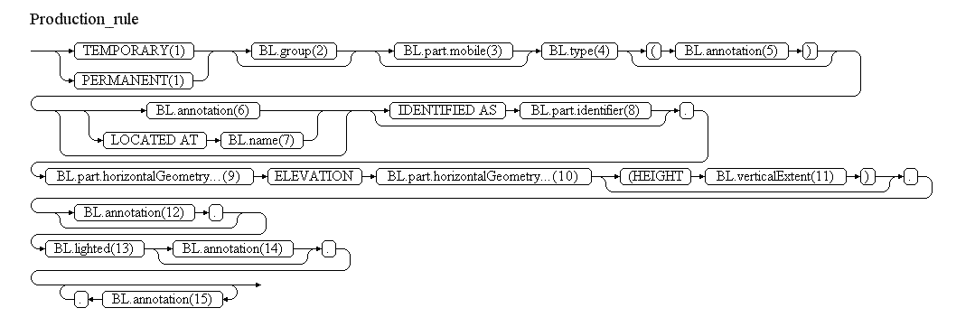
Reference | Rule
(1) | If BL.validTime.TimePeriod.endPosition is NIL and BL.validTime.TimePeriod.endPosition@indeterminatePosition has the value "unknown" (the obstacle is permanent), then insert the word "PERMANENT". Otherwise insert the word "TEMPORARY".
(2) | If BL.group="YES", then insert the words "GROUP OF". Otherwise leave empty.
(3) | If BL.VerticalStructurePart.mobile="YES", then insert the word "MOBILE". Otherwise leave empty.
(4) | If the BL.type="OTHER:...", then insert the text that follows after "OTHER:". In all situations decode the BL.type by replacing the "_" characters with blanc. If BL.Type="OTHER", then insert the word "OBSTACLE".
(5) | If there exists a VerticalStructure.annotation with propertyName="type" and purpose="DESCRIPTION", then insert the text of that note according to the decoding rules for Notes. Otherwise leave empty.
(6) | If there exists a VerticalStructure.annotation with purpose="WARNING", then insert the text of that note according to the decoding rules for Notes. Otherwise leave empty. Attention: the data provider interface shall warn the operator to check if the information received from the originator is consistent with the airport(s) for which the obstacle is situated in the Area 2, as automatically calculated by the application using the obstacle positional data (lat/long).
(7) | Insert the content of BL.name, if available. Otherwise leave empty the whole branch (including "LOCATED AT").
(8) | Insert the content of BL.VerticalStructurePart.designator, if available. Otherwise leave empty the whole branch (including "IDENTIFIED AS").
(9) | The GML encoding of the horizontalProjection (gml:Point, gml:Curve or gml:Surface) shall be translated into human readable text, following the rules for encoding and decoding GML geometries.
(10) | Insert the value of the aixm:ElevatedPoint.elevation or aixm:ElevatedCurve.elevation or aixm:ElevatedSurface.elevation that is associated with the BL.VerticalStructurePart, followed by the value of the respective uom attribute.
(11) | Insert the content of BL.VerticalStructurePart.verticalExtent and of its uom attribute, if available. Otherwise leave empty the whole branch.
(12) | If there exists a VerticalStructure/VerticalStructurePart.annotation with propertyName="horizontalProjection_location" and purpose="REMARK", then insert the text of that note according to the decoding rules for Notes. Otherwise leave empty. Attention: the data provider interface shall help the operator to check if the information received from the originator is consistent with the real position of the obstacle on the airport surface. For example, this can be done by overlaying the obstacle (position and shape) on an airport map.
(13) | If BL.lighted="YES", then insert "LIGHTED." If BL.lighted="NO", then insert "NOT LIGHTED." Otherwise leave empty.
(14) | If there exists a VerticalStructure.annotation with propertyName="markingICAOStandard" and purpose="DESCRIPTION", then insert the text of that note according to the decoding rules for Notes. Otherwise leave empty.
(15) | Annotations shall be translated into free text according to the decoding rules for Notes.

Items F & G
Leave empty.

Event Update
The eventual update of this type of event shall be encoded following the general rules for Event updates, which provide instructions for all NOTAM fields, except for item E and the condition part of the Q code, in the case of a NOTAMC
If a NOTAMC is produced, then the 4th and 5th letters (the "condition") of the Q code shall be "CN" and the following pattern should be used for automatically generating the E field text from the AIXM data:
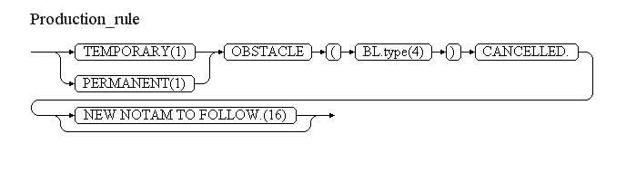
Reference | Rule
(16) | If the NOTAM will be followed by a new NOTAM concerning the same situation, then the operator shall have the possibility to specify "NEW NOTAM TO FOLLOW" and this text shall be appended at the end of item E of the NOTAM C.

Withdrawn obstacle [OBS.WDN]

Work in progress, will be included in a later version (probably 1.1).

Taxiway closure [TWY.CLS]

Work in progress, will be included in a later version (probably 1.1).

Airport surface contamination [AD.CONT]

Work in progress, will be included in a later version (probably 1.1).

Other Event [OTHER]

General concept
This concerns events for which the data is encoded as a simple text Note associated with the feature concerned. This solution will be used in two situations:
- During the transition period, while it is not possible or not necessary for certain NOTAM to be made available as fully structured digital data. For example, NOTAM concerning the temporary change of the Minima of a Procedure might not be supported in the initial phase. Such events will be encoded as a text Note associated with the feature concerned.
- If the corresponding AIXM feature does not have the necessary attributes for encoding the information in structured format. For example, a NOTAM concerning grass cutting in the airport area. There is no dedicated property for "grass cutting" in AIXM, therefore this can only be encoded as a text Note on the AirportHeliport concerned.

Data encoding Rules
The following procedure shall be applied:
- the text NOTAM shall be created as usual;
- a new Event (encoding="ANNOTATION") shall be created, including the associated NOTAM class with the NOTAM text;
- a new Tempdelta TimeSlice shall be created for the affected feature, referring the Event; this shall have:
  - the text of the NOTAM (only the information from items D, E, F and G) as a Note with purpose "warning". Eventually, a specific feature property could be specified by the operator
  - in the case of a non-PERM NOTAM, the same validity as the NOTAM (could be estimated);
  - an "undetermined" end of validity in the case of a PERM NOTAM; once the NOTAM is cancelled because the information is put in an AIP AMDT, a correction TimeSlice shall be issued with the appropriate end of validity;
Note that if there is no relevant affected feature, then the corresponding FIR of airport (as specified in item A) will be used as affected feature.
The rules for Event update apply as for any other Event update.

Data encoding rules

Events with estimated end time

Operational requirements
A NOTAM message may have an estimated (EST) end of validity. The operational needs that require this possibility seem to remain applicable when the event data is encoded digitally. Although the digital data is expected to be more precise than the NOTAM text messages, there are situations where the end of an activity cannot be known with sufficient precision in advance.

Data encoding
An estimated end of validity is supported in AIXM through the use of the attribute "indeterminatePosition" for the gml:endPosition element, as in the example below:
...
<gml:validTime>
<gml:TimePeriod gml:id="CY01_TS02_TP01">
<gml:beginPosition>2010-04-07T09:00:00</gml:beginPosition>
<gml:endPosition indeterminatePosition="unknown">2010-04-15T09:00:00</gml:endPosition>
</gml:TimePeriod>
</gml:validTime>
<aixm:interpretation>TEMPDELTA</aixm:interpretation>
<aixm:sequenceNumber>13</aixm:sequenceNumber>
...
Note that the allowable values for indeterminedPosition also include the values "before" and "after", which enable the provision of a more detailed estimation. For example, if an event is estimated to end at maximum at 09:00 on 15 APR 2010, this can be encoded as:
<gml:endPosition indeterminatePosition="before">2010-04-15T09:00:00</gml:endPosition>
The usage of the values "before" and "after" is not recommended in the current version of this specification. A future version might include rules for the usage of these values, if the operational need is confirmed.

Event update rules
The detailed rules for the update of an Event with an estimated end of validity are provided in the Event update section.
According to Annex 15,Appendix 6 - NOTAM Format, "any NOTAM which includes an 'EST' shall be cancelled or replaced before the date-time specified in Item C)". This is even more important for digital data, as general purpose software (databases, parsers, etc.) are very likely to work with all times as firm values and consider the information being no longer effective after the estimated end time has passed.
Therefore, events that have an estimated end of validity shall be updated before that time is reached. The OPADD document makes some recommendations, which can also be applied to digital data encoding:
Events that contain a gml:endPosition element with a value for the "indeterminatePosition" attribute (end of validity) require an action by the publishing organisation for their replacement or cancellation before the indeterminate (estimated) time is reached.
The data management system shall ensure that a reminder is provided before the "estimated" end of validity, to produce an update of the Event. Individual parameters can be installed, depending upon the type of information, and the operational possibilities of the organisation.
The following parameters are indicative, depending on the estimated validity of the Event:
- up to 1 day : 6 hours before reaching the indeterminate (estimated) time
- more than 1 day and up to 1 month : 1 day before reaching the indeterminate (estimated) time
- more than 1 month and up to 3 months : 3 days before reaching the indeterminate (estimated) time
It is a serious safety hazard if an Event with an estimated end of validity is not updated before that estimated time is reached. That's because general purpose software from the market is very likely to treat such data as "expired" when the estimated time is reached.
Not being able to update the information about estimated events in time, for example because of recurrent difficulties to obtain updated information from their originators, is a serious handicap for NOTAM offices that wish to implement this specification.
For end users, in the unwanted situation that no update is received from the NOTAM office before the expiration time for an Event with an estimated end of validity, it is recommended to automatically extend it's end of validity to a "high value" (31-DEC-9999) and to contact the NOTAM originator in order to clarify the situation. Note that this recommendation is only applicable to end user systems, not for NOTAM offices!

Events with schedule

Introduction
A schedule is a description of a series of discrete time periods, which occur within the overall validity time of an Event,such as:
- daily from 09:00 to 17:00
- every Monday from 13:00 to sunset
- every week from Friday 17:00 till Monday 07:00
- etc.
In general, AIXM supports the encoding of schedules that contain truly repetitive time periods, such as "daily...", "every MON...", "SAT 09:00 - SUN 19:00", etc. The following time periods do not really qualify as Event schedules:
- on 1, 2, 15 and 25 of October
- on 1/10 09:00-15:00 and on 3/10 10:00-12:00
- etc.
Such non-repetitive time periods could be encoded as individual Events. However, banning non-repetitive times from schedules does not seem realistic because:
- the OPADD document allows them in the specification for item D;
- it could increase the workload of the input operators, as they would have to encode more identical events. However, this can be solved with a good HMI, which would allow the operator to view all such identical Events as a single one, with an applicability schedule.
Therefore, this specification also accepts non-repetitive time periods as part of a schedule, with the limitations described further down in this section.

Schedule data
The following diagrams identify the information items that may occur in the definition of schedules for Digital NOTAM Events. There are three types of schedules:
- daily schedules, e.g. "daily from 09:00 to 17:00"
- date based schedules, e.g. "1/10 09:00-15:00 and on 3/10 10:00-12:00"
- weekday based schedules, e.g. "every Monday from 13:00 to sunset"
Each of these types of schedule is detailed in one diagram. Note that, the OPADD does not forbid combining these types of schedules in a single NOTAM. However, this is explicitly forbidden in this specification because it was considered that such combined schedules could become too complex for being understood and have a high potential to contain conflicting information. For example, "daily 0900-1700 and each MON 1900-2300" does not has a clear meaning. Is the schedule for Mondays just 1900-2300, or is it both 0900-1700 and 1900-2300. Therefore, such combined schedules are not supported.
Note that the concept of "weekday ranges" (such as "MON-WED")is also not supported in this specification because it does not have a direct mapping in the current AIXM model for Timesheets and because sometimes there are confusions between MON-FRI and "working days". However, the automatic NOTAM generation rules for item D ensure that a set of consecutive weekdays with a similar start/end time will generate a "weekday range", according to the OPADD recommendations. This does not exclude also that input screens for operators allow the input of weekday ranges, for efficiency reasons. They will have to be converted into individual weekday records in AIXM.
Finally, schedules in the form "from date & time" - "to date & time" (such as "MAR 02 09:00 - 09 16:00") are not supported either. This type of schedules does not fit easily in the Timesheet class of AIXM, because the startTime and endTime properties are, by definition, related only to day and/or dayTill. The AIXM definitions could be changed, but that would also change the meaning of the existing schedules, already encoded for AIXM 4.5 static data. Such semantic changes would significantly complicate the mapping between AIXM 4.5 and AIXM 5.1 data sources. It is also open for discussions if such schedules are really needed, as they can also be treated as individual (separate) Events.
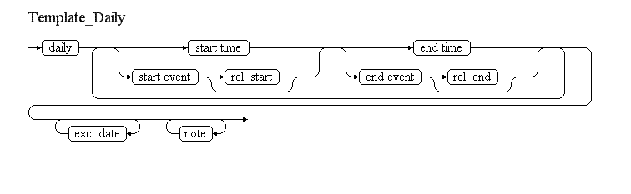
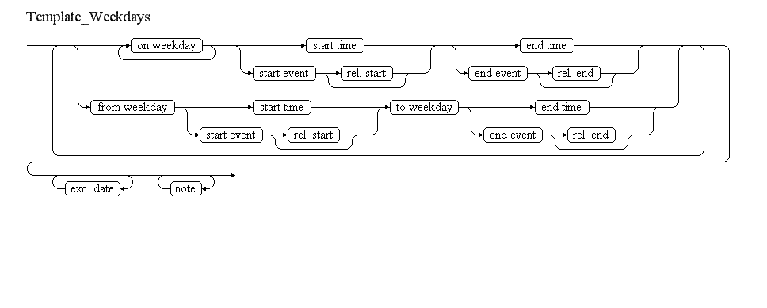
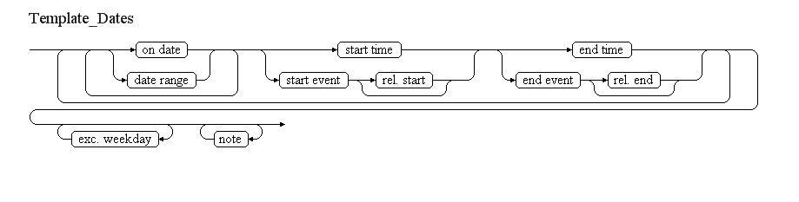
The table below provides more details about each information item contained in the diagram. It also provided the mapping of each information item within the AIXM 5.1 structure. The name of the variable (first column) is recommended for use as label of the data field in human-machine interfaces (HMI).
Data item | Description | AIXM mapping
daily | An indication that the time schedule defined further applies every day | Timesheet.day with the value "ANY"
start time | The time of the day (hour and minute) when the period included in the schedule starts. | Timesheet.startTime
start event | An event (like sunset or sunrise), the occurrence of which indicates when the period included in the schedule starts. | Timesheet.startEvent with this list of values CodeTimeEventType
rel. start | A number of minutes indicating the start of the period included in the schedule, relative to the event. | Timesheet.startTimeRelativeEvent and Timesheet.startEventInterpretation
end time | The time of the day (hour and minute) when the period included in the schedule ends. | Timesheet.endTime
end event | An event (like sunset or sunrise), the occurrence of which indicates when the period included in the schedule ends. | Timesheet.endEvent with this list of values CodeTimeEventType
rel. end | A number of minutes indicating the end of the period included in the schedule, relative to the event. | Timesheet.endTimeRelativeEvent and Timesheet.endEventInterpretation
on date | A specified date of a month that is included in the schedule, such as 02 FEB, 30 JUN, etc. | Timesheet.startDate and Timesheet.endDate Note that both startDate and endDate get the same value.
date range | A series of consecutive days of a year that are included in the schedule, such as 02-15 FEB, 23 MAR - 04 APR, etc. | Timesheet.startDate and Timesheet.endDate
on weekday | A specified day of the week that is included in the schedule, such as MON, TUE, etc. | Timesheet.day with this list of values CodeDayType
from weekday | A day of a week that, combined with a start time or event, indicates the start of the period included in the schedule. For example, "From MON 09:00...", etc. | Timesheet.day with this list of values CodeDayType
to weekday | A day of a week that, combined with an end time or event, indicates the end of the period included in the schedule. For example, "...till FRI 17:00", etc. | Timesheet.day with this list of values CodeDayType
exc. date | A specified date of a month that is fully excluded from the schedule. | Timesheet.startDate and Timesheet.endDate;in addition, the Timesheet.excluded shall get the value "YES". Note that both startDate and endDate get the same value (see also further data encoding rules).
exc. weekday | A specified day of the week that is fully excluded from the schedule. | Timesheet.day with this list of values CodeDayType;in addition, the Timesheet.excluded shall get the value "YES".
Notes:
- It is recommended that the HMI for schedules encoding enables both:
  - "forms based" input - the operator enters values in pre-defined fields) and
  - "text based" input - the operator types directly a textual description of the schedules and the application automatically decodes that into structured data; the text based input is expected to be used for simpler but frequently used schedules;
- As a consequence of the previous recommendation, the schedules encoding form should include an "item D" field, where the text description of the schedule is encoded or decoded by the application in real time;
- See the Eurocontrol item D encoder/decoder for an example of a HMI that allows encoding schedules. Note that this encoder/decoder does not fully comply with neither the OPADD nor this specification. Still, it can provide hints for the development of such a HMI.

Additional versus complete hours
According to the AIXM Temporality document, a Tempdelta shall contain a complete description of the operating times. This has two consequences for applications that enable the encoding of schedules:
- there should be no times left unspecified during the validity time of the TimeSlice. The schedule shall explicitly state when a feature is, for example operative and non-operative, if that is important for the recipient of the information;
- the concept of "additionally active..." is not supported; the TEMPDELTA shall contain the complete definition of the activity times, including any eventual time ranges that are recuperated from the BASELINE schedules. Note that according to the OPADD, notification of a schedule modification by NOTAM shall be done by including the new schedule in item E, not in item D. Therefore, the list of Event Scenarios has to include separate scenarios for such situations.

Data encoding rules
The data encoding rules provided in this section shall be followed in order to ensure the harmonisation of the digital encodings provided by different sources. The compliance with some of these encoding rules can be checked with automatic data validation rules (see next section).
Identifier | Data encoding rule
ER-01 | Each use of "daily", "on date", "date range", "on weekday", or "from weekday...to weekday" shall be encoded as a single Timesheet, according to the mapping table
ER-02 | All Timesheets shall get timeReference=UTC and daylightSavingAdjust=NO
ER-03 | If "on date" is used, then both the Timesheet.startDate and the Timesheet.endDate shall get the value specified for "on date"
ER-04 | If "on date" or "date range" are used, then Timesheet.day shall get the value "ANY" and Timesheet.dayTill shall be left empty
ER-05 | If "daily", "on weekday" or "from weekday...to weekday" are used, then in the corresponding Timesheet(s) both startDate and endDate shall be left empty
ER-06 | If "on weekday" is used, then Timesheet.day shall get that value and Timesheet.dayTill shall be left empty
ER-07 | If "exc. date" is used, then it shall be encoded as one Timesheet that has excluded=YES, startTime=00:00 and endTime=23:59; startDate and endDate shall both get the value specified for "exc. date"
ER-08 | If "exc. weekday" is used, then it shall be encoded as one Timesheet that has excluded=YES, startTime=00:00 and endTime=23:59; day shall get the value specified for "exc. weekday"; startDate and endDate shall be left empty
ER-09 | The values WORK_DAY, BEF_WORK_DAY, AFT_WORK_DAY, HOL, BEF_HOL, AFT_HOL and BUSY_FRI cannot be used in Timesheet.day or Timesheet.dayTill for Event Schedules
ER-10 | According to the OPADD, item D is not allowed to exceed 200 characters. The application interface should check the length of the item D that results from the schedule encoding and invite the operator to split the NOTAM into two separate events in case this limit is exceeded. The HMI should allow copying a draft event into a second draft event
ER-11 | It is not allowed to use "overnight" time periods in Event Schedules, e.g. 2200-0600. These shall be split into two separate time periods, e.g. 2200-2359 and 0000-0600
ER-12 | If a schedule is more complex than the supported by the Template provided for this scenario, then it shall be described in as a free text "note"

Automatic data validation rules
To be provided in future versions.

NOTAM text production rules
This section provides rules for the automated decoding of the Event Schedule in text format, based on the AIXM 5.1 data encoding of the Event Schedule. According to most Event Scenarios, this textual schedule description is provided in item D of the generated NOTAM. However, if the Event concerns the modification of a baseline schedule, then the new/temporary schedule has to be provided in item E. This is identified in the particular scenarios concerned.
The ICAO DOC 8126 and the OPADD rules have been followed in the definition of the text schedule production rules.
Algorithm (to be further detailed in the next version)
- first identify all Timesheets that have "ANY" day and no date range
- group all Timesheets that have the same date or date range
- group by dates or date ranges, then by times; attention to stay within the same month!
- group by weekdays, then by times; attention to stay within one week!
- SR-SS should not be decoded as HJ; SS-SR should not be decoded as HN; 0000-2359 should be decoded as H24, but attention that this can be misleading, not all pilots would know that H24 refers to the UTC time!
- Etc.
In addition to the text production rules provided above, any eventual TS.note (schedule annotations) shall be converted into free text according to the decoding rules for annotations and appended at the end of the item E of the NOTAM generated for the Event.
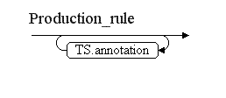

Encoding of geometrical and geographical data

Introduction
AIXM 5.1 uses the Geographical Markup Language (GML) for the encoding of geometrical and geographical data. This is done by directly including the GML 3.2.1 Schema into the AIXM XML Schema.
GML can provide geographical data in a format that is suitable for spatial calculations and for direct graphical representation. For example, all latitude/longitude values are typically encoded as pairs in numerical format (degrees with decimals). By contrast, the information provided by aeronautical data originators and included in NOTAM messages is less "mathematical" and more descriptive. For example, arcs are sometimes described as "from point X, to point Y, with centre C and radius R", which contains more information than necessary. Typically, the radius information is rounded and the centre position is not exactly at the same distance from the start and end of the arc. This information needs to be translated into precise GML encodings. A document that contains guidance for the use of GML in the aviation domain is being developed in the frame of the Aviation Domain Working Group of the Open Geospatial Consortium (OGC).
Note:The "Use of GML for aviation data" document is expected to become available on the OGC Web site as an OGC Discussion Paper towards the end of 2011. Until then, working draft versions are available from the members of the Aviation Domain Working Group of OGC.
In order to automatically generate the text of the NOTAM messages, it is also necessary to translate back the GML encodings into human readable information. Therefore, the purpose of this section is to provide guidelines for both the encoding in GML and decoding from GML of the geographical and geometrical data that is in the scope of the Event Scenarios covered by the specification.

Geometrical and geographical data - encoding
There are three high-level shapes that are used in the description of the location/geometry of aeronautical data features: points, lines and polygons. Lines and polygons can be defined with straight lines, arcs of circle or parallels (points of constant latitude on the surface of the Earth). Apart from the general case of an arbitrary polygon, there are some sub-types of polygons for which the encoding/decoding needs to be defined separately: full circle, sector of circle and corridor (centreline and width). The purpose of this section is to define the encoding rules for each such geometrical/geographical feature. Further details may be found in the "Use of GML for aviation data" document.
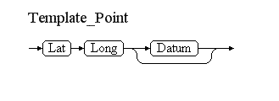
A Point is a single geographical position (such as the location of navaid) expressed as a pair of a latitude/longitude values, possibly with reference to a specific geographical datum.
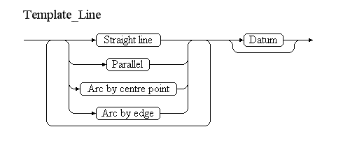
A Line is defined as a series of points connected through straight lines, arcs or parallels, located on the surface of the Earth or in a plane parallel with the surface of the Earth. The lat/long position of each point might be with reference to a specific geographical datum. An example of such as shape is the centreline of a taxiway.
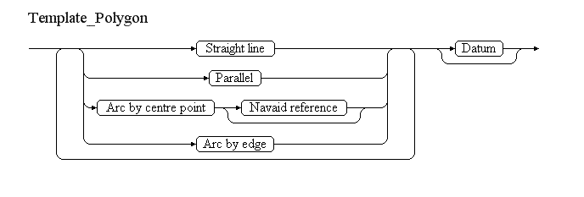
A Polygon is represented by series of points connected through straight lines, arcs or parallels, located on the surface of the Earth or in a plane parallel with the surface of the Earth. The first and the last position in these series of points are identical. The lat/long position of all points might be with reference to a specific geographical datum. An example of such as shape is the horizontal projection of an AirspaceVolume.
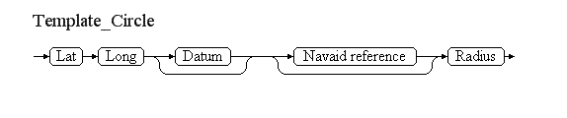
A Circle is a type of polygon in which all the points are located at constant geodesic distance from the centre of the circle. An example of such a shape could be a CTR airspace.
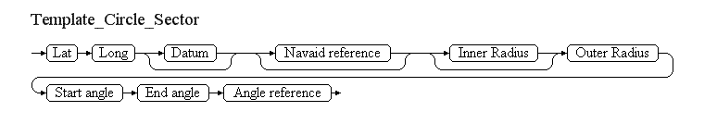
A Circle Sector is a type of polygon that consists in part of a circle situated between two specified angular values and eventually between an inner and an outer radius. For example, an airspace defined as "a sector of 55 NM radius centred on VOR/DME REN between RDL 140 and 230 DEG".
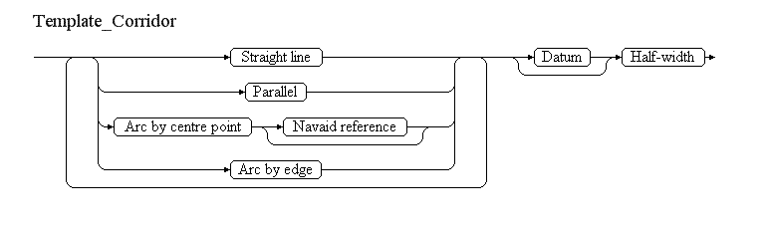
A Corridor is a type of polygon for which the outer border is not defined explicitly but as the result of offsetting a centreline with a specified distance ("half-width") to the left and to the right of that centreline. The two lines are connected by arcs of circle.
The table below provides more details about each information item contained in the diagrams. The AIXM encoding shall be done according to guidelines contained in the "Use of GML for aviation data" document. The name of the variable (first column) is recommended for use as label of the data field in human-machine interfaces (HMI).
Data item | Description | Encoding
Point | A position on or above the surface of the Earth | Encoded as an "aixm:Point" (if located on the surface of the Earth) or as aixm:ElevatedPoint (if located above the surface of the Earth)
Line | A series of consecutive straight or curved lines located on the surface of the Earth or in a plane parallel with the surface of the Earth | Encoded as an aixm:Curve/gml:segments if located on the surface of the Earth or as an aixm:ElevatedCurve/gml:segments if located on a Surface that is parallel to the surface of the Earth. The individual lines that compose the line are encoded as child elements, as detailed further in this table.
Polygon | A closed area defined by an outer border composed of a series of consecutive straight or curved lines located on the surface of the Earth or in a plane parallel with the surface of the Earth | Encoded as an aixm:Surface/gml:patchs/gml:PolygonPatch/gml:exterior/gml:Ring/gml:curveMember/gml:Curve/gml:segments if located on the surface of the Earth or as an aixm:ElevatedSurface/gml:patchs/gml:PolygonPatch/gml:exterior/gml:Ring/gml:curveMember/gml:Curve/gml:segments if located on a Surface that is parallel to the surface of the Earth. The individual lines that compose the polygon outer edge are encoded as child elements, as detailed further in this table.
Lat | The angular distance of a point south or north of the equator. | The first value of an .../gml:pos element.
Long | The the east-west position of a point on the Earth's surface. | The second value of an .../gml:pos element.
Datum | The geographical datum in which the Lat and Long positions are expressed. | Encoded as srsName attribute for the aixm:Point, aixm:ElevatedPoint, aixm:Curve, aixm:ElevatedCurve, aixm:Surface or aixm:ElevatedSurface concerned. According to ICAO Annex 15, all aeronautical geographical data shall be expressed with reference with the WGS-84 reference datum. Therefore, this should appear as default in a data encoding interface. If another datum is used, a corresponding srsName might need to be identified. For practical reasons, applications might need to limit the number of datums other than WGS-84 that are supported.
Straight line | The shortest path between two points on the Surface of the Earth or in a plane parallel with the Surface of the Earth. Expressed as two lat/long pairs. Note that the two points should be at the same elevation. | Encoded as .../gml:GeodesicString/gml:posList element. Note that if the next element is also a Straight line, then all the points shall be specified in a single gml:posList element.
Parallel | A path that keeps a constant Latitude value on the Surface of the Earth or in a plane parallel with the surface of the Earth. Expressed as two lat/long pairs, in which the lat value is the same for both points. | Encoded as .../gml:LineStringSegment/gml:posList element.
Arc by centre point | A path that keeps a constant geodesic distance from a specified centre point. Expressed as a lat/long value (the start of the arc) followed by a lat/long value for the position of the arc centre, a radius values and a lat/long value corresponding to the end of the arc. | Encoded as .../gml:ArcByCenterPoint element.
Navaid reference | A navaid, typically of type DME or TACAN, which is used as centre of the arc. | Encoded using a .../gml:PointProperty element.
Arc by edge | A path that keeps a constant geodesic distance from a non-specified centre point and which passes through a specified point. Expressed as a lat/long value (the start of the arc) followed by a lat/long value for the control position on the arc and a lat/long value corresponding to the end of the arc. | Encoded as .../gml:Arc element.
Circle | A type of polygon defined as a closed curve located at constant geodesic distance from the centre of the circle | Encoded as an aixm:Surface/gml:patchs/gml:PolygonPatch/gml:exterior/gml:Ring/gml:curveMember/gml:Curve/gml:segments/gml:CircleByCenterPoint if located on the surface of the Earth or as an aixm:ElevatedSurface/gml:patchs/gml:PolygonPatch/gml:exterior/gml:Ring/gml:curveMember/gml:Curve/gml:segments/gml:CircleByCenterPoint if located on a Surface that is parallel to the surface of the Earth.
Circle Sector | A type of polygon defined as the area situated between an outer arc, eventually a concentric inner arc and two straight lines that connect the ends of the arc and which are collinear with the arc centre | Encoded as an aixm:Surface/gml:patchs/gml:PolygonPatch/gml:exterior/gml:Ring/gml:curveMember/gml:Curve/gml:segments if located on the surface of the Earth or as an aixm:ElevatedSurface/gml:patchs/gml:PolygonPatch/gml:exterior/gml:Ring/gml:curveMember/gml:Curve/gml:segments if located on a Surface that is parallel to the surface of the Earth. The child elements of gml:Segments are:  - .../gml:GeodesicString/gml:posList followed by  - .../gml:ArcByCentrePoint followed by  - .../gml:GeodesicString/gml:posList which either connects with the arc centre or is followed by another .../gml:ArcByCentrePoint (the inner arc)
Corridor | Defined as a centreline and an offset distance | Encoded as an aixm:Surface/gml:patchs/gml:PolygonPatch/gml:exterior/gml:Ring/gml:curveMember/gml:Curve/gml:segments if located on the surface of the Earth or as an aixm:ElevatedSurface/gml:patchs/gml:PolygonPatch/gml:exterior/gml:Ring/gml:curveMember/gml:Curve/gml:segments if located on a Surface that is parallel to the surface of the Earth. The child elements are  - .../gml:OffsetCurve that has the uses the centreline as gml:offsetBase and gml:distance=+(Half-Width) followed by  - .../gml:Arc calculated in order to connect the end of the first OffsetCurve with the start of the second OffsetCurve by points of equal geodesic distance from the end of the centreline followed by  - .../gml:OffsetCurve that has the uses the centreline as gml:offsetBase and gml:distance=-(Half-Width) followed by  - .../gml:Arc calculated in order to connect the end of the second OffsetCurve with the start of the first OffsetCurve by points of equal geodesic distance from the start of the centreline
Start angle | The value of the angle, measured clockwise from the North direction (magnetic or true, as indicated by the angle reference), where the arc of the sector starts. The start angle shall have a value between [0º... 360º). | Encoded as child gml:startAngle element of a gml:ArcByCentrePoint, eventually adjusted with the local magnetic declination or the station declination if the angle reference is not the True North.
End angle | The value of the angle, measured clockwise from the North direction (magnetic or true, as indicated by the angle reference), where the arc of the sector ends. The value of the end angle shall be always higher than the value of the start angle and shall be between (0º...720º). | Encoded as child gml:endAngle element of a gml:ArcByCentrePoint, eventually adjusted with the local magnetic declination or the station declination if the angle reference is not the True North.
Angle reference | The reference direction for the 0º reading. Three values are possible:  - True North = the zero degrees reading is in the direction of the True North from the arc centre  - Magnetic North = the zero degrees reading is in the local direction of the Magnetic North from the arc centre  - VOR Radial = the zero degrees reading is according to the VOR antenna declination | Used for calculation the true start/end angles, if the angle reference is not the True North.
Notes:
- the use of geographical or administrative features (such as State borders, rivers, sea shores, etc.) in the definition of polygon geometries is not supported. Individual scenarios concerned by this aspect (such as Ad-hoc special activity area - creation provide suggestions/workarounds for the encoding of situations;
- the use of names of geographical places in the definition of airspace borders (such as "444508N 0201455E (VILLAGE JAKOVO)") is not supported. Such annotations cannot be encoded in GML geometries and would prevent the automatic processing of the geo-spatial information. If operationally significant, they can be provided as Notes in the concerned scenario;
- the encoding of Circle Sector will result in a polygon that, when decoded into a textual description, will be described as a polygon, not as a sector of a circle. This is a limitation of the current specification. Identifying that a particular polygon is in fact a sector of a circle would require very complex rules, which might be defined in a future version of the specification;
- It is recommended that the input forms of a data encoding application enables the graphical visualisation of the geometry that is encoded, with a suitable background;
- For geometries of type polygon, corridor and line, it is recommended that the input forms also enable to paste a series of lat/long positions at once, instead of requiring the input of each individual lat/long position in a separate input field;
- For geometries of type sector of circle, it is assumed that if the start/end angles are expressed as radials, then the "navaid reference" is provided and it is a VOR or TACAN navaid.

Data encoding rules
The data encoding rules provided in this section shall be followed in order to ensure the harmonisation of the digital encodings provided by different sources. The compliance with some of these encoding rules can be checked with automatic data validation rules (see next section).
Identifier | Data encoding rule
ER-01 | If the datum is not specified, it is assumed to be WGS-84
ER-02 | In the case of a circle sector, if the reference angle is "True North", then the values of the start angle and end angle shall be used as such in the GML encoding of the ArcByCentrePoint.
ER-03 | In the case of a circle sector, if the reference angle is "Magnetic North", then the values of the start angle and end angle shall automatically adjusted with the local magnetic variation in order to convert them into angles with reference to the True North, which will be used in the GML encoding of the ArcByCentrePoint.
ER-04 | In the case of a circle sector, if the reference angle is "Radial", then the Navaid Reference must be provided and it shall have a VOR or TACAN component. The values of the start angle and end angle shall automatically adjusted with the declination value of the reference navaid in order to convert them into angles with reference to the True North, which will be used in the GML encoding of the ArcByCentrePoint. If the navaid declination is not known, then the local magnetic variation at the site of the navaid shall be used.

Text NOTAM production rules
As explained in the previous section, all geometrical/geographical data is encoded in AIXM/GMl as one of the following elements:
- aixm:Point or aixm:ElevatedPoint
- aixm:Curve or aixm:ElevatedCurve
- aixm:Surface or aixm:ElevatedSurface
This section provides rules for converting these geometries into NOTAM text.
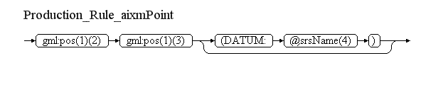
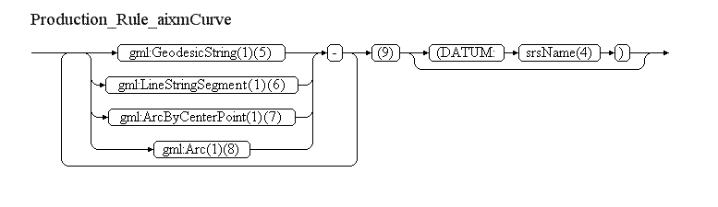
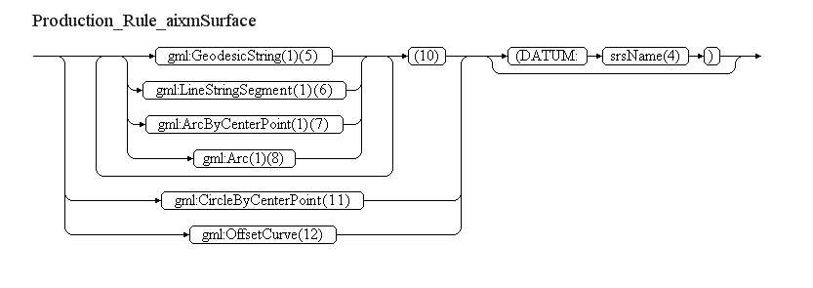
Reference | Rule
(1) | Identify the srsName that applies (see section 3.2 of the "Use of GML for aviation data" guidance document). If this specification was followed for the data encoding, then it is an attribute of the ancestor aixm:Point, aixm:ElevatedPoint, aixm:Curve, aixm:ElevatedCurve, aixm:Surface or aixm:ElevatedSurface element.  - If srsName="urn:ogc:def:crs:EPSG::4326", then the first value in the gml:pos element is the latitude and the second one is the longitude, both in WGS-84;  - If another srsName is found, then specific decoding rules must be available for it.
(2) | Convert the latitude value into the format "DDMMSSH" or "DDMMSS.ssH" as appropriate; trim to 2 decimals if necessary, but do not add trailing zeros after the decimal point!
(3) | Convert the longitude value into the format "DDDMMSSH" or "DDDMMSS.ssH" as appropriate; trim to 2 decimals if necessary, but do not add trailing zeros after the decimal point!
(4) | If srsName="urn:ogc:def:crs:EPSG::4326", then leave empty this branch. Otherwise, decode the srsName as appropriate.
(5) | Convert each pair of latitude/longitude values of the child gml:posList into the format "DDMMSSH DDDMMSSH"; insert " - " as separator between consecutive "lat long" pairs.
(6) | Convert each pair of latitude/longitude values of the child gml:posList into the format "DDMMSSH DDDMMSSH"; insert " - " as separator between consecutive "lat long" pairs.
(7) | Decode the gml:ArcByCenterPoint as detailed in the diagram below  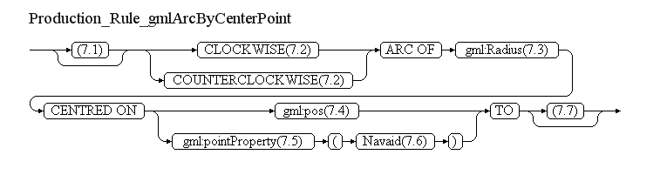  Important note: It is assumed that the srsName applicable to the gml:ArcByCentrePoint has the value "urn:ogc:def:crs:EPSG::4326". Otherwise, the result of this decoding might be incorrect.
  Reference | Rule
  (7.1) | If the gml:ArcByCenterPoint is the first child element of gml:segments, then calculate the position of the start of the arc using the gml:pos, gml:radius and gml:startAngle data and insert here in format "DDMMSSH DDDMMSSH - ". Otherwise leave empty (the start of the arc is the end of the previous curve segment).
  (7.2) | If gml:startAngle is lower than gml:endAngle, then insert "CLOCKWISE", otherwise insert "COUNTERCLOCKWISE".
  (7.3) | Insert the value of the gml:radius element followed by the value of its uom attribute, decoded as follows:  - m -> "M"  - km -> "KM"  - [nmi_i] -> "NM"
  (7.4) | If a gml:pos is provided for the centre of the arc, then decode here the lat/long values of that element in the format "DDMMSSH DDDMMSSH";
  (7.5) | If a gml:pointProperty is used in order to refer to the position of another gml:Point element, then decode here the lat/long values of its gml:pos child element in the format "DDMMSSH DDDMMSSH"
  (7.6) | If a gml:pointProperty is used, then insert here the type and the designator of the Navaid that owns the referenced gml:Point.
  (7.7) | If the gml:ArcByCenterPoint is the last child element of gml:segments or it is followed by another gml:ArcByCenterPoint, then calculate the position of the end of the arc using the gml:pos, gml:radius and gml:endAngle data and insert here in format "DDMMSSH DDDMMSSH". Otherwise leave empty (the end of the arc is the start of the next curve segment).
(8) | Decode the gml:Arc as detailed in the diagram below  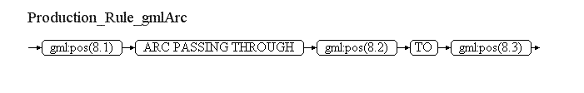
  Reference | Rule
  (8.1) | Decode the lat/long data of the first gml:pos child element of the gml:Arc in the format "DDMMSSH DDDMMSSH"
  (8.2) | Decode the lat/long data of the second gml:pos child element of the gml:Arc in the format "DDMMSSH DDDMMSSH"
  (8.3) | Decode the lat/long data of the third gml:pos child element of the gml:Arc in the format "DDMMSSH DDDMMSSH"
(9) | If there exist more than one child element of gml:segments, it is possible that the individual decoding of each gml:GeodesicString, gml:LineStringSegment, gml:ArcByCenterPoint or gml:Arc results into duplicate pairs of lat/long values (because the start of one curve may be the end of the previous one). To prevent this situation, inspect check the complete decoding of the geometry and eliminate any duplicate consecutive lat/long values.
(10) | If there exist more than one child element of gml:segments, it is possible that the individual decoding of each gml:GeodesicString, gml:LineStringSegment, gml:ArcByCenterPoint or gml:Arc results into duplicate pairs of lat/long values (because the start of one curve may be the end of the previous one). To prevent this situation, inspect check the complete decoding of the geometry and eliminate any duplicate consecutive lat/long values. Pay attention that the first and the last position should be identical. If this is not the case, a warning message shall be raised.
(11) | Decode the gml:CircleByCenterPoint as detailed in the diagram below  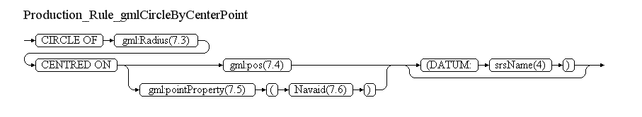
(12) | If a gml:Offset curve is encountered as child element of the aixm:Surface, then it is assumed that it is the encoding of a corridor type of geometry. In this case the geometry should be composed by a sequence of gml:OffsetCurve, gml:ArcByCenterPoint, gml:OffsetCurve, gml:ArcBuCenterPoint, according to the encoding rules for airspace of type corridor. The first gml:OffsetCurve contains all the necessary information for the generation of the NOTAM text and shall be decoded as detailed in the following diagram:  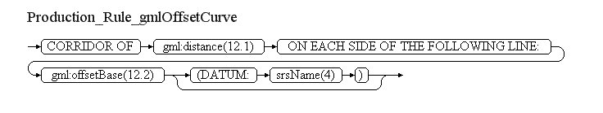
  Reference | Rule
  (12.1) | Insert the value of the gml:distance element followed by the value of its uom attribute, decoded as follows:  - m -> "M"  - km -> "KM"  - [nmi_i] -> "NM"
  (12.2) | Decode the gml:Curve that is the child element of gml:offsetBase following the same decoding rules as for aixm:Curve.

Rules for encoding/decoding vertical limits

Encoding

Numerical values
Vertical limits are typically encoded in AIXM as a pair of two attributes:
- a "...Limit" attribute, which includes the value and its unit of measurement (as an "uom" attribute) with the list of values UomDistanceVerticalType
- a "...LimitReference" attribute, which indicates what reference system is used for the vertical limit value. It uses the following list of values: CodeVerticalReferenceType
The following consistency rules apply between the uom value and the reference value:
Reference | Reference Meaning | Possible uom values
SFC | Height (above surface) | FT, M
MSL | Elevation (above mean sea level) | FT, M
W84 | Ellipsoidal height (above the WGS 84 Ellipsoid) - currently not used for aeronautical operations | FT, M
STD | Pressure difference expressed as an equivalent vertical distance | FL, SM
OTHER:MY_VALUE | Exact meaning depends on what "MY_VALUE" says | FT, M

Coded values (GND, UNL, etc.)
In addition to numerical values, the "...Limit" attributes can use four coded values:
- GND - meaning "from surface"
- UNL - meaning "unlimited"
- FLOOR - meaning "from the bottom of the airspace/route, whatever that one is"
- CEILING - meaning "to the top of the airspace/route, whatever that one is"
The values FLOOR and CEILING may be used only in AirspaceLayer, in relation with AirspaceActivation, AirspaceLayerClass, RouteAvailability).
These special values should be encoded as follows:
Coded value | uom (mandatory)
GND | FT
UNL | FT
FLOOR | OTHER
CEILING | OTHER
The "...Reference" attribute shall be left empty in this situation. However, even if another uom is used or even if the "...Reference" attribute gets a value, they should be ignored by a recipient application because they do not have any meaning in combination with these coded values.

Decoding
The following rules shall be applied for decoding the vertical limits:
"...Limit" Value | "...Limit" @uom | "...LimitReference" | Text to be inserted
GND |  |  | "SFC"
UNL |  |  | "UNL"
FLOOR |  |  | "ITS LOWER LIMIT" (see Notes below)
FLOOR |  |  | "ITS UPPER LIMIT" (see Notes below)
XXXXX | FT | SFC | "XXXXXFT AGL"
XXXXX | FT | MSL | "XXXXXFT AMSL"
XXXXX | FT | W84 | "XXXXXFT ABOVE WGS-84 ELLIPSOID"
XXXXX | M | SFC | "XXXXXM AGL"
XXXXX | M | MSL | "XXXXXM AMSL"
XXXXX | M | W84 | "XXXXXM ABOVE WGS-84 ELLIPSOID"
XXX | FL | STD | "FLXXX"
XXX | SM | STD | "SMXXX"
Notes:
- The values FLOOR and CEILING will not occur in the items F or G, just in the decoding of vertical limits in item E of some particular scenarios;
- The decoding for the values having as reference 'W84' is provided for completeness sake, but they will not occur in the current practice;
- The decoding of "standard meters" (SM) is similar to the decoding of the FL values; although this value is not mentioned in the OPADD, there is no reason to exclude it from this decoding, for those regions that use SM instead of FL.

Encoding annotations

Introduction
Annotations represent free text notes that complement the structured data with explanations, descriptions, warnings that are primarily addresses to humans involved in aeronautical operations. The AIXM model enables the encoding of annotations in multiple languages and it also enables a basic classification of the annotation purpose, as defined by the Note class.
In the Event scenarios, annotations are used for encoding information that is not suitable for encoding as specific feature properties. In some situations,there might exist dedicated features and properties that can provide the same information in a more structured format, but at the expense of significantly more encoding and application development effort. At the current stage of the Digital NOTAM concept implementation, it was not considered necessary to recommend that such data is provided more structured than using notes. For example, in the Published special activity area - activation scenario, the information about the authority to be contacted for further information on an active restricted area might be encoded as an information (service) provider Unit for that Airspace. However, taking into consideration the expected usage of this information (the pilot will manually contact the authority), it was considered sufficient to encode this information as a text annotation only.

Text NOTAM production rules
The content of the AIXM annotations will typically be included at the end of the E) item, according to the following pattern:
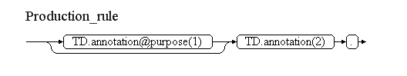
Reference | Rule
(1) | If specified, the "purpose" attribute shall be decoded as follows:  - DESCRIPTION, REMARK or OTHER => nothing  - WARNING => "WARNING: "  - DISCLAIMER => "DISCLAIMER: "
(2) | The text of the annotation shall be translated into UPPER CASE and cleaned of any characters not supported by the AFS/AFTN communication network, in the language selected for the NOTAM text generation.

Event Update

Definition
This scenario provides the rules for updating an already published Digital NOTAM Event, which was encoded following one of the specific scenarios for new events. These rules are based on the general AIXM Temporality Concept rules.
Three situations requiring the update of an Event may occur:
- Active Event - end time update - The typical situation is when the end of validity of an event needs to be modified, either as an immediate cancellation of the Event or as a shortening/extension of the end time. This concerns in particular events with an EST (estimated) end of validity, but not only;
- Inactive Event - cancellation - Another, less frequent situation is when an Event that is not yet active needs to be completely cancelled before taking place;
- Other situations - This includes situations when some characteristics of the event are changed during the event time of validity - such as the vertical limit of an ad-hoc special activity area, the height of a temporary obstacle, the activation schedule, etc. This also includes the change of the start and/or end of validity of an event that is not yet active. In the interest of clarity of the specification, such updates are not supported by this scenario. Instead, they shall be encoded as a cancellation of the original Event at the appropriate time, followed by the encoding of a new Event for the same AIXM Feature, containing the updated information. This is also in-line with the OPADD Rules.
Another parameter to be considered in the scenario is the type of TimeSlices that were created with the original Event. Most of the Event Scenarios described in this specification are encoded as new TEMPDELTA TimeSlices for existing features. However, some scenarios may result in the creation of new features, encoded as a pair of PERMDELTA/BASELINE TimeSlices, with a limited lifespan. For example, an ad-hoc special activity area will be encoded as a new Airspace PERMDELTA/BASELINE, with the lifespan limited to the event duration. The update of an event in the second case (BASELINE TimeSlice) is encoded differently from the event update of the first case (TEMPDELTA TimeSlice).

Active Event - end time update
This scenario occurs when all the other parameters of the event remain unchanged and the only change is the modification of the Event end time. Typically, the original Event had an estimated end of validity, which was encoded according to the specific rules for such situations.

Assumptions for existing data
- it is assumed that this is an update of an Event that was already communicated;
- it is assumed that the end of validity of the original event has not yet passed; if that occurred, then it should be treated as a new Event, not as an update of that original event.

Data encoding rules
The data encoding rules provided in this section shall be followed in order to ensure the harmonisation of the digital encodings provided by different sources. The compliance with some of these encoding rules can be checked with automatic data validation rules (see next section).
Identifier | Data encoding rule
ER-01 | First, the Event update shall be encoded as a new PERMDELTA TimeSlice of the corresponding Event feature, with an incremented sequenceNumber. The PERMDELTA shall contain the updated value for the featureLifetime property. If the new end of validity is estimated, then the rules for Events with estimated end of validity shall be followed.
ER-02 | If the original Event has been encoded as one or more TEMPDELTA TimeSlices for existing AIXM Features, then the update shall be encoded as a "correction" TimeSlice for each affected feature. A new TEMPDELTA shall be created having the same content and sequenceNumber as the original one, an incremented correctionNumber and an updated end of validity. If the new end of validity is estimated, then the rules for Events with estimated end of validity shall be followed.
ER-03 | If the original Event has been encoded as one or more PERMDELTA/BASELINE TimeSlices for a new AIXM Feature, then the update shall be encoded as an additional PERMDELTA TimeSlice, with an incremented sequenceNumber. A new BASELINE shall be created having the same data content as the original one, an incremented sequenceNumber, an updated end of validity and an updated feature lifetime. If the new end of validity is estimated, then the rules for Events with estimated end of validity shall be followed.
ER-04 | If the Event update is an immediate cancellation of the condition that has triggered to the original event, then the current date & time of the system shall be used as gml:validTime.TimePeriod.endPosition.

Automatic data validation rules
These validation rules apply to the AIXM encoded data:
Title | Definition | Category | Error level
Event update PERMDELTA | An Event update PERMDELTA TimeSlice shall include:  - a sequenceNumber higher than the one of the previous PERMDELTA and  - an aixm:featureLifetime element with a gml:endPosition different than the one of the previous PERMDELTA | Data consistency | error
Feature TEMPDELTA correction | For each AIXMFeature TEMPDELTA TimeSlice that was associated with the original Event encoding, there should exist a new TEMPDELTA for the same AIXMFeature that has:  - the same sequenceNumber and  - the same content and  - an incremented correctionNumber and  - a different value for the gml:validTime.TimePeriod.endPosition. | Data consistency | error
Feature update PERMDELTA | For each AIXMFeature PERMDELTA TimeSlice that was associated with the original Event encoding, there should exist a new PERMDELTA for the same AIXMFeature that has:  - a sequenceNumber higher than the one of the previous PERMDELTA and  - an aixm:featureLifetime element with a gml:endPosition different than the one of the previous PERMDELTA  - no other content | Data consistency | error

Text NOTAM production rules
An update of the Event end of validity shall be translated into a NOTAMR or NOTAMC, based on the following criteria:
- if the Event PERMDELTA TimeSlice has aixm:featureLifetime.gml:endPosition equal or before the current date & time of the system, then a NOTAMC shall be created;
- if the corrected Event BASELINE TimeSlice has aixm:featureLifetime.gml:endPosition after the current date & time of the system, then a NOTAMR shall be created;

Item A
NOTAMR and NOTAMC have the same Item A) contents as the NOTAM to be replaced or cancelled. Therefore, this shall be copied from the NOTAM associated with the previous Event BASELINE TimeSlice.

Q code
NOTAMR and NOTAMC deal with precisely the same subject as the NOTAM to be replaced or cancelled. Therefore the 2nd and 3rd letters of the NOTAM code in Item Q) shall be copied from the NOTAM associated with the previous Event BASELINE TimeSlice.
If a NOTAMR is created, then the 4th and 5th letters of the NOTAM code in ITEM Q shall also be copied from the NOTAM associated with the previous Event BASELINE TimeSlice.
If a NOTAMC is created, then the 4th and 5th letters of the NOTAM code in ITEM Q shall be as specified in each individual scenario. Note that the use of a "CN" as a general condition code for all NOTAMC is under discussion by the operational NOTAM experts. However, at the time when this version was released, no definitive conclusion has been drawn yet.

Items B, C and D
The value in the item B shall be the current date & time of the system, formatted according to the NOTAM syntax for this field: yymmddhhmm.
If a NOTAMR is created, then:
- in item D, copy the value from the NOTAM associated with the previous Event BASELINE TimeSlice;
- in item_C, insert the value of the new PERMDELTA aixm:featureLifetime.gml:endPosition formatted according to the NOTAM syntax for this field: yymmddhhmm.
- if the PERMDELTA aixm:featureLifetime.gml:endPosition has an indeterminatePosition attribute with the value "unknown", "before" or "after" (the Event has an estimated end of validity), then append "EST" at the end of the item C value.
If a NOTAMC is created, then item C and D shall be left empty.

Item E
If a NOTAMR is created, then copy the value of the item E from the NOTAM associated with the previous Event BASELINE TimeSlice.
If a NOTAM C is created, follow the rules provided for each particular Event scenario, under title "Event update". For example:
- for cancelling the temporary activation of a special activity area, see Published special activity area - activation / Event Update;
- for cancelling the temporary operational status change of a navaid, see Navaid unserviceable / Event Update;
- Etc.

Items F & G
If a NOTAMR is created, then copy the values of the F and G items respectively, from the NOTAM associated with the previous Event BASELINE TimeSlice.
If a NOTAMC is created, then item F and G shall be left empty.

Inactive Event - cancellation
This scenario occurs when an Event that is not yet active needs to be cancelled before taking place. Note that this corresponds to the situation described in section 3.7 of the AIXM Temporality document, version 1.0 of 15 SEP 2010.

Assumptions for existing data
- it is assumed that this is an update of an Event that was already communicated;
- it is assumed that the start of validity of the original event has not yet passed.

Data encoding rules
The data encoding rules provided in this section shall be followed in order to ensure the harmonisation of the digital encodings provided by different sources. The compliance with some of these encoding rules can be checked with automatic data validation rules (see next section).
Identifier | Data encoding rule
ER-01 | First, the Event cancellation shall be encoded as "correction" of the initial PERMDELTA TimeSlice. The PERMDELTA shall contain the same sequenceNumber as the initial PERMDELTA ("1"), an increment correctionNumber ("1"), an empty gml:validTime with nilReason="inapplicable" and an empty aixm:featureLifetime with nilReason="inapplicable".
ER-02 | If the original Event has been encoded as one or more TEMPDELTA TimeSlices for existing AIXM Features, then the update shall be encoded as a "correction" TimeSlice for each affected feature. A new TEMPDELTA shall be created having the same sequenceNumber as the initial PERMDELTA, an increment correctionNumber ("1"), an empty gml:validTime with nilReason="inapplicable" and an empty aixm:featureLifetime with nilReason="inapplicable"..
ER-03 | If the original Event has been encoded as one or more PERMDELTA/BASELINE TimeSlices for a new AIXM Feature, then the update shall be encoded as a "correction" of the initial PERMDELTA TimeSlice, having the same sequenceNumber as the initial PERMDELTA ("1"), an increment correctionNumber ("1"), an empty gml:validTime with nilReason="inapplicable" and an empty aixm:featureLifetime with nilReason="inapplicable".

Automatic data validation rules
These validation rules apply to the AIXM encoded data:
Title | Definition | Category | Error level
Event PERMDELTA correction | The Event correction PERMDELTA TimeSlice shall have:  - the same sequenceNumber as the initial PERMDELTA  - an increment correctionNumber  - an empty gml:validTime with nilReason="inapplicable"  - an empty aixm:featureLifetime with nilReason="inapplicable"  - no other Event data | Data consistency | error
Feature TEMPDELTA correction | For each AIXMFeature TEMPDELTA TimeSlice that was associated with the original Event encoding, there should exist a new TEMPDELTA for the same AIXMFeature that has:  - the same sequenceNumber as the initial TEMPDELTA  - an increment correctionNumber  - an empty gml:validTime with nilReason="inapplicable"  - an empty aixm:featureLifetime with nilReason="inapplicable"  - no other Feature data | Data consistency | error
Feature PERMDELTA correction | For each AIXMFeature PERMDELTA TimeSlice that was associated with the original Event encoding, there should exist a new PERMDELTA for the same AIXMFeature that has:  - the same sequenceNumber as the initial PERMDELTA  - an increment correctionNumber  - an empty gml:validTime with nilReason="inapplicable"  - an empty aixm:featureLifetime with nilReason="inapplicable"  - no other Feature data | Data consistency | error

Text NOTAM production rules
The cancellation of the Event shall be translated into NOTAMC.

Item A
The NOTAMC shall have the same Item A) contents as the NOTAM to be cancelled. Therefore, this shall be copied from the NOTAM associated with the previous Event BASELINE TimeSlice.

Q code
NOTAMC deal with precisely the same subject as the NOTAM to be replaced or cancelled. Therefore the 2nd and 3rd letters of the NOTAM code in Item Q) shall be copied from the NOTAM associated with the previous Event BASELINE TimeSlice.
The 4th and 5th letters of the NOTAM code in ITEM Q shall be "CN".

Items B, C and D
The value in the item B shall be the current date & time of the system, formatted according to the NOTAM syntax for this field: yymmddhhmm.
The item C and D shall be left empty.

Item E
Follow the rules provided for each particular Event scenario, under title "Event update". For example:
- for cancelling the temporary activation of a special activity area, see Published special activity area - activation / Event Update;
- for cancelling the temporary operational status change of a navaid, see Navaid unserviceable / Event Update;
- Etc.
If the NOTAM that is cancelled will be followed by a new NOTAM concerning the same situation, then the data encoding interface shall enable the inclusion of the text "NEW NOTAM TO FOLLOW." at the end of the item E of the NOTAM C. For digital users, this is of no use, it does not need to be in the AIXM encoding. They will eventually get a new TimeSlice for the same feature. Even for text NOTAM users, this might be not very useful, because NOTAMC do not appear in PIB. However, this is a current practice in NOTAM offices, which is good to support.

Items F & G
The item F and G shall be left empty.

NIL values
For any property of an AIXM feature, instead of providing a value, it is possible to indicate that it is left NIL on purpose. In addition, a NIL reason can be specified, using the pre-defined AIXM list of values, which is in fact inherited from the GML Specification.
The following usage is recommended for the NIL reason values defined in AIXM:
NIL Reason | recommended usage
missing | when the correct/real value is not readily available to the sender of this data and the sender does not know if a value really exists for this property
template | should not be used in the Digital NOTAM encodings
unknown | the correct value is not known to, and not computable by, the sender of this data. However, a correct value probably exists, which is a subtle difference as compared to the "missing" value. The use of "unknown" indicates that a correct value will be provided later, when it becomes known
withheld | the value cannot be divulged; this may be the case for certain military aeronautical data, when the sender wants to indicate that this data exists, but it can only be made available to authorised clients
other | other reason for a NIL value
Note also that "NIL on purpose" and a corresponding NIL reason can also be provided for associations with other features/objects. For example, the whole geometry of a VerticalStructure could be NIL, in which case the NIL reason would be provided for the part property of the VerticalStructure class.
These aspects shall be considered in the design of the input interfaces of any Digital NOTAM application.

Bounding Box
An Event being an AIXM feature, it is also a GML feature and it has a "bounding box". This can be used for raw spatial filtering, assuming that it has a similar meaning to the location/radius of influence used currently in the Q line of the ICAO NOTAM - an area likely to be impacted by the event.
The size of the bounding box shall be estimated based on the same OPADD rules that are applied for the calculation of the location/radius of an ICAO NOTAM, but encoded as a square with lower-left and upper-right corner positions, as indicated in the diagram below:
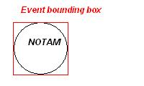

References
- Aeronautical Information Exchange Model (AIXM), version 5.1, http://www.aixm.aero
- Annex 15 to the Convention on International Civil Aviation - Aeronautical Information Services. 12th Edition. ICAO. July 2004.
- AIS Services Manual, ICAO DOC 8126
- Operating Procedures for AIS Dynamic Data (OPADD), version 3.0 - EUROCONTROL-GUID-0121, 08 April 2009

