AIXM 5. 1 Application Schema Tutorial - 101

1. Before you start…checklists
- Review the latest “AIXM UML to AIXM XSD Mapping 1.1.doc”
- Get the latest MDL & CAT files from the AIXM KSN repository (or the www.AIXM.org website if you).
  - Ensure that the main MDL file is checked out.
  - Checkout any of the CAT files you will update.
- Get the latest UML to XSD scripts (AIXM-DataTypeGenerator.ebs, AIXM-FeatureTypeGenerator.ebs, AIXM-ApplicationSchemaGenerator.ebs ) from the AIXM website or KSN.
- Check to see if there are any existing application schemas that can be repurposed for your application.
- Remember to check in the MDL & CAT files as soon as you have finished working so that others can work on those.
- Ensure that the Rational Rose “Virtual Path Map” is set (go to File → Edit Path Map…) as shown below.
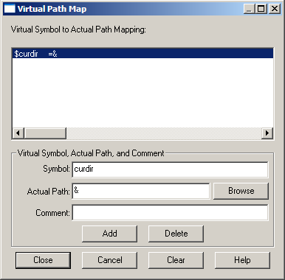

2. Setting up the package structure
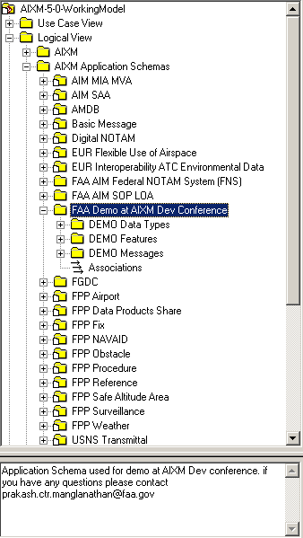
- Set up a package structure as shown below (a package for the app schema, and packages for data types, features and messages).
- Note that each of the sub-packages can generate a single XSD file.
- Create an annotation with information such as who to contact at the package level (annotations entered in the uml model are available in the generated XSD – need to add more detail).

Naming Recommendations
- For App Schema Package (for Org specific)
  - {org} {dept} {project}
  - E.g FAA AIM SOP LOA
- For App Schema Package (non Org specific)
  - {project}
  - E.g Digital NOTAM
- Sub Packages
  - {project} Data Types
  - {project} Features
  - {project} Messages

3. Control the App Schema package
Controlling a package will create a CAT file for that package. This will ensure that one can send the package instead of sending the entire model. Please ensure that the CAT file is checked into the KSN along with the MDL file. By checking into KSN the package is version controlled.

To Control the package right click on the App Schema package as shown below.

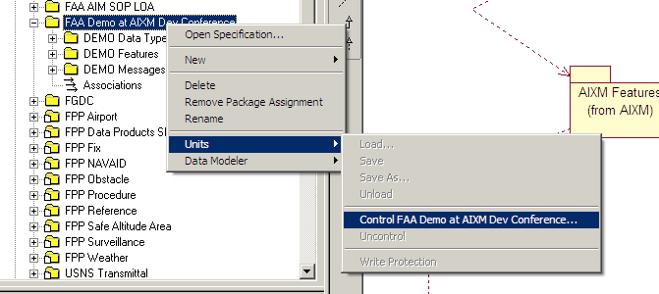

4. Package Level Metadata
Each package that will be converted to an XSD (in our example DEMO Data Types, DEMO Features & DEMO Messages) needs metadata.

Required properties
- targetNamespace
- targetNamespacePrefix
- version
- generateFilename

To access the package specification shown below to set the metadata
right click on the package → Open Specification…

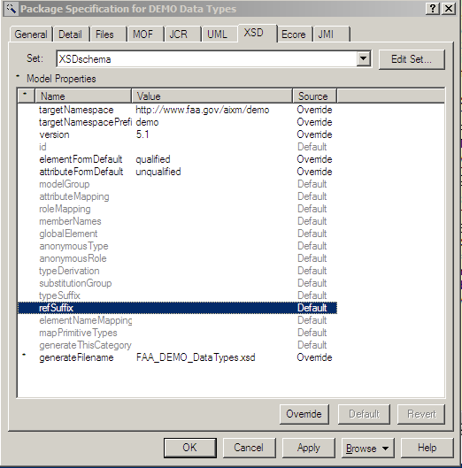
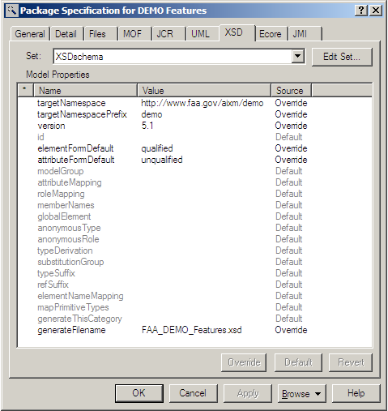
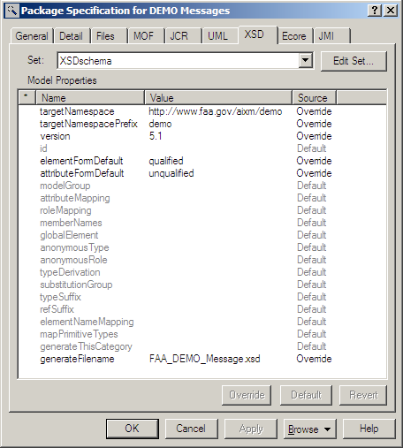

4. Setting up the import paths
(this doesn’t work perfectly in older versions of Rational Rose <=2003 and this file import may have to be done manually in the generated XSD)

Shown below is the dependency that needs to be implemented in the XSD by way of file imports. This is not automatic and should be manually done on a package level.

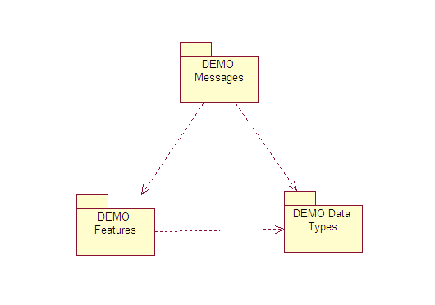

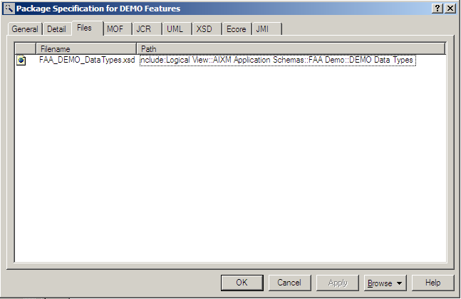
A. In this example FAA_DEMO_Features.xsd should import FAA_DEMO_DataTypes.xsd

To accomplish this import edit the Package Specification for the DEMO Features package. In the files tab use the “insert URL” option and set the values as shown→

The path attribute in this example is…
include:Logical View::AIXM Application Schemas::FAA Demo::DEMO Data Types

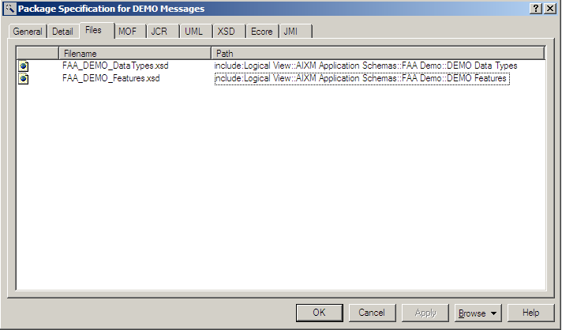
B. The file FAA_DEMO_Message.xsd needs to import from both FAA_DEMO_DataTypes.xsd and FAA_DEMO_Features.xsd.

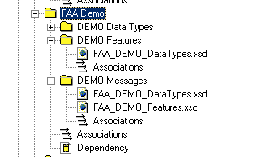

5. DEMO Data Types Package
Any Data types that are specific to this application schema go here.
- Create a Diagram to help with the modeling efforts

To create a Datatype 2 classes are needed the “BaseType” class and the “Type” class. The classes need to be suffixed with “BaseType” and “Type”.
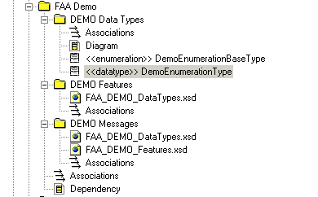
To create a “DemoEnumeration” data type, we need to create 2 classes
- DemoEnumerationBaseType (stereotype enumeration)
- DemoEnumerationType (stereotype datatype)

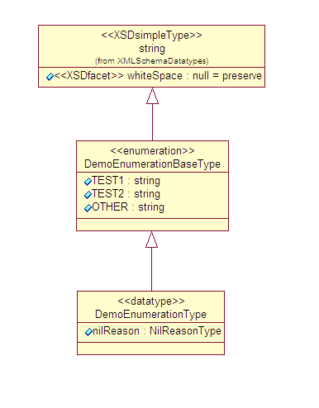
Add the classes created above to the diagram and
Use the “generalize” arrows to connect as shown in the
diagram.

The enumeration values go into the “*BaseType” class and the nilReason attribute goes into the “*Type” class.

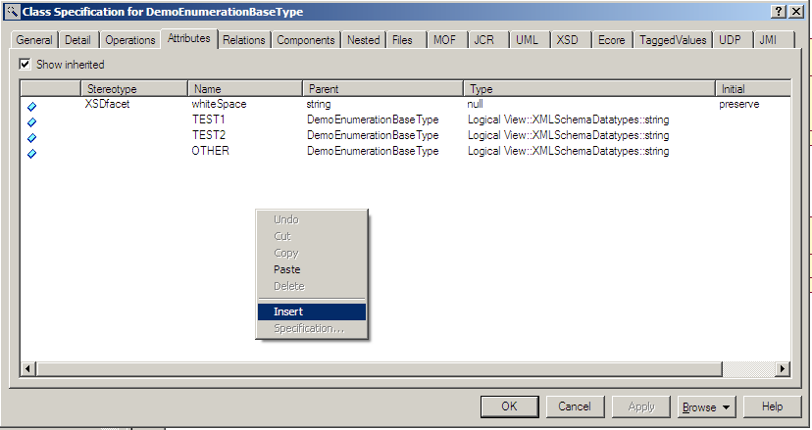

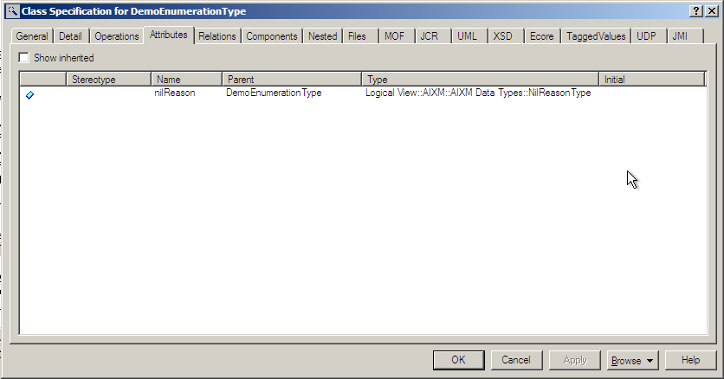

A Codelist from the core AIXM can be extended however an enumeration cannot be extended.
{need to add more detail and clarifications}

To test if what has been modeled is accurate we need to run the UML to XSD script for datatypes which is AIXM-DataTypeGenerator.ebs.

We recommend that this

Click on Tools → Open Script and select the AIXM-DataTypeGenerator.ebs file.

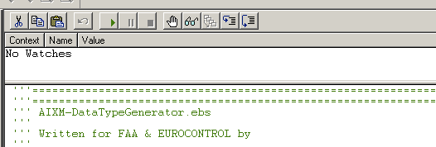
Select the DEMO DataTypes Package.

Click on the Run Script button

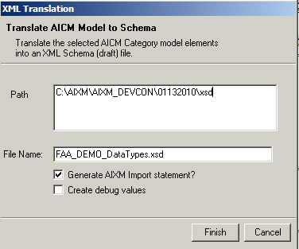

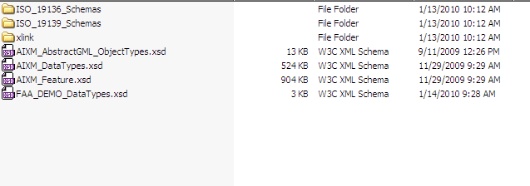

We recommend downloading the latest AIXM 5.1 schemas into the file system and storing the generated XSD in the same location (it can be modified if necessary). This helps in validation of the generated XSD.

6. DEMO Feature Package
Stereotypes Available
- feature
- object
- extension
- choice

Use “feature” as the core entity.
Only features can be uniquely referenced by just using GML identifier (?).
Only features can be served using a webservice (WFS) or file.

Use “objects” to model the complexity of a feature.
Objects cannot exist by themselves.
Objects cannot be served independent of a feature.

Use “extension” to extend the properties available in an existing feature/object.

Use “choice” to give an option between different objects or features.

Here is a simple Feature – Object model
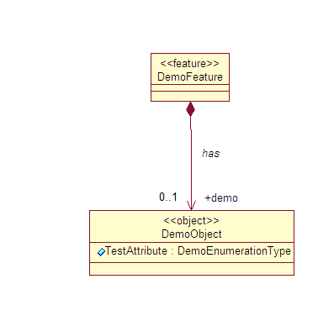
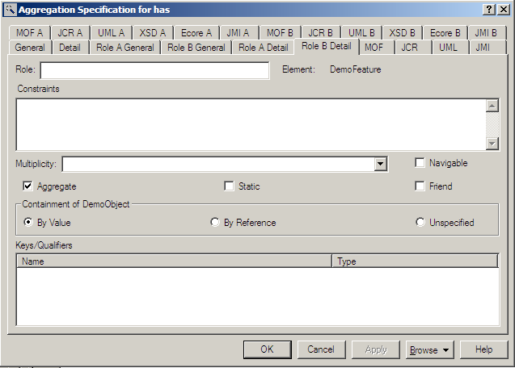

name

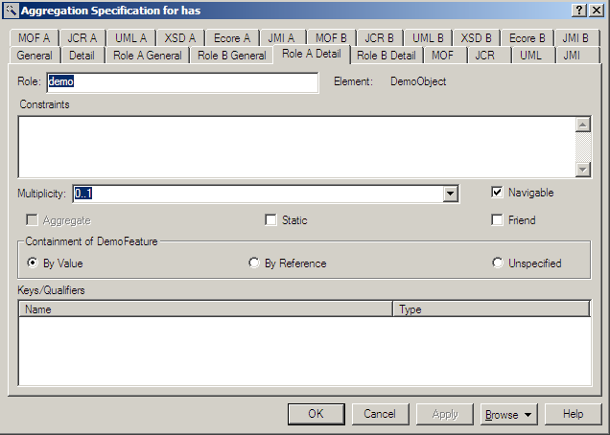

To create a FAA_DEMO_Features.xsd run the AIXM-FeatureTypeGenerator.ebs script (similar to the data types script)

Ensure that the path is set correctly and the “include AIXM NS” flag is set.

If new classes have been added check the “Load QUID from model”

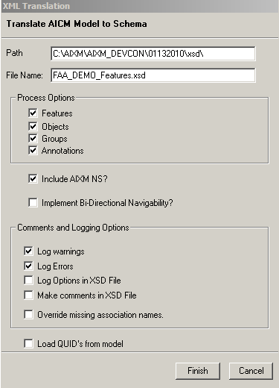
Make sure that the “DEMO Feature” package is selected / highlighted before this script is run.

7. DEMO Message Package
Used to exchange multiple features between systems.
You mostly need the message package to create interfaces between systems.

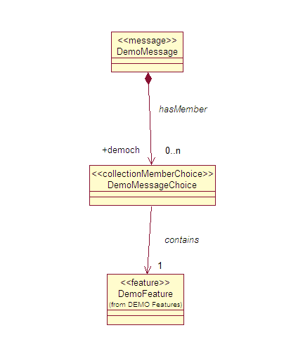

Header
Basic construct needed for most messages

Payload
Add one or more features that this message can carry

To create a FAA_DEMO_Message.xsd run the AIXM-ApplicationSchemaGenerator.ebs script (similar to the data types script)

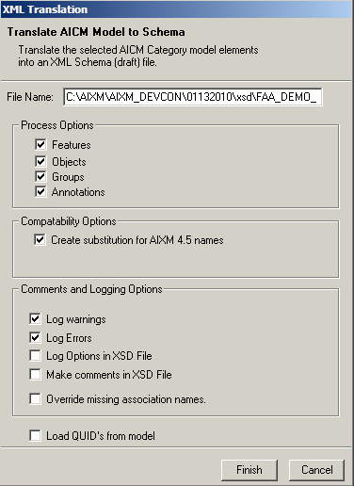
Make sure that the “DEMO Message” package is selected / highlighted before this script is run.

Please send questions/comments to Prakash.ctr.manglanathan@faa.gov
MDL is the main Rational Rose model file. In KSN the name is AIXM-5-0-WorkingModel.mdl
https://ksn.faa.gov/km/ATO/aim/aixm/default.aspx (contact Navin.Vembar@faa.gov for access)
Not necessary if the app schema is not going to be shared in public***
The file name for the package was set in section 4 (Package level Metadata)

