
  AISAIMSG/1-SN No. XX
  22/11/08
AERONAUTICAL INFORMATION SERVICES TO AERONAUTICAL INFORMATION MANAGEMENT STUDY GROUP (AIS-AIMSG)

FIRST MEETING

Montréal, 2 to 4 December 2008

Agenda Item | 6: | AIS to AIM transition roadmap

Including AIM into Annex 15

(Presented by United States Federal Aviation Administration in coordination with the Global AIM Consortium)

SUMMARY
It is widely recognized that the aviation community needs to transition from AIS to AIM. The transition from AIS to AIM is characterized by 1) a transition from a manual, paper product environment to a digital, standards-based environment and 2) the establishment of new services that directly support current and future ATM service requirements. The new services provided by AIM expand upon the traditional AIS safety information to include information services that support aviation system efficiency, capacity, and environment performance requirements.

While it is known that AIM must provide timely, high quality and digital information, the fundamental business services included in AIM have not been completely defined. In addition, ICAO Annex 15 requires amendment to include the SARPS necessary to address the full scope of AIM.

ICAO Doc 9854, Global ATM Operational Concept, outlines the services and performance requirements necessary to support aviation through 2025. Doc 9854 structures future ATM based on the principle of “service provision” and recommends that future concepts be technology independent. The ATM operational concept document identifies seven capabilities for future ATM and recognizes an information service that supports the seven capabilities. The scope of AIM can be defined by identifying the information management services that support the seven ATM capabilities.

This study note introduces the concept that AIM must be defined in terms of a framework that considers performance, business services, information exchange and standards. By using such a framework based on the principles of enterprise architecture for AIM, the study group can ensure that all aspects of the AIS to AIM transition are identified and incorporated as revisions to Annex 15.

- INTRODUCTION
    - The role of Aeronautical Information Management (AIM) is to provide accredited, timely, quality-assured information necessary to support flight operations [ICAO Doc 9854]. Today, Aeronautical Information Services (AIS) supports flight operations by providing static information publications (AIP), notices to airmen (e.g., NOTAM, SNOWTAM) and pre-flight information briefings (PIB). When addressing the question of transition from AIS to AIM, ICAO needs to look beyond these traditional AIS services to identify the information needs to support current and future Air Traffic Management (ATM). This study note describes a framework identifying the concept and content of AIM by considering performance requirements, business activities and information requirements within the context of the Global ATM Operational Concept [ICAO Doc 9854].
  - As a consequence of the 2006, 2007 and 2008 Global AIM Congresses and subsequent strategy and information papers, the ICAO community is well aware of the need to transition from traditional AIS to AIM [AIM Strategy].
  - It is understood that AIS today is primarily responsible for making available the information necessary for the safe and efficient conduct of international air navigation [ICAO Annex 15]. However, this is mandated to be achieved by the production and distribution of paper and manually processed products such as the NOTAM, Aeronautical Information Publication (AIP) and charts. These AIS products no longer meet customer needs for [AIM Strategy]:
- Timeliness, quality and accuracy;
- Support for electronic cock-pit displays, dispatch systems and air traffic control/management systems;
- Collaborative decision making;
- Content or format that end-users desire.
  - In contrast, AIM expands and modernizes the responsibilities of traditional AIS to cover user requirements today and for the future. AIM includes [AIM Strategy]:
- Information lifecycle management including digital data acquisition and quality mandates;
- Improved data accuracy and precision to support safety critical operations;
- Increased data collection and business activity requirements to support efficiency, capacity and environmental aviation system performance requirements as identified in the Global ATM Operational Concept document;
- Standardization of data models and exchange formats, to ensure digital interoperability.
  - Several global initiatives provide evidence of AIM’s value and the steps that can be taken to transition from AIS to AIM:
- The Aeronautical Information Exchange Model (AIXM) provides a reference data model for all the aeronautical information necessary to support international air operations (www.aixm.aero);
- The electronic AIP (eAIP) initiative promoted by EUROCONTROL illustrates the enhanced usability of digital documents rather than paper distribution of AIPs;
- The digital NOTAM concept espoused by EUROCONTROL and the United States Federal Aviation Administration with the support and collaboration of the AIS community worldwide shows how digital information concerning temporary changes can improve the accuracy, timeliness and value of notices to airmen.
  - The ICAO Standards and Recommended Practices (SARPS) need to be updated to satisfy the performance requirements, business needs, data requirements and standards inherent to AIM. The AIM Enterprise Architecture framework can bring coherence to this process.
- discussion
- Defining AIM
    - According to ICAO Annex 15, the role of AIS is to enable international air navigation. Traditionally AIS supports international air navigation by providing three basic services:
- Assembly and publication of static information products like the AIP, Aeronautical Information Circular (AIC) and Charts;
- Collection and distribution of notices of aeronautical information changes like NOTAM, SNOWTAM, BIRDTAM and ASHTAM;
- Provision of Pre-flight Information Briefings (PIB) for pilots.
    - AIM is an evolution of AIS to provide expanded services and information to support the current and future ATM requirement for high quality, timely, digital aeronautical information and services. The full scope of AIM can be determined by considering the services, performance requirements and information needs that best support global ATM.
    - To formulate the linkage between AIM and ATM, this paper recommends that the AIS-AIMSG review the ICAO Doc 9854 “Global Air Traffic Management Operational Concept.”
    - Summary of Global ATM Operational Concept
      - According to the Global ATM Operation Concept, the goal of ATM is to provide “a holistic, cooperative and collaborative decision-making environment where the diverging expectations and interests of all members of the ATM community are balanced to achieve equity and access.” The future ATM system needs to evolve to a seamless global air traffic management concept. Such a system requires international harmonization and global interoperability [ICAO Doc 9854].
      - Doc 9854 identifies seven concept components that make up the Global ATM of the future:
- Airspace organization and management;
- Demand and capacity balancing;
- Aerodrome operations;
- Traffic synchronization;
- Conflict management;
- Airspace user operations;
- ATM service delivery management.
      - Additionally Doc 9854 defines an eighth service that describes AIM by noting “Information management provides accredited, quality-assured and timely information used to support ATM operations.” AIM provides the information services that support the seven ATM capabilities listed above.
    - AIM Scope and Operational Concept
      - The scope of AIM should be aligned to these seven Global ATM elements. The figure below provides a high level operational concept of AIM based on the information management principles identified in the ICAO Global ATM Operational Concept:
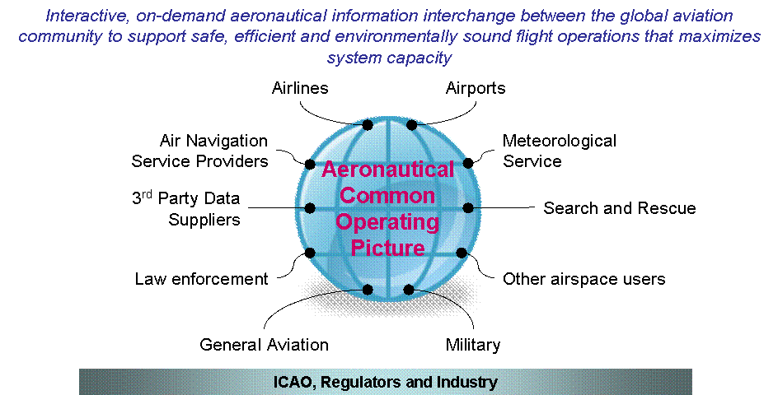
As shown in this operational concept diagram, AIM provides “interactive, on-demand aeronautical information interchange between the global aviation community to support safe, efficient and environmental sound flight operations that maximizes system capacity.” In this concept, AIM delivers a Common Operating Picture of Aeronautical Information for international and external customers and stakeholders and perhaps more appropriately should be renamed ATM Information Management. ICAO and other regulators provide the mandate for AIM; while industry provides information constraints, recommendations and requirements to AIM.
      - Given this high level operational concept, consider the scope of AIM:
- What business services should AIM provide?
- What are the performance requirements to satisfactorily provision AIM services for use by ATM?
- What are the information requirements to support future ATM?
    - Process for defining scope of AIM
      - This study note introduces the concept that AIM must be defined in terms of a framework that considers performance, business services, information exchange and standards. By using such a framework based on the principles of enterprise architecture for AIM [AIM EA], the study group can ensure that all aspects of AIS to AIM transition are identified and incorporated as revisions to Annex 15 as follows:
  - Link AIM to ATM by associating ATM operational activities to information service needs. This is done by decomposing Global ATM into a set of operational activities. The information requirements of these operational ATM activities can be used to determine AIM business activities and information exchange needs.
  - Identify performance requirements. Consider the operational requirements for accuracy, quality, timeliness, precision and other factors that specify the performance requirements for the AIM services.
  - Validate Global ATM information requirements against state-proposed concepts of operation. The United States NextGen program and the European SESAR initiative are two of many state-sponsored future ATM concepts that can be used to validate the AIM scope identified from the Global ATM Operational Concept.
  - Perform gap analysis between AIS and AIM. The gap analysis identifies the changes that need to be made to AIS including enhancements to information exchange models.
  - Prepare recommendations for the AIS – AIMSG. The previous steps identify recommended changes to ICAO Annex 15.
    - Illustration of AIM Scope
      - This section contains a preliminary analysis of AIM requirements for Global ATM, based upon an analysis of ICAO Doc 9854.
      - The figure below shows a partial decomposition of the ATM concept components into ATM business activities:
Provide ATM Services
Provide Airspace
Operate Aerodrome Facility
Maintain Traffic Flow
Support Airspace User Operations
Manage ATM Service Delivery
Balance Demand and Capacity
Synchronize Traffic
Manage Conflict
Determine CapacityEvaluate Traffic Flow
Access Demand and Capacity ImbalanceAllocate Capacity
Mitigate Demand and Capacity ImbalanceFacilitate Collaborative Decision Making
      - In this decomposition “Balance Demand and Capacity”, “Synchronize Traffic” and “Manage Conflict” have been combined into an overall “Maintain Traffic Flow” business activity. For brevity only the decomposition of “Balance Demand and Capacity” is shown in the figure.
      - Each of the ATM concept components has been decomposed into business activities as illustrated for “Balance Demand and Capacity”. The six sub-activities for Balance Demand and Capacity are:
- Determine Capacity – calculate capacity levels based on theoretical capacities, environmental conditions (e.g., weather, visual conditions) and aeronautical information common operating picture (e.g., AIP, NOTAMs and other status information);
- Evaluate Traffic Flow – evaluate expected traffic flows based on historical information, schedules and flight planning;
- Assess Demand and Capacity Imbalance – Determine if there is excess demand because there is more traffic than available airspace and/or airport capacity;
- Mitigate Demand and Capacity Imbalance – Propose restrictions, flight changes and other initiatives to balance demand and capacity;
- Facilitate Collaborative Decision Making – Incorporate stakeholder involvement to solve demand and capacity imbalance;
- Allocate Capacity – Execute capacity utilization strategy.

      - These sub-activities can be further analyzed to understand resource flows, interactivities and functions. The analysis for the “Determine Capacity” is shown below using a style proposed by the AIM Enterprise Architecture Framework.
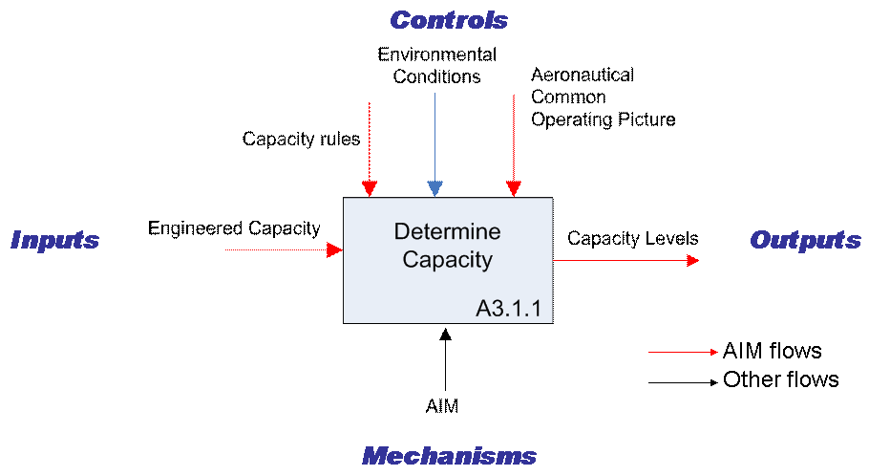
      - This diagram shows Inputs, Outputs, Controls and Mechanisms. Flows involving aeronautical information are colored red.
      - Inputs are the resources needed to support the activities. In this example, the engineered or theoretical capacity is the input.
      - The outputs are those resources produced during the activity. In this example, the output is the calculated capacity level taking into account the operational environment.
      - The controls are resources that influence the activity. This example shows three controls: 1) Environmental conditions including weather, and other external factors that can affect system capacity, 2) Aeronautical Common Operating Picture is the current status of aeronautical information combining static and dynamic information and 3) capacity rules are the heuristics used to estimate capacity levels given the environmental factors and aeronautical information.
      - Mechanisms are the organizations that support the activity. This example shows that AIM is one of several organizations that would contribute to this business activity.
      - Now that the “Balance Demand and Capacity” Concept Component has been decomposed into business activities, it is possible to consider how AIM should support demand and capacity balancing.
      - Consider the information requirements for the Determine Capacity sub-activity. The analysis shows that capacity information is an important component of aeronautical information that is currently not provided by AIS. This capacity includes airport capacity (runway arrival/departure rates, taxiway capacity, and gate turn around time, to name a few) and airspace capacity (route capacity, air traffic control sector thresholds, etc). Furthermore, there is information associated with the capacity rules used to calculate the capacity levels.
      - In addition to managing capacity information, what business services should AIM support? Should AIS be expanded to include capacity services such as:
- Capacity rules validation and digital rules management;
- Capacity calculations;
- Capturing environmental conditions;
- Providing Aeronautical Common Operating Picture.
      - To complete the definition of a new AIM capacity service, we should consider the performance requirements for AIM by considering quality, timeliness and accuracy specifications for capacity information. These levels of performance should be directly linked to the performance needs of the overlying ATM activity – Determine Capacity.
    - Summary of AIM Scope Analysis
      - By considering Global ATM business activities, it is possible to systematically identify the scope of AIM. The “Balance Demand and Capacity” example given above shows that AIM needs to expand to cover system capacity information. Analysis of other Global ATM business activities is expected to identify additional requirements for AIM.
    - Information lifecycle management issues
      - The expansion of AIM to cover information services that support Global ATM emphasizes the need for a systematic process for information lifecycle management. ICAO Doc 9854 identifies four components for information management:
- Monitor quality;
- Control quality;
- Provide information sharing;
- Integrate historical, planned and operational information.

      - The quality components are currently incorporated into the Quality System standards and recommendations of ICAO Annex 15 Chapter 3. Providing information sharing and integrating historical, planning and operational information are new information management requirements identified in Doc 9854.
      - To that list of information management requirements, this paper recommends the addition two additional components:
- Provide Decision Information Support – AIM should assist decision support by providing information support services such as query, filter, search, subscribe and notify;
- Digital Capture – AIM should capture and process digital aeronautical information to ensure that the products and services provided by AIM are equally available to humans or computer systems.
- What is the AIM Enterprise Architecture Framework?
    - To articulate the performance requirements, business activities and information exchange needs that make up the scope of AIM, we recommend the use of the AIM Enterprise Architecture Framework [AIM EA].
    - At the 2008 Global AIM Congress in Singapore, Air Services Australia and the United States Federal Aviation Administration proposed a Global AIM Enterprise Architecture Framework [AIM EA] to assist the AIS to AIM working group with defining the role of AIM within ATM.
    - The proposed Global AIM Enterprise Architecture framework considers four aspects of AIM:
- Performance requirements – AIM goals, objectives and performance requirements;
- Business Service/Activities – common business activities that enable AIM to support ATM;
- Information Exchange Model – the data necessary to support business services;
- Standards Model – standards recommended for AIM.

    - These four components are shown in the figure below:

    - This structured approach can be used to ensure that the full scope of AIM is incorporated into the ICAO SARPS.
- action by the AIS-AIMsg
  - The study group participants are requested to:
- Revise Annex 15 to describe the objective of AIM within the context of the Global ATM vision and to provide the SARPS for the transition from AIS to AIM. Information and services provided by AIM should be based on the requirements of Global ATM to:
  - Ensure that future definitions of AIM include performance requirements, business activities, information exchange requirements and technology standards;
  - Undertake a systematic assessment of the Global ATM Operational Concept to ensure all AIM requirements are included in future revisions to Annex 15.
- Ensure the Annex 15 is in harmony with the future ATM guiding principles of “service provision” and “technology independence.” Revise Annex 15 chapters to be service-based and technology independent. It is recommended that technology and product specifications be included as informative appendices to the main Annex 15 SARPS or as part of an AIM-OPS document.
- REFERENCES
  - [AIM Strategy] “Moving Towards Global Information Management” by Ana Paula Franghola, EUROCONTROL. Presented at the December 2008 AIM Strategy Workshop.
  - [AIM EA] “Building an AIM Enterprise Architecture.” By Brett Brunk, Federal Aviation Administration. Presented at the 2008 Global AIM Congress.
  - [ICAO Annex 15] “Aeronautical Information Services.” ICAO Annex 15
  - [ICAO Doc 9854] “ICAO Global Air Traffic Management Operational Concept”. ICAO Doc 9854.
— END —

